CHAPTER THREE
METHODOLGY
The methodology process is structured to ensure a systematic approach to evaluating the compressive strength of high-performance concrete (HPC) containing burnt guinea corn husk ash (GCHA) and rice husk ash (RHA).

3.1 Materials Selection and Preparation
To ensure the quality and consistency of the HPC mix, the materials used were carefully selected and prepared as follows:
Cement (Ordinary Portland Cement)
Cement of grade 42.5R was used as the primary binder, conforming to ASTM C150 standards, ensuring adequate hydration and strength development.
Fine Aggregate
It was sourced and sieved to remove organic matter and clay, meeting BS 882 requirements for quality.
Coarse Aggregate
Coarse aggregates used were obtained from graded crushed stones, with fractions sizes ranging from 10mm to 20mm. The required quantity was purchased from reputable quarries with crushing plants within Ilorin,kwara state Which was used to enhance the strength and durability of the concrete.
Guinea Corn Husk Ash (GCHA)
The husk was collected from, dried thoroughly to reduce moisture content, and burnt in a controlled environment at a temperature of 650°C. The resultant ash was finely ground to pass through a 75-micron sieve, ensuring better pozzolanic activity.

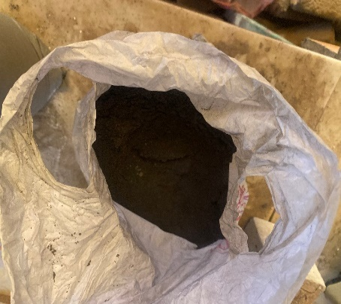

Figure 3.1: Guinea corn husk ash

Rice Husk Ash (RHA)
The rice husk was collected from a rice refining industry at offa, kwara state and underwent controlled burning at temperatures below 700°C to retain high amorphous silica content. It was then ground and sieved to 75 microns to ensure optimal reactivity in the cementitious matrix.
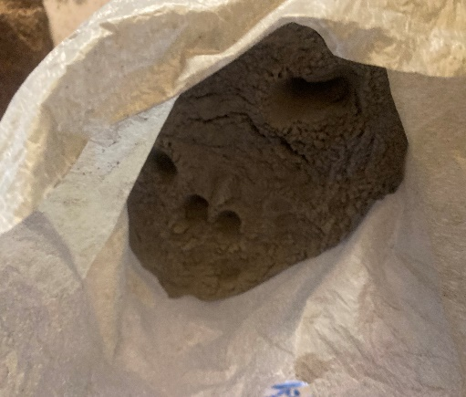

Figure 3.2: Rice husk ash

Superplasticizer
Admixture was used to improve the workability of the concrete.
Water
Clean, potable water was obtained around the school premises and used to facilitate hydration and chemical reactions in the cementitious materials.
3.1.1 Physical Properties
Some physical properties tests were conducted on the various materials include sieve analysis, specific gravity, moisture content, setting time and silt content.
Sieve analysis of Fine aggregates and coarse aggregates
Sieve analysis according to BS 812 was carried out to determine the size particle distribution of both fine and coarse aggregates. The procedure involved passing the dried samples through a set of standard sieves arranged in descending order of size between sizes (8mm to 150micron), the assembled sieves were shaken manually for sufficient time to separate in different fraction sizes. The weight retained on each sieve was recorded, and the cumulative percentage passing was calculated to determine the grading of the aggregates. A graph of cumulative percentages passing was against the sieve sizes was plotted.
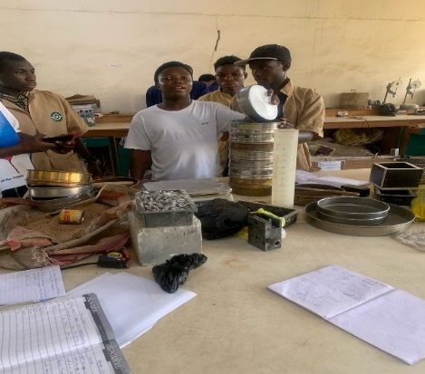
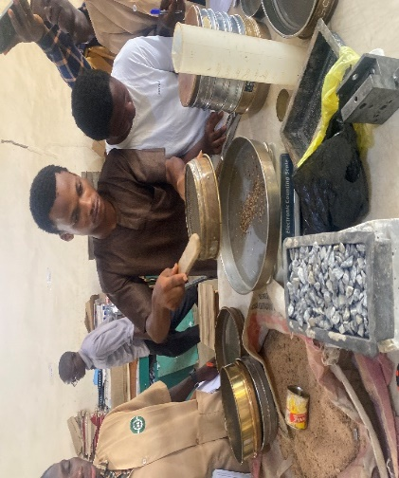
Finesse Modulus= Ʃ% cumulative weight retained btw 80mm to 0.150mm/100 (fine aggregates)

Figure 3.3: Test on sieve analysis

Specific Gravity of Fine aggregates and coarse aggregates
Specific gravity was conducted according to BS 812-2. Before testing for specific gravity, the aggregates were first brought to Saturated Surface Dry (SSD) condition. For fine aggregates the sand was soaked in water for 24 hours. After that, it was spread out and air-dried gently while being stirred occasionally in order to reach a point in which the sand no longer looked shiny or wet on the outside, but still felt moist inside. While for coarse aggregates, the aggregates were soaked for the same amount of time, then dried using a clean, dry towel to remove any surface moisture. After the aggregates were brought to SSD condition the test was carried out to test how heavy the materials are compared to the same volume of water. The weight of measuring cylinder was recorded as W1. The sample were filled into the cylinder and weighed; the weight was recorded as W2(weight of cylinder + sample). The cylinder was filled gradually with distilled water to gauge mark soon after the end of soaking air entrapped and bubbles on the surface of the sample was removed by shaking the cylinder and weighed to be W3(weight of cylinder + sample + water) after which the cylinder was emptied and cleaned. The cylinder was then filled with water to the brim and weighed as W4(weight of cylinder + water) and a formula was used to calculate the specific gravity.
Specific gravity= W2-W1/(W4-W1)-(W3-W2)
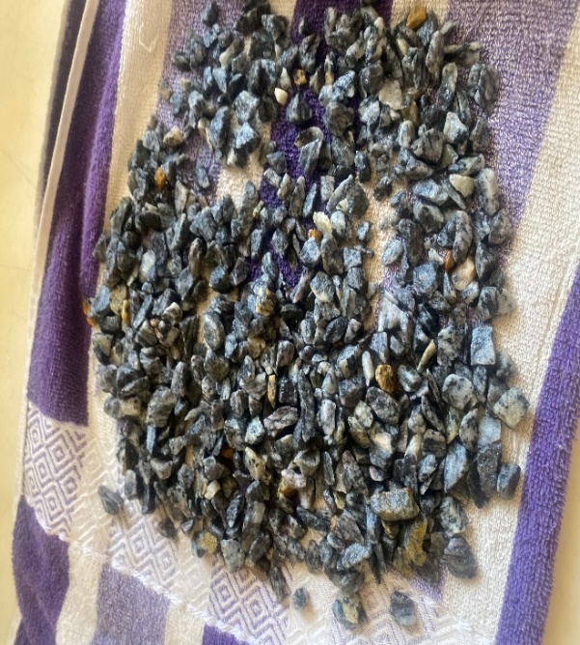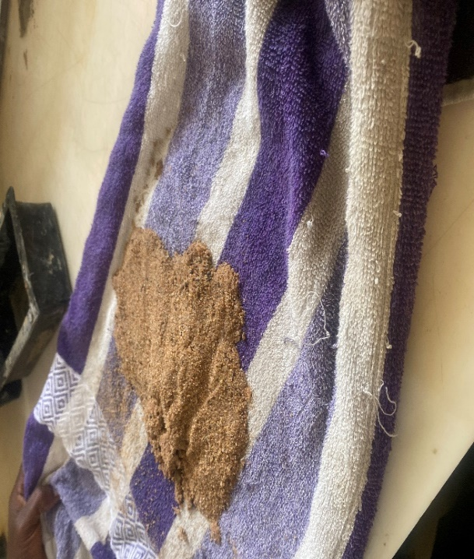
Figure 3.4: Fine and coarse aggregate in SSD condition

Moisture content of fine aggregates
The moisture content of both fine aggregates was determined to adjust the water-cement ratio in the concrete mix. The test involved weighing the aggregate samples before and after oven drying at 105°C for 24 hours. The difference in weight was used to calculate the moisture percentage.
Moisture content (%) = Weight of moisture/Dry weight of sand x 100
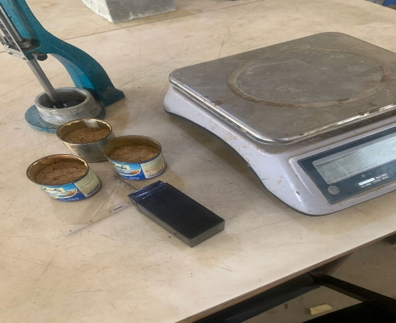
Figure 3.5: Sand samples in can for moisture content test

Silt content of fine aggregates
The silt content of the fine aggregate was determined to assess the level of impurities. A 50ml measured quantity of sand was mixed with a salt-water solution of 100ml (10% of volume of water was measured for the salt added) in a graduated cylinder of 250ml, shaken thoroughly, and allowed to settle for 3 hours. The thickness of the silt layer was compared to the total height of the sand layer to determine the percentage of silt present.
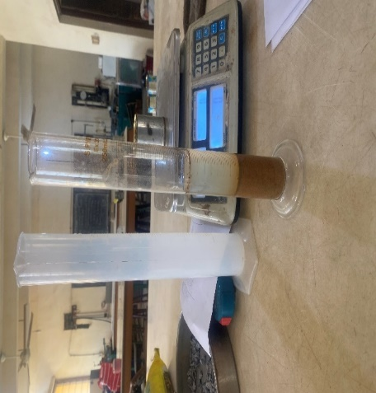
Silt content (%) = (Volume of silt / Volume of sand) x 100

Figure 3.6: Silt content test

Slump Test
Slump test was conducted to determine the workability or consistency of concrete from a freshly mixed batch. The concrete mix was placed in a slump cone with a bottom diameter of 200 mm and top diameter of 100 mm placed on smooth floor while mixing is done. The concrete was placed in three equal layers and each layer tamped evenly with 25 strokes using a tampering rod. Excess concrete was removed and the surface leveled with a trowel. The mould was raised slowly in vertical direction. Slump was measured as the difference between height of the mould and the height of concrete specimen. The slump readings were read directly from a tape rule and recorded in millimeters of subsidence of the mix. The readings were plotted on a graph for the various mixes for comparison (0,5,10,15% partial replacement of cement with RHA/GCHA).
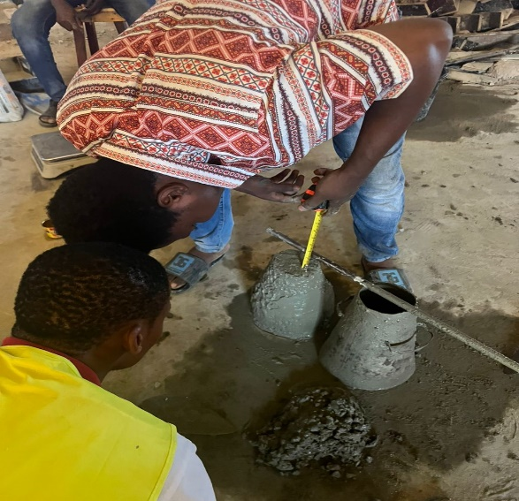
Figure 3.7: Slump Test

Chemical Properties of RHA AND GCHA
The chemical composition of Rice Husk Ash (RHA) and Guinea Corn Husk Ash (GCHA) was determined at Kwara State University, Malete and measured on a Scanning Electron Microscope (SEM) (ASPEX 3020) at 16.0 kV accelerating voltage. The samples were coated with gold using Balzer’s sputtering device before observing them in the microscope. The ashes were initially oven-dried to remove moisture and then sieved through a 75 µm mesh to ensure uniformity.
Representative samples of each ash were placed in sample holders and analyzed under an electron microscope to determine the weight percentage of key elements such as Silicon (Si), Calcium (Ca), Iron (Fe) and other trace elements. The resulting data was used to classify the pozzolans in accordance with ASTM C618, which categorizes pozzolanic materials as either Class F or Class C based on their silica, alumina, and calcium content.

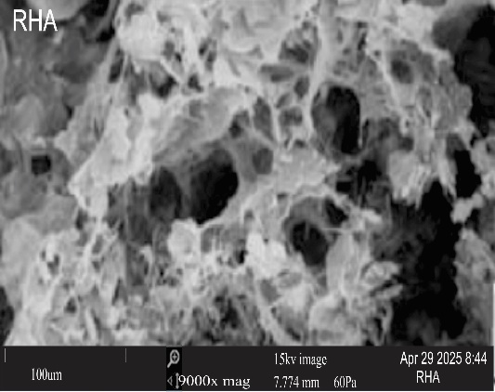
Figure 3.8: Image of SEM Test on RHA

Consistency and Setting time Test of Cement
This test investigates the effect of partially replacing Ordinary Portland Cement (OPC) with a combined pozzolanic mixture of Rice Husk Ash (RHA) and Guinea Corn Husk Ash (GCHA) at 5% varying percentages up to 15% by determining the initial and final setting time of cement paste using Vicat apparatus to BS 4550 Part 3.5-1978. 400g of cement was mixed with water, starting with 25% water-cement ratio and thoroughly mixed to form a consistent paste within 10seconds. The paste was then filled into a vicat mould on a glass plate and leveled mould was placed under a vicat plunger which was gently lowered to touch the surface and then released to measure the penetration depth. This process was repeated with varying water content until a penetration of about 33mm-35mm was achieved indicating the standard consistency of the cement paste.
Cement paste was prepared with 400g of cement and mixed with water equivalent to 0.85P by weight of cement serving as the control sample. Other samples were prepared with partial replacement of cement with RHA and GCHA at varying percentages of 5%, 10%, and 15%. The Gauge time was 3-5 minutes. A stop watch was started immediately water was added to the sample and the time recorded at t₁.The Vicat mould was filled with cement paste and smoothened on the surface to form a test block. Initial setting time was determined by lowering a plunger with a needle and recording the penetration of the needle into the test block. This was repeated every 2 minutes until the needle failed to pierce the test block for about 5 mm. This time was recorded as t_{2.}
Final setting time was determined by replacing the needle of the Vicat apparatus with an annular attachment. Final setting time t₃ was determined as the time at which the needle makes an impression and the annular attachment fails to make an impression on the surface of the test block. The setting times were determined for unblended cement paste and also for cement paste with cement partially replaced with various percentages of rice husk ash and guinea corn husk ash .

3.3 Mix Design
The mix design was done according to Building Research Establishment (BRE, 1988) method with a target characteristic strength of 40N/mm2 at 28 days. The choice of class concrete strength was informed by compressive strengths used by previous researchers: Khusbu and Sharma (2014) used a concrete strength of 32 N/mm2, Faseyemi (2012) used a concrete strength of 30 N/mm2, Olutoge et al. (2012) used a concrete strength of 34 N/mm2. The BRE method of design involved the selection of correct proportions of cement, fine aggregate and water to produce concrete having specified properties namely: workability of fresh concrete, compressive strength at specified age and durability by specifying minimum cement content and/or maximum free water/cement ratio.

Table 1: Mix proportion for one cubic metre of concrete
Quantities | Cement (kg) | Water (kg or lit) | F.A (kg) | C.A (kg)
 |  |  |  | 10mm | 20mm | 40mm
per m³ | 416.66 | 195.83 | 782.10 | 331.80 | 663.61 | 0
Ratio | 1 | 0.47 | 1.88 | 2.39

3.2 Mix Proportioning
A well-structured mix design was essential to produce HPC with varying percentages of cement replacement by GCHA and RHA. The absolute volume method was applied to proportion the materials accurately. The mix design followed ACI 211.4R-08 guidelines, ensuring an optimal balance between workability, strength, and durability.
Four mix variations were prepared:
- Control mix (100% Ordinary Portland Cement)
- Partial cement replacement mixes with 5%, 10% and 15% GCHA and RHA.

3.3 Concrete Mixing and Casting
The concrete mixing and casting process were executed meticulously to ensure uniform distribution of materials and eliminate inconsistencies in strength development.

Batching
Each material was precisely weighed using a digital scale in relation to the mix ratio. Fine and coarse aggregates were sun-dried before use to eliminate moisture variations.

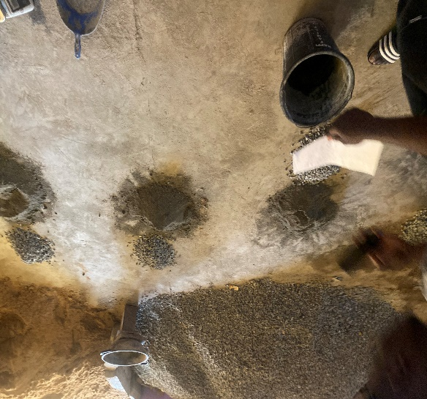

Figure 3.9: Batching of cements and aggregates

Mixing
After dried the materials (cement, GCHA, RHA, fine aggregate, and coarse aggregate) were mixed for two minutes to ensure uniform distribution, water was then gradually added while mixing continued for an additional five minutes to achieve a homogenous mix.

Casting
The fresh concrete was poured into 100mm × 100mm × 100mm cube molds in three layers, each layer was compacted using a tamping rod (25 strokes per layer) to eliminate air voids and ensure uniform compaction. A total of 24 cubes were casted for replacement mixes with 5%, 10% and 15%, of GCHA and RHA in relation to the curing 7, 14, and 28 days.
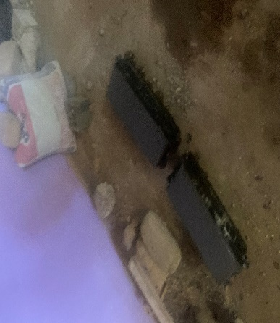
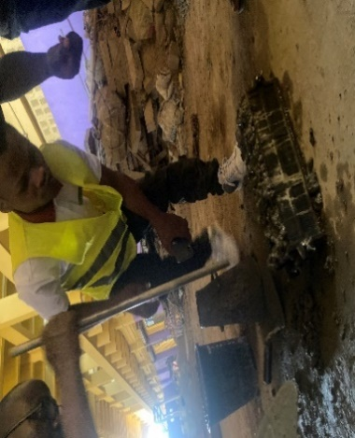

Figure 3.10: Casting of cubes

Curing
The cubes were demolded after 24 hours and placed in a curing tank with clean water. Curing was done for 7, 14, and 28 days to allow for optimal hydration and strength gain.
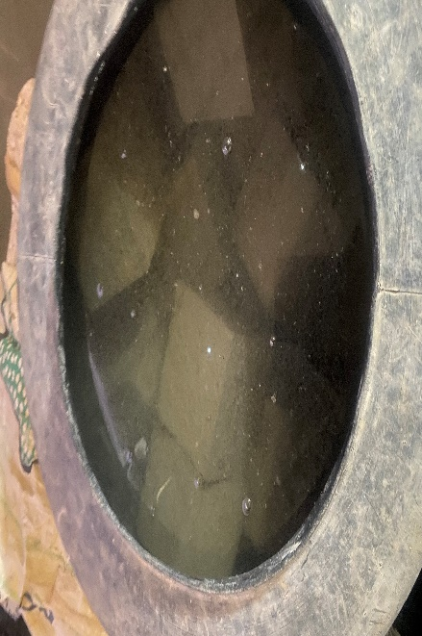
Figure 3.11: Curing of cubes

3.4 Compressive Strength Test
The compressive strength test was conducted in accordance with BS EN 12390-3:2019 standards. This test measures the ability of the concrete to withstand compressive loads, which is a crucial parameter in structural applications.
Cubes Preparation
The cured concrete cubes were removed from the water and allowed to surface-dry before testing.
Testing Procedure
A compression testing machine (1560 KN capacity) was used to apply compressive loads. Each cube was centered on the loading platform, ensuring even distribution of the applied force.

Load Application
The load was applied uniformly until the cube failed.

Strength Determination
The maximum failure load was recorded and compressive strength was calculated using the formula:
fc =f/A

where:
fc​ = Compressive strength (N/mm^2)
P = Maximum load applied (N)
A = Cross-sectional area of the cube (mm²)

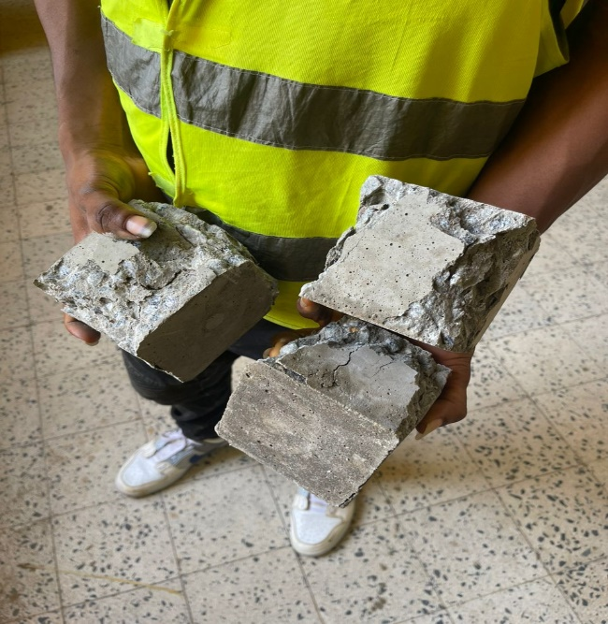
Figure 3.12: Crushing test

