CHAPTER THREE

METHODOLOGY
3.1 INTRODUCTION
To achieve all stated objectives of this research, concrete was produced using a 1:2:4 mixing ratio because its more sensitive to variation in mix design and testing conditions and also when focusing on more general construction applications and potentially more pronounced effects of coconut shells. Various tests such as sieve analysis, slump test, compacting factor test, and compression strength test were conducted on the concretes.
3.2 MATERIALS AND APPARATUS
Coconut Shells (CS), Portland Limestone Cement (PLC) 42.5R compliant with BS 12 (1996), was utilized for creating concrete cubes as part of the research. In accordance with BS 3148 (1980), clean water from the laboratory was used, and fine aggregate (natural sand) compliant with BS 882 (1992) was employed. The coarse aggregate consists of crushed Coconut Shells.
Apparatus used for this research include: Stack of BS sieves, vernier caliper, weighing balance, shovel, slump cone, ruler, head pan, tamping rod, cube mold, spanners, compacting factor apparatus, engine oil, compression machine, hand trowel, scoop and curing tank.
3.2.1 COCONUT SHELL: The Coconut Shell were brought from Oja gbooro market along Balogun Gambari road, Ilorin, Kwara State. It was dried in the sun in an open air and transported to Kwara State Polytechnic, Institute of Technology, Civil Engineering Laboratory. Plate 3.1 shows the Coconut Shells used in the research.

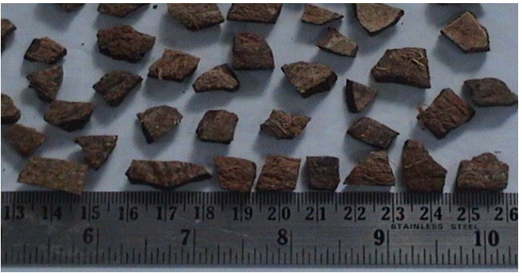

PLATE 3.1: COCONUT SHELL
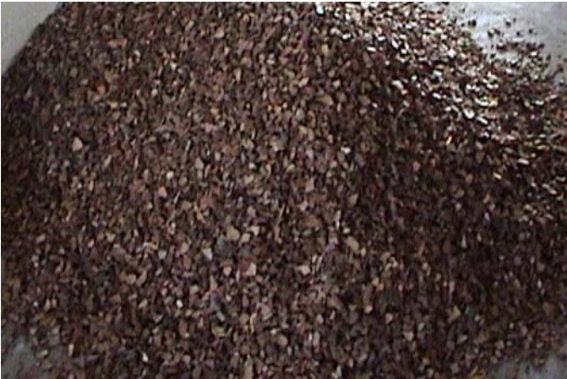
After the Coconut Shell was crushed, then the particles were further ground and allowed to pass through sieve 90 µm (micron) and measured through Varner caliper. Plate 3.2 shows the Crushed Coconut Shell particle.

PLATE 3.2: CRUSHED COCONUT SHELL
AGGREGATE: The aggregates used are:
FINE AGGREGATE: The fine aggregate which was used for the project was obtained from Asa River, Ilorin. The fine aggregates pass through sieve 4.75mm, conforming to ASTM (2017).
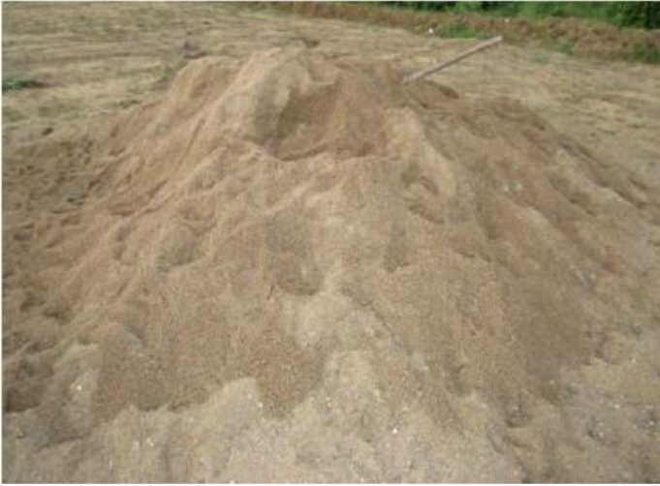
PLATE 3.3: FINE AGGREGATE

WATER: The water used in this project is portable water conforming to BS EN1262 (2013), obtained from Kwara State Polytechnic, Ilorin, Kwara State.
CEMENT
The cement used is Portland Limestone Cement (PLC) conforming to BS 8500-2 (2015) which was bought at SEFRAZ Cement Ilorin, Kwara State.
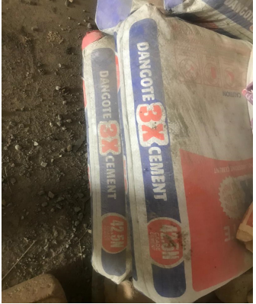
PLATE 3.4: DANGOTE CEMENT

3.3 SLUMP TEST
A slump test was conducted to measure the workability or consistency of fresh concrete with Coconut Shell as Coarse Aggregate. The slump cone was cleaned and lubricated with oil, then placed on a horizontal non-porous base then concrete was placed inside in four layers with each layer tamped 25 times with a tamping rod. Excess concrete was scraped away, and the cone was removed vertically. The difference in height of cone and specimen was then measured with a ruler to define the type of slump each concrete with different aggregate sizes possesses. The decrease in height at the center point was measured to nearest 5mm or 0.25 inch and it is known as ‘slump’. This test was carried out for all concrete mixes and the set-up is shown in Plate. 3.5.

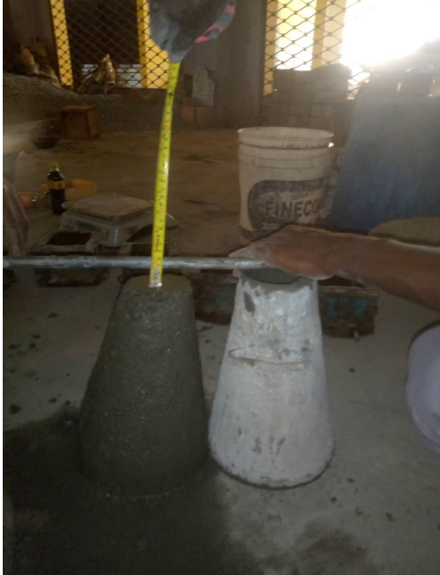
PLATE 3.5: SLUMP TEST

3.4 MIX PROPORTION
All raw materials used in this investigation were locally obtained. These includes Portland Limestone cement confirming to standard code BS 8112-1995, river sand as fine aggregate and crushed coconut shell as coarse aggregate. The potable water was used for mixing and curing. After crushed the coconut shells, they were sieved and the aggregates passing 12.5mm sieve size was used for this investigation (Fig.1 and Fig.2). The physical and mechanical properties of the river sand, coconut shells aggregate and granite aggregates are shown in Table 1. The normal design procedures for ordinary conventional concretes are not applicable to the mix design of lightweight aggregate concrete for two reasons: -The water content of the cement paste in the fresh lightweight aggregate concrete mix is reduced progressively through absorption by the aggregate and therefore the water-cement ratio will also decrease, and -The compressive strength of lightweight aggregate concrete is not only influenced by the strength of the mortar but also by the aggregate used. Hence, it is recommended to go for trial mixes for designing lightweight concrete mix. For lightweight concrete, the cement is recommended in the range of 285–510 kg/m³. The concrete mix proportion obtained from the trials is 1:1.83:2.63. The mix proportion consists of 480 kg/m3 cement with the water / cement ratio of 0.5 All the ingredients of the mix were weighed and mixed in concrete mixture machine. Steel moulds were used for casting specimens Sides of the moulds and bottom of all the moulds were properly oiled for easy demoulding. The concrete was placed in the mould and proper care was taken for uniform compaction and surface finish.
