CHAPTER FOUR
4.0 DATA PROCESSING AND RESULT ANALYSIS
4.1 DATA PROCESSING PROCEDURE
This is the process that follows downloading of data into the computer system. It is the manipulation of data into a more used form. Data processing includes numerical calculation, classification of data and the transmission of data from one place to another.
This stage involves downloading of the acquired data on field from the digital equipment (total station) to the personal computer for further processing.
The data obtained using Topcon(ES-103) total station were downloaded in sequential arrangement. After successful download and process using notepad for sorting them into desired arrangements.
The file was opened and point data were displayed. This was then copied to Microsoft excel environment for further processing.
On Microsoft excel, data were prepared for scripting purpose in AutoCad. A small program was written to prepare point and text scripts files.
The coordinates obtained were x,y,z format which were used for plotting the routes longitudinal profile and cross sections.

4.2 TOTAL STATION DATA PROCESSING
The downloaded data from the total station was further edited using Microsoft excel, the final copy was saved as text file containing x,y,z coordinates of all points observe in the field.
4.3 DATA EDITING
Data editing is done using the Microsoft excel. The following steps are followed to edit our data in the project:
- The Microsoft excel was lunched.
- Click on file, the click on “all file” and select the group data.
- On open “test import wizard”, select “delimitated” and click on next.
- Select comma, tap and space then click on next. All the co-ordinates will be arranged then click on finish.
Cut and copy and put them in its appropriate positions if there is any misclosure.

4.4 DESIGN AND VOLUME CALCULATIONS
The design of the route was done after the creation of the longitudinal profile. The longitudinal profile was created using AutoCAD Civil 2012. The steps in the creation of the longitudinal profile are as follows:
- The Centerlines of the entire data is first extracted and arranged in Microsoft Excel and saved with the extension txt.
- The AutoCAD Civil 2012 Software is launched.
- A new project is created and named
- The Units icon is clicked to set the units of the drawing as follows:
- Length
- Type- Decimal
- Precision- three (3) places (i.e., 0.000)
- Insertion Scale
- Units to scale inserted content- Meters
- Angle
- Type- Deg/Min/Sec
- Precision- 0d00’00”
- The Clockwise Box below is clicked

- The Direction icon below is clicked and a direction control dialogue box is opened. The North is selected.
- The icon Points is clicked, the point settings are selected. The Coordinates icon is clicked to select the method of data arrangement (i.e., Easting-Northing). The type of Marker is also selected.
- Under the point icon, the import/export point icon is selected.
- The import point’s icon is selected. A dialogue box opens, the format in which the data is arranged is selected (E.g., ENZ (space delimited)). Also, the source file where the data is saved and ok is clicked to continue.
- The points are imported and are joined with the polyline drawing icon on the AutoCAD Civil 2012 Environment. The OSNAP (object snap) below the AutoCAD Civil 3D 2012 Environment is switched on so as to highlight the endpoints for ease of joining the points.
- On the Alignment icon, the icon define from polyline is selected.
- The line is clicked and where the alignment is to start is also clicked; a dialogue box opens and the alignment is named.
- On the Alignment icon, the station label settings is clicked; the station label increment, station tick increment and the station label offset are edited appropriately. The perpendicular labels and plus sign location are also clicked. Then the station labels are also created.
- The Terrain is created by clicking on the Terrain icon, Terrain Model Explorer is selected. A dialogue box opens; a new surface is created and named. The point files are added, the format in which it is arranged is selected as well as the file where it is located. The surface is built by right clicking on it and select build. When the surface is built, the dialogue box is closed.

4.4.1 PROFILE GENERATION
On the Profile icon, sampling is selected and import is clicked. The Tangent Labels, Vertical Curve Labels and the Vertical Grid Lines values are edited appropriately. The created surface is made current by clicking on surfaces and set current surface. The profile is sampled by clicking on existing ground, sample from surface and accepting the beginning and ending stations. Then the profile is created by clicking on create profile, full profile is selected; a dialogue box opens where the grid height is adjusted and ok is clicked.
When the profile is created, the route is designed by first creating the Tangents along the route and the Vertical Curves are created by selecting the incoming and outgoing tangents and inserting the K- Value (see appendix).

4.4.2 CALCULATION OF THE VOLUME OF EARTHWORK
One of the applications of survey products (profile and cross section) is in determining the estimate of the volume or quantity of earthworks, it is necessary to know the volume of materials which would be required to cut and to fill in road construction. For the scope of this project, the volume and fill were determined from the cross section using AutoCAD land development software. This is done also for subsequent cross-sections and the volume is cumulatively summed up to obtain the final cut and fill (see appendix)

4.4.3 CUT AND FILL ANALYSIS
This is an important aspect in route survey data analysis. The volume of earthwork needed can be calculated to a high degree of accuracy. It helps in the area of project costing to determine earthwork and materials quantity. The cut and fill table is shown in the appendices. The total cut was estimated to be 16803.12m3 while the total fill is estimated to be 10563.82m3. Having subtract the total fill from the total cut, therefore, the volume of material needed to be cut is 6239.30m3
Refer to the appendix for the entire cut and fill data (Appendix).

4.5 INFORMATION PRESENTATION/ PLAN PRODUCTION
The adjusted coordinates (X, Y, Z) were plotted in AutoCAD Civil 2012 Environment to generate the centerline of the road, longitudinal profile and cross-section. The details were also plotted.

4.5.1 DETAIL PLAN
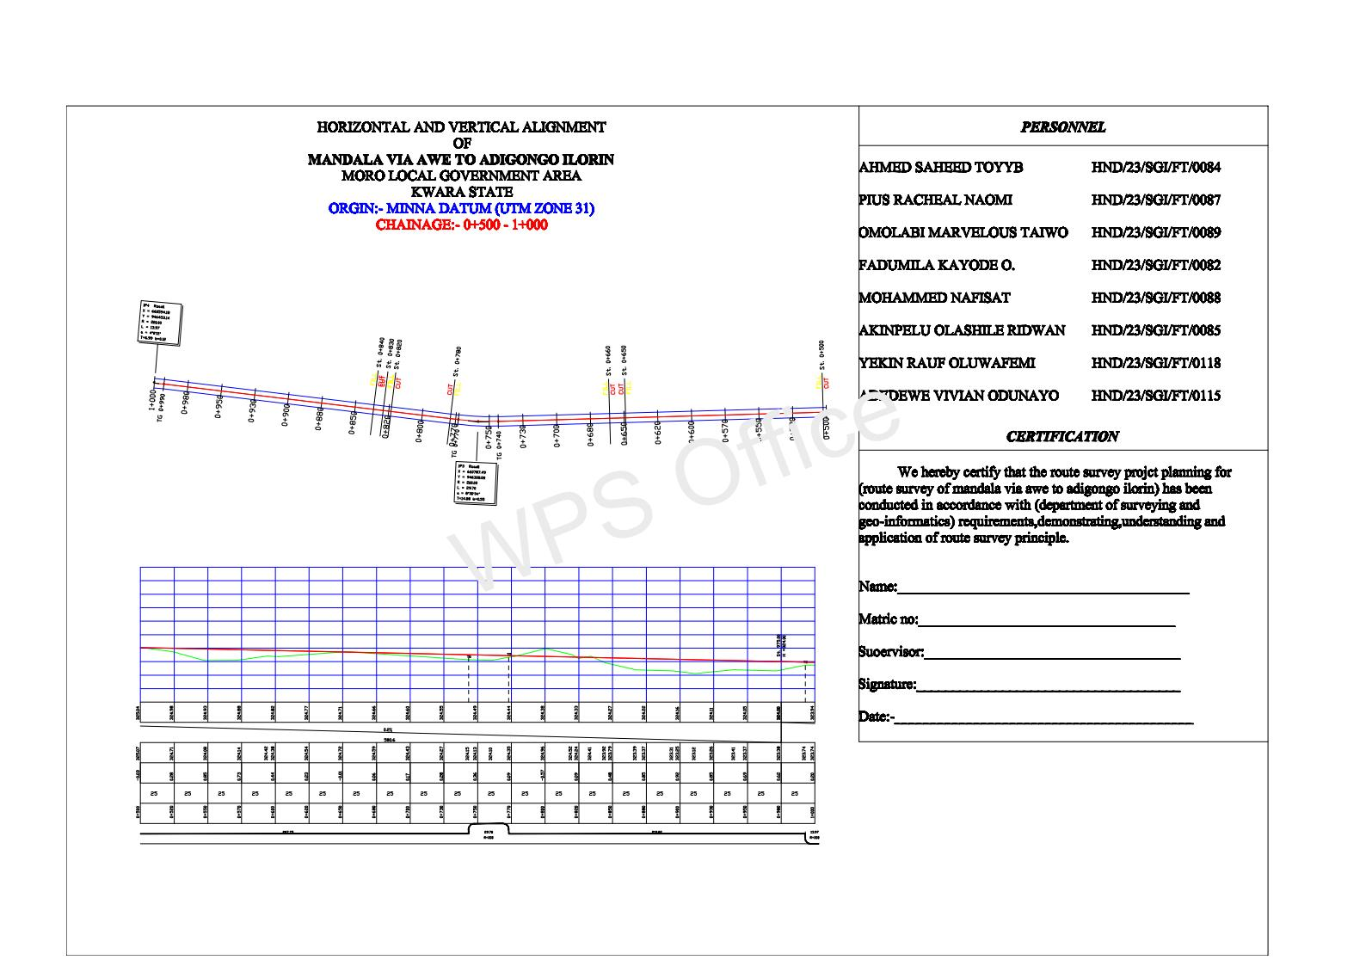
The essence of obtaining a detail plan is to provide a platform for horizontal curve and alignment design for the road expansion/rehabilitation. Geometric information is also shown on the detail plan making a vivid representation of the land mass for easy understanding of the route.

4.5.2 LONGITUDINAL PROFILE
Profile was generated to provide vertical height/terrain information along a route for vertical alignment/curve design. It provides a vivid picture of the terrain and decisions of where to cut or fill was determined. It provides information such as the grade percent, tangent points, existing level and formation level.
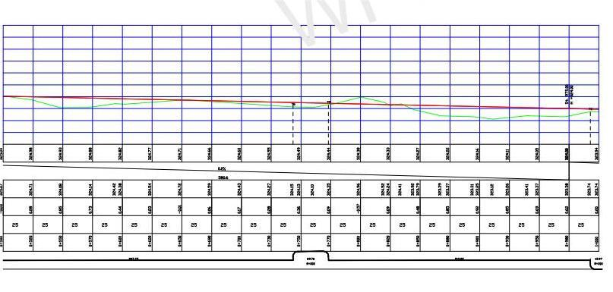

4.5.3 CROSS-SECTIONS
Cross-section depicts the terrain information across the road chainage. Information such as the height of existing and proposed center line and embankments were shown. The cross-section parameters were used to generate the area and hence, volumes of earthwork in cut and fill analysis (see appendix).

Earth drain Earth drain

Concrete drain

Earth drainage was used throughout except where we have culvert, concrete drainage was used 150m before and 150m after each culvert, the culvert used was 800mm by 800mm because the volume of the water that will be flowing there is much. The concrete drainage used was 0.10cm thick and 0.60cm by 0.60cm for easy flowing of waters.

Having carried out the flying method to checks on the linear accuracy of the closing control, it was discovered that the linear accuracy conforms with third order accuracy which show that the closing controls could still be used for this project.

