CHAPTER THREE
3.0 METHODOLOGY
Methodology comprises of the method and procedure employed in executing the project both in office and on the field. The method adopted for this project was based on the principle of surveying which was working from whole to part, aim at acquiring reliable and accurate data needed for the computation and presentation of information in form of a plan.
The procedure adopted in carrying out the project followed a pattern in which one step leads to another, for easy execution and for the aims and objectives of the project to be realized, it was planned as under listed;
- Reconnaissance survey
- Chainage marking
- Control establishment
- Data acquisition
- Data downloading and processing
- Data analysis
- Road design
- Information presentation
3.1 RECONNAISSANCE
This is a very important aspect of surveying that involves planning and preliminary inspection of the area before the commencement of the actual data acquisition of the project site, this is done for the purpose of planning on how to execute the project, fixing stations, locating controls etc. its importance to the actual survey operation that cannot be underestimated as it enable it to give the best method to carry out the task.
The two phases of reconnaissance are;
- Office planning
- Field reconnaissance
3.1.1 OFFICE RECONNAISANCE
This involved the office work carried out before the actual field work. This aspect involved the computation and study of the available information the project site as this helped in yielding result within the expected accuracy. It comprises of the following
- Understanding the purpose of the survey from the project instructions.
- Obtaining the specification for the accuracy required leading to the choice of a suitable scale.
- Deciding the method to be employed for the measurement.
- The kind of instruments to be used in executing the project.
The coordinates of control stations around the project area were collected from the SOUTH GALAXY G1 (GNSS receiver).
Table 3.1 coordinates of the existing ground control used origin (U.T.M)
Control id | Easting  (Nm) | Nothing (Nm) | Height (m)
BM1 | 661425.0232 | 945950.9002 | 324.7349
BM2 | 661402.8991 | 945939.4238 | 324.8356
BM3 | 661457.0369 | 945934.9219 | 324.0516

3.1.2 FIELD RECONNAISSANCE
The field reconnaissance was done after the office planning it involved a visitation to the project site by all the group numbers to have a pre requisite knowledge of how it looks like and how the field operations would be carried out.
During the visit the control pillars planned to be used were located, traverse stations which were to form the traverse framework were selected and marked using pegs and nails, inter visibility between successive traverse station were ensured.
At the end of the visit, a sketch diagram known as “recce diagram” showing the physical appearance of the project site was drawn.
To sum up the reconnaissance facilitated the planning and execution of the actual survey as it was taking into consideration the possible problems that are likely to be encountered, how such problems can be overcome or reduced to the barest minimum.

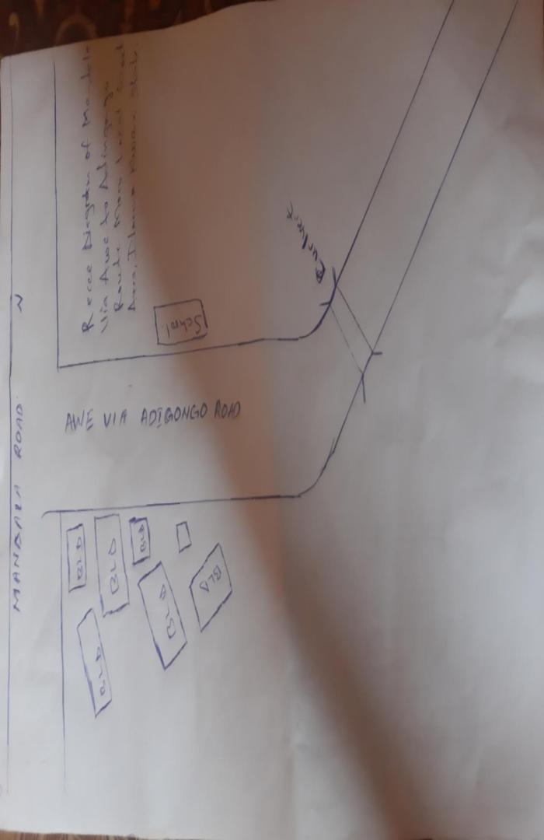
Fig. 1 Field Recci diagram Mandala Via Awe to Adigongo Route.

3.2 A TYPICAL PEG USED
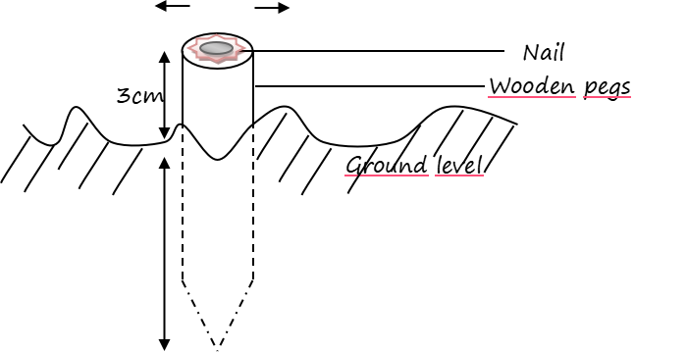
Fig 3.2 An Illustration diagram of peg
3.3 DATA ACQUISITION
This entails all activities involved in the collection of data for the successful execution of the project. This was carried out in chronological order using mode digital surveying equipment such that: they were coordinated using Topcon(ES-103) total station, the position of the center line was determined using Topcon(ES-103) total station and also both national and man-made features were observed and determined.
3.3.1 EQUIPMENT USED
- Topcon (ES-103) total station
- Tripod stand
- S50mm steel tape
- 5m packet tape
- Plumb pop
- Nails with crown corks
- Downloading cables
- Writing materials
3.3.1.1 HARDWARE USED
The hardware used for this project includes.
- Laptop computer for data processing
- An Hp desk set for the printing of hard copy
3.3.1.2 SOFTWARE USED
- Note pad
- Microsoft excel 2010
- Civil cad 2010
- Hp printer devices

3.3.2 CONTROL CHECK
The essence of carrying out the operation was to ascertain the reliability of all the controls used for the project whether they were in situ. The check was carried out by setting total station instrument on BM1 and all the necessary temporary station adjustment(i.e catering; leveling and focusing) was carried out, the reflector at back station on BM2 was then bisected, read and recorded, the instrument was turn to fore station BM3 and the reflector was also bisected read and recorded and on getting to every 500m interval where there are 2 benchmarks on the both side of the road same procedures where adopted in until the end of the road.
The coordinates obtained were compared with the coordinates extracted from the use of SOUTH GALAXY G1(GNSS receiver) which the result shows that the discrepancy was very little and lower than the allowable standard for the specification of this project which shows that BM1, BM2 and BM3project were reliable enough for the third order survey project given.
Table 3.3.2.1 showing the collected co-ordinates of the controls
STATION | EASTING (Nm) | NORTHING (Nm) | DISTANCE (M) | BEARING
BM1 | 661425.0232 | 945950.9002 | 324.7349
BM2 | 661402.8991 | 945939.4238 | 324.8356 | 179⁰14’ 9”
BM3 | 661457.0369 | 945934.9219 | 324.0516 | 24⁰27’ 53”
Source: Supervisor (May 2025)
Table 3.3.2.2 showing the observed co-ordinates of the controls
STATION | EASTING (Nm) | NORTHING (Nm) | DISTANCE (M) | BEARING
BM1 | 661425.0232 | 945950.9002 | 324.7349
BM2 | 661402.8991 | 945939.4238 | 324.8356 | 179⁰14’ 9”
BM3 | 661457.0369 | 945934.9219 | 324.0516 | 24⁰27’ 53”
The included angle = bearing of bm2 to bm1 minus bearing of bm2 to bm3

Table 3.3.2.3.showing the Comparison of observed and computed data
 | Bearing | Back dist (m)
Computed value | 179⁰ 14’ 09” | 220.590
Observed value | 24⁰ 27’ 53” | 14.6427
Error | 00⁰01’ 06” | 0.006

For the control points, the allowable heights misclosure were lesser than obtained misclosure for each control point. There, the set of controls (bm1, bm2and bm3) were in situ vertically and could be used as benchmark for height determination of profile and cross sectional points.
3.3.3 SELECTION OF STATION
The station selected were ensured to be inter visible to each other, accessible and firmly pegged to the ground with wooden pegs and bottle corks carrying mills at the centre point to denotes its exact point on the earth surface.
3.4 FIELD OBSERVATION
3.4.1 HORIZONTAL ALIGNMENT
This way carried out on loops with the aid of Topcon (ES-103) total station which has the capability to capture all the three dimensional (3d) terrain characteristics (easting, northing and height) concurrently. To control swing, the observation we carried out by commencing it on a set of controls and ending on another control from loops.
The instrument was set up on Bm2 and the reflector was placed on Bm1and the orientation was performed, the reflector was placed at change 0+000, which was the starting point of the route survey. The chainage 0+000 served as nail.
The target (reflector) was properly leveled and the coordinate of all the changes in the direction were observed and recorded in the internal memory of the instruments; other points which were visible from this instrument station were bisected and coordinated. This was done repeatedly until the entire section of the route was covered.
3.4.2 LONGITUDINAL / PROFILING
This was carried out with the aid of Topcon (ES-103) total station as well. The instrument was set on Bm2 and the reflector was placed on Bm1and the orientation was at every 25m interval. Whenever the target from the instrument station is too far and cannot be sighted from the instrument which might affect the accuracy of data, another stations were coordinated station where same procedures were repeated until all the data were captured.
12cm
3cm
Nail
Ground level
Wooden pegs

