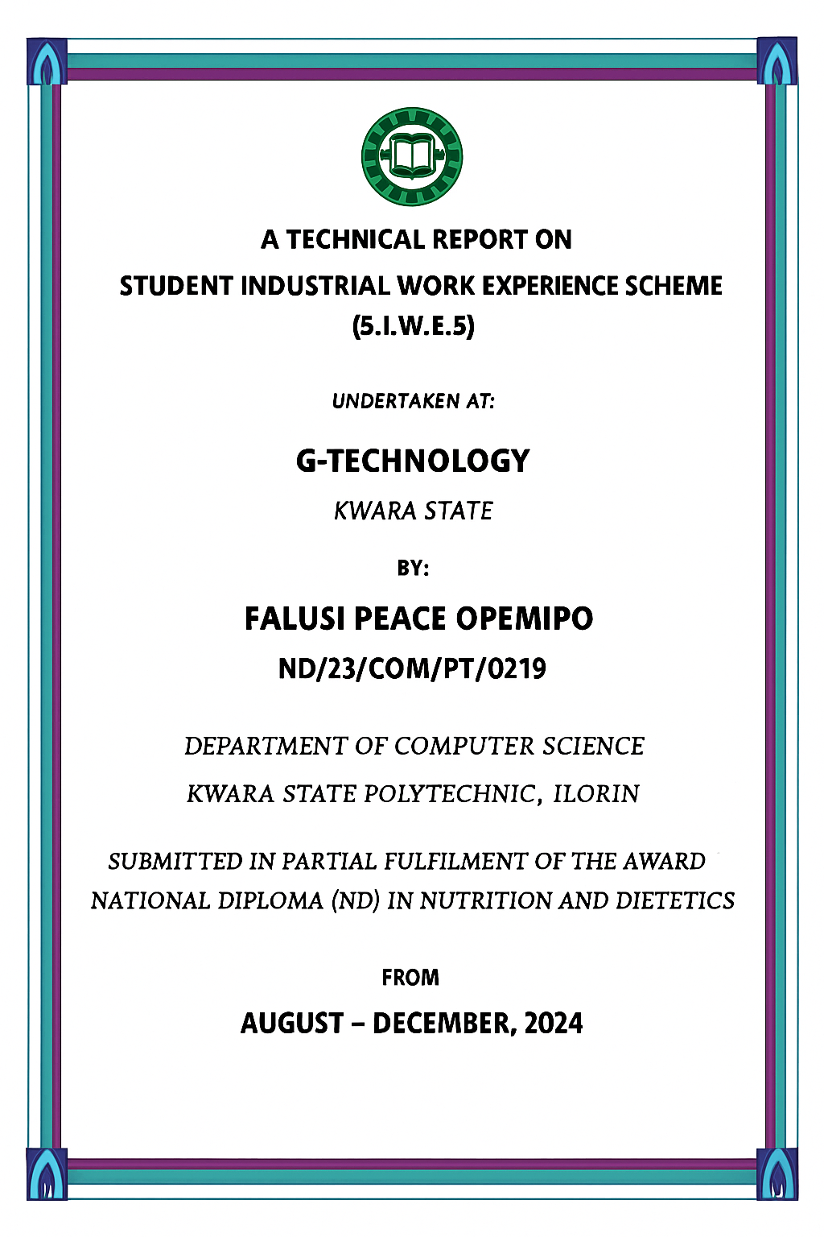

DEDICATION

To my wonderful parents, who taught me that the largest task can be accomplished if one can work hard and remain committed to one’s true self.

ACKNOWLEGEMENT
All praise and adoration are to God Almighty my creator, my strong pillar, my source of inspiration, wisdom, knowledge and understanding. He has been the source of my strength throughout this program.
I owe thanks to my parents for their unstinting support, co -operation, encouragement and understanding throughout the span of this program and many other close friends and family members.
I have taken effort in this report. However, it would not have been possible without the kind of roles played by all the technical staffs of Robust Technology computer package for their relentless supports, guidance, constant supervision, and explanation of work(s) done even though the work was so hectic. Other members of staff of Robust Technology computer package who contributed to one form, or the other are deeply appreciated and to the people who have willingly helped me out with their abilities.

TABLES OF CONTENTS

Front Page i
Dedication ii
Acknowledgment iii
Tables of contents iv
Chapter One
  - Introduction to SIWES 1
  - Importance of SIWES 1
  - Organizational structures of Robust Technology Computer package 2
Chapter Two
  - Web Design 3
  - Web Design in ICT 3
    - Key Aspects of Web Design in ICT 3
    - Importance of Web Design in ICT 4
  - What are the 7 steps in web design 5
  - Introduction to Bootstrapping in Computer 7
  - Processing of bootstrapping in Computer 7
Chapter Four
  - Introduction to Operating System 9
  - Computer Hardware 9
  - Computer Software 9
Chapter Five
  - Summary, Conclusions and Recommendations 12
  - Summary and Conclusions 12
  - Problem Faced During SIWES Program 12
  - Recommendations 13

CHAPTER ONE

Introduction to SIWES

The Students Industrial Work Experience Scheme (SIWES) is the accepted skills training program, which forms part of the approved minimum Academic Standards in the various degree program for all the Nigerian Universities. It is funded by the Federal Governm ent of Nigeria and jointly coordinate by the Industrial Training Fund (ITF) and the National Universities Commission (NUC). It is also designed to expose and prepare students at Universities, Polytechnics, Colleges of Technology, Colleges of Agriculture and Colleges of Education for the industrial work situation they are likely to meet after graduation. The scheme also affords students the opportunity of familiarizing and exposing themselves to the needed experience in handling equipment and machinery that are usually not available in their Institutions. Before the establishment of the scheme, there was a growing concern among our industrialists that graduates of our Institutions of higher learning lacked adequate practical background studies preparatory fo r employment in Industries. Thus, the employers believed the theoretical education going on in higher institutions was not responsive to the needs of the employers of labor. It is against this background that the rationale for initiating and designing the scheme by the Industrial Training Fund (ITF) during its formative years – 1973/74 was introduced to acquaint students with the skills of handling employers’ equipment and machinery. The ITF solely funded the scheme during its formative years. But as the fi nancial involvement became unbearable to the Fund, it withdrew from the Scheme in 1978. The Federal Government handed over the scheme in 1979 to both the National Universities Commission (NUC) and the National Board for Technical Education (NBTE). Later the Federal Government in November 1984 revert the management and implementation of the SIWES Programmed to ITF and it was effectively taken over by the Industrial Training Fund in July 1985 with the funding being solely borne by the Federal Government (SA'AD, 2018).
  - Importance of SIWES

⇧ It provides students with an opportunity to apply their theoretical knowledge in real life situations.
⇧ It strengthens links between the employers, universities, and industrial training fund (ITF).
⇧ It also prepares the students for the labor market after graduation (Hameed, 2019).

⇧ It helps in increasing self-confidence and identifying their own proficiency.
⇧ The industrial training program improves students’ awareness in single technology.
⇧ The learners can obtain hands-on experience and know the real job scenario
⇧ It cultivates the leadership ability of the students and gives them the responsibility to execute and perform the given task (NIMS, 2018).

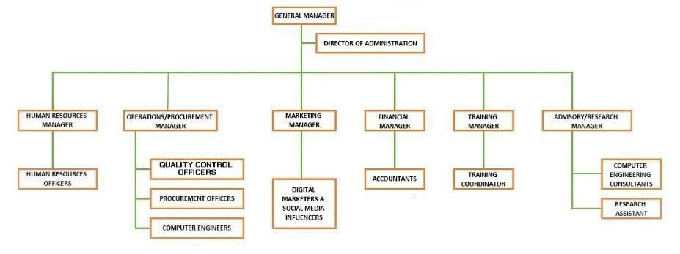
Organizational structures of Robust Technology Computer package

CHAPTER TWO

Web Design

Web design is the process of planning, conceptualizing, and implementing the design of websites, focusing on creating visually appealing pages that reflect a brand's identity while ensuring functionality and a user-friendly experience. It involves various aspects, including layout design, color schemes, typography, and the overall user interface. The term typically refers to the frontend design, which includes writing markup and coding to bring the visual elements to life.

Web Design in ICT

Web design in Information and Communication Technology (ICT) encompasses the creation and maintenance of websites using various tools, technologies, and best practices to ensure that users can interact with content effectively. Here’s a deeper dive into its components and significance:

Key Aspects of Web Design in ICT

      - User Interface (UI) Design:
        - Focuses on the layout, colors, fonts, and overall aesthetic of the website.

        - Ensures that the site is visually appealing and easy to navigate.

User Experience (UX) Design:

        - Focuses on optimizing the overall experience of users when they interact with a website. o Involves understanding user behavior and designing pathways that facilitate easy access to information or services.

Responsive Design:

        - Involves creating designs that adapt to different screen sizes and devices (desktop, tablet, mobile).
        - Ensures usability across various formats and platforms.

Accessibility:

        - Making sure that websites can be accessed and used by people with disabilities, adhering to standards like WCAG (Web Content Accessibility Guidelines).

Web Development:

        - Integrating the design with back-end technologies to ensure functionality.

        - Involves HTML, CSS, JavaScript, and sometimes back-end programming languages (Python, PHP, etc.).

SEO Considerations:

        - Designing websites with best practices in mind to improve search engine visibility (like using proper tags, image optimization, etc.).

Content Management Systems (CMS):

        - Utilizing platforms like WordPress, Joomla, or Drupal to facilitate easy content updates and management.

Graphic Design:
        - Incorporating visual elements like images, icons, and infographics to enhance communication.

Importance of Web Design in ICT

- Brand Identity: A well-designed website helps establish and convey a brand's identity and values.
- Communication: Acts as a primary channel for organizations to communicate with customers and stakeholders.
- Customer Engagement: A good design can lead to higher user engagement, increasing the likelihood of conversions or desired actions.

- Information Accessibility : Helps in making information readily available and easy to access for users, which is essential in the digital age.

What are the 7 steps in web design

The web design process typically involves seven key steps that guide you from concept to completion. Here’s a breakdown of each stage:

Planning

  - Define Goals: Establish the purpose of the website (e.g., inform, sell, educate).

  - Identify Target Audience: Understand who your users are and what they need.

  - Research Competitors: Analyze competitors' websites for design ideas and functionality.

Scope Definition

  - Outline the Project: Establish the project scope, including deliverables, features, and functionalities.
  - Create a Sitemap: Organize the site's structure by creating a sitemap that outlines the pages to be included.

Design

  - Wireframing: Develop low -fidelity wireframes to visualize the layout and structure of individual pages.
  - Visual Design: Create high-fidelity mockups with colors, typography, and visual elements that align with branding.

Content Creation

  - Develop Content: Write and gather textual and multimedia content that will be displayed on the website.
  - SEO Optimization: Ensure that content is optimized for search engines to improve visibility.

Development

  - Front-end Development: Convert the design into code using HTML, CSS, and JavaScript to create the website's interface.
  - Back-end Development: Implement server-side technologies (like databases) that support the front-end functionality.

Testing

  - User Testing: Perform usability testing with real users to gather feedback on functionality and design.
  - Browser and Device Testing: Ensure that the website functions correctly across different web browsers and devices.

Launch and Maintenance

  - Launch the Website: Publish the site to a live server and ensure all features are operational.

  - Ongoing Maintenance: Regularly update content, monitor performance, and make improvements based on user feedback and analytics.

CHAPTER THREE

Introduction to Bootstrapping in Computer

Bootstrapping in a computer operating system refers to the process of loading and initializing the operating system from a powered-o ffstate. This involves executing a bootstrap program, the first code that runs when the system starts, which helps in prepa ring the system so that the operating system can take over and manage the hardware effectively.
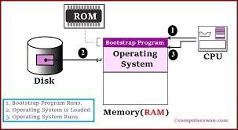

Processing of bootstrapping in Computer

The boot process in computers is a series of steps that initializes hardware and loads the operating system. Here’s a simplified overview:

Power-On:

      - When you turn on the computer, it receives power, and the CPU begins executing code from a predefined location.

POST (Power-On Self-Test):

      - The BIOS/UEFI runs POST, checking hardware (like RAM, keyboard, etc.) to ensure they are functioning correctly.
      - Any errors detected will typically be indicated with beeps or error messages.

Bootloader:
      - The BIOS/UEFI locates the bootloader, typically located in the Master Boot Record (MBR) or EFI system partition (for UEFI systems).
      - The bootloader is responsible for loading the operating system kernel into memory.

Kernel Loading:

      - The bootloader loads the operating system kernel. o The kernel initializes core components, manages hardware and system resources, and starts essential services.

Initialization:

      - The kernel initializes the system's drivers, mounts the filesystem, and configures system parameters.
      - User space processes and services, such as login prompts or GUI elements, are started.

User Login:

      - Once the operating system is ready, users can log in.

    - System Ready for Use: o The system is now ready for user interaction and can run applications.

CHAPTER FOUR

Introduction to Operating System

In our first few days in the training department, we were made to understand the design and working principles of computers’ components, it is important to have the design knowledge of both laptop and desktop computers before proceeding into their hardware repair and software installations. The manufacturer of computers must know what brand of computer to produce for a targeted market. We were made to understand that there are three components of a computer, these are:
i. Hardware ii.

Software iii.

Human ware

COMPUTER HARDWARE
The hardware refers to the physical components and the devices which make up the visible computer. It can be divided into two: Central Processing Unit (CPU) and the Peripherals. The CPU is responsible for all processing that the computer does while the peripherals are responsible for feeding data into the system and for collecting information from the system. The CPU consists of Main Storage, Arithmetic and Logic Unit (ALU) and Control Unit. The main storage is used for storing data to be processed as w ell as the instructions for processing them. The ALU is the unit for arithmetic and logical operations. The control unit ensures the smooth operation of the other hardware units. It fetches instruction, decode (interprets) the instruction and issues commands to the units responsible for executing the instructions.(Rossmann et al., 1975)
The Peripherals are in three categories: Input devices, Output devices and Auxiliary storage devices. The input device is used for supplying data and instructions to the computer. Examples are terminal Keyboard, Mouse, Joystick, Microphone, Scanner, Webcam, and so on. Output device is used for obtaining result (information) from the computer. Examples are Printers, Video Display Unit (VDU), loudspeaker, projector, and so on. Auxiliary Storage Devices are used for storing information on a long-term basis. Examples are hard disk, flash disk, magnetic tape, memory card, and so on (Babatunde, 2019).



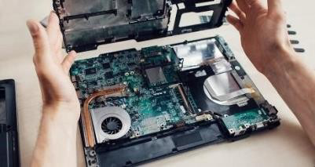
Fig. 3.1 computer keyboard, mouse, and motherboard

COMPUTER SOFTWARE
Software basically refers to programs written to control the operations of computer hardware. A program consists of sequence of coded instructions showing the logical steps required to accomplish a well -defined task. It also refers to the instructions, programs, data, and protocols which run on top of hardware(Alfred, 2021). Examples of such tasks include:
    - Finding the average score of a student
    - Computing the net pay of an employee
    - Solving a set of simultaneous linear equations
It is the software that enables the hardware to be put into effective use; i. e the software that makes the computer versatile. There are two main categories of software – System software and Application software.
- System software are programs commonly written by computer manufacturers, which have direct effect on the control, performance and ease of usage of the computer system. Examples are Operating System, Language Translators, and System Utilities Programs.
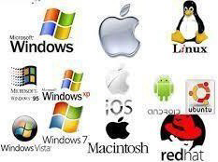
Fig. 4.2 System software (operating systems)

- Application software are programs written by a user to solve his/her own application problem. They do not have any effect on the efficiency of the computer system. An example is a program to calculate the grade point average of all the 100L students. Application software can be divided into two namely: Application Package and User’s Application Program . When application programs are written in a very generalized and standardized nature such that they can be adopted by several different organizations or persons to solve similar problem, they are called Application Packages. There are a few micro-computer-based packages. These include word processors (such as MS -word, WordPerfect, WordStar); Database packages (such as Oracle, MS-access, Sybase, SQL Server, and Informix); Spreadsheet packages (such as Lotus 1-2-3 and MS-Excel); Graphic packages (such as CorelDraw, Fireworks, Photoshop etc.), and Statistical packages (such as SPSS).
User’s Application Program is a program written by the user to solve specific problem which is not generalized in nature. Examples include writing a program to find the roots of quadratic equation, payroll application program, and program to compute students’ results (Babatunde, 2019).

Fig.4.4 computer application packages

CHAPTER FIVE

SUMMARY, CONCLUSIONS AND RECOMMENDATIONS

Summary and Conclusions
The whole experience gained during the attachment at Robust Technology was very enlightening. The practical skills we were exposed to and the opportunity to relate with typical situations relating to computer engineering industry. These experiences have successfully broadened my understanding and interest in Electrical and Electronics Engineering as a profession especially in the field of Control and Automation engineering.
The training was worthwhile, has it accorded me the privilege of gaining insight into job preparation as well as what it meant to carry out proper inspection and also working condition under stress which in a way prepares undergraduates for the outside world after school.
The program gave me the privilege to relate with senior professionals and other students from different institutions and this experience made me appreciate the nature, benefits, and intricacies of my chosen field of study both in the classroom and in the s ociety at large while also gives me the opportunity to put into practice the theoretical knowledge acquired throughout my stay in school. The program has given me the rare privilege of gaining practical knowledge and widened my knowledge about the application of Electrical and electronics engineering in the world.

Problem Faced During SIWES Program
Some the problems experienced during the SIWES program. These are as stated below.

- Limited orientation before starting the program.
- There is also difficulty in getting a placement since placement letter was not issued on time.
- The workload is too broad to the extent that engineers were unable to explain the importance of work done on particular equipment to me as well as how it relates to the theoretical knowledge gathered.

Recommendations
Based on the experience and knowledge acquired at the course of the SIWES training, I hereby give the following recommendation based on my observations.
- Proper orientation should be given to the students by the university before they go on SIWES at least before mid-semester break of first semester.
- The placement letter should be given to students early enough so as to avoid attachment in irrelevant organization.
- I recommend that substantial percent of the National budget should go into the development, improvement and sustenance of the power sector. Doing this would help improve Electricity production and in turn improve development and industrialization and subse quently, the income the country generates.
- Student should avoid prioritizing money over work and experience and should develop a good attitude, good work ethics and be a good ambassador of the university they are representing.

- Institution and ITF should ensure that students are attached at relevant establishment for effective training, experience and exposure related to their course of study in the university.

