CHAPTER FOUR
RESULTS AND DISCUSSION
4.1 Analysis of Micro-flora in Microbiology Laboratory
The present study was conducted to isolate and identify airborne bacteria in some selected Microbiology Laboratorys within the Federal University Dutse. A total of sixty four samples were collected during the course of this study out of which fifty six (87.5 %) were positive while eight (12.5%) showed negative bacterial growth (Table 4.5). Four bacterial genera were identified from the sampling sites as shown in Table 4.6. Overall, 124 bacteria were isolated comprising of Staphylococcus aureus, Streptococcus spp, E. coli and Bacillus subtilis (Table 4.7). Staphylococcus aureus has the highest percentage occurrence of 51% followed by E. coli (25%) and Streptococcus species 21% while Bacillus subtilis recorded the least 3% (Table 4.7). These pathogens could be linked with several infections such as gastrointestinal tract, respiratory tract, urinary tract and skin disorders.

Table 4.5: Number and percentage of positive bacterial samples
S/N | Sample Areas | No. of Samples | No. of Positive  Samples | Percentage (%)
1 | Microbiology Laboratory | 8 | 8 | 100%
2 | Lecture Room 29 (LR 29) | 8 | 6 | 75.0%
3 | LR 28 | 8 | 8 | 100%
4 | LR 27 | 8 | 8 | 100%
5 | LR 26 | 8 | 5 | 62.5%
6 | LR 25 | 8 | 7 | 87.5%
7 | LR 24 | 8 | 6 | 75.0%
8 | Seminar Room | 8 | 8 | 100%
 | Total | 64 | 56 | 87.5%

Table 4.6: Isolated Bacteria at various Microbiology Laboratory and Lecture rooms
Sample areas | Isolated organisms
Microbiology Laboratory | Staphylococcus aureus, Streptococcus spp, E. coli
Lecture Room 29 (LR29) | Staphylococcus aureus, Streptococcus spp, E. coli, Bacillus spp
LR 28 | Staphylococcus aureus, Streptococcus spp, E. coli
LR 27 | Staphylococcus aureus, Streptococcus spp, E. coli, Bacillus spp
LR 26 | Staphylococcus aureus, Streptococcus spp, E. coli
LR 25 | Staphylococcus aureus, Streptococcus spp, E. coli
LR 24 | Staphylococcus aureus, Streptococcus spp, E. coli, Bacillus spp
Seminar Room | Staphylococcus aureus, Streptococcus spp, E. coli, Bacillus spp
Table 4.7: Percentage frequency of occurrences of the isolated bacteria
Organisms | Frequency of occurrence | Percentage (%) of Occurrences
Staphylococcus aureus | 63 | 51
Streptococcus spp | 26 | 21
E. coli | 31 | 25
Bacillus | 4 | 3
Total | 124 | 100

Staphylococcus aureus belong to normal flora of the human skin and nose, it is likely that these organism may be originated from the nose and skin flora of the students and staff of our Polytechnic. However, this higher incidence of Staphylococcus aureus obtained from this study correlate with several and similar findings of the studies conducted by several researchers. A study conducted by Yaghoub and Elagbash (2010) at Omdurman and El-Rhibat hospital Sudan found that Staphylococcus aureus was the predominant air bacteria isolated from these hospitals. This study also support the finding of Sheik et al. (2015), in which the occurrence was reported to be 38% in a research conducted to detect the airborne microorganism from a college in Saudi Arabia. This result is also inconformity with the result obtained by Badri et al. (2016), who reported Staphylococcus aureus as the highest bacteria isolated from their study. In the present study Staphylococcus aureus was the dominant isolated organism and this bacterium is a common causative agent of various human diseases, it is responsible for many gastrointestinal tract infections, respiratory tract infections and skin disorders (Yaghoub and Elagbash, 2010). Another pathogen E. coli (25%) which was also isolated is of medical concern. It is one of the most commonly examined Gram-negative bacteria in microbiology. Though it is well known that E. coli inhabits the human bowel as part of normal microbiota, some strains are capable of causing a significant intestinal/diarrheal and extraintestinal infections (Alteri and Mobley, 2012). E. coli is a leading cause of urinary tract infections and intra abdominal infections in which the extent of the disease can range from cystitis to life threatening sepsis (Ejrnaes. 2011). It is well known that E. coli is the most common etiologic agent of urinary tract infections (Alós, 2005). Uropathogenic E. coli (UPEC) infections occur in otherwise healthy individuals and account for more than 90% of uncomplicated urinary tract infections (Warren, 1996). Also the isolation of Streptococcus species 21% is of great concern due to the fact that thisbacteria are responsible for many cases of meningitis, endocarditis, bacterial pneumonia and necrotizing facilities. The reasons for high percentage frequency of occurrence of bacteria in this study could be due to low minimal usage of disinfection procedures against airborne pathogens, more number of students attending lecture classes and low degree of hygiene practices.

4.2 Results
Table 4.3: Distribution of bacterial species isolated from the outdoor air environment of the different locations in Microbiology Laboratory.
Bacterial Isolate | Location* |  |  |  |  |  |  |  |  | Occurrence
Bacterial Isolate | A | B | C | D | E | F | G | H | I | J | (%)
Staphylococcus aureus | + | + | + | + | + | + | + | + | + | + | 100
Streptococcus pyogenes | + | + | + | + | + | + | + | + | + | + | 100
Escherichia coli | + | + | + | + | + | - | + | + | + | + | 90
Bacillus sp. | + | + | + | + | + | + | + | + | + | + | 100
Enterobacter aerogenes | - | - | - | - | - | - | + | + | + | + | 40
Shigella sp. | - | - | - | - | - | + | + | + | + | + | 50

*Locations: A = Main Campus; B = Angwan Lambu; C = Federal Medical Center; D = Emir’s Palace; E = Pyanku Campus; F = Government Reserve Area; G = Main Market; H = Angwan NEPA; I = Dadin Kowa; J = High Court Area.

Table 4.4: Distribution of fungal species isolated from the outdoor air environment of the different locations of Institute Of Applied science Kwara State Polytechnic Microbiology Laboratory and Various lecture rooms.
Bacterial Isolate | Location* |  |  |  |  |  |  |  |  | Occurrence
Bacterial Isolate | A | B | C | D | E | F | G | H | I | J | (%)
Aspergillus flavus | - | + | - | + | + | - | + | + | + | + | 70
Aspergillus niger | + | + | + | + | - | + | + | + | + | + | 100
Aspergillus fumigatus | - | + | + | - | + | - | + | + | - | + | 60
Penicillium sp. | - | + | + | + | - | + | + | + | + | + | 80
Rhizopus stolonifer | + | + | + | + | + | + | + | + | + | + | 100
Absidia corymbifera | - | - | - | + | - | - | + | + | - | - | 30

*Locations: A = Microbiology Laboratory; B = Lecture room 29; C = Lecture room 28; D = Lecture room 30; E = Lecture room 31; F = Seminar Room; G = Lecture room 27; H = Lecture room 26; I = Lecture room 25; J =Lecture room 24

4.3 Presentation and Analysis of Data
The data collected from the respondents were analyzed in tabular form with simple percentage for easy understanding.
A total of 50 (fifty) questionnaires were distributed and 50 questionnaires were returned.
The Socio-demographic Characteristics of the Respondents
This section deals with the description of the characteristics of all the respondents (50) involved in the study by randomly selection of respondents from the study area. The characteristics of respondents include age, gender, and educational state.

RESEARCH QUESTION 1: What are the sources of microflora contaminants in microflora laboratories and Lecture rooms In Kwara State Polytechnic ?

TABLE 4.1: Response of the respondent

Response |  | Frequency | Percent | Cumulative Percent
Valid | Filled | 31 | 62.00% | 62.00%
Valid | Unfilled | 19 | 38.00% | 100.00%
Valid | Total | 50 | 100.00%

From the above table it shows that 62.0% of the respondents filled the section while 38.0% of the respondents didn’t respond.
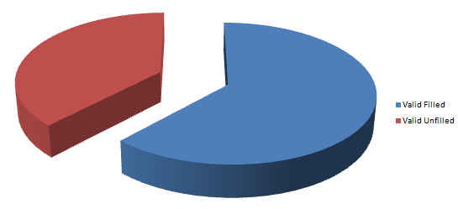
Figure 4.1: Response of the respondent

RESEARCH QUESTION 2: Are the bacterial and fungal contaminants encountered in microbiology laboratories and Lecture rooms different morphologically?
TABLE 4.2: Response of the respondent

Response |  | Frequency | Percent | Cumulative Percent
Valid | Yes | 31 | 62.00% | 62.00%
Valid | No | 19 | 38.00% | 100.00%
Valid | Total | 50 | 100.00%

From the above table it shows that 62.00% of the respondents responded yes while 38.00% of the respondents marked no.
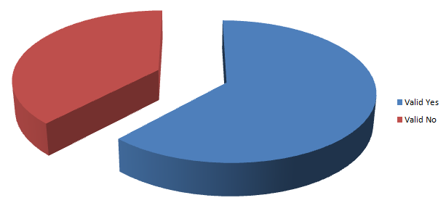
Figure 4.2: Response of the respondent

RESEARCH QUESTION 3: Are the persistent bacteria to hypochlorite based disinfection genotypically similar to standard bacteria strains?

TABLE 4.3: Response of the respondent

Response |  | Frequency | Percent | Cumulative Percent
Valid | Yes | 22 | 44.00% | 44.00%
Valid | No | 28 | 56.00% | 100.00%
Valid | Total | 50 | 100.00%

From the above table it shows that 44.0% of the respondents responded yes while 56.00% of the respondents marked no.
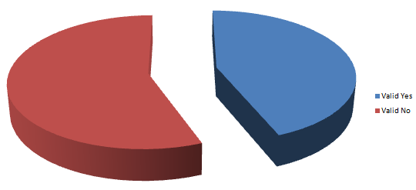
Figure 4.3: Response of the respondent

4.4 Test of Hypothesis 1
Hypothesis One
H0; There is no significant bacterial and fungal contamination encountered in microbiology laboratories and Lecture rooms in Kwara State Polytechnic
H1; There is a significant bacterial and fungal contamination encountered in microbiology laboratories and Lecture rooms in Kwara State Polytechnic
Table I: There is no significant bacterial and fungal contamination encountered in microbiology laboratories and Lecture rooms in Kwara State Polytechnic
Response | Observed N | Expected N | Residual
Yes | 27 | 16.6666667 | 10.33333333
No | 13 | 16.6666667 | -3.66666667
Undecided | 10 | 16.6666667 | -6.66666667
Total | 50

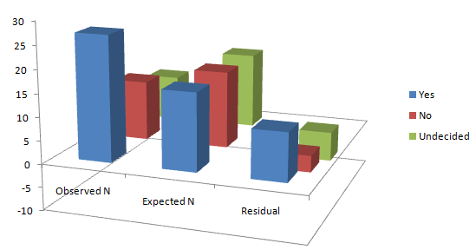

Figure I: There is no significant bacterial and fungal contamination encountered in microbiology laboratories in Nigeria
Test Statistics
 | There is no significant bacterial and fungal contamination encountered in microbiology laboratories and Lecture room
Chi-Square | 28.211ª
Df | 2
Asymp. Sig. | .000

a. 0 cells (0.0%) have expected frequencies less than 5. The minimum expected cell frequency is 16.7.

Decision rule:
The researcher therefore rejects the null hypothesis which states that there is no significant bacterial and fungal contamination encountered in microbiology laboratories in Nigeria, as the calculated value of 28.211 is greater than the critical value of 5.99.
Therefore the alternate hypothesis is accepted which states thatthere is a significant bacterial and fungal contamination encountered in microbiology laboratories in Nigeria.

4.5 Discussion of Findings
The results of the bacterial concentrations in the outdoor air environment of different locations of Microbiology Laboratory are shown in Table 3.1. The bacterial concentrations in the different locations ranged from 2.8 x 103 to 6.4 x 103 CFU/m3. The highest bacterial concentration of 6.4 x 103 CFU/m3 was recorded at the Main Market, followed by 6.2 x 103 CFU/m3 and 5.7 x 103 CFU/m3 recorded for Emir’s Palace and Angwan NEPA, respectively. The lowest con- centration of 2.8 x 103 CFU/m3 was recorded at Government bacteria and fungi isolated are presented in Tables 4.3 and 4.4, respectively. Six bacterial species were isolated at varying frequencies of occurrence. The bacterial species with their respective frequencies of occurrence were Staphylococcus aureus (100%), Streptococcus pyogenes (100%), Escherichia coli (90%), Bacillus spp. (100%), Enterobacter aerogenes (40%) and Shigella spp. (50%).

Nine species of fungi belonging to seven genera were isolated with respective percentage frequencies of 100% (Aspergillus flavus, Aspergillus niger, Rhizopus stolonifer), 80% (Penicillium spp.), 60% (Aspergillus fumigatus, Candida albicans) and 30% (Mucor spp., Absida corymbifera, Alternaria alternata), respectively.

Epidemiological studies have shown that a large number of people around the world are exposed to biological agents (Daisey et al., 2003; Dales et al., 2004; Golofit-Szymczak and Gorny, 2010). Unfortunately, there is no official reference limit for the microbiological quality of air in human environments, whether indoor or outdoor. The lack of quantitative health-based guideline values or thresholds for the acceptable levels of microbial contamination in the air may be due to a lack of dose-response relationship for most of the air microbiological agents (Golofit-Szymezak and Górny, 2010). Several investigators in this area had highlighted that source data on concentrations of biological agents in the air environmentsare still insufficient (Adhikar et al., 2004; Mouli et al., 2005; Golofit-Szymczak and Gorny, 2010; Kalwasińska et al., 2012). This notwithstanding, the qualitative and quan- titative information on the composition and concentrations of microorganisms in the air environment of human habitations at any point in time would help in alerting the public of possible health risk that may be encountered by vulnerable individuals.

Several researchers in this area had earlier reported that exposure to high concentrations of microorganisms in the air frequently lead to allergies, asthma (Björnsson et al., 1995; Newson et al., 2000), pueumonia (Siersted and Gravesen, 1993), and other health side-effects. In addition to public health advantage, routine monitoring of air quality can serve as a means of military surveillance for the detection of any possible biological threat of bioterrorism (Douwes et al., 2003).

Data resulting from this study revealed that the concentrations of bacteria in Microbiology Laboratory ranged from2.8 x 103 - 6.4 x 103 CFU/m3and that of fungi ranged from4.71 x 102 - 4.60 x 103CFU/m3. However, the concentrations for both bacteria and fungi have been shown to vary (P<0.05) in the different locations of the Microbiology Laboratory. The concentrations of bacteria at all the locations exceeded the recommended limit (103CFU/m3) suggested by National Institute of Occupational Safety and Health (NIOSH). The American Conference of Governmental Industrial Hygienists (ACGIH) had suggested 500 CFU/m3 for culturable bacteria (Kalogerakis et al., 2005). Górny and Dutkiewiez (2002) earlier presented to WHO Expert Meeting in Berlin, a proposed Residential Limit Values of 250 CFU/m3 for bacterial concentrations.

Considering all available threshold limits for bacterial concentrations in the air environments, it is clear that the outdoor air of Faculty of Science SSU Microbiology Laboratory is heavily loaded with bacteria. The Main Market that had the highest bacterial concentration followed by the Emir’s Palace is among the busiest locations in the metropolis in terms of human and vehicular movements. The high bacterial concentration recorded in these two locations is not surprising, and this agrees with reports by several researchers (Kalogeraskis et al., 2005; Chen and Hildermann, 2009). Similarly, the concentrations of fungi in most of the locations exceeded the recommended proposal of 103 CFU/m3 as threshold limits for fungal concentrations in the air (Górny and Dutkiewiez, 2002).

The qualitative analysis of the microbial flora provides additional information on airborne microorganisms in the outdoor air of Microbiology Laboratory and lecture room. In this study, six species of bacteria, S. aureus, S. pyogenes, E. coli, Bacillus spp., E. aerogenes and Shigella spp., and nine species fungi belonging to six genera, which included A. flavus, A. niger, A. fumigatus, Penicillium spp., R. stolonifer, A. corymbifera, A.alternata, Mucor spp. and C. albicans were isolated from the outdoor air environment of Microbiology Laboratory. Some of these bacteria and fungi have been shown to be amongst the most common bacterial and fungal species isolated from the air (Burge and Hoyer, 1990).

From this study, S. aureus, S. pyogenes, Bacillus spp. and E. coli are the most prevalent bacterial species isolated. S. aureus is known to be carried in the naso- pharynx, throat, skin, cuts, boils, nails, and such can easily contribute to the microflora in the Microbiology Laboratory and Lecture roomswhich is always busy with activities involving in most cases human and vehicular movements. Bacillus spp. is spore-forming soil bacteria and the most persistent in the atmosphere (Shaffer and Lighthart, 1994). S. pyogenes are often found as commensals in the upper respiratory tract of human (Cheesbrough, 2000). If host defenses are weakened or a new highly virulent strain is introduced it can lead to acute suppuration infections (Brooks et al., 2001). E. coli is an enteric coliform which is a normal resident flora of the large intestines of mammals including humans and are used as indicators of pollution of feacal origin (Willey et al., 2008). The high prevalence of E. coli in the air of Microbiology Laboratory suggests a very low personal and environmental hygiene practice in this town.

A. niger and Penicillium spp. are the most predominant species isolated. Maktkovic et al. (2007) in their study reported Aspergillus spp. and Penicillium spp. as the predominant genera of organisms isolated from the air, while Ekhaise et al. (2008) reported Aspergillus species as the most common genus of fungi in the air environment. Aspergillus and other species of fungi have been implicated as pathogenic in causing several mycotic infections. The relatively high concentrations of fungi in the air environment of Microbiology Laboratory and Lecture rooms may pose only little health hazard to healthy individuals, but would pose serious danger and special risk to immunosuppressed persons and other severely immunocompromised individuals (Flannigan et al., 1994). Fungal spores from species of Penicillium have been implicated with allergies and elicit asthma in vulnerable individuals (Flannigan et al., 1991).

