CHAPTER THREE

DESIGN METHODOLOGY

3.0 INTRODUCTION
This chapter presents the comprehensive methodology adopted in the design and implementation of a solar-powered system for an electronic laboratory. The project involves a 3.2kVA hybrid inverter with an inbuilt MPPT charge controller, a DC breaker, four 450W solar panels, and a locally made 28V 2kWh lithium battery. The design ensures an efficient, renewable, and sustainable energy supply tailored for laboratory operations involving sensitive electronic equipment.

3.1 BLOCK DIAGRAM
The block diagram illustrates the major components of the solar-powered system and their interconnection.
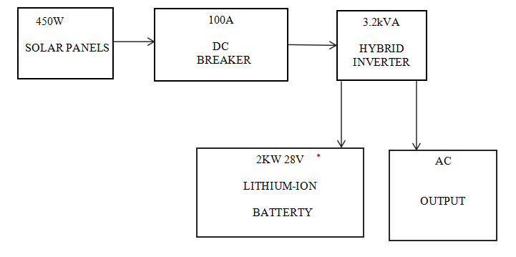
Fig. 3.1 The block diagram of the solar powered system
- 3.2kVA Hybrid Inverter
A hybrid inverter integrates solar charging, battery charging, and AC
output control in one unit. It ensures stable output for electronic lab use and includes MPPT functionality.
- 28V 2kWh Lithium Battery
A locally made battery capable of storing up to 2kWh, supplying stored energy during non-solar hours.
- DC Breaker
A protective device to safely isolate the battery and solar input in case of faults or maintenance.
- 450W Solar Panels
Four high-efficiency panels provide 1.8kW total capacity under standard conditions, powering the lab and charging the battery.
- AC Output
A 230V AC is supplied to the lab equipment, including instruments, computers, and lighting.

3.2 SITE SURVEY AND LOAD ASSESSMENT
A site survey was conducted to assess lab energy needs and determine installation feasibility. Power requirements were analyzed based on existing devices like oscilloscopes, soldering stations, lighting, PCs, and cooling fans.

3.2.1 LOAD IDENTIFICATION AND CATEGORIZATION
Essential loads include measurement devices, computers, and lighting. Estimated total load:
i. Lighting: 6 units of 18W = 108W
ii. Oscilloscopes & Tools: 3 units of 100W = 300W
iii. Soldering Stations: 2 units of 150W = 300W
iv. Desktop PCs & Monitors: 4 sets of 250W = 1,000W
v. Fans: 2 units of 75W = 150W
vi. Miscellaneous and Margin (20%) = 372W
Total Load = 2,230W
3.3 SYSTEM DESIGN SPECIFICATIONS
3.3.1 INVERTER SPECIFICATION
- Rating: 3.2kVA Hybrid Inverter
- Input: 28V DC
- Output: 230V AC, 50Hz
- Features: Inbuilt MPPT charge controller, LCD display, auto switch-over
- Protections: Overload, short circuit, overtemperature

3.3.2 BATTERY BANK

Type: Locally made lithium battery

Capacity: 28V, 2kWh

Features: Compact size, deep discharge protection

Protection: Connected via DC breaker

3.3.3 SOLAR PANELS

Quantity: 4 panels

Rating: 450W each

Total Capacity: 1.8kW

Orientation: South-facing, with optimal tilt

3.3.4 CABLING AND PROTECTION-

DC Cables: 6mm², UV resistant

AC Cables: 4mm² for lab distribution

Protection: Inline DC breaker, surge protectors, AC circuit breakers

3.4 DISTRIBUTION SYSTEM
AC output from the inverter is fed into a distribution board connected to all laboratory circuits. Proper fusing and cable sizing ensure safety and efficiency.

3.5 SYSTEM CONFIGURATION AND WIRING
The four solar panels were connected in a configuration optimized to match the input voltage range of the inverter. The battery was connected to the inverter's DC input terminals through a DC breaker. The inverter's AC output was routed to a distribution box that powers the laboratory's equipment. Proper wire gauges and color codes were used for safety and compliance.

3.6 INSTALLATION PROCESS
a) Panel mounting on a secured frame at optimal angle
b) Battery and inverter setup in a dry, ventilated room
c) Electrical wiring with safety breakers
d) Load testing and configuration of the system

3.7 MONITORING AND MAINTENANCE

Real time monitoring of battery SOC and solar generation

Monthly inspection of panels and inverter

Quarterly testing of breakers and wiring connections

Dusting of panels to improve efficiency
3.8 SYSTEM MAINTENANCE STRATEGY
To ensure long-term performance and reliability of the solar-powered system, a well-structured maintenance strategy is essential. Maintenance is divided into two categories: preventive and corrective maintenance.
3.8.1 PREVENTIVE MAINTENANCE
Preventive maintenance involves regular inspections and proactive measures to avoid system failure. The following routine tasks are scheduled monthly or quarterly:

- Solar Panel Cleaning: Dust, bird droppings, and other debris can reduce panel efficiency. Panels are cleaned using non-abrasive materials and clean water.
- Connection Inspection: All electrical connections are checked for corrosion, tightness, and insulation integrity.
- Battery Check: Battery voltage, state of charge (SOC), and overall health are assessed using a battery management system or multimeter.
- Inverter Diagnostics: System logs are reviewed to identify any unusual operation, fault codes, or shutdown events.
- Ventilation: Ensure the inverter and battery areas are well-ventilated and free from moisture and dust accumulation.
3.8.2 CORRECTIVE MAINTENANCE
Corrective maintenance is performed when a component failure is detected. This may include replacing a faulty solar panel, repairing inverter firmware issues, or swapping degraded battery cells. Fault identification is aided by the inverter’s error logs and performance trends over time.
3.9 SYSTEM MONITORING AND PERFORMANCE EVALUATION
An efficient monitoring system is necessary to evaluate energy production, consumption, and system health. While this hybrid inverter may come with a basic monitoring display, advanced monitoring is considered using tools like mobile apps or web dashboards.
Important performance indicators (KPIs) monitored include:
- Daily Energy Yield (kWh/day)
- Peak Power Output
- Battery Depth of Discharge (DoD)
- Charging and Discharging Cycles
- System Efficiency
- Load vs. Generation Balance
Data from these indicators helps to optimize system usage and troubleshoot underperformance.

