CHAPTER THREE
METHODOLGY
3.1 Introduction
This chapter deals with the preliminary design analysis of the smart scarecrow system. It has the general procedures for designing the control circuits, the selection of materials for construction, and design for some structural parts of the scarecrow. The smart scarecrow consists of mainly two systems, that is, the motion detecting system, and the sound producing system. The motion detecting system comprises of four motion sensors while the sound producing system consists of siren horn speaker switched on and off by a transistor which is activated by a passive motion sensor that is integrated with the system.
The smart scarecrow system autonomously detects animals in all directions and deters them using sound. It is powered entirely by solar energy, stores energy in a battery, and regulates voltage using an adjustable voltage regulator. An audio amplifier circuit boosts the microcontroller’s output to drive a speaker for effective deterrent sound delivery.
3.3 Principle of system operation
The system is wholly automatic and is turned on for a predetermined time interval and off by a passive infrared motion sensor set by the designer in the program uploaded into the microcontroller. The dynamic and smart scarecrow consists of two separate subsystems operating as one system in order to make the scarecrow effective in scaring off the quelea birds and animals from the fields making it difficult for the them to get accustomed to the scaring technique implemented.
Sensors are placed at 90° intervals from each other which are arranged radially to cover 360° around the scarecrow. The sensors interface with the microcontroller which processes sensor data and triggers a response if motion or proximity is detected. When an animal is detected (motion or distance threshold triggered), the microcontroller activates the sound module to emit a pre-programmed deterrent sound (e.g predator noise). A solar panel charges the battery through a charge controller. The adjustable voltage regulator steps down the battery voltage to suit the operating voltage of the microcontroller and sensors.
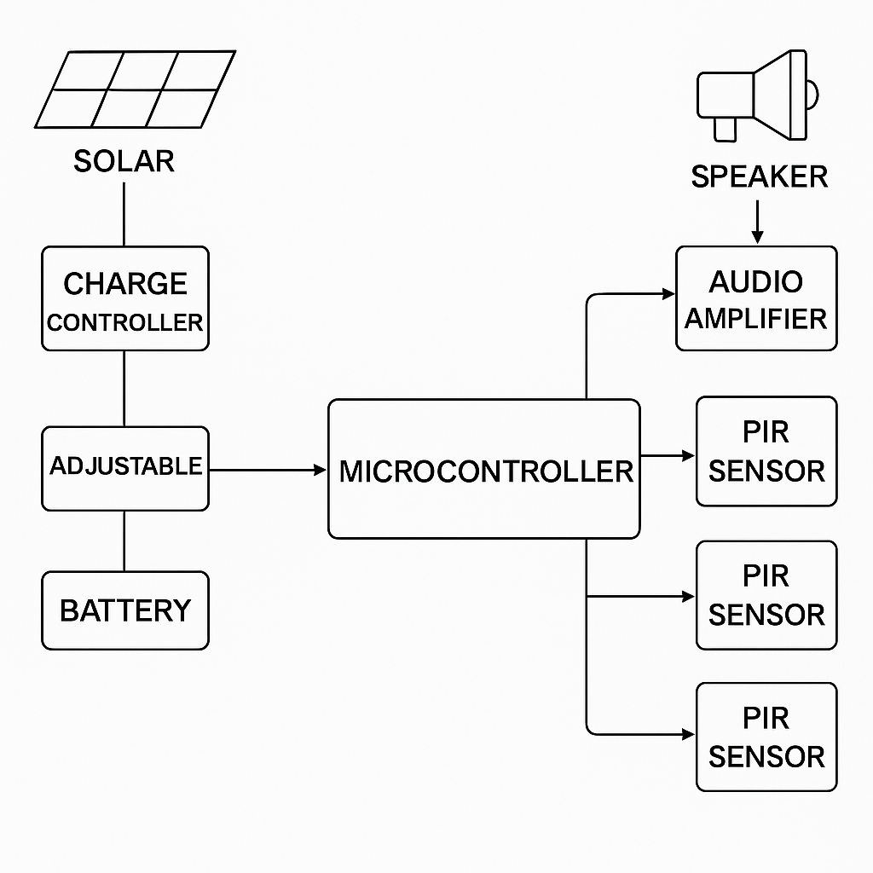
Figure 13: Block diagram of the smart scarecrow
These two subsystems are the motion gesturing system and the sound producing system working simultaneously. The working principle of each subsystem is described in detail as below;
- Motion system
The operating principle of the motion system is that a PIR sensor acts as an input to the microcontroller which sends a digital high (1/ON) or digital low (0/OFF) signal to the microcontroller depending on the differential changed sensed by it to trigger on or off the rotation system. A high digital signal is sent to the microcontroller from the PIR sensor when an animal is detected to trigger for a specified period of time set by the designer as motion is detected. Otherwise, the PIR sensor sends a low digital signal if no animal is detected in its proximity, which means the system remains at the same state of no motion.
- Sound producing system
This system consists of a siren horn speaker producing 90db of sound level intensity at 12V at 10 W and two PIR sensors. The operation of this system is that the PIR sensor acts as input to the microcontroller just as the motion system. When motion is detected by the PIR on the scarecrow in its range of detection of motion, it sends a digital high signal (1/ON) to the microcontroller to switch on the siren which produces multiple sounds for a predetermined time (7 seconds) as written in the program by the designer to produce sounds of high intensity and frequency to irritate and scare off the birds. Also, a transmitter placed at different point in the field with a PIR sensor attached on sends a high digital signal whenever it detects motion to the receiver to trigger on the siren for the same predetermined time, otherwise the system sends a low digital signal which keeps the siren off till motion is detected.
The following are the list of components used in the project construction:
Table 1:
S/N | Components | Descriptions | Specifications
1 | PIR Motion Sensors  (x4) | It detects the motion of animals for full 360° coverage (all directions). | Supply Voltage: 5–12V  Detection Range: ~6–10 meters.  Field of View: Approximately 120°
2 | Microcontroller  (ATmega328P) | It serves as the central control unit to process sensor inputs and manage outputs. | Operating Voltage: 5V  Clock Speed: ~16 MHz (Uno),  I/O Pins: 14
3 | Sound Module  (Amplifier+ Speaker) | It plays deterrent sounds upon detection of animal movement.  (Alarm, predator noise) | Operating Voltage: 3.2V–5V- Storage: Micro SD card support. Impedance: ~8Ω- Power Rating: ~3W
4 | Solar Panel  (20W, 12V) | It harvests solar energy to supply the system and charge the battery. | Rated Power: 20W  NominalVoltage:12V.  Maximum Current: ~1.67A Open-Circuit Voltage: Typically 17–18V
5 | Battery (12V, 7Ah) | It stores energy produced by the solar panel for continuous operation. | Nominal Voltage: 12V.  Capacity: 7Ah.
6 | Adjustable Voltage Regulator (LM317) | It drops the battery voltage to levels suitable for microcontrollers and modules. | Input Voltage: Up to 37V.  Output Voltage: Adjustable from 1.25V up to (Vin – ~1.5V).  Maximum Output Current: ~1.5A
7 | Relay Module/  MOSFETs | It switches the power supply to the sound module on/off based on control signals. | Coil Voltage: Typically 5V.  Contact Ratings: ~10A/250VAC
8 | Diodes  (Schottky) | It provides reverse current protection to prevent damage when power polarity is reversed. | Forward Voltage Drop:  ~0.3–0.5V.  Reverse Voltage Rating: ~40V
9 | DC-DC  Charge Controller | Manages the solar charging process, prevents overcharging, and ensures proper voltage regulation. | Input Voltage: Compatible with solar panels rated around 12V–18V

3.4 Design procedure
To ensure the system remains functional under all conditions, this section calculates:
- The daily energy consumption
- Solar panel requirements
- Battery capacity
- Voltage regulator settings and power loss
The following electronic components are designed accordingly:
- Microcontroller (ATmega328P):
The operating voltage = 5V
The active current = ~20mA
The operating time required = 24 hrs/day
E_{mcu} ​= V×I×t = 5V × 0.02A × 24h = 2.4Wh/day

- ​PIR sensors (x4 HC-SR501)
The supply voltage = 5V-12V
The active current per sensor = ~0.07A (during detection), standby ~0.005A
If we assume 10% duty cycle
I_{avg} = (0.07 x 0.1 + 0.005 x 0.9) x 4 = 0.028 + 0.018 = 0.046A

- Audio amplifier (PAM8403)
The supply voltage = 5V
Active current per sensor = ~0.07A
Assume 30 minutes of activity per day (wildlife trigger events)
E_{AMP} = 5×0.4×0.5 = 1.0Wh/day

- Miscellaneous losses (voltage conversion, regulator, leakage, LED indicator, e.t.c)
Assume 15% overhead:
E_{total} = 0.15×(2.4 + 5.52 + 1.0) = 1.38Wh/day

- Total energy requirement (per day):
E_{total} = 2.4 + 5.52 + 1.0 + 1.38 = 10.3Wh/day

- Solar panel sizing: we selected a standard panel size (10W/18V), which is adequate and provide buffer against cloudy days.
- Battery capacity:
We designed for 4 days autonomy (in case of rainy days)
E_{4 days} = 10.3 x 4 = 41.2
Using 12V SLA battery, the required Ah is:
C_{Ah} = $\frac{41.2}{12}=3.43Ah$
Accounting for 60% maximum depth of discharge (DoD) (to prolong battery life)
C_{Ah,adj =} $\frac{3.43}{0.6}=5.72Ah$
Thus, a 7Ah/12V battery is ideal and provides enough backup.
- Adjustable voltage regulator output:
R₁ = 1K$Ω,$R₂ = 3K$Ω$
Typical LM317 formula:
$$V_{out}=1.25\left(1+\frac{R_{2}}{R_{1}}\right)=1.25 \left(1+\frac{3}{1}\right)=5.0V$$

- Efficiency and losses in regulation:
Assume efficiency of buck converter = 90%
Input energy from battery needed =
E = $\frac{E_{load}}{μ}=\frac{10.3}{0.9}=11.4Wh/day$
This confirms our battery sizing is safe and conservative.
Estimated Total Daily Energy Consumption
Table 2: Specifications and output from circuit sections
Component | Voltage (V) | Current (A) | Time (h) | Energy (Wh/day)
Microcontroller (ATmega328P) | 5 | 0.020 | 24 | 2.4
PIR Sensors (4x) | 5 | 0.046 | 24 | 5.52
Audio Amplifier (PAM8403) | 5 | 0.4 | 0.5 | 1.0
Miscellaneous Losses (15%) | - | - | - | 1.38
Total | - | - | - | 10.3Wh/day

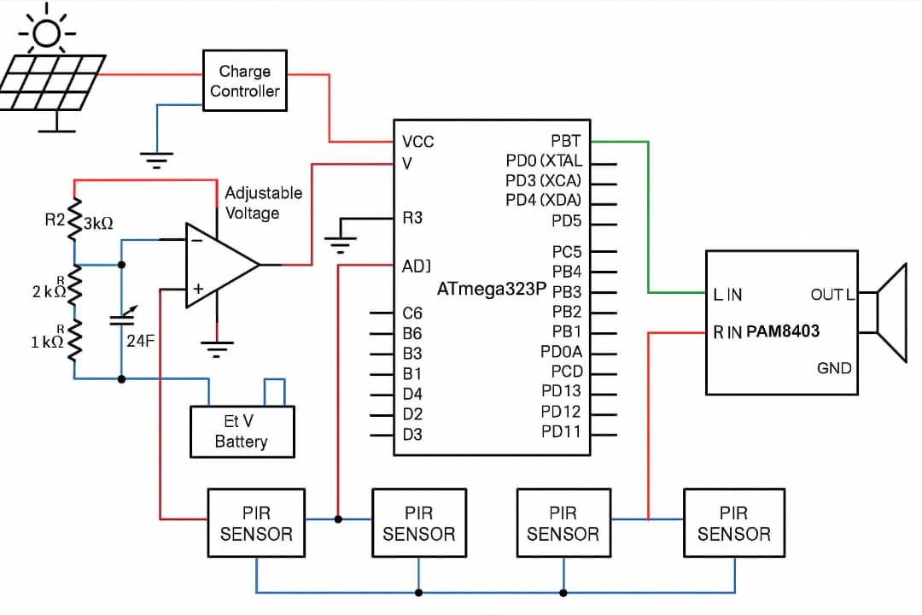
Figure 14: Circuit Diagram

