CHAPTER FOUR

SYSTEM DESIGN AND IMPLEMENTATION

4.1 JADE PROGRAMMING MODEL
JADE is fully object-oriented, Like all of the other popular programming languages used to create database-driven software. JADE was designed to have all the most important features of object-oriented programming, but it was also designed to make programming simple, and so does not exhibit the full range of tools that some other languages do. For example, JADE does not support the overloading of methods or operators. This may seem like a big loss to some programmers, but for programming database applications which is what JADE is designed for, the parts that are left out do not end up being major drawbacks, as they are almost never needed. One notable feature that JADE lacks is parameterized constructors and this lead to some dangerous consequences in that one can never know if an object has been properly initialized.

From a fault tolerance standpoint, JADE does not perform very well due to single point of failure represented by the Front End container and, in particular, by the AMS [15]. Classes in JADE are kept together in schemas. Schemas serve the same purpose as Java packages or namespaces in .NET, but they are much different in the fact that schemas have a hierarchy, and inherit classes from super schemas. This becomes useful especially when programming using the model-view-controller methodology, as model classes can be put in one schema, and then the controller and view classes can be built on top of the model classes in a subschema.

4.2 JADE PROGRAM STRUCTURE
JADE applications are structured quite differently from most programming languages in the fact that JADE programs are not developed by writing code into long files and then compiling all the files together at once. JADE programs are actually developed using a user interface that allows programmers to visually create classes and define their properties and methods. Instead of locating methods in large files, programmers select the method they would like to edit and only the code for that particular method is displayed. Also instead of compiling all the code of a program at once, in JADE, each method is compiled individually as soon as the method is completed, meaning code can be checked immediately.

All the code for a JADE application is stored in its object-oriented database. This has several advantages. First, it allows for multi-user development, as the database maintains concurrency control. Second, with each piece of the code being a separate object in the database, in a lot of the cases it is possible to recode the system while it is live and online as long as the parts of the system being changed are not in use.

4.3 OBJECT MODEL
JADE is an object-oriented software development and deployment platform. It has its own programming language that exhibits a seamlessly integrated application server and object database management system. It is designed to be an end-to-end development environment, which allows systems to be coded in one language from the database server down to the clients. There are four classes needed to be inherited and extended, these are:

- The ‘CreateAgent’ class provides a graphical interface to let the user enters the parameters to an agent.
- The ‘Agent’ class implements the local behaviour of the agent.
- The ‘Conversation’ class is extended for each conversation that the agent can have.
- The ‘ConvRule’ class is extended for each rule changing the state of conversation.

Receives Has addsMessage
Conversation

initializeRules()
ruleControlFn()
initializeRules()

ConvRule

action()
transmit()
initializeRules()

MsgQueue

addMessage()
removeMessage()
Message

getSender()
getReceiver()
getcontent()

RequestResrcProvider

findresource()
respond()
ConvOpinterface

DisplayAction()
Agent

setRecvdDirectedMsg()
setRecvdMulticasMsg()
subscribeTo()
unsubscribe()
startConversation()
CreateAgent

CreatAgent()
AgentOpInterfa
MsgRouter

routerMessage()
MulticastComm

joinGroup()
leaveGroup()
receive()
serndMsg()
DirectedComm

SendMsg()
SetRcvdMsg()

Creates

Creates

Creates
recieves

Figure 4.1: Object Model Design [9]

4.4 OBJECT DATABASE
The most difference between JADE and other object-oriented programming languages is that its object database is a native part of its language. For example, when creating an object in JADE, it can be created as transient or persistent. Creating an object as transient is just the same as creating objects in other object-oriented programming languages. The object is simply created in memory, and then lost when the program ends. On the other hand, when an object is created as persistent, when the program ends, the object will still exist and be there the next time the program starts up. In other words, when an object is persistent JADE automatically works in the background to store and retrieve the object in the database when necessary. Persistent objects can be distributed across multiple co-operating servers, with JADE automatically handling object caching and cache coherency.

There are very few differences between manipulating transient and persistent objects. It has been said that JADE makes it appear to the programmer as if all the objects in the entire database were in local memory. Most of the time, JADE's object-oriented database is used in a multi-user system, and so this statement could be extended to say that JADE makes it appear to the programmer as if all the objects in the database were stored in some shared memory that all users connected to the system could access, even from different computers. With all of the program code centralised on the database server as well the data, JADE achieves its goal of an end-to-end system, as JADE presents such a level of abstraction that all client nodes can be programmed as if they were running on the database server. This is very desirable to most database programmers as they don't have to take several different technologies and link them together; they just create one application for everything.

JADE's database is also inherently object-oriented, and so it eliminates the performance loss in an object-relational mapping system where objects must constantly be converted from object-oriented form to relational form. Like all other commercial database products, JADE is ACID-compliant and has all of the standard features such as atomic transactions, locking, rollback, crash recovery and the ability to keep one or more secondary database servers synchronized with the main database for backup, disaster recovery and performance reasons. JADE also provides a Relational Population Service that enables automatically replicating objects from the main database to one or more relational databases. This allows JADE systems to interoperate with relational databases for reporting, business intelligence and data warehouse purposes.

4.5 MAS IMPLEMENTATION
Usually, the network implementation has been included inside the agents. Therefore two main actors constitute the system: the router agent (including the router implementation) and the end-host agent. This system is organized as pictured model below,

4.5.1 ROUTER AGENT

The router agent is an agent managing a network node. It is composed of two layers:

a. Router Layer
The router layer is the network itself. Its goal is to route the arriving messages according to their destination. A simple routing table is associated to it so that the router knows where to forward the messages. A fixed size buffer is also used to temporary stock the arriving messages. The router treats the messages as fast as it can. If the buffer is overloaded, the extra messages are discarded. It is the work of the agent to synchronize the traffic so that no messages are lost. Each router possesses also a certain bandwidth. That means that no more bandwidth than what is possessed by the router can be allocated to user requests. A simple graphical user interface is provided so that information can be observed on what is happening. One can also change the router bandwidth, option useful for testing and debugging.

AgentOpInterface
Agent
EndHostUserInterface
RouterUserInterface
EndHost
Router
Packet
RoutingTable
Conversation
EndHostUserConversation
EndHostUserConversation
Message

has

has

encapsulation
inputBuffer
Message
Send/ contain has
Recieve

Creates Creates

Send/receive Send/receive

Figure 4.2: Overall MAS Implementation of agent [6]
b. Intelligent Layer
The intelligent layer is the actual intelligent agent. It communicates with other agent’s intelligent layers and with the router layer in order to manage the node properly. When it has to accomplish a goal that involves other agents, it creates a Conversation object to talk with other agents and reach the given objective.

4.5.2 END-HOST AGENT
The end-host Agent plays the role of intermediate between the user and the network. A graphical interface is displayed so that the user can interact with the system. Ideally, the endhost agent should interface the multimedia application, so that the whole agent infrastructure is invisible to the user. The user has to explicitly reserve some bandwidth or send messages. Only fake data is sent, however the simulated network is able of transporting real data and therefore act as a real network. However, the end-host agent is not only a composition of graphical component. The underlying layer should support an intelligent infrastructure able of conversing with the network. An end-host is usually attached to a unique router. The end-host agent will have to talk with his router agent in order to reserve some bandwidth. It should also be able to interpret the demand requested by the user. For example, if the user asks for a good connection, the end-host agent should know (or learn with feedback from the user) that a good connection is about 500kb/s.

4.5.3 MESSAGE CLASS
The message class encapsulates all the information exchanged amongst agents. Every instance of that class has a performative variable. This variable represents the nature of interaction that is going to take place. The class provides methods for specifying both the sender and the receiver agent. It is also possible to specify the intent of the message. The intent enables the sender agents to express the intention which required them to send the message, and the receiver agents to filter the message upon looking at only the intent slot. It also facilitates message routing. Messages are of two general types:
- Declarative messages are used to announce the presence of an agent. This type of message is used to set up the network at the beginning: each agent broadcasts his name and then waits for the agent he is connected to answer.
- Content messages contain a description of the piece of knowledge being accompanied with the actual data. They are used to transport data packets along the network. A data packet can be assimilated to an IP packet on the Internet. It possesses the sender address, the destination address and the actual data.

4.6 DESIGN METHODOLOGY
Five-step methodology was proposed for building a multi-agent application. The methodology focuses on logical issues of the problem being considered and then converges to the implementation. The stages are:

- Identifying the Agents: Starting with the list of aims we want the system to satisfy, then considering various entities that will be interacting with each other to achieve this global aim. These entities represent the agents in the system. After identifying the agents, clarify the aims of each agent and the service they provide. The agents are divided into different categories by grouping the agents with similar aims and services into a single category. These categories help in identifying the agent classes in the application. After identifying the agent classes, then identify the application specific classes that each agent class may use.
- Identifying the Conversations: When developing agents, the world is being viewed as composing of intelligent things. At this stage, we begin to model the interaction between these things in the form of conversations. Identify every possible conversation an agent can engage in, and represent those conversations by developing an automata model for each of them. These different automata models identify the different conversation classes in the application.
- Identifying the Conversation Rules: Each conversation is represented by an automata model. Alternative action of an agent produce different states in the conversation (automation) and the current state of a conversation influences how the agent react in the next moment. Conversations are rule-based descriptions of what agent does in certain situations.
- Analyzing the Conversation Model: It is important to do an analysis of the logical consistency of all agent conversation in order to design multi-agent system that finds a coherent solution to the entire system problem. They should be analyzed to verify the coherency of the system.
- MAS Implementation: At this final stage, suitable tools for multi-agent application implementation will be chosen, this ensures communication, interoperation and coordination support.
Initial Requirement
Next Iteration
Ontology Description
Ontology Description
Protocols Description

Deployment model

Deployment Configuration
System Requirements Model

Domain Description

Agent Identification

Roles Identification

Tasks Specifications

Agent implementation Model
Multi-Agent
Structure Definition
Behaviour Description
Single-Agent
Structure Definition
Behaviour Description
Code Model
Code Re-use
Code Production

Agent Test

Society test

Figure 4.3: The Models for Design Methodology

4.7 CHOICE OF PROGRAMMING LANGUAGE
JADE is entirely written using the Java programming language, exploiting such advanced features as Java RMI, Java CORBA IDL, Java Serialization and Java Reflection API. The following are reasons why Java was use to design JADE:

i. Architecture Neutral and Portable
Because the agents are inherently distributed, applications must be able to execute anywhere on the network without prior knowledge of the target hardware and software platform. Java provides the advantages of architecture neutrality and portability to agent developers. If the Java run-time platform is made available for a given hardware and software environment, an application written in Java can then execute in that environment without the need to perform any special porting work for that application. The primary benefit of the interpreted byte code approach is that compiled Java language programs are portable to any system on which the Java interpreter and run-time system have been implemented.

ii. Multithreaded
The Java library provides a Thread class that supports a rich collection of methods to start a thread, run a thread, stop a thread, and check on the status of a thread. Java has built-in that supports threads which is one of the most powerful tools in Java, not only to improve interactive performance of graphical applications, but also to run multiple events concurrently. Multithreading is the way to obtain fast, lightweight concurrency within a single process space.

iii. Distributed
Java especially lends itself as an extremely suitable choice in this regard. It offers an extensive library of classes and routines which cope easily with both UDP and TCP/IP protocols, and thus supports sending both broadcast and directed messages across the network. In any MAS, agents residing on different machines or different environments need to communicate information and knowledge about their goals, beliefs and intentions to each other in order to coordinate and cooperate so as to bring about a coherent solution. Communication is a very important aspect in the development of any MAS.

iv. Secure
Java enables the construction of virus free, tamper free systems. Java is a strongly typed language and it does not support pointers, which make it a very robust language. The Java run-time system uses a byte code verification process to ensure that code loaded over the network does not violate any Java language restrictions. The authentication techniques are based on public key encryption.

v. Object Oriented
Java adopts the four principles of object oriented languages: inheritance, encapsulation, abstraction and message passing communication. Object oriented design is a very powerful concept because it facilitates the clean definition of interfaces and makes it possible to provide reusable software. The user has no choice but to encapsulate all data in objects. Since agents are essentially built around a group of different object components.

vi. Database Connectivity JDBC
The Java Database Connectivity kit lets Java programmers connect to any relational database, query it, or update it using the industry standard query language (SQL). This is a very useful feature as databases are among the most common uses of software and hardware today, and any application using Java can easily integrate with preexisting databases to update the local model of its agents. This is even more useful for MAS as agents usually possess a knowledge base. As this knowledge base gets bigger, it has to be organized and stored efficiently.

4.8 IMPLEMENTING JADE AGENTS
JADE is a middleware that enables fast and reliable implementation of multi-agent distributed systems and which can be integrated with Artificial Intelligence (AI) tools. Beyond a runtime library, JADE offers some tools to manage the running agent platform and to monitor and debug agent societies.

4.8.1 THE AGENT CLASS
To create a JADE agent is as simple as defining a class extending the jade.core.Agent class and implementing the setup() method as shown in the code below.
import jade.core.Agent;
public class BookBuyerAgent extends Agent {
protected void setup() {
// Printout a welcome message
System.out.println(“Hello! Buyer-agent “+getAID().getName()+” is ready.”);
}
}
The setup() method is intended to include agent initializations. The actual job an agent has to do is typically carried out within “behaviours”.

4.8.2 AGENT IDENTIFIERS
Each agent is identified by an “agent identifier” represented as an instance of the jade.core.AID class. The getAID() method of the Agent class allows retrieving the agent identifier. An AID object includes a globally unique name plus a number of addresses. The name in JADE has the form <thename>@<platform-name> so that an agent called Ayour living on a platform called P1 will have Ayour@P1 as globally unique name. The addresses included in the AID are the addresses of the platform the agent lives in. These addresses are only used when an agent needs to communicate with another agent living on a different platform.

Knowing the nickname of an agent, its AID can be obtained as follows:

String nickname = “Ayour”;
AID id = new AID(nickname, AID.ISLOCALNAME);

The ISLOCALNAME constant indicates that the first parameter represents the nickname (local to the platform) and not the globally unique name of the agent.
4.8.3 RUNNING AGENTS
The created agent can be compiled as follows.
javac –classpath <JADE-classes> BookBuyerAgent.java
In order to execute the compiled agent the JADE runtime must be started and a nickname for the agent to run must be chosen:
java –classpath <JADE-classes>;. jade.Boot buyer:BookBuyerAgent

4.8.4 AGENT TERMINATION
Even if it does not have anything else to do after printing the welcome message, the agent is still running. In order to make it terminate its doDelete() method must be called. Similarly to the setup() method that is invoked by the JADE runtime as soon as an agent starts and is intended to include agent initializations, the takeDown() method is invoked just before an agent terminates and is intended to include agent clean-up operations.

4.8.5 PASSING ARGUMENTS TO AN AGENT
Agents may get start-up arguments specified on the command line. These arguments can be retrieved, as an array of Object, by means of the getArguments() method of the Agent class. The BookBuyerAgent can be given title of the book to buy as a command line argument. This can be done as follows

import jade.core.Agent;
import jade.core.AID;
public class BookBuyerAgent extends Agent {
// The title of the book to buy
private String targetBookTitle;
// The list of known seller agents
private AID[] sellerAgents = {new AID(“seller1”, AID.ISLOCALNAME),
new AID(“seller2”, AID.ISLOCALNAME)};
// Put agent initializations here
protected void setup() {
// Printout a welcome message
System.out.println(“Hello! Buyer-agent “+getAID().getName()+” is ready.”);
// Get the title of the book to buy as a start-up argument
Object[] args = getArguments();
if (args != null && args.length > 0) {
targetBookTitle = (String) args[0];
System.out.println(“Trying to buy “+targetBookTitle);
}
else {
// Make the agent terminate immediately
System.out.println(“No book title specified“);
doDelete();
}
}
// Put agent clean-up operations here
protected void takeDown() {
// Printout a dismissal message
System.out.println(“Buyer-agent “+getAID().getName()+” terminating.”);
}
}

4.9 AGENT TASKS - THE AGENT BEHAVIOUR CLASS
The actual job an agent has to do is typically carried out within “behaviours”. A behaviour represents a task that an agent can carry out and is implemented as an object of a class that extends jade.core.behaviours.Behaviour. In order to make an agent execute the task implemented by a behaviour object it is sufficient to add the behaviour to the agent by means of the addBehaviour() method of the Agent class. The behaviours can be added at any time: when an agent starts (in the setup()method) or from within other behaviours.

Each class extending Behaviour must implement the action() method, that actually defines the operations to be performed when the behaviour is in execution and the done() method (returns a Boolean value), that specifies whether or not a behaviour has completed and have to be removed from the pool of behaviours an agent is carrying out.

4.9.1 BEHAVIOURS SCHEDULING AND EXECUTION
An agent can execute several behaviours concurrently. However it is important to notice that scheduling of behaviours in an agent is not pre-emptive but cooperative. This means that when a behaviour is scheduled for execution its action() method is called and runs until it returns. Therefore it is the programmer who defines when an agent switches from the execution of a behaviour to the execution of the next one.

Setup()
Get the next behaviour from the pool of active behaviours.
Remove currentBehaviour from the pool of active behaviours
takeDown()

Agent has been Killed YES
(do delete() method called)?

NO

b.action()

NO b.done()?

YES

Figure 4.4: Agent Thread path of execution
It is important to stress that a behaviour like that reported below prevents any other behaviour to be executed since its action() method never returns.

public class OverbearingBehaviour extends Behaviour {
public void action() {
while (true) {
// do something
}
}
public boolean done() {
return true;
}
}

When there are no behaviours available for execution the agent’s thread goes to sleep in order not to consume CPU time. It is wakening up as soon as there is again a behaviour available for execution.

4.9.2 TYPES OF BEHAVIOUR
There are three type of agent behaviour:

1. One-shot behaviours: One shot behaviour complete immediately and its action() method is executed only once. The jade.core.behaviours.OneShotBehaviour already implements the done() method by returning true and can be conveniently extended to implement one-shot behaviours.

public class MyOneShotBehaviour extends OneShotBehaviour {
public void action() {
// perform operation X
}
}

Operation X is performed only once.

2. Cyclic behaviours: It never complete and whose action() method executes the same operations each time it is called. The jade.core.behaviours.CyclicBehaviour already implements the done() method by returning false and can be conveniently extended to implement cyclic behaviours.

public class MyCyclicBehaviour extends CyclicBehaviour {
public void action() {
// perform operation Y
}
}

Operation Y is performed repetitively forever (until the agent carrying out the above behaviour terminates).

3. Generic behaviours: It embeds a status and executes different operations depending on that status. They complete when a given condition is met.

public class MyThreeStepBehaviour extends Behaviour {
private int step = 0;
public void action() {
switch (step) {
case 0:
// perform operation X
step++;
break;
case 1:
// perform operation Y
step++;
break;
case 2:
// perform operation Z
step++;
break;
}
}
public boolean done() {
return step == 3;
}
}
Operations X, Y and Z are performed one after the other and then the behaviour completes. JADE provides the possibility of combining simple behaviours together to create complex behaviours.

4.10 GUI TO MONITOR THE ACTIVITIES OF AGENTS PROTOCOL
JADE develop some tools to support the difficult task of debugging multi-agent applications. The tools are packaged as an agent itself. It obeys the rules and communication capabilities of generic application agents.

4.10.1 REMOTE MONITORING AGENT (RMA)
The general management console for a JADE agent platform is called RMA. The RMA acquires the information about the platform and executes the GUI commands to modify the status of the platform. JADE Remote Monitoring Agent allows controlling the life cycle of the agent platform and all the registered agents. The distributed architecture of JADE also allows remote controlling, where the GUI is used to control the execution of agents and their life cycle from a remote host. RMA is a Java object, instance of the class jade.tools.rma.rma More than one RMA can be started on the same platform as long as every instance has a different local name, but onl/lkOy one RMA can be executed on the same agent container.

Figure 4.5: Snapshot of the RMA GUI

The followings are the commands that can be executed from the menu bar of the RMA Graphical User Interface (GUI);

1. File menu: This menu contains the general commands to the RMA.

i. Close RMA Agent: It terminates the RMA agent by invoking its doDelete() method. The closure of the RMA window has the same effect as invoking this command.

ii. Exit this Container: It terminates the agent container where the RMA is living in, by killing the RMA and all the other agents living on that container. If the container is the Agent Platform Main-Container, then the whole platform is shut down.

iii. Shut down Agent Platform: It terminates all the connected containers and all the living agents.

2. Actions menu:
Action menu contains items to begin all the various administrative actions needed on the platform as a whole or on a set of agents or agent containers. The requested action is performed by using the current selection of the agent tree as the target; most of these actions are also associated to and can be executed from toolbar buttons.

i. Start New Agent: This is used to create a new agent. The user is prompted for the name of the new agent and the name of the Java class the new agent is an instance of. Moreover, if an agent container is currently selected, the agent is created and started on that container; otherwise, the user can write the name of the container he wants the agent to start on.

ii. Kill Selected Items: This action kills all the agents and agent containers currently selected. Killing an agent is equivalent to calling its doDelete() method, whereas killing an agent container kills all the agents living on the container and then de-registers that container from the platform. If the Agent Platform Main-Container is currently selected, then the whole platform is shut down.

iii. Suspend Selected Agents: This action is used to suspend the selected agents and is equivalent to calling the doSuspend() method. When suspend a system agent, particularly the AMS, deadlocks the entire platform.

iv. Resume Selected Agents: This action puts the selected agents back into the AP_ACTIVE state, provided they were suspended, and works just the same as calling their doActivate() method.

v. Send Custom Message to Selected Agents: This action allows us to send an ACL message to an agent. When the user selects this menu item, a special dialog is displayed in which an ACL message can be composed and sent, as shown in the figure.

Figure 4.6: Compose and send ACL Message

vi. Migrate Agent: This action is used to migrate an agent. When the user selects this menu item, a special dialog is displayed in which the user must specify the container of the platform where the selected agent must migrate. Not all the agents can migrate because of lack of serialization support in their implementation. In this case the user can press the cancel button of this dialog.

vii. Clone Agent: This action used to clone a selected agent. When the user selects this menu item a dialog is displayed in which the user must write the new name of the agent and the container where the new agent will start.

3. Tools Menu
This menu contains the commands to start all the tools provided by JADE to application programmers. These tools will help developing and testing JADE based agent systems.

4. RemotePlatforms Menu
This menu allows controlling some remote platforms that comply with the FIPA specifications. Notice that these remote platforms can even be non-JADE platforms.

i. Add Remote Platform via AMS AID: This action is used to get the description (called APDescription in FIPA terminology) of a remote Agent Platform via the remote AMS. The user is requested to insert the AID of the remote AMS and the remote platform is then added to the tree showed in the RMA GUI.

ii. Add Remote Platform via URL: This action allows getting the description of a remote Agent Platform via a URL. The content of the URL must be the string field APDescription, as specified by FIPA. The user is requested to insert the URL that contains the remote APDescription and the remote platform is then added to the tree showed in the RMA GUI.

iii. View APDescription: This can be used to view the AP Description of a selected platform.

iv. Refresh APDescription: This action asks the remote AMS for the APDescription and refreshes the old one.

v. Remove Remote Platform: This action permits to remove from the GUI the selected remote platform.

vi. Refresh Agent List: This action performs a search with the AMS of the Remote Platform and the full list of agents belonging to the remote platform is then displayed in the tree.

4.10.2 MEETING SCHEDULER
This is an application that uses JADE for message exchange and for the implementation of the interaction protocols. It implements a meeting scheduler agent that helps a user in scheduling meetings with other users. This sample application is based on the one that was successfully used at the FIPA Interoperability. It allows and to try check:

- the registration of an agent with the default DF (Directory Facilitator) of the platform;
- the registration of an agent with a remote DF belonging to another platform or, different from the default DF;
- the search within the known DFs for a list of agents and their properties, in particular the list of Meeting Scheduler agents and the name of the user that they represent;
the usage of the FipaContractNet protocol, both the initiator and responder role.

When the two agents start, two login windows appear. Enter different user names (ignore the password), e.g. "Tizio" and "Ayour".

Figure 4.7 a and b: Snapshot of Meeting scheduler between Tizio and Ayour

Then, use the calendar window of Tizio to fix a couple of appointments in different dates (notice that only the day is used and not the month) with different descriptions. For instance, that Tizio has fixed two appointments for the 1st and the 2nd. Switch then to the calendar window of Ayour. From the directory menu, execute the item "Update known persons with the facilitator" such that Ayour comes to know about Tizio existence. Use the calendar window of Ayour to fix an appointment with Tizio between 1st and 4th. The ContractNet protocol should be then executed and both agents should converge to the date 3rd.

4.10.3 DUMMY AGENT
Dummy Agent is a readymade “tool” agent that allows sending/receiving custom messages, to stimulate them. The DummyAgent tool allows users to interact with JADE agents in a custom way. The GUI allows composing and sending ACL messages and maintains a list of all ACL messages sent and received. This list can be examined by the user and each message can be viewed in detail or even edited. Furthermore, the message list can be saved to disk and retrieved later. Many instances of the DummyAgent can be started as and where required. The DummyAgent can both be launched from the Tool menu of the RMA and from the command line, as follows:

Java jade.Boot theDummy:jade.tools.DummyAgent.DummyAgent

Figure 4.8: Snapshot of the DummyAgent GUI

4.10.4 GUI OF DIRECTORY FACILITATOR
The Directory Facilitator agent also has a GUI, with which it can administered, configuring its advertised agents and services. This action is actually implemented by sending an ACL message to the DF asking it to show its GUI. Therefore, the GUI can just be shown on the host where the platform (main-container) was executed. A GUI of the Directory Facilitator can be launched from the Tools menu of the RMA. By using this GUI, the user can interact with the DF: view the descriptions of the registered agents, register and deregister agents, modify the description of registered agent, and also search for agent descriptions.

The GUI also allows federating the DF with other DF’s and creating a complex network of domains and sub-domains of yellow pages. Any federated DF, even if resident on a remote non-JADE agent platform, can also be controlled by the same GUI and the same basic operations (view/register/deregister/modify/search) can be executed on the remote DF.

Figure 4.9: Snapshot of the GUI of the DF

4.10.5 SNIFFER AGENT
The Sniffer agents allow us to track messages exchanged in a JADE agent platform. Sniffer Agent is basically a FIPA-compliant Agent with sniffing features. When the user decides to sniff an agent or a group of agents, every message directed to/from that agent / agent group is tracked and displayed in the Sniffer Agent’s gui. The user can view every message and save it to disk. The user can also save all the tracked messages and reload them from a single file for later analysis.This agent can be started both from the Tools menu of the RMA and also from the command line as follows: java jade.Boot sniffer:jade.tools.sniffer.Sniffer.

Figure 4.10: Snapshot of the sniffer agent GUI

At start up, the sniffer subscribes itself with the platform in order to be informed every time an agent is born or dies, as well as a container is created or deleted. A properties file may be used to control different sniffer properties.

4.10.6 INTROSPECTOR AGENT
This tool allows to monitoring and control the life-cycle of a running agent and its exchanged messages, both the queue of sent and received messages. It allows also to monitoring the queue of behaviours, including executing them step-by-step.

Figure 4.11 - Snapshot of the Introspector Agent GUI

Agent can be passed to the Introspector Agent in the same way as to the Sniffer Agent via the command line, or via a configuration file. The specification of performative filters, e.g. inform, agree, etc. is not supported by the Introspector Agent.

  - DESCRIPTION OF PROPOSED NETWORK SIMULATION

To develop and test the application, a simple network was set up. This network was designed not to be too complex so that the development was not too time consuming. The distributed Multi Agents System manages a simulated network, which is also a distributed system where each agent is tied to one node by a TCP/IP socket. Both the network simulator and the MAS are distributed systems and are able to be executed using several computers in a Local Area Network. The network simulator was implemented as independent as possible from the MAS. The application is distributed software that can be on several computer hosts with one of them acting as a front end for monitor, manage and for inter-system communication. When the front-end computer detects any new computer, it connects it to the network. Once connected, the user can select the end-host name to communicate with. The system can be executed on different hosts, thus achieving a distributed system. The GUI of the proposed system is shown below;
S

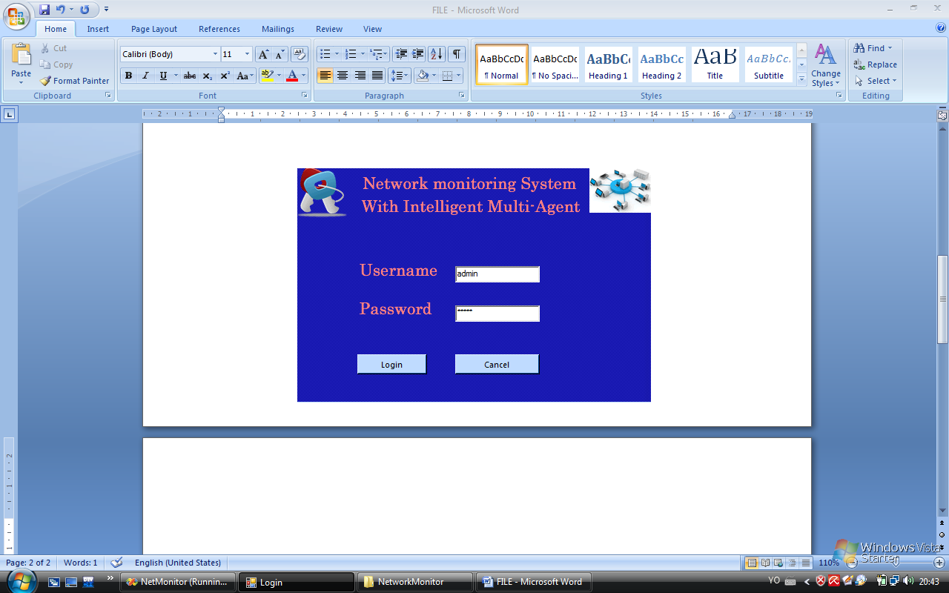

Figure 4.13: Password Confirmation Menu
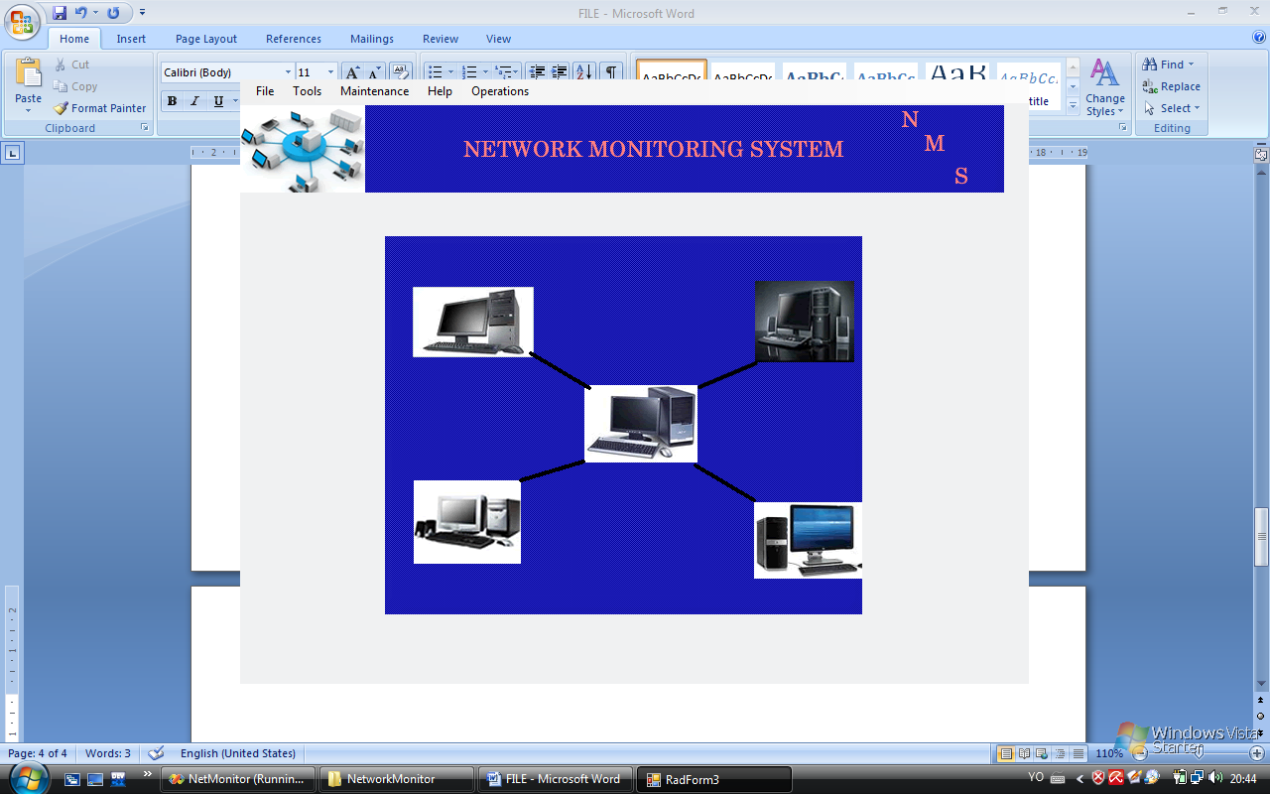
Figure 4.14: Main Menu


Figure 4.15: Computers Connected on Network

