 |   A TECHNICAL REPORT | 
 |  | 
 |  | 
 |  | 
 |  | 
 |  | 
 |  | 
 |  | 
 |  | 
 | STUDENT INDUSTRIAL WORKING EXPERIENCE SCHEME
 | (SIWES) | 
 | Held at | 
 | Held at | 
 | GUINESS NIGERIA LIMITED
 | GUINESS NIGERIA LIMITED | 
 | Prepared by: | 
 | Prepared by: | 
 | ADEBAYO AYISHAT TIMILEYIN
 | ADEBAYO AYISHAT TIMILEYIN | 
 | ND/23/PSM/FT/0046 | 
 | ND/23/PSM/FT/0046 | 
 | SUBMITTED TO | 
 | SUBMITTED TO | 
 | DEPARTMENT OF PROCUREMENT AND SUPPLY CHAIN MANAGEMENT | 
 | DEPARTMENT OF PROCUREMENT AND SUPPLY CHAIN MANAGEMENT | 
 | INSTITUTE OF FINANCE AND MANAGEMENT STUDIES
 | INSTITUTE OF FINANCE AND MANAGEMENT STUDIES | 
 | KWARA STATE POLYTECHNIC, ILORIN
 | IN PARTIAL FULFILLMENT OF THE AWARD OF THE REQUIREMENTS OF | 
 | IN PARTIAL FULFILLMENT OF THE AWARD OF THE REQUIREMENTS OF | 
 | IN PARTIAL FULFILLMENT OF THE AWARD OF THE REQUIREMENTS OF | 
 | IN PARTIAL FULFILLMENT OF THE AWARD OF THE REQUIREMENTS OF | 
 | THE AWARD OF NATIONAL DIPLOMA IN PROCUREMENT AND SUPPLY
 | THE AWARD OF NATIONAL DIPLOMA IN PROCUREMENT AND SUPPLY | 
 | CHAIN MANAGEMENT
 | CHAIN MANAGEMENT | 
 | August – December, 2024 | 

DEDICATION
I dedicate this technical report to the Almighty Allah, the giver of knowledge, the beneficent and the merciful for his protection and provision throughout this SIWES programme.

ACKNOWLEDGEMENTS
I’m using this opportunity to express my profound gratitude and deep regards to the creator of heaven and earth, the one who knows the beginning and the end, the Almighty Allah and also to my guardian (MR & MRS. ADETUNJI), and to all those who has helped me during my SIWES programme. The blessings, help and guidance given by them, time to time has carry me so this far and shall carry on the journey of life on which I am about to embark. I ‘m using this opportunity to express a deep sense of gratitude to compliment my mentors for their cordial support valuable information and guidance which helped me in completing my SIWES through various stages.
My deep regard to the best and most inspiring siblings.
Lastly , a big thanks goes to my friends, May Almighty Allah bless, protect and guide you through all your life’s entire journey. And also my regard to the school board of trustees and the staff a very big thank you to all.

TABLE OF CONTENTS
Title page i
Table of content ii
Dedication iii
Acknowledgements iv
TABLE OF CONTENTS
CHAPTER ONE
1.1. | Introduction of SIWES
1.2. | History of SIWES
1.3. | Objectives of SIWES
1.4. | Objectives of Establishment
CHAPTER TWO
2.1 Benefit derived from SIWES programme
2.2 Overview of the company
2.3 Precaution taken in the store
2.3 Introduction to the apparatus and equipment
2.4 Organizational Chart of the store
CHAPTER THREE
3.1 | Overview of procurement process
3.2 | Supply chain management in the store
3.3 | Challenges in procurement and supply management
3.4 | Solution and recommendation
CHAPTER FOUR
4.1 Conclusion
4.2 Recommendation
REFERENCE

CHAPTER ONE
1.1 INTRODUCTION TO STUDENT INDUSTRIAL WORK EXPERIENCE SCHEME
The student’s industrial work experience scheme (SIWES) is a skill training programme designed to expose and prepare students of Universities, Polytechnics, Colleges of Technology\Colleges of Agriculture and Colleges of Education for industrial work situations they are likely to meet after graduation. The scheme also affords students the opportunity of familiarizing and exposing themselves to the needed experience in handling equipment and machinery that are usually not available in the institutions. It is a cooperative industrial internship program that involves institutions of higher learning, industries, the Federal Government of Nigeria, Industrial Training Fund (ITF), and Nigerian Universities Commission (NUC).
The student’s industrial work experience scheme (SIWES) was initiated in 1973 by the industrial training fund (ITF). This is in response to the mandate given to the ITF, through decree 47 of 1971, charging it with the responsibility of promoting and encouraging the acquisition of skills in industry and commerce with the view to generating a pool of trained indigenous manpower sufficient to meet the needs of the economy. SIWES has come to be recognized as the major avenue of bridging the gap between the theory acquired by student of tertiary institutions and to the various professions and disciplines essential to the technological and economic development of Nigeria. The scheme has, over the years contributed immensely to the personal development and motivation of students to be able to understand the important connection between the taught and learnt content of their academic programs and what knowledge and skills will be expected of them in professional practice after graduation.
More so, SIWES is a program designed by ITF to prepare students for the challenges they will face in their respective fields when they become part of the nation’s workforce. Furthermore, ITF through SIWES, aims at ensuring that Universities and Polytechnics do not produce “half-baked graduates” that will not be useful industrially because of their inability to relate the theoretical knowledge acquired to the necessary industrial practice.
Over the years, SIWES has contributed immensely to building the common pool of technical and allied skills available to the Nigerian Economy which is needed for the nation’s industrial development. These contributions and achievements have been possible because of regular innovations and improvements in the modalities employed for the management of the scheme. In view of acquired industrial skill, the Federal University of Agriculture, Abeokuta (FUNAAB) has made it compulsory for all students to undergo the Students Industrial Work Experience Scheme (SIWES). Therefore, Universities and Polytechnics now produce graduates with a great wealth of experience.
1.2 HISTORY OF SIWES
The SIWES program was introduced in Nigeria in 1973 by the Industrial Training Fund (ITF) to address the growing concern about the lack of practical skills among graduates. The scheme was created in collaboration with the Nigerian Universities Commission (NUC), the National Board for Technical Education (NBTE), and the National Commission for Colleges of Education (NCCE). Over the years, SIWES has evolved to become a critical component of tertiary education in Nigeria, ensuring that students are well-prepared for the demands of the labor market.
The Students’ Industrial Work Experience Scheme (SIWES) was initiated in 1973 by the Federal Government of Nigeria under the Industrial Training Fund (ITF) to bridge the gap between theory and practice among products of our tertiary Institutions. It was designed to provide practical training that will expose and prepare students of Universities, Polytechnics, and Colleges of Education for work situation they are likely to meet after graduation.
Before the establishment of the scheme, there was a growing concern among the industrialists that graduates of institutions of higher learning lacked adequate practical background studies preparatory for employment in industries. Thus the employers were of the opinion that the theoretical education going on in higher institutions was not responsive to the needs of the employers of labour.
As a result of the increasing number of students’ enrolment in higher institutions of learning, the administration of this function of funding the scheme became enormous, hence ITF withdrew from the scheme in 1978 and was taken over by the Federal Government and handed to National Universities commission (NUC), National Board for Technical Education (NBTE) and National Commission for Colleges of Education (NCCE). In 1984, the Federal Government reverted back to ITF which took over the scheme officially in 1985 with funding provided by the Federal Government
1.3 OBJECTIVES OF STUDENTS INDUSTRIAL WORK EXPERIENCE SCHEME
- To provide an avenue for students in the university to acquire industrial skills and experience in their course of study.
- To expose students to the practical aspect of their discipline, thereby enhance creativity and skills in them.
- To teach students the techniques and methods of working with facilities and equipments that may not be available within the walls of an educational institution.
- To make students learn how to manage work environment and increase their interactive skills will colleagues, subordinates, superiors and clients.
- To provide students with an opportunity to apply their knowledge in real work situation, thereby bridging the gap between theory and practice.
1.4. OBJECTIVES OF ESTABLISHMENT
The establishment of SIWES was driven by the need to:
Address the gap between academic training and industry requirements.
- Produce graduates who are not only theoretically sound but also practically competent.
- Promote collaboration between educational institutions and industries.
- Enhance the quality of education by integrating practical training into the curriculum.
- Contribute to national development by producing a skilled workforce capable of driving innovation and economic growth.
- To maintain good relationship with patients, relations and the community through health education.
- To carry out diagnosis and intervention.
- To provide training for students.
- To maintain sufficient hospital supply of equipment and promote their utilization and maintenance.
CHAPTER TWO
2.1. BENEFIT DERIVED FROM SIWES PROGRAMME
The experience, knowledge, skills and exposure acquired during the period of attachment in the industrial exercise cannot be over emphasized. I was exposed to certain areas in my course of study, such as:
1. Skill Development: Students acquire practical skills and competencies that are essential for their professional growth.
2. Industry Exposure: The program provides students with firsthand experience of industrial operations, processes, and technologies.
3. Networking Opportunities: Students interact with professionals in their field, building valuable connections for future career prospects.
4. Enhanced Employability: Employers prefer candidates with practical experience, making SIWES participants more competitive in the job market.
5. Improved Academic Performance: The application of theoretical knowledge in real-world scenarios enhances students' understanding of their coursework.
6. Contribution to National Development: By producing a skilled workforce, SIWES contributes to the economic and technological advancement of the nation.
2.2 OVERVIEW OF THE COMPANY
Guinness Nigeria Limited, a subsidiary of Diageo Plc, is one of the leading beverage companies in Nigeria. Established in 1962, the company produces and markets a wide range of alcoholic and non-alcoholic beverages, including Guinness Stout, Harp Lager, Smirnoff Ice, and Malta Guinness. The company is headquartered in Lagos and operates breweries in Lagos, Benin, and Aba.
Mission and Vision
Mission: To become the most celebrated beverage company in Nigeria, delivering exceptional quality products and creating value for stakeholders.
Vision: To inspire people to celebrate life every day.
Organizational Structure
Guinness Nigeria Limited operates under a hierarchical structure with departments such as Procurement, Production, Marketing, Finance, Human Resources, and Supply Chain Management. The Procurement and Supply Chain Management department plays a critical role in ensuring the smooth flow of materials and services required for production and operations.
2.2 PRECAUTION TAKEN IN THE COMPANY
In a company like Guinness Nigeria Limited, which operates in the manufacturing and beverage industry, several precautions are taken to ensure safety, quality, compliance, and operational efficiency. Below are the key precautions typically observed in such an organization:
1. HEALTH AND SAFETY PRECAUTIONS
- Personal Protective Equipment (PPE): Employees are required to wear appropriate PPE such as helmets, safety boots, gloves, and goggles in production areas to prevent injuries.
- Safety Training: Regular safety training programs are conducted to educate employees on hazard identification, emergency response, and safe work practices.
- Machine Guarding: All machinery is equipped with safety guards to prevent accidents during operation.
- Emergency Exits and Signage: Clearly marked emergency exits and safety signage are placed throughout the facility.
- Fire Safety Measures: Fire extinguishers, smoke detectors, and fire alarms are installed, and fire drills are conducted periodically.
- First Aid Kits: First aid kits are readily available in all departments, and staff are trained in basic first aid procedures.
2. QUALITY CONTROL PRECAUTIONS
- Raw Material Inspection: All incoming raw materials are inspected for quality and compliance with specifications before use in production.
- Production Process Monitoring: Strict quality checks are conducted at every stage of the production process to ensure consistency and adherence to standards. Sanitation and Hygiene: Regular cleaning and sanitization of equipment and production areas are carried out to prevent contamination.
- Product Testing:
Finished products are tested in laboratories to ensure they meet regulatory and company quality standards before distribution.
3. ENVIRONMENTAL PRECAUTIONS
- Waste Management: Proper disposal and recycling of waste materials are practiced to minimize environmental impact.
- Emission Control: Measures are taken to control emissions from production processes to comply with environmental regulations.
- Water and Energy Conservation: Efficient use of water and energy is promoted to reduce the company’s carbon footprint.
4. OPERATIONAL PRECAUTIONS
- Standard Operating Procedures (SOPs): Employees are required to follow SOPs to ensure consistency and safety in operations.
- Equipment Maintenance: Regular maintenance and servicing of machinery are conducted to prevent breakdowns and ensure smooth operations.
- Inventory Management: Proper inventory control measures are in place to avoid overstocking or stockouts.
5. CYBERSECURITY PRECAUTIONS
- Data Protection: Sensitive Company and customer data are protected through encryption and secure access controls.
- Regular Software Updates: IT systems are regularly updated to protect against cyber threats.
- Employee Training: Staff are trained on cybersecurity best practices to prevent phishing and other cyber-attacks.

6. COMPLIANCE PRECAUTIONS
Regulatory Compliance: The company adheres to local and international regulations, including those related to food safety, labor, and environmental protection.
Documentation and Audits: Proper documentation is maintained, and regular internal and external audits are conducted to ensure compliance.
7. EMPLOYEE WELL-BEING PRECAUTIONS
- Ergonomic Workstations: Workstations are designed to reduce physical strain and prevent work-related injuries.
- Health Insurance: Employees are provided with health insurance to cover medical expenses.
- Work-Life Balance: Policies are in place to promote work-life balance, such as flexible working hours and leave entitlements.
8. SUPPLY CHAIN PRECAUTIONS
- Supplier Vetting: Suppliers are carefully vetted to ensure they meet quality and ethical standards.
- Risk Management: Contingency plans are in place to address potential disruptions in the supply chain.
- Contractual Agreements: Clear contracts are established with suppliers to define expectations and responsibilities.
9. CUSTOMER SAFETY PRECAUTIONS
Product Labeling: All products are properly labeled with ingredients, nutritional information, and expiration dates.

2.3 INTRODUCTION OF APPARATUS USED AND THEIR FUNCTIONS In a company like Guinness Nigeria Limited, which operates in the beverage manufacturing industry, various apparatus and equipment are used across different departments such as production, quality control, logistics, and maintenance. Below is a list of common apparatus and their functions:
1. PRODUCTION DEPARTMENT
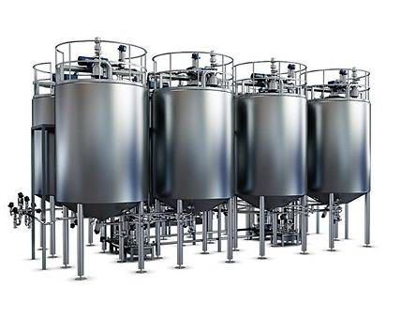
Fermentation Tanks: These large tanks are used for fermenting raw materials like barley and hops to produce beer. Yeast is added to convert sugars into alcohol and carbon dioxide during fermentation.

Labeling Machines: These machines apply labels to bottles and cans, providing product information and branding.
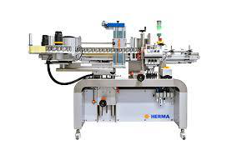

2. QUALITY CONTROL DEPARTMENT
pH Meters: pH meters measure the acidity or alkalinity of liquids, ensuring the product meets quality standards.
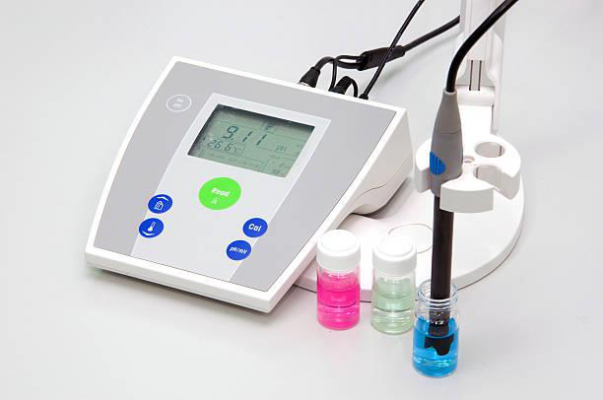

Microscopes: Microscopes are used to detect microorganisms or contaminants in raw materials and finished products.
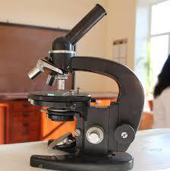

Refractometers: Refractometers measure the sugar content in liquids, which is critical for monitoring fermentation.
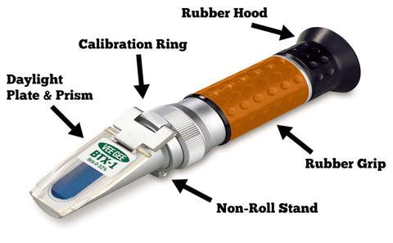
Gas Chromatographs: Gas chromatographs analyze the chemical composition of products, ensuring consistency and quality.
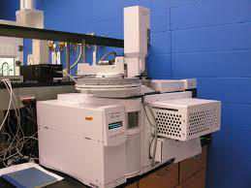

4. LOGISTICS AND WAREHOUSE DEPARTMENT
Forklifts: Forklifts are used to move heavy pallets and materials within the warehouse.
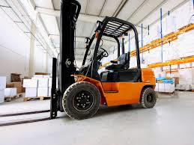

Conveyor Belts: Conveyor belts transport materials and products within the facility, improving efficiency.
Storage Tanks: Storage tanks hold raw materials like water and malt, as well as finished products before distribution.

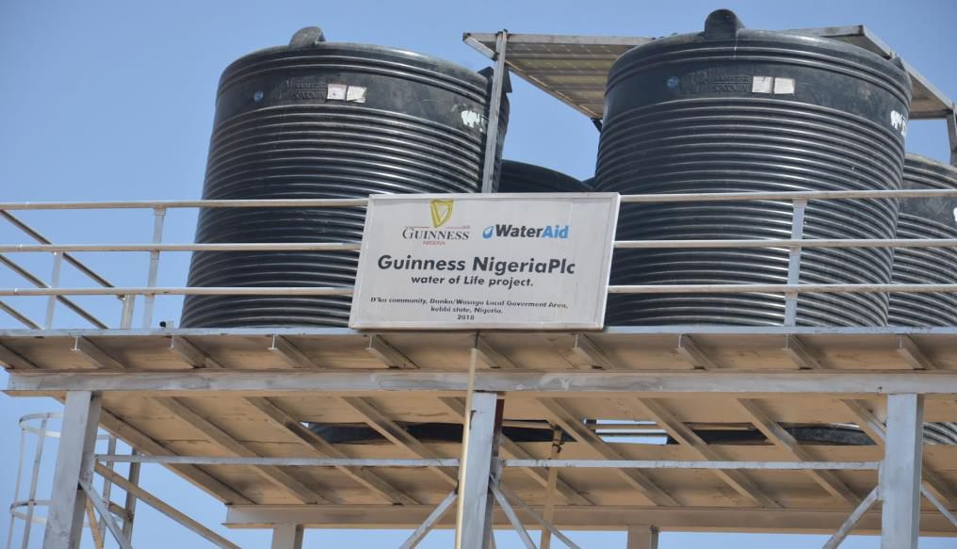

5. LABORATORY (RESEARCH AND DEVELOPMENT)
Autoclaves: Autoclaves sterilize equipment and media to prevent contamination during experiments.
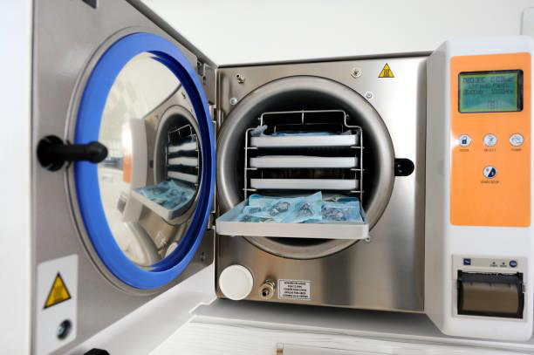

Centrifuges: Centrifuges separate components of a mixture based on density, which is useful for analyzing liquids.
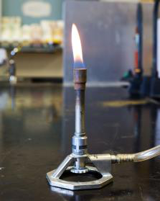
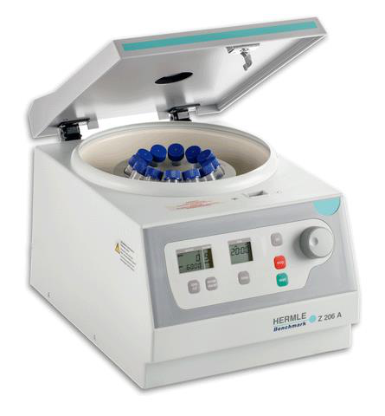
Bunsen Burners: Bunsen burners provide a flame for heating and sterilizing in the lab.

6. UTILITIES AND ENGINEERING DEPARTMENT
Boilers: Boilers generate steam for production processes like heating and cleaning.
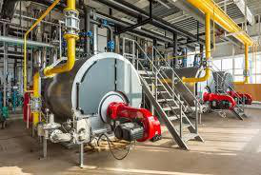
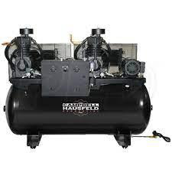
Compressors: Compressors supply compressed air for machinery and equipment operation.

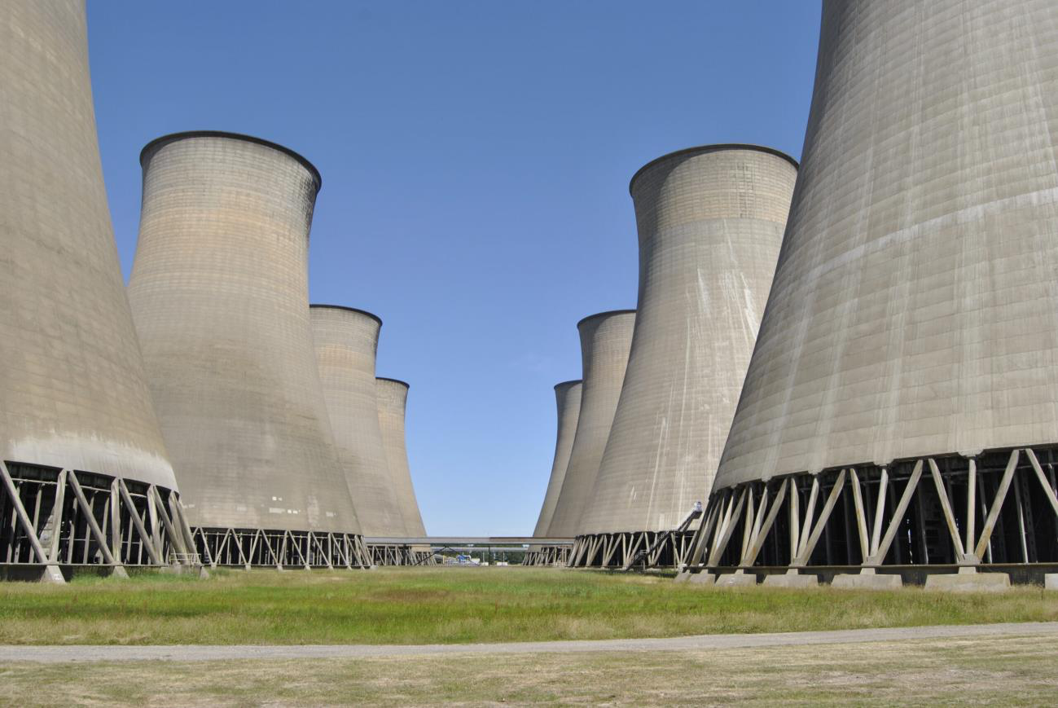
Cooling Towers: Cooling towers cool water for reuse in production processes, improving efficiency.

7. SAFETY AND ENVIRONMENTAL DEPARTMENT
Fire Extinguishers: Fire extinguishers are used to control small fires in emergencies.
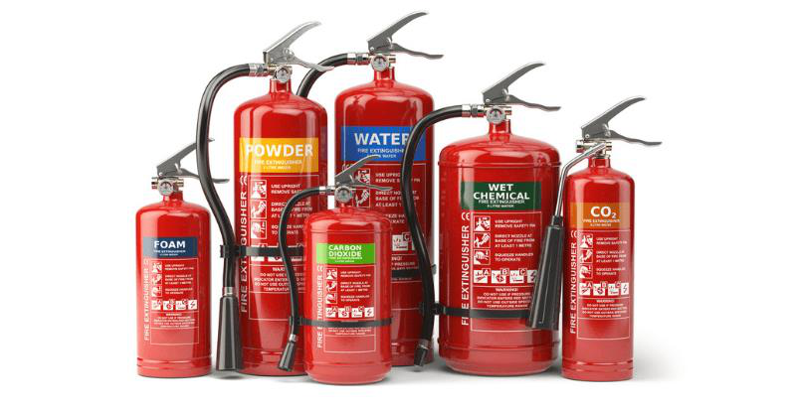

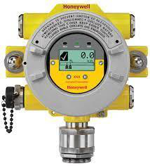
Gas Detectors: Gas detectors monitor the environment for harmful gases, ensuring worker safety.

First Aid Kits: For treating minor injuries or accidents in the store.

8. INVENTORY MANAGEMENT APPARATUS
- Barcode Scanners: Used to scan barcodes on products for quick and accurate inventory tracking.
- Inventory Management Software: Digital systems like ERP (Enterprise Resource Planning) or WMS (Warehouse Management Systems) to track stock levels, reorder points, and product movement.
- Label Printers: For printing barcodes, product labels, and shelf tags.

9. SECURITY APPARATUS
CCTV Cameras: For monitoring activities in the store and preventing theft.
Access Control Systems: Keycards or biometric systems to restrict access to authorized personnel.
Alarm Systems: To alert staff in case of unauthorized entry or emergencies.

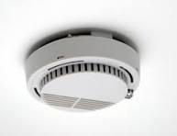



CHAPTER THREE
3.1 OVERVIEW OF PROCUREMENT PROCESSES
Procurement in the store involves sourcing the company product from reliable suppliers.
The process includes:
- Identifying suppliers and negotiating contracts.
- Placing orders and ensuring timely delivery.
- Inspecting goods for quality and compliance with specifications.
- Managing vendor relationships to ensure long-term partnerships.
3.2 SUPPLY CHAIN MANAGEMENT IN THE STORE
The supply chain management process ensures that products are delivered to customers efficiently. Key activities include:
- Inventory management to maintain optimal stock levels.
- Logistics and distribution to ensure timely delivery of goods.
- Monitoring and analyzing supply chain performance to identify areas for improvement.
3.3 CHALLENGES IN PROCUREMENT AND SUPPLY MANAGEMENT
Some of the challenges observed during my SIWES program include:
- Delays in delivery from suppliers.
- Fluctuations in product prices due to market conditions.
- Difficulty in maintaining consistent quality across suppliers.
- High competition in the retail and technology industry.

3.4 SOLUTIONS AND RECOMMENDATIONS
To address these challenges, the following solutions are recommended:
- Establishing long-term partnerships with reliable suppliers.
- Implementing advanced inventory management systems to track stock levels in real- time.
- Diversifying the supplier base to reduce dependency on a single source.
- Conducting regular training for staff on procurement and supply chain best practices.
CHAPTER FOUR
CONCLUSION
The SIWES program provided me with a unique opportunity to gain practical experience in procurement and supply chain management. Through my attachment at Esteem-G mall, I was able to apply the theoretical knowledge gained in the classroom to real-world scenarios. The program enhanced my understanding of procurement processes, inventory management, supplier relationship management, logistics, and compliance. It also equipped me with essential skills such as problem-solving, communication, and teamwork, which are critical for success in the procurement and supply chain industry.
Overall, the SIWES program was a transformative experience that prepared me for the challenges of the professional world. I am confident that the skills and knowledge I acquired during this program will significantly contribute to my career growth and development.
RECOMMENDATION
Based on my experience during the SIWES program, I recommend the following:
- Increased Collaboration between Institutions and Industries: Educational institutions should strengthen their partnerships with industries to ensure that students are exposed to the latest trends and technologies in their fields.
- Extended Duration of SIWES: Extending the duration of the program would allow students to gain deeper insights and more hands-on experience in their chosen fields.
- Regular Monitoring and Evaluation: Supervisors from both the institution and the industry should conduct regular monitoring and evaluation to ensure that students are meeting their learning objectives.
- Provision of Resources: Organizations should provide students with the necessary resources, such as access to software and equipment, to enhance their learning experience.

REFERENCE

Diageo Plc Annual Reports Offers insights into the parent company’s global operations and performance.www.diageo.com
Nigeria Industrial Standards (NIS), Provides guidelines and standards for manufacturing and quality control in Nigeria.
International Organization for Standardization (ISO) ISO 9001 (Quality Management Systems) and ISO 22000 (Food Safety Management). Available at: www.iso.org
Occupational Safety and Health Administration (OSHA) Guidelines for workplace safety and health practices. Available at: www.osha.gov
Food and Agriculture Organization (FAO) Provides resources on food safety and quality standards. Available at: www.fao.org
Monczka, R., Handfield, R., & Giunipero, L. (2020). Purchasing and Supply Chain Management.
Chopra, S., & Meindl, P. (2021). Supply Chain Management: Strategy, Planning, and Operation.
Slack, N., Brandon-Jones, A., & Johnston, R. (2022). Operations Management.
Heizer, J., Render, B., & Munson, C. (2020). Principles of Operations Management.

