CHAPTER THREE

3.0 DESIGNMETHODOLOGY
This chapter discusses the design processes, methodology, and practical steps undertaken in the development of the RLC Trainer. It includes the conceptual design, choice of components, system block diagram, circuit diagram, construction steps, and testing methodology. The RLC Trainer was designed to facilitate the learning of AC circuit principles, including resonance, impedance variation, and power factor, through interactive experimentation with resistors, inductors, and capacitors.

The project work will involve the following stages:
- Input power (AC)
- Energy Meter
- Function Generator
- RLC Load
- Oscilloscope
- Signal Analyzer

3.1 INPUT POWER IN AN AC RLC CIRCUIT
In an AC-powered RLC circuit, the input power depends on the type of components (resistor, inductor, capacitor) and their behavior under alternating current. The power supplied by the ACsource is distributed differently across resistive and reactive components.

3.1.1 Types of Power in an RLC Circuit
There are three types of power to consider in an AC RLC circuit:

Table 3.1: Types of Power in RLC Circuit
Type of Power | Symbol | Formula | Description
Real (Active) Power | P | P=VIcosϕ | Power actually consumed or used in the circuit, e.g., by resistors. Measured in watts(W).
Reactive Power | Q | Q=VIsinϕ | Power that oscillates between source and reactive components (L and C). Measured in volt-ampere reactive (VAR).
Apparent Power | S | S = VI | The total power supplied by the source (combines P and Q). Measured in volt-amperes (VA).

Power Factor (cos ϕ)
The power factor indicates the efficiency of power usage:
- Φphi is the phase angle between voltage and current.
- 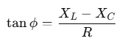In an RLC circuit, ϕ depends on the net reactance:

(3.1)

Power factor = 1 (or 100%) at resonance (when X_{L}=Xc) circuit is most efficient.
•Power factor < 1 when there's phase difference due to reactance (current leads or lags).

3.1.2 Input Power Flow in RLC

1. Resistor (R) Only
- Power is dissipated as heat.
- Real power: P=I²R (3.2)
- All input power is used.

2. Inductor (L) Only
- Stores energy in a magnetic field temporarily.
- Power alternates between source and inductor:
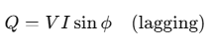 (3.3)
- No real power is consumed.

3. Capacitor (C) Only
- Stores energy in an electric field temporarily.
- Power alternates between source and capacitor:
- 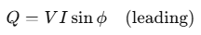No real power is consumed.
(3.3)

Full RLC Circuit
- Real power is only consumed by theresistor.
- Inductor and capacitorcontribute toreactive power.
- Total input powermust account for both:
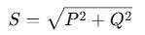 (3.4)

At Resonance
At resonance:
- X_{L}=X_{C}

ϕ = 0^
- cosϕ= 1
- P = IV
- Entire input power is real:

3.2 ENERGY METER IN AN RLC TRAINER

An Energy Meterin anRLC trainer is an instrument or module used to measure the electrical energy consumed by the circuit over time. It plays a vital role in analyzing real power usage, especially in circuits containing resistive (R), inductive (L), and capacitive (C) elements.

3.2.1 Purpose of Energy Meter in RLC Trainer
- To measure real (active) energyconsumed by the circuit.
- To observe how energy usage changes with different RLC configurations (series, parallel).
- To support the study ofpower factor, phase angle, andresonance impact on power consumption.
- To provide practical, measurable feedback in educational labs.

Table 3.2: Energy Meter Measure
Parameters |  | Unit | Description
  Symbol
Voltage | V | Volt (V) | Supplied voltage to the circuit
Current | I | Ampere (A) | Current flowing through the circuit
Power Factor | Cos ϕ |  | Phase alignment between current and voltage
Real Power | P | Watt (W) | Actual power consumed
Energy | E | KWh or Wh | Power consumed over time: E = P × t

Working Principle
The energy meter works by calculating the real power:
P= V × I× cosϕ (3.5)
And then integrating it over time to find energy:
Energy=∫Pdt (3.6)

3.3 FUNCTION GENERATOR IN AN RLC TRAINER
A function generator in an RLC trainer is a crucial component used to supply alternating current (AC) signalsof variable frequency and waveform. It allows students and engineers to observe how RLC circuits respond to different input conditions, particularly frequency variation.

3.3.1 Purpose of the Function Generator in an RLC Trainer
- To provide a controllable AC signal for testing RLC circuits.
- To vary the frequency and observe resonance conditions.
- To study the impedance behavior of RLC circuits at different frequencies.
- To generate standard waveforms like sine, square, or triangle waves.

3.3.2 Function Generator Role in RLC Circuit Experiments
- 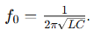Resonance Testing: Slowly increase frequency and observe maximum current at resonant frequency
(3.7)

- PhaseShiftAnalysis: Use oscilloscope or phase meter to detect phase difference between voltage and current.
- ImpedanceAnalysis: Measure how voltage/current ratio changes with frequency.
- TransientResponse: Study behavior when waveforms abruptly change (using square/triangle waves).

3.4 RLC LOAD
An RLC load is a type of electrical load that consists of a combination ofresistor (R),inductor (L),andcapacitor (C) connected in a circuit. It is a common model used in AC circuit analysis and electrical engineering education to study the behavior of power systems, impedance, and resonance.

3.4.1 Characteristics of RLC Loads
1. Impedance: RLC loads have impedance, which is a measure of the total opposition to the flow of an alternating current (AC).
2. Resonance: RLC loads can exhibit resonance, where the inductive and capacitive reactance cancel each other out, resulting in maximum current flow.
3. Frequency response: RLC loads can affect the frequency response of a circuit, with different frequencies being attenuated or amplified.

3.4.2 Types of RLC Loads
1. Series RLC load: Components are connected in series.
2. Parallel RLC load: Components are connected in parallel.

3.4.3 Applications of RLC Loads
1. Circuit testing: RLC loads are used to test circuit behavior under various conditions.
2. Filter design: RLC loads are used in filter design to select or reject specific frequencies.
3. Power systems: RLC loads are used to simulate real-world loads in power systems.

3.4.4 Importance of RLC Loads
1. Accurate circuit analysis: RLC loads help engineers understand circuit behavior.
2. Design optimization: RLC loads enable designers to optimize circuit performance.
3. Troubleshooting: RLC loads aid in identifying and resolving circuit issues.

3.5 OSCILLOSCOPE IN RLC TRAINER: An oscilloscope is a crucial tool in an RLC trainer, allowing users to visualize and measure the behavior of RLC circuits. Here's how an oscilloscope is used in an RLC trainer:

3.5.1 Uses of Oscilloscope in RLC Trainer
1. Waveform observation: Observe the waveform of voltage and current in the RLC circuit.
2. Frequency response analysis: Measure the frequency response of the RLC circuit.
3. Resonance identification: Identify the resonant frequency of the RLC circuit.
4. Phase shift measurement: Measure the phase shift between voltage and current.

3.5.2 Benefits of Using Oscilloscope in RLC Trainer
1. Hands-on learning: Students can gain hands-on experience with oscilloscopes.
2. Circuit behavior visualization: Visualize circuit behavior, making it easier to understand complex concepts.
3. Measurement and analysis: Measure and analyze circuit parameters, such as voltage, current, and frequency.

3.5.3 Features to Consider
1. Bandwidth: Choose an oscilloscope with sufficient bandwidth to measure the frequency range of interest.
2. Channels: Consider a multi-channel oscilloscope to measure multiple signals simultaneously.
3. Triggering: Ensure the oscilloscope has suitable triggering options to capture specific events.

3.6 SIGNAL ANALYZER: A signal analyzer is a valuable tool in an RLC trainer, enabling users to analyze and understand the behavior of signals in RLC circuits. Here's how a signal analyzer is used in an RLC trainer:

3.6.1 Uses of Signal Analyzer in RLC Trainer
1. Frequency response analysis: Measure the frequency response of RLC circuits.
2. Signal distortion analysis: Analyze signal distortion and identify sources of distortion.
3. Noise analysis: Measure noise levels and signal-to-noise ratio (SNR).
4. Circuit optimization: Optimize circuit performance by analyzing signal characteristics.

3.6.2 Benefits of Using Signal Analyzer in RLC Trainer
1. In-depth analysis: Gain a deeper understanding of signal behavior in RLC circuits.
2. Circuit troubleshooting: Identify and troubleshoot circuit issues using signal analysis
3. Design optimization: Optimize circuit design for improved performance.

3.6.3 Features to Consider
1. Frequency range: Choose a signal analyzer with a suitable frequency range for the RLC circuit.
2. Dynamic range: Ensure the signal analyzer has a sufficient dynamic range to measure signal amplitudes.
3. Measurement capabilities: Consider a signal analyzer with advanced measurement capabilities, such as FFT analysis.

3.7 POWER FACTOR MEASUREMENT
Power factor measurement involves determining the ratio of true power (watts) to apparent power (volt-amperes) in an AC circuit, which is essentially the cosine of the phase angle between voltage and current. This can be achieved through direct measurement using a power factor meter, or by using instruments like wattmeters and voltmeters/ammeters to calculate the ratio.

3.7.1 Direct Measurement with a Power Factor Meter:
- A power factor meter directly reads the cosine of the phase angle between voltage and current, providing a direct measurement of the power factor.
- These meters are designed to indicate the power factor value, typically displayed as a percentage or a decimal.

3.7.2 Indirect Measurement Using Separate Instruments:
- Wattmeter:Measures the true power (watts) consumed by the load.
- Voltmeter and Ammeter:Measure the voltage and current, respectively, which can be used to calculate the apparent power (volt-amperes).
- Calculation:The power factor can then be calculated using the formula: Power Factor = True Power / Apparent Power.
Apparent Power Calculation:
Apparent power (S) is calculated as S = V * I (3.8)
where V is the voltage and I is the current.

3.7.3 Circuit Diagrams and Measurement Techniques:
- SeriesCircuit:
In a series circuit, a wattmeter, voltmeter, and ammeter can be connected to measure true power, voltage, and current, respectively, allowing for power factor calculation.
- ParallelCircuit:
In a parallel circuit, measuring the current and voltage in each branch, and then calculating the total apparent power, can be used to determine the overall power factor.

3.7.4Understanding Power Factor:
- LaggingPowerFactor:When the current lags the voltage (common in inductive loads), the power factor is lagging.
- LeadingPowerFactor:When the current leads the voltage (common in capacitive loads), the power factor is leading.
- IdealPowerFactor:An ideal power factor is 1 (or 100%), indicating that all apparent power is being used as true power.

3.7.5 Importance of Power Factor
- Efficiency:A high-power factor indicates efficient use of electrical power, while a low power factor suggests that more apparent power is being supplied than true power is being used.
- CostSavings:Improving power factor can lead to reduced energy bills, especially for industrial customers.
- SystemStability:Maintaining a good power factor is crucial for the stable operation of electrical systems.

3.8 TESTING
Thefollowingtestswerecarriedoutduringandaftertheconstruction
- Continuitytest: The continuitytest was carried out to check for disconnectionand opencircuit in the work using a multimeter.
- Powerconsumption: The voltage across each component and the entire circuit was measured when the system was powered.
- SystemTesting and Integration:After the design and implementation stage, the system was tested for durability and effectiveness and also to ascertain if there is need to modify the design. The system was first assembled using breadboard. All the component where properly soldered to the ferro board and test werecarriedoutatvariousstages.Toensureproperfunctioningofthecomponents,theywere testedusingadigitalmultimetertoensurethattheywerewithinthetolerancevalue.Faulty components were discarded.

EXPERIMENTS
The following experiments are carried out on the constructed Single Phase RLC Trainer

3.9.1 Experiment1: MeasurementofPowerFactor
Objective:
Tounderstandtheconceptofpowerfactorandmeasurethepowerfactorofdifferenttypesof loads.
ApparatusRequired:

Voltmeter,Ammeter,Wattmeter.(MULTIFUNCTIONDIGITALMETER PANEL)

ACpowersource.

Loadbanks:(RLCLOADVECTORANALYZER)

Resistiveload(e.g.,incandescentbulbsorresistive heaters).

Inductiveload(e.g.,coil orinductionmotor).

Capacitiveload(e.g.,capacitorbank).

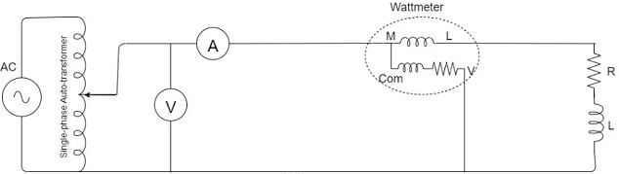

Figure 3.1:Circuit Diagramfor power factor measurement
Procedure:
Step1:ResistiveLoad
- Connecttheresistiveload(100wincandescentbulbto Routand NoutoftheMDMPOUTPOUTS.
- ConnecttheinputsofMDMPRinandNinusingpatchchordstothepowersupply source through a variac transformer.
- Measureandrecord:
  - Voltage(V) usingavoltmeter.
  - Current(I)usinganammeter.
  - Activepower (P)usingawattmeter.
- Calculatethepowerfactorusingtheformula:Power Factor(PF)=P/V×I Note: Vx I= apparent power (S). Calculate and compare it. Is this true? Therefore PF = Active or Real power / apparent power = P/S = Cosθ
- Observethat the power factor is closeto 1 for apurelyresistiveload
Step2:InductiveLoad
- Replacetheresistiveload with aninductiveload. (either 1H,0.8H, 0.6H only)
- Repeatthemeasurements ofvoltage,current,andactive power.
- Calculatethepower factorusingthe same formula.
- Observethatthepowerfactorislessthan1duetothelaggingphasedifferencebetween voltage and current.
Step3:CapacitiveLoad
- Replacethe inductiveload with acapacitive load. (either 1uF,0.36uF, 0.22uF only)
- Repeatthemeasurements ofvoltage,current,andactive power.
- Calculatethepower factor.
- Observethatthepowerfactorislessthan1dueto theleadingphasedifferencebetween voltage and current.

Step4:MixedLoads (RESISTIVEandINDUCTIVE)
- Combineresistiveand inductive. (100wincandescent bulband0.8H inductor)
- Repeatthemeasurements andcalculations.
- Observehowthecombination affectstheoverallpowerfactor.

Step5:MixedLoads(RESISTIVE,INDUCTIVEandCAPACITIVE)
- Combineresistive,inductive,andcapacitiveloads. (100wincandescentbulband0.8H inductor 0.36uF)
- Repeatthemeasurements andcalculations.
- Observehow thecombination affectstheoverallpower factor.

Observations:

RecordthemeasuredvaluesofV,I,P,andthecalculatedpowerfactorforeachtypeofloadina table.

3.9.2 Experiment 2: Series RLC resonant circuit.
Objective:
- Determine the resonant frequency of a series RLC circuit.
- Measure the voltage and current at different frequencies to observe the resonance phenomenon.
- Compare the experimental results with the theoretical prediction

ApparatusRequired

Functiongenerator

Oscilloscope(dual-channel)

RLCVectorAnalyzer

1. Frequency Generator: Use a function generator to provide an AC voltage source with variable frequency.
2. Oscilloscope:Use an oscilloscope to measure the voltage and current across the circuit at different frequencies.
3. Ammeter:Use an ammeter (if available) to measure the current in the circuit.
Theory:
In a series RLC circuit, the impedance (Z) is given by:
Z = √(R² + (X_{L} - X_{C})²) (3.6)
where:
- R is the resistance
- X_{L} is the inductive reactance (X_{L} = 2πfL)
- X_{C} is the capacitive reactance (X_{C} = 1/(2πfC)
At resonance in a series RLC circuit:
- InductiveReactance (Xₗ) = CapacitiveReactance(X𝒸)
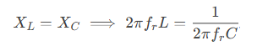
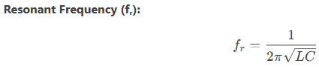(3.7)

(3.8)
- Impedance (Z) isminimized (Z = R), and current (I) is maximized.
- VoltageacrossLandC can exceed the supply voltage (voltage magnification).
Circuit Diagram:
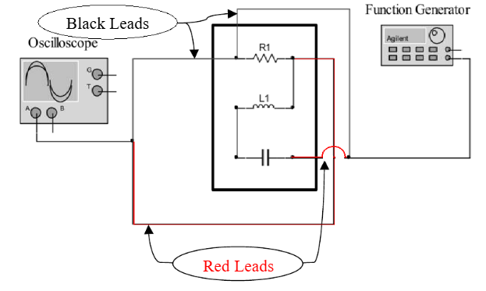

Figure 3.2.a: Wire connection Diagram of Series RLC

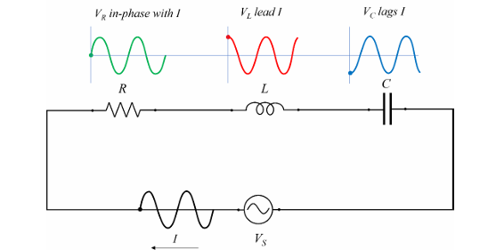

Figure 3.2.b: Series RLC resonant circuit.

Illustrate the equivalent circuit or RLC in series and the voltages across each element.
- Build, connect the circuit shown in Fig. 1 using a 1kΩ resistor, a 100 mH inductor and
- 0.1µF capacitor.
- Set the input voltage at 5V and frequency at 500 Hz.
Using the Oscilloscope, read the voltage across the 1kΩ resistor 100 mH inductor and
0.1µF capacitor.
- Change the input frequency from 500 to 1 kHz, 1.5 kHz 2 kHz 2.5 kHz and 3 kHz.
- Repeat step 3, measuring the voltage across the 1kΩ resistor 100 mH inductor and
0.1µF capacitor.
- Based on the experimental measurement, Calculate the phase shift difference (𝜃)
theoretically
- Measure also the phase shift between V_{S} and V_{R} at these three frequencies
- Write down all the measured and calculated values.
Procedure
Part 1: Setup the Circuit
- Series RLC Circuit:
  - Connect a resistor (R), inductor (L), and capacitor (C) in series with the function generator.
  - Connect Channel 1 of the oscilloscope across the resistor to measure current indirectly.
  - Connect Channel 2 of the oscilloscope across the entire circuit to measure input voltage.

Part 2: Frequency Sweep and Data Collection
- Set the function generator to produce a sinusoidal signal with a small amplitude (e.g., 1V peak-to-peak).
- Start at a low frequency (∼500 Hz) and gradually increase the frequency while observing the waveforms on the oscilloscope.
- For each frequency, record:
  - Voltage amplitude across the resistor.
  - Phase difference between input voltage and current (via the resistor).
  - Shape of the Lissajous figure in XY mode

