CHAPTER TWO

2.0 LITERATURE REVIEW

2.1 INTRODUCTION

The design and analysis of RLC (Resistor–Inductor–Capacitor) circuits form a foundational part of electrical and electronics engineering. These circuits are essential for understanding the behavior of AC systems, transient responses, filters, and oscillators. Given the abstract nature of these concepts, there is a need for hands-on educational tools such as an RLC trainer to facilitate active learning. This chapter reviews the theoretical background of RLC circuits, previous designs of educational trainers, and current trends in trainer development.

2.2 OVERVIEW OF RLC CIRCUITS
An RLC circuit is composed of a resistor (R), an inductor (L), and a capacitor (C) connected in either series or parallel form. These elements exhibit unique behaviors under alternating current (AC) conditions:
- Resistors dissipate energy as heat and oppose current flow linearly.
- Inductors store energy in a magnetic field and oppose changes in current.
- Capacitors store energy in an electric field and oppose changes in voltage.
The impedance of each element varies with frequency, making RLC circuits frequency-dependent. When combined, these components demonstrate key phenomena such as:
- Resonance: Occurs when inductive and capacitive reactance are equal and cancel each other out, leading to purely resistive impedance at a specific frequency.
- Phase Shift: The angle between the voltage and current waveform, significant in AC analysis.
- Damping and Bandwidth: Relevant in filter and oscillator design (Hambley, 2011).

2.3 RLC CIRCUIT THEORY
An RLC circuit is an electrical circuit composed of three passive components: a Resistor (R), an Inductor (L), and a Capacitor (C). These circuits are fundamental in electrical engineering, especially in alternating current (AC) analysis, signal processing, and communications.

2.3.1 Components of RLC Circuit
- Resistor (R): Opposes the flow of current by dissipating energy as heat. Its opposition is independent of frequency.
- Inductor (L): Stores energy in a magnetic field when current flows. It opposes changes in current. Its opposition to AC is called inductive reactance, and it increases with frequency:
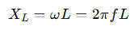 (2.1)
- Capacitor (C): Stores energy in an electric field. It opposes changes in voltage. Its opposition to AC is called capacitive reactance, and it decreases with frequency
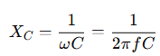 (2.2)

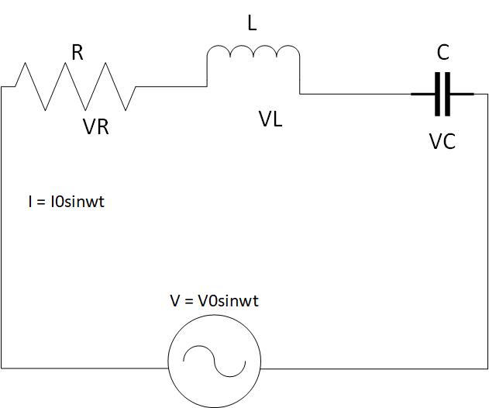

Figure 2.1: Series RLC Circuit

2.3.2 Fundamental Principles of Series RLC Circuits
Series RLC circuits form the backbone of AC circuit analysis, demonstrating the interaction between resistance (R), inductance (L), and capacitance (C) when connected in series with an AC power source (Nilsson & Riedel, 2015). The total impedance (Z) in a series RLC circuit is given by:
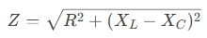 (2.3)
represent inductive and capacitive reactance, respectively (Alexander & Sadiku, 2021).

2.3.3 Resonance in Series RLC Circuits
At resonance, the inductive and capacitive reactance cancel each other out (X_{L}=X_{C}​), resulting in:
- Minimum impedance (Z=R)
- Maximum current I_{max} =V_{in}/R
- Resonant frequency
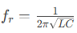 (Hayt et al., 2018) (2.4)
Experimental studies by Smith & Johnson (2020) demonstrate that series RLC circuits exhibit a sharp current peak at resonance, making them ideal for bandpass filtering applications.

2.3.4 Phase Relationships and Phasor Analysis
The phase angle (θ) between voltage and current is determined by:
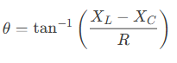 (2.5)
Key phase characteristics:
- Below resonance: Capacitive dominance (current leads voltage)
- At resonance: Purely resistive (current and voltage in phase)
- Above resonance: Inductive dominance (current lags voltage) (Dorf & Svoboda, 2022)

Practical Applications
Series RLC circuits are fundamental to:
- Radio tuning circuits (selecting specific frequencies)
- Impedance matching networks
- Bandpass filters in communication systems
- Power factor correction (Glover et al., 2017)

2.3.5 Resonance in parallel RLC Circuits
A parallel RLC circuit consists of a resistor (R), inductor (L), and capacitor (C) connected in parallel across an alternating current (AC) voltage source. Unlike series RLC circuits, parallel RLC circuits exhibit unique behaviors, particularly at resonance, making them essential for applications like filtering, tuning, and impedance matching.

2.3.6 Key Characteristics of Parallel RLC Circuits

- Shared Voltage
  - All components (R, L, C) experience the same voltage from the AC source.
  - Current divides among the branches based on their impedance.
- Resonance (Anti-Resonance)
  - At the resonant frequency 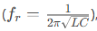 the inductive and capacitive reactance’s cancel each other.
  - The circuit behaves like a pure resistor, reaching maximum impedance (opposite of series RLC, which has minimum impedance at resonance).
  - Current is minimized at resonance (only the resistive current flows).
- Current Magnification
  - While the total current is minimized at resonance, the individual currents through L and C can be much higher (depending on the Q factor).
  - This is called current resonance (vs. voltage resonance in series RLC).
- Phase Relationships
  - Below resonance: Inductive reactance dominates → current lags voltage.
  - At resonance: Purely resistive → current and voltage are in phase.
  - Above resonance: Capacitive reactance dominates → current leads voltage.

- Quality Factor (Q)
  - Determines the sharpness of resonance:
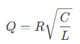 (2.5)
Higher Q means narrower bandwidth and stronger current magnification in L and C

Practical Applications
- Band-Stop (Notch) Filters – Blocks signals at resonant frequency.
- Tank Circuits – Used in oscillators and radio tuners.
- Power Factor Correction – Cancels inductive reactance in power systems.
- Impedance Matching – Maximizes power transfer in RF circuits

2.4 THEORETICAL BACKGROUND AND APPLICATIONS
RLC circuits are widely used in:
- Radio Frequency (RF) and Communication Systems: Tuned circuits in receivers and transmitters.
- Signal Processing: Low-pass, high-pass, band-pass, and band-stop filters.
- Power Systems: Harmonic filters, transient response analysis, and impedance matching (Sedra & Smith, 2015).

2.5 NEED FOR RLC TRAINERS IN EDUCATION

Conventional teaching often relies on circuit simulation software and whiteboard explanations, which may fail to convey the full behavior of AC circuits, particularly resonance and phase shift. An RLC trainer bridges this gap by offering real-time interaction with the circuit elements and observing results using multimeters or oscilloscopes (Boylestad & Nashelsky, 2013).
Research shows that active learning tools significantly improve student engagement and knowledge retention in technical education (Prince, 2004). An RLC trainer provides a safe, modular platform where students can observe:
- The effect of frequency on impedance.
- The voltage drops across each component.
- The variation in current and phase angle.
- Real-life resonance behavior.

2.6 REVIEW OF EXISTING RLC TRAINERS

Several educational trainers have been developed, ranging from basic analog circuit boards to sophisticated digital trainers:
- Analog Trainers: These are constructed using discrete components mounted on boards with switches and terminals. They are cost-effective but may lack flexibility.
- Digital Trainers: Include microcontrollers or display modules for real-time measurement and control. These are more expensive and require programming knowledge.
- Virtual Labs and Simulators: Such as NI Multisim or Proteus, which allow for RLC circuit simulation without physical hardware. While useful, they do not replace the tactile experience of real circuit assembly and measurement.
In their study, Anbalagan et al. (2017) designed a modular RLC trainer using banana plug terminals and toggle switches to demonstrate resonance and filtering. However, their model was not portable and lacked protective features. Okwu et al. (2020) improved upon this by adding short-circuit protection and color-coded indicators for safer student use.
Despite these advancements, many available trainers remain costly or complex, especially for developing nations. Hence, there is still a need for affordable, user-friendly RLC trainers that are durable, intuitive, and effective for classroom and laboratory use.

2.7 ADVANCEMENTS AND TRENDS
Modern educational tools are now integrating:
- Digital displays for voltage and current readings.
- Built-in function generators to eliminate the need for external signal sources.
- Modular components using magnetic or socket-based connections.
- IoT-based features for remote access and performance monitoring.
However, for most undergraduate or diploma-level students, these added complexities may not be necessary. A basic analog trainer that demonstrates the core behaviors of RLC circuits remains highly relevant and effective (Theraja & Theraja, 2014).

2.7.1 Resonant Frequency

Resonant frequency in electronics is expressed when a circuit exhibits a maximum oscillatory response at a specific frequency. This is observed for a circuit that consists of an inductor and capacitor
It is known that the value of capacitive and inductive reactance changes accordingly to the frequency. Capacitive reactance is defined by the equation X_{c} = 1/ (2ℼfC), while inductive reactance is given by the equation X_{L} = 2ℼfL
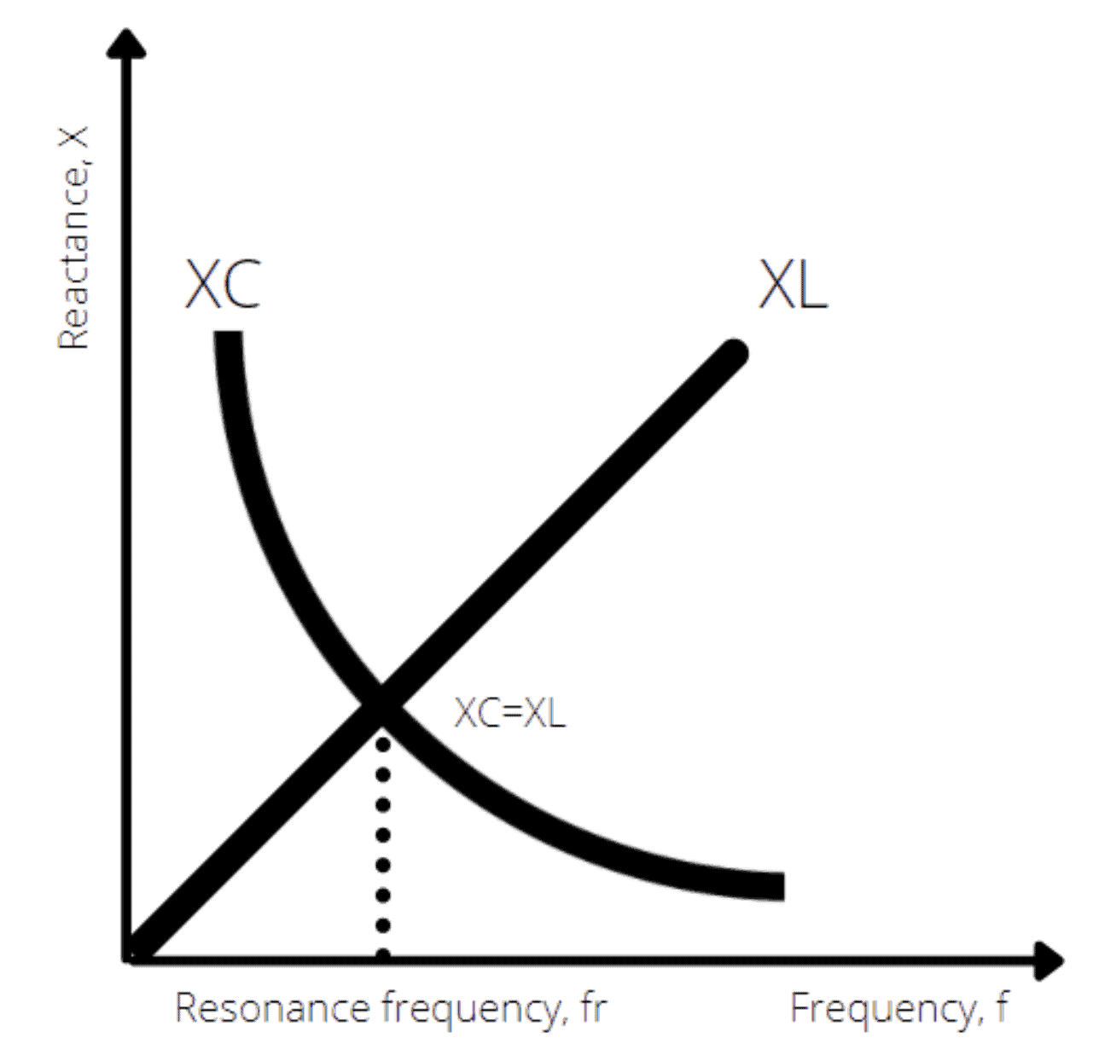

Figure 2.2: The relationship of inductive and capacitive reactance across frequencies

When plotted on a chart, the decreasing capacitive reactance will cross paths with the increasing inductive reactance at a specific frequency. The frequency where both parameters overlap is known as the resonant frequency of an RLC circuit. Therefore, the resonant frequency can be derived by expressing the equal value of both capacitive and inductive reactance as follows:
- X_{L} = X_{C} (2.6)
- 2ℼfL = 1/ (2ℼfC) (2.7)
- f_{r} = 1/ (2ℼ √LC) (2.8)
In a series RLC circuit, the impedance is at its minimum when it’s driven at the resonant frequency. The circuit’s impedance is expressed by the following equation:
- Z = R + X_{L} - X_{C} (2.9)
At resonance, X_{L} equals X_{C}, meaning they cancel each other out. This leaves the impedance of the circuit to be purely resistive. As a result, the current that flows through the series RLC circuit is at its peak when it’s operating at its resonant frequency.
In a parallel RLC circuit, the formula for calculating the resonant frequency remains the same. However, you’ll find the current is suppressed to the minimum, as the circuit’s impedance is at its maximum. This happens as the LC of the circuit appears as an open circuit when connected in parallel.

