CHAPTER THREE
RESEARCH METHODOLOGY
3.1 Introduction
This chapter outlines the methodology employed in conducting the research. It discusses the research design, population of the study, sample and sampling techniques, method of data collection, instrument used for data collection, method of data analysis, and the validity and reliability of the research instrument.

3.2 Research Design
This study adopts a descriptive survey design. The design is suitable for this research because it allows the researcher to collect, analyze, and interpret data from a selected sample of respondents to determine the effect of computerized accounting systems on the performance of banking industries, with a specific focus on Access Bank Nigeria.

3.3 Population of the Study
The population of this study comprises the staff of Access Bank Nigeria, particularly those working in the finance, IT, and accounting departments across selected branches. The total population is estimated at 120 staff members drawn from different departments that make use of computerized accounting systems.

3.4 Sample Size and Sampling Technique
To calculate the sample size using Taro Yamane's formula, you can use the following formula:
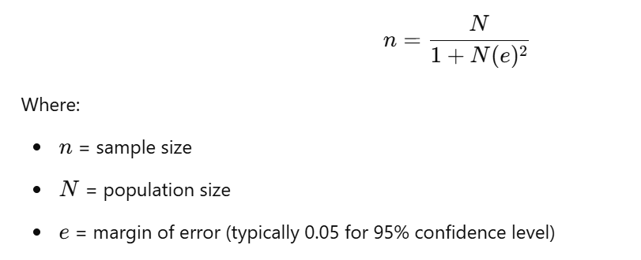
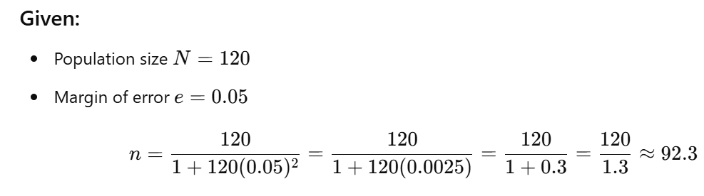
For accuracy the sample size will be rounded up to 100 bank staff.

3.5 Sources and method of Data collection
The study will utilize primary and secondary data:
- Primary data were collected through the use of structured questionnaires administered to the selected respondents.
- Secondary data were obtained from existing literature, journals, textbooks, company reports, and online publications relevant to computerized accounting systems and banking performance.
Method pf data collection
- questionnaire design: a structured questionnaire to capture relevant information
- sampling technique: simple random sampling
- administration: questionnaire was administered personally.
3.6 Instrument of data collection
The main instrument for data collection was the questionnaire. The questionnaire was divided into two sections:
- Section A: Demographic information of respondents.
- Section B: Questions related to the use of computerized accounting systems and their effect on banking performance.
A 5-point Likert scale was used to measure respondents’ opinions on various statements.
3.7 Technique of Data Analysis
The data collected were analyzed using descriptive statistics such as frequency tables and percentages to present demographic data. For the analysis of research questions, mean scores and standard deviations were used. Furthermore, inferential statistics such as Chi-square (χ²) tests were employed to test the formulated hypotheses at a 0.05 level of significance using SPSS software.
3.8 Model specification
The study adopts a linear regression model to assess the impact of computerized accounting systems (independent variable) on banking performance (dependent variable):
Y=β0+β1X1+β2X2+ϵ
Where:
- Y= Banking performance (e.g., efficiency, profitability)
- X1​ = Computerized accounting system adoption
- X2​ = Control variables (staff training, IT infrastructure)
- ϵ = Error term

