
A TECHNICAL REPORT
ON
STUDENT INDUSTRIAL WORKING EXPERIENCE SCHEME

(SIWES)
HELD AT
ADMAK ROYAL SURVEY CONSULTANT LIMITED, ONDO NO B11, VERONICA AKINPELU MEMORIAL COMPLEX, SABO
ONDO STATE

PREPARED BY
NINIOLA MUTIAT OMOWUMI
ND/23/SGI/FT/0024
SUBMITTED TO:
DEPARTMENT OF SURVEYING AND GEO-INFORMATICS
INSTITUTE OF ENVIRONMENTAL STUDIES
KWARA STATE POLYTECHNIC ILORIN.
IN PARTIAL FULFILLMENT OF THE REQUIREMENT OF THE AWARD OF NATIONAL DIPLOMA
IN SURVEYING AND GEO-INFORMATICS (S.G.I)
Sep-dec, 2024
CERTIFICATION

This is to certify that this report is original to the author, NINIOLA MUTIAT OMOWUMI of matric number ND/23/SGI/FT/0024 of the SURVEYING AND GEO-INFORMATICS, INSTITUTE OF ENVIRONMENTAL STUDIES, Kwara State Polytechnic, Ilorin and was supervised accordingly by;

………………………….. …………………………...
SIWES COORDINATOR DATE & SIGNATURE

……………………….. ..………………………..
SIWES SUPERVISOR DATE & SIGNATURE

…………………………… …………………………
HEAD OF DEPARTMENT DATE & SIGNATURE

PREFACE

This is a report of four months industrial training which was done as part of the requirement needed for the award of National Diploma Certificate which was embarked upon by the technical student after their first year of stay in school.
It is also done to enable the student’s to be exposed the practical aspect of their course of study and write down what he/she has gained during the training.
The program is aimed at correcting the incompetence in the school leaving the scientific and technical in country.

DEDICATION
This report is dedicated to the Almighty God, the Lord of lords, the merciful, the cherisher of the universe, the uncreated creator of all creatures and the most knowledgeable who seek knowledge just from himself for giving me the opportunity, privilege an understanding to participate in the student industrial work experience scheme (SIWES).
I also dedicate this report to my amiable parent Mr. and Mrs. NINIOLA for their financial support during the course of the program. May GOD continue to bless them (AMEN).

TABLE OF CONTENTS
Title
Preface
Dedication
Acknowledgement
Table content
CHAPTER ONE
  - Introduction
  - Background
  - Objective of SIWES
CHAPTER TWO
2.0 Brief History of the Establishment
2.1 Organizational structure
2.2 The various Department/Units in the Establishment
CHAPTER THREE & FOUR
3.0 Experience gained during the SIWES program
3.1 Interactive relationship within the organization
CHAPTER FIVE
4.0 Summary
4.1 Recommendations
4.1 Conclusion

CHAPTER ONE
1.0 INTRODUCTION OF SIWES
The Students Industrial Work Experience Scheme (SIWES) for the 2023 /2024 academic session kicked off the month of in August 2024 and was concluded (4) months in the month of December, 2024. The industrial attachment program is solely aimed at improving in working skills of students in tertiary institutions as well as effecting, learning, participation and observation into proactive invariable fields with respect to grasp very useful practical knowledge which not only makes them employable but also aids in the perfect understanding of theories and operation in their different profession. It is a corporative industrial internship program that involves industries, the Federal Government of Nigeria, Industrial Training Fund (ITF), and Nigeria Universities Commission (NUC). The program is of very high importance considering the lack of adequate practical equipment for learning in most Nigeria tertiary institutions and itself proven as it has been part and parcel of the countries system of education for over 28 years.

AIMS OF SIWES
The Industrial Training Funds Policy document Number 1 of 1973, which established SIWES outline the objective of the scheme. The objectives are to:-
- To provide an avenue for Students in Nigerian Tertiary Institutions to acquire Industrial Skills and Experience during their course of Study.
- To prepare Students for the work they are likely to meet after graduation.
- To expose students to work methods and techniques of handling equipment and machinery that may not be available in their Institutions.
- To allow the transition phase from school to the world of working environment easier and facilitate students contact for later job placement.
- To provide students with an opportunity to apply theoretical knowledge in real work situation there by bridging the gap between theory and practice.

1.1 Historical Background of SIWES
SIWES (Student Industrial Work Experience Scheme) was set up by the federal government of Nigeria to close the gap between theoretical learning and practical work experience. It was first kicked off and funded by the Industrial Training Fund ITF) in 1973 the scheme has gone through series of reforms. Its management has changed hands from the ITF in 1978 to various regulatory agencies such as National Universities (NUC) and National Board for Technical Education (NBTE) and board to the ITF again in 1985. These are the major stake holders in SIWES. Consequently, SIWES program was introduced into the curriculum of tertiary institution in the country as far back as 1974 with 948 students from two institution of higher earning and the scheme has over the year contributed immensely to the personal development and motivation of their academic programs and what knowledge and skill will be expected of them on professional practice after graduation.

DEFINITION OF TERMS
- SIWES: Student Industrial Work Experience Scheme. The Scheme was established by the Industrial Training Fund (ITF) in 1973 to solve the problem of lack of adequate preparatory for employment in Industrial by Nigeria graduates of tertiary Institution.
- Industrial Training Fund: The fund was established in 1971 and has operated consistently and painstakingly within the context of its.
3. CONSOLE: It is considered as the center piece or the very heart of Radio station Hasan (2013) in Adoyi (2020:54) Says, professionally, a mixing console is an electronic device for combining (Mixing), routing, and changing the level, tone and/ or dynamics of audio signals
CHAPTER TWO
DEPARTMENTS IN ADMAK ROYAL SURVEY CONSULTANT LIMITED, ONDO NO B11, VERONICA AKINPELU MEMORIAL COMPLEX, SABO ONDO STATE AND THEIR FUNCTION
1. Surveying and Field Operations Department
Function: This department is responsible for conducting on-site surveys, including topographic, cadastral, engineering, and control surveys. Field crews use instruments like total stations, GPS receivers, and levels to collect accurate spatial data.
2. Data Processing and Cartography Department
Function: After field data collection, this department processes the data to produce maps and plans. Tasks include data reduction, coordinate computations, and the creation of detailed survey plans using software such as AutoCAD and GIS applications.
3. Geographic Information Systems (GIS) Department
Function: This unit manages spatial data analysis and visualization. They integrate various data sources to create comprehensive maps and models, supporting decision-making processes in urban planning, resource management, and infrastructure development.
4. Quality Assurance and Control Department
Function: Ensures that all surveying activities and outputs meet established standards and client specifications. This department conducts regular checks and validations to maintain data accuracy and reliability.
5. Administrative and Human Resources Department
Function: Handles the organization's administrative tasks, including staff recruitment, training, welfare, and compliance with labor laws. They also manage internal communications and office logistics.
6. Finance and Accounts Department
Function: Manages the company's financial transactions, budgeting, and financial reporting. They ensure timely invoicing, payroll processing, and compliance with tax regulations.
7. Marketing and Business Development Department
Function: Focuses on client acquisition and relationship management. They develop marketing strategies, prepare proposals, and seek new business opportunities to expand the firm's client base.
8. Equipment Maintenance and Logistics Department
Function: Responsible for the maintenance and calibration of surveying instruments and equipment. They also manage the logistics of deploying teams and equipment to various project sites.

BRIEF HISTORY OF ADMAK ROYAL SURVEY CONSULTANT LIMITED.
ADMAK ROYAL SURVEY CONSULTANT LIMITED is a reputable surveying and geo-informatics firm located in ONDO NO B11, VERONICA AKINPELU MEMORIAL COMPLEX, SABO ONDO STATE, involved in land surveying, geospatial data collection, and spatial analysis for planning and development. The organization engages in topographic surveys, cadastral surveys, site inspections, boundary demarcation, and plan production using modern instruments and software.

STRUCTURE OF ADMAK ROYAL SURVEY CONSULTANT LIMITED
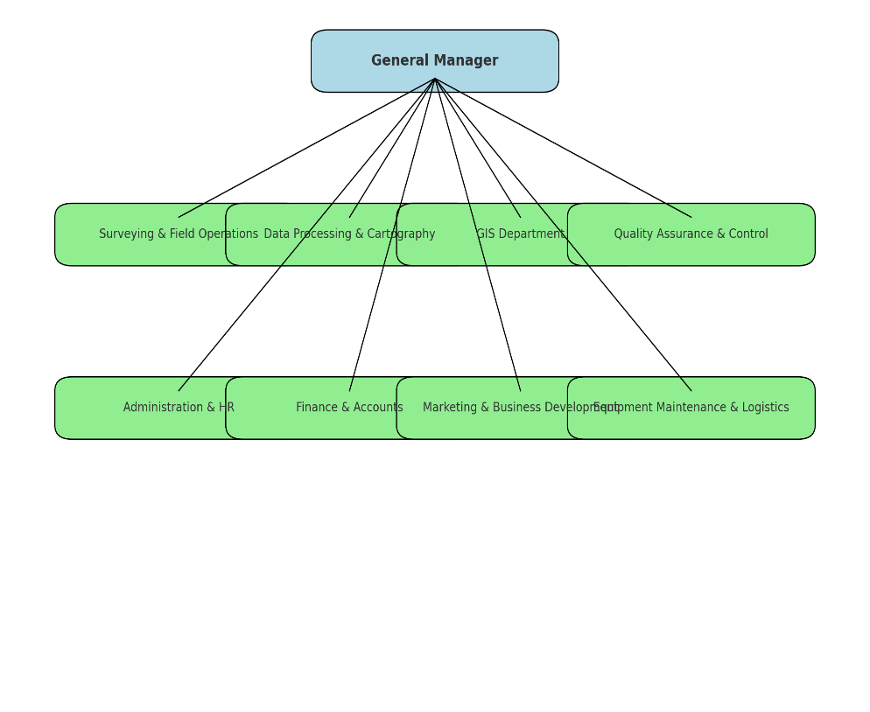

CHAPTER THREE & FOUR
SIWES EXPERIENCE AT ADMAK ROYAL SURVEY CONSULTANT LIMITED, ONDO NO B11, VERONICA AKINPELU MEMORIAL COMPLEX, SABO ONDO STATE

1. Introduction to Office Staff and Survey Instruments
Upon resumption, I was warmly introduced to the staff of the organization, including licensed surveyors, technicians, and administrative personnel. I was also introduced to various survey instruments such as the Total Station, GPS receivers, leveling instruments, measuring tapes, prismatic compass, and ranging poles. I learned about their names, functions, and handling procedures which are vital in carrying out any surveying operation.
2. Introduction to Computer Software
During the training, I was introduced to essential software used in the surveying field. This included:
- Notepad for taking quick notes and modifying simple coordinate data,
- Microsoft Excel for data entry, field book computation, and tabular analysis of coordinates,
- AutoCAD for plotting, plan production, and map design. This gave me a good understanding of how technology supports surveying and mapping tasks.
3. Introduction to Field Book Reduction
I learned how to reduce data recorded in the field book by converting raw measurements into usable data. This included computing reduced levels, bearings, and distances. Proper understanding of field book reduction is crucial for further analysis and mapping.
4. Introduction to Chain Traversing
I participated in chain traversing activities which involved linear measurements using chains or tapes. I learned how to conduct traverses, record the necessary data, and correct errors in chain survey to ensure accuracy and reliability.
5. Site Inspection
Site inspection formed a critical part of my training. It involved visiting survey sites before and during fieldwork to assess terrain conditions, locate existing pillars, and determine appropriate survey techniques and instruments to use. This enhanced my ability to make professional judgments on-site.
6. Computation of Forward and Back Bearings
I was trained on how to compute both forward and back bearings using survey data. This computation is essential in checking angular misclosure and verifying the correctness of traverse surveys. I also learned to use the compass rule to balance traverses.
7. Plotting and Plan Production
I participated in plotting field data and producing survey plans using AutoCAD. This involved converting reduced data into scaled drawings that represent physical features and boundaries. I learned to include title blocks, north arrows, and scales on survey plans.
8. Writing Pillar Numbers on Site
I was involved in identifying and marking pillar numbers on boundary monuments. This task ensured the proper documentation and traceability of land boundaries and helped in preventing land disputes.
9. Tracing Boundary Pillars
I learned how to trace and verify the positions of boundary pillars using field observations and GPS coordinates. This was particularly useful during cadastral surveys and land demarcations.
10. Ranging Line Using Ranging Pole
I was taught how to range straight lines between two survey stations using ranging poles. This skill is essential for accurate alignment and distance measurement during linear surveys.
11. Introduction to Leveling Instrument
I was introduced to the use of leveling instruments such as the Dumpy Level and Automatic Level. I learned how to set up the instrument, take readings, and compute reduced levels using the rise and fall method and the height of collimation method.

CHAPTER FIVE
SUMMARY, RECOMMENDATION AND CONCLUSION
The SIWES training was an eye-opener and a valuable experience in my academic and professional journey as a Surveying and Geo-informatics student. It provided me with practical knowledge of the field, enhanced my technical skills, and prepared me for future career responsibilities
RECOMMENDATION
- SIWES should be made compulsory for all students in the department to expose them to the field.
- Institutions should partner with reputable survey firms to ensure students receive high-quality training.
- Students should be encouraged to participate fully and show commitment during the training to maximize learning.
CONCLUSION
The SIWES training was an eye-opener and a valuable experience in my academic and professional journey as a Surveying and Geo-informatics student. It provided me with practical knowledge of the field, enhanced my technical skills, and prepared me for future career responsibilities.

