CHAPTER ONE
1.0 INTRODUCTION
In the past, engineering survey usually the construction, transportation, Water conservancy and other industries, but the continuous development of science and technology, the intelligent level of survey instrument is more supervisor and also promoted more industries to start to wisely use digital surveying and mapping technology. Al present, along with the development of ground survey technology, digital mapping technology, quality and remote sensing of photographic data. agent information technology and global positioning and other Advance technologies, the collection and mathematical of survey data have gradually realized digitization, real time and automation. and constantly expanded the service field of engineering survey. so as to meet the needs of all aspects of society.
At present, digital surveying and mapping technology is one of the key contents of the scientific and technological innovation of surveying and mapping enterprises. Only by doing a good job in the innovation and optimization of digital surveying and mapping technology and applying it in the construction engineering can we guarantee the improvement of the market competitiveness of enterprises.
This paper explores the application of digital surveying and mapping technology in construction engineering survey, and analyzes the advantage of digital surveying and mapping technology in construction engineering survey.
Digital mapping also called digital cartography is that branch of survey that is concern with the surveying and collection of digital data. The data is compiled and formatted into a virtual image the virtual image is usually in 3 – D
Advantages And Characteristics Of Digital Mapping Technology
The real - time processing of relevant data with complex professional Technology in the so called essence of digitalization. Some real time dita can be obtained through computer analysis, and then the characteristics of these data can be displayed in a simple and vivid way. Usually 3D models or charts are used to show the geological and geomorphic information, which are used in construction engineering digital Technology can show the data of construction engineering survey more clearly,
The application of digital survey and mapping technology can change the traditional way of work and avoid the use of artificial paper to collect and process the data and information of engineering survey. The workload is very huge. At the same time, the kind of complex data can only be read and understood by professional.
The application of digital mapping Technology can directly simplify the complex problem, and make the abstract geographic information more vivid and intuitive. With the constantly updated Technology and equipment, the application of digital surveying and mapping technology has become more simple. As long as the surveying and mapping unit pay attention to the new survey and mapping analysis software on the network regularly, it can achieve the effectiveness of product information and form the information updating mode synchronized with the market. Secondly, while updating the hardware facilities, we should also pay attention to updating the software of digital surveying and mapping Technology, so as to make a strong guarantee for the effectiveness of digital surveying and mopping technology.
- HIGH ACCURACY
Compared with other measurements technologies, digital measurements technology has higher accuracy. Compared with the traditional measurements Technology, they are quite different. The accuracy of modern digital measurements Technology has been greatly improved. In addition digital measurements Technology can effectively combine each intelligent Technology with digital Technology which to a certain extent. It can greatly improve the accuracy of measurements, effectively reduce the probability of error. So as to Improve the accuracy and stability of digital measurements Technology.
- HIGH LEVEL OF AUTOMATION
In the application of geographical measurements technology, automation technology, as a way of engineering measurements, plays a very important role in the measurements work, digital measurements technology is based on the technology of computer, with the help of computer, the real time operation of terrain can be realized, the detailed analysis is terrain, land form and specific geological characteristics can be carried out, and the relevant data can be formed in time. In the digital measurements technology. The computer technology is applied to combine the two together to form an interdependent relationship, which can greatly improve the level of its intelligence, automation and refinement to a certain extent. In the process of data processing and drawing, using digital measurements technology can effectively improve the work efficiency, and optimize the previous method with poor operability, which is conducive to improving the automation level of drawing.
- INFORMATION QUANTITY
In the process of digital survey, the relevant workers need to fully grasp the terrain and cadastral condition of the project, and then count the results as a reference data for planning. which can effectively help the workers to use the map to design and plan the computer project. Though the digital survey technology, the workers according to the number obtained according to the analysis and statistics, then form a huge information database, which is of great significance for the measurements work.
- GRAPHICS DATA CAN BE UPDATED IN TIME
There are some difference between the modern digital technology and the traditional way. At present the surveying and mapping technology we applied can be used conveniently and quickly by computer. By this way, we can better ensure that the digital products keep the same development trend with the society in term of information, and that the graphics and data can be updated in time, so as to promote the usability of graphics and data and make engineering measurements more convenient and quick.
DIGITAL MAPPING HAVE THE FOLLOWING TYPE
- State Wap: most maps on the internet are of this type
- Editable Maps: The file format for these is eps or sometimes Pot and they Can be edited with the right software.
- Online Atlases: The collection of maps: It is typically a bundle of maps or of a region of earth
- Geospatial Data: It is time-based data that is related to a specific location on the earth surface
1.1 STATEMENT OF PROBLEM
Adewole Federal Staff School needs a new digital map to help people find their way around and manage facilities better. The current map is old and the information on is outdated.
1.2 AIM OF THE PROJECT
This project is aimed at producing an up to date digital map in surveying at the Federal Staff School Adewole, Kano Road, Ilorin, Kwara State.
1.3 OBJECTINES OF THE PROJECT
- To determine the perimeter and area of the project site
- To show the position of the artificial features
- To develop an up-to date digital map of the location
1.4 SCOPE OF THE PROJECT
- Planning
- Data processing
- Data acquisition
- Information presentation
- Report writing
1.4 SCOPE OF THE PROJECT
- Planning
- Data processing
- Data acquisition
- Information presentation
- Report writing
1.5 SPEE- PROJECT SPECIFICATION
- The area should not be less than 3 hectares
- A closed traverse must be carried out for field work
- The scale should not be more than 1:2,500
- Linear accuracy should not be less than 1:5000
1.6 PARTICIPANTS INVOLVED
S/N | NAME | MATRIC NO | ROLE
1 | OLADIMEJI RAPHAEL OLUWASEGUN | HND/23/SGI|FT /0045 | Author 2025
2 | ADEBAYO BLESSING MARY | HND|23/SGI|FT|0042 | Member
3 | DADA ELIZABETH OLUWAPELUMI | HND|23/SGI|FT|0043 | Member
4 | IBITOYE JOSHUA AYOKUNLE | HND|23/SGI|FT|0047 | Member
5 | OSUNLEKE HABEEB OLALDE | HND|23/SGI|FT|0052 | Member
6 | OJO ADEBISI MOTUNRAYO | HND|23/SGI|FT|0041 | Member
7 | AKINYEJO EZEKIEL DAMILOLA | HND|23/SGI|FT|0051 | Member
The study was carried out at the Federal Staff School, located in Ilorin, the capital city of Kwara State, and Nigeria, Ilorin lies in the north-central region of the country serves as a major administrative and educational center. The Federal staff school is situated within the Federal Secretariat Complex along Fate Road, in the Ilorin West Local Government Area. The school is a government-owned institution established to provide quality education for the children of federal workers and the general public. Its campus comprises classroom buildings, administrative blocks, playgrounds, and other school infrastructure that require proper spatial documentation for effective planning and management.
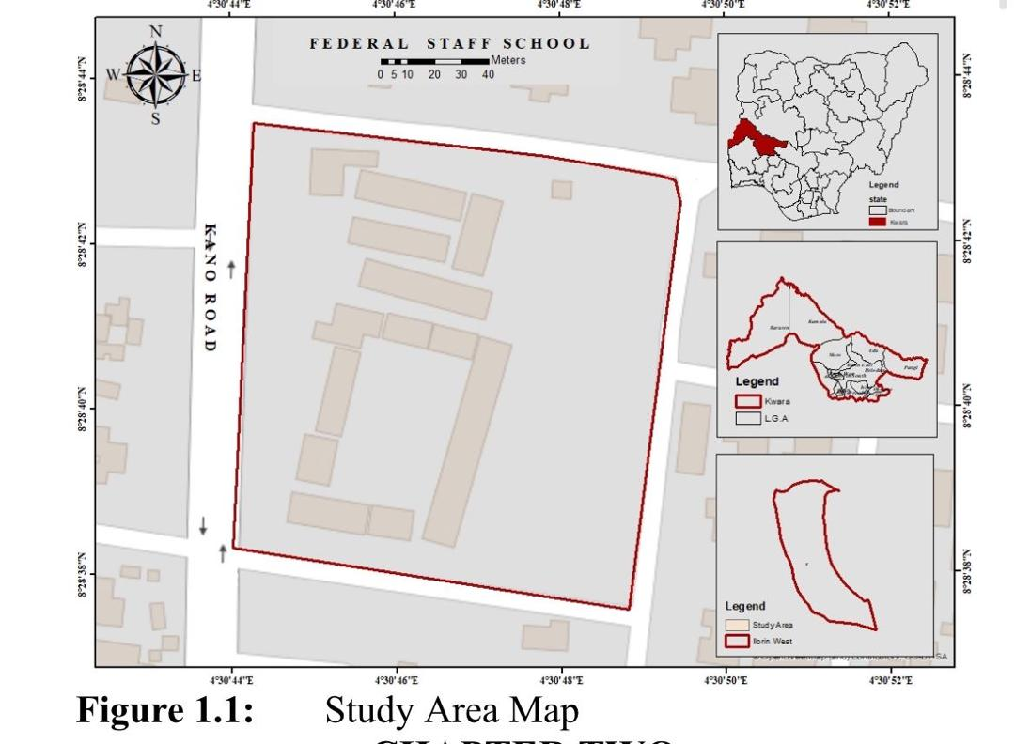
Spatially, Federal Staff School, Ilorin, is located approximately within the coordinates 8.4820°N latitude and 4.5600°E, longitude. The school is bounded by Kano Road to the west, residential areas to the north and south, and other government facilities to the eat. The perimeter of the school covers a modest area suitable for basic and secondary education activities, making it ideal for digital mapping using total station technology. The well-defined boundary and relatively flat terrain provide a conducive environment for field data acquisition, spatial analysis, and the eventual production of a detailed digital map to support school administration and infrastructural development.
CHAPTER TWO
2.0 LITERATURE REVIEW
Digital mapping, by definition is performed through some kind of digital inference, typically a computer system with a graphical user interface (GUI). Whilst GUls have been available for some considerable time, it is worth stressing that image interpretation requires graphical display and the greater the size and number of pertinent displays, the easier the interpretation potentially becomes. It is also essential for all work to be performed within a geographical information system (GIS) in order to ensure that input imagery and interpreted data sets maintain the same geographical coordinate system. This allow data export into other geographic products and facilitates accurate map production and quantitative analysis. Interpreted need to be familiar with the operation and use of a GIS, and familiarity with the principles of remote sensing is beneficial.
The author of this book (development in Earth surface processes) Mike J. Smith, 2011 was tried to explain the geomorological mapping to us, a lot of Researchers have carry out a lot of mapping methods.
But in the new development of digitalization it is more easier and more fluent to acquire data those are acquire with the help of some instrument which satellite is one of them. Digital mapping explains to us more accurately than others mapping methods and in some cases all recently and usually supplied in a projected coordinate system.
Image interpretation and digitization is often an iterative process. involving repeated mapping session, using a variety of data sources and visualization techniques. During digitizing, it is common to review and remap region as the visual representative system is generally drawn to primary features.
In the summary by Michael cousins we come to understand that a lot of method are there in making a map, there are many two distinct aspects to process mapping.
One is using a process mapping software tools to create process maps' and provided that you pick the right software.
- This is easier part - the other is capturing the content of the processes - what is actually done - and often this is much harder parts.
In other words for the harder parts is ground mapping ground mapping is showing actual ground features and as seen on the radarscope. A model in multimode or weather airborne roader in which the Rader indicates principal terrain features, such as lakes, rivers, cities and shorelines.
The easiest way of acquiring our data is by (D M S) Digital mapping system. The digital mapping system is an airborne digital camera system that captures image of terrain below low and medium altitude aircraft. And creates mosaic of those images. The primary use of DMS data with operation iceberg is to detect leads of leads to open water in Sea ice.
And in this new mapping era we realize that a lot of difference and a lot of development. Before the digital mapping system the paper maps are used along with compass for navigation and directions, but they do provide more details and Research than digital maps in this process time are wasted. And also the paper maps generally need to be printed and sold by the thousands to recapture the cost of production, in digital mapping system all these are not hard and not involve.
Digital mapping shows us more accurate images that we need, in mere looking it' more delighted and correct a lot of Researchers errors.

