
TECHNICAL REPORT
ON
STUDENT INDUSTRIAL WORK EXPERIENCE SCHEME (S.I.W.E.S)
HELD AT
CASHCOM GLOBAL INVESTMENT LIMITED

WRITTEN BY
OJELADE YOYINSOLA REBECCA
MATRIC NO: ND/23/ETM/PT/0064
SUBMITTED TO:
DEPARTMENT OF ESTATE MANAGEMENT AND VALUATION
INSTITUTE OF ENVIRONMENTAL STUDIES KWARA STATE POLYTECHNIC, ILORIN.

MARCH 2025

DEDICATION
I dedicate this report first and foremost to Almighty God who made it possible for me to go through this SIWES program safely and soundly and who has been there from the beginning to this very point also for the opportunity given to me to be in Estate Management Department of this citadel of learning and to complete my 4month SIWES.

ACKNOWLEDGEMENT
My deeper appreciation goes to Supreme God for granting me life, health, favor, wisdom knowledge and understanding all through the period of my SIWES program.
With a deep sense of appreciation, respect and gratitude, I want to say a big thank you to my parents, Mr and Mrs Ojelade brothers, sisters and other relatives and non-relatives friends, for their caring attitude and support from the beginning of my ND program
I will like to express my gratitude to my honourable (H.O.D) , my SIWES supervisor, and also the entire staff of the Department of Estate management, kwara state Polytechnic Ilorin, I say more grace to your elbow all.
My sincere appreciation also goes to everyone that has been by me all this while. THANKS TO ALL

CHAPTER ONE
INTRODUCTION
1.1 BACKGROUND
SIWES which stands for Student Industrial Work Experience Scheme was initiated by the Industrial Training Fund (ITF) in 1973 so as to complement the theoretical knowledge acquired in higher institutions with practical experience.
The goal of SIWES is to promote industrialization in Nigeria, and an avenue between the world of teaching, learning, industry and work with reference to a field of study such as engineering, science, Agriculture, technology and other professional education programs.
Functions of the SIWES Unit
By the directive of National Universities Commission (NUC) and Industrial Training Fund (ITF), the Unit is mandated to carry out the following functions.
- Seeking of industrial placement for undergraduate students enrolled in disciplines scheduled for participation in SIWES.
- Supervision of the students placed in the industries located within our ITF zone.
- Processing of students’ logbooks, ITF forms and industrial attachment reports upon which is based on the Federal Government funding of supervision and students’ allowances.
- Fostering of close links between the university and industries participating in SIWES programme.
- Provision of advisory guidance to participating students on career employment opportunities.
- Monitoring of compliance with the requirements of SIWES on the part of students in eligible disciplines as a condition for graduation.
- Facilitation of the disbursement of the students’ allowance to deserving students through e-payment.
Overview of the Students Industrial Work Experience Scheme (SIWES)
Students Industrial Work Experience Scheme (SIWES) is a mandatory skills acquisition and training programme. It is designed to expose students to the industrial workplace environment in their respective disciplines during their course of study. The students are also expected develop occupational competencies that would facilitate their fitting into the world of work after graduation.
1.2 OBJECTIVE
The objectives of the scheme are to:
- Provide avenues for students to acquire industrial skills and experience during their course of study;
- Prepare students for industrial work situation they are likely to meet after graduation;
- Expose students to work methods and techniques in handling equipment and machineries that may not be available in the university;
- Provide students with the opportunities to apply their educational knowledge in real work situations, thereby bridging the gap between theory and practice; and,
- To make the transition from the schooling to world of work easier through enhancing students’ contact for later job placement.

CHAPTER TWO
2.1 HISTORICAL BACKGROUND
Cash com global investment limited is located at no 59 Nnobi street ikate Surulere lagos
2.2 ORGANIZATIONAL CHART OF PLACE OF WORK
C E O
PRINCIPAL OFFICER

Managing director

SECRETARY

CHAPTER THREE
3.1 EXPERIENCED GAINED
3.2 PROPERTY VALUATION
Property valuation is a specialized area within estate management practice, involving the assessment of real estate's worth for various purposes. Estate Surveyors and Valuers, authorized by law and recognized by the Estate Surveyors and Valuers Registration Board of Nigeria (ESVARBON), are the professionals responsible for this. Property valuation is crucial for informed decision-making in real estate transactions, investment, and financial reporting.
- Purpose:
Property valuation is conducted to determine a property's worth for specific reasons, such as sales, mortgages, investment analysis, or financial reporting.
- Professionalism:
Estate Surveyors and Valuers (ESVs) are the designated professionals in Nigeria who are trained and authorized to conduct valuations.
- Importance:
Accurate property valuation is essential for fair pricing, informed investment decisions, and risk assessment in the real estate market.

- Methods:
Various methods are employed in property valuation, including market comparison, cost approach, and income approach.
- Regulation:
The Estate Surveyors and Valuers Registration Board of Nigeria (ESVARBON) regulates the practice of estate surveying and valuation in Nigeria.
- Educational Requirements:
To become a registered valuer, individuals typically need a degree or diploma in Estate Management or a related discipline, along with professional registration with Nigerian Institution of Estate Surveyors and Valuers (NIESV) and practical experience

3.3 PROPERTY MANAGEMENT
Property management within real estate involves the professional handling of day-to-day operations and upkeep of a property to ensure its value and financial stability. This includes tasks like tenant screening, rent collection, maintenance, and managing lease agreements. Essentially, property managers act as the primary point of contact between property owners and tenants, ensuring the property is well-maintained and generating income.

Elaboration:
- Scope of Work:
Property management encompasses a wide range of responsibilities, including:
  - Marketing and Leasing: Advertising properties, screening potential tenants, and negotiating lease agreements.
  - Tenant Relations: Addressing tenant concerns, handling complaints, and ensuring lease compliance.
  - Maintenance and Repairs: Overseeing routine maintenance, scheduling repairs, and managing contractors.
  - Financial Management: Collecting rent, managing funds, and providing financial reports to the owner.
- Types of Properties Managed:
Property managers can specialize in various types of real estate, including residential, commercial, and industrial properties.
- Role of Property Managers:
They act as a bridge between property owners and tenants, ensuring both parties are satisfied. They also play a key role in maintaining the property's value and profitability.
- Importance of Property Management:
Effective property management is crucial for maximizing returns on investment, minimizing potential risks, and ensuring long-term property health.
- Benefits of Hiring a Property Manager:
Property owners can benefit from a professional's expertise, freeing them from the day-to-day tasks associated with property management. They can also benefit from the manager's network of contractors and their ability to attract qualified tenants.

CHAPTER FOUR
4.1 REAL INVESTMENT
Real estate investment involves acquiring properties (land, buildings, etc.) with the goal of generating income or profit through rental income, resale, or appreciation, and can be done directly or indirectly through entities like REITs.
What it is:
- Acquiring Real Estate:
Real estate investment fundamentally involves buying, owning, managing, renting, or selling real estate to generate profit or long-term wealth.
- Direct Investment:
This includes purchasing properties like homes, rental properties, or land, with the intention of generating income or capital gains.
- Indirect Investment:
This involves investing in entities that own or manage real estate, such as Real Estate Investment Trusts (REITs).
- Examples of Investment Properties:
  - Residential properties (homes, apartments, condos).
  - Commercial properties (office buildings, retail spaces, warehouses).
  - Land.
How it works:
- Rental Income:
Investors can generate income by renting out properties to tenants.
- Appreciation:
Real estate values can increase over time, leading to capital gains when the property is sold.
- Flipping:
Some investors buy properties, renovate them, and then sell them quickly for a profit.
- Leverage:
Real estate investments often involve using debt (mortgages) to finance purchases, which can amplify potential returns.
Benefits:
- Potential for High Returns: Real estate can offer significant returns through rental income and appreciation.
- Diversification: Real estate can provide diversification within an investment portfolio.
- Long-Term Wealth Building: Real estate can be a tool for building long-term wealth.
- Tax Benefits: Real estate investors can potentially benefit from tax deductions and credits.
Risks:
- Market Volatility: Real estate values can fluctuate, and there's a risk of losses.
- Vacancy and Management: Rental properties can face periods of vacancy, and managing tenants and properties can be time-consuming and costly.
- Debt: Using debt to finance investments carries the risk of default and foreclosure.
4.2 ESTATE AGENCY
an estate agency refers to a business or professional that acts as an intermediary between property owners (sellers/landlords) and potential buyers/renters. They handle the entire process of selling, leasing, or managing properties, acting on behalf of their clients and earning commission for their services.
- Acting on behalf of clients:
Estate agencies represent either the seller/landlord (listing agent) or the buyer/tenant (buyer's agent) in a real estate transaction.
- Handling the transaction:
This includes tasks like marketing the property, providing advice on pricing and preparing the property for sale/rental, negotiating deals, and managing paperwork.
- Market expertise:
They have knowledge of local market trends and property values, helping clients make informed decisions.

- Variety of services:
Estate agencies can specialize in different areas, such as residential, commercial, or investment properties.
- Regulatory bodies:
To operate legally, estate agencies in Nigeria are often required to register with bodies like the Nigerian Institution of Estate Surveyors and Valuers (NIESV) or the Real Estate Developers Association of Nigeria (REDAN)

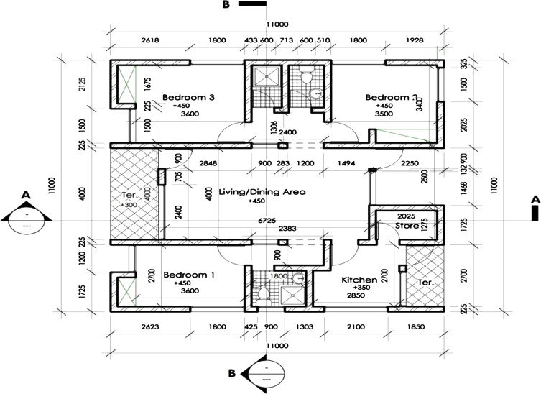

CHAPTER FIVE
5.1 CONCLUSION AND RECOMMENDATION
WORK CARRIED OUT
- Calculation of Land Charge which is the annual payment to the government for the occupation or uses of land by the property owner/user.
- 2. Preparation of Schedule of Right of Occupancy: I also take part in preparing schedule of R of O for printing which one of the major work of Approval section.
- Dipping of fills: dipping of file at Deed Record in to their respective set in the file rack, changing of spoilt file jacket and dispatching of file requested by other unit.
- Filing of payment receipts made by applicant into their respective files.
- preparation of schedule of assignment for printing at transaction section
- property inspection and valuation
5.2 SUMMARY OF ATTACHMENT ACTIVITIES
The bureau of land have the responsibilities on the following:
Issuance of Certificate on Land Statutory such as Right of Occupancy and Certificate of Occupancy.
Generation of Land charge bills for the use and Occupation of Land
As a student I was able to learn all the requirements and the stages of documentation before the issuance of such certificate and rate use in calculating the land charge for different purposes

