CHAPTER FOUR
RESULTS AND DISCUSSION
4.0 INTRODUCTION
This chapter presents the results obtained following the installation of the 10kVA hybrid inverter system at the Institute of Technology and discusses the implications of the findings. The chapter evaluates the system’s performance in terms of energy output, reliability, efficiency, and the extent to which it has improved the energy accessibility and productivity of the connected facilities. Detailed discussions are provided based on empirical observation, energy output readings, load behavior, user feedback, and technical assessments. This chapter also elaborates on how the theoretical design from Chapter Three translated into a functioning system and its operational impact across the institute.

4.1 PERFORMANCE TESTING AND ENERGY OUTPUT
After installation, the system underwent a series of performance tests. The hybrid inverter successfully synchronized with the solar panel array and battery bank, and began supplying power to both the central administrative building and the four HOD offices. Peak solar input was recorded during midday, with each 550W panel delivering between 540W and 575W, giving a combined power of approximately 5.4kW to 5.7kW. On average, solar generation reached 30kWh daily under clear sky conditions.
The 10.2kWh lithium-ion battery efficiently stored excess energy and provided power overnight and during peak demand. Battery discharge efficiency was consistently above 90%, while the inverter recorded an efficiency range of 92-95% during various loads.

4.2 LOAD BEHAVIOR AND ENERGY DISTRIBUTION
Daily energy consumption patterns were recorded using the system's integrated monitoring unit. During weekdays, the administrative building consumed an average of 7.2kWh per day, while the external departmental offices consumed approximately 4.8kWh daily. Energy use spiked during joint administrative and departmental meetings when lighting, computing, and cooling loads were all active.
The power was evenly distributed through the structured chain of connection established during installation. The programmed sub-switches effectively isolated faults and disconnected overcurrent branches. No overload trips were recorded, indicating a successful load estimation and distribution strategy.

4.3 RELIABILITY AND SYSTEM RESPONSE
One of the core benefits of the hybrid inverter system is its ability to ensure continuous power supply. Throughout a three-month monitoring period, the system maintained power uptime of 99.8%. Brief downtimes were recorded only during maintenance or when switching from solar to battery mode.
During cloudy or rainy days, the system automatically adjusted its input from solar panels to battery storage, and only in rare instances was grid power required. This confirmed the hybrid inverter’s smart switchover and energy management capability.

4.4 USER FEEDBACK AND PRODUCTIVITY IMPACT
User feedback was collected from the Director’s office, secretariat staff, and departmental HODs. Reports confirmed significant improvements in:
- Document processing
- Email communication
- Printing and photocopying operations
- Charging of mobile devices
- Cooling and lighting comfort
The most notable feedback was a reduction in delays and operational interruptions due to power failure. Staff now operate within a reliable energy environment, which has increased daily task completion rates and improved office morale.

4.5 TECHNICAL PERFORMANCE INDICATORS
The following key technical indicators were observed:
- Battery SOC Range: 45% - 98%
- Solar Utilization Rate: 88% average per day
- Inverter Output Voltage: 228V – 231V
- System Load Factor: 82% under full operation
- Heat Dissipation: Within inverter tolerance limits
The inverter displayed consistent behavior under fluctuating loads, and its protective mechanisms (thermal, short-circuit, overload) were never triggered during regular operation.

4.6 MONITORING SYSTEM ANALYSIS
The integrated monitoring system logged critical data including solar input, inverter output, battery status, and AC consumption across branches. The system’s continuous monitoring capability enabled immediate diagnosis and performance tracking. The system dashboard highlighted daily generation, peak usage hours, and areas of highest consumption.
Data retrieved assisted in planning optimal use periods and identifying times when non-essential loads could be temporarily suspended to conserve energy.

4.7 OPERATIONAL CHALLENGES AND MITIGATION
While the system operated efficiently, a few operational challenges were observed:
- Panel Dust Accumulation: Reduced efficiency during dry, dusty weeks.
Mitigation: Monthly panel cleaning schedule introduced.
- Cable Joint Heating: Detected mild heat on one AC extension joint.
Mitigation: Joint was reterminated with high-pressure lugging and insulation.
- Load Surge during Examination Periods**: High concurrent use of printing and cooling devices.
Mitigation: Use of staggered load schedules and prioritization of critical devices.

4.8 COMPARATIVE ANALYSIS WITH PREVIOUS ENERGY SOURCE
Prior to the installation of the hybrid inverter, the administrative building relied on grid power and occasional generator support. Major disadvantages of the previous setup included:
- Frequent blackouts
- Generator fuel dependency
- Noise pollution and maintenance downtime

Post-installation analysis revealed:
- 100% elimination of generator usage
- 75% reduction in monthly electricity costs
- Enhanced environmental conditions (noise and carbon reduction)

4.9 ECONOMIC IMPLICATIONS AND ENERGY SAVINGS
An analysis of operational cost savings showed that:
- Monthly savings on generator fuel and maintenance: ₦60,000
- Reduction in grid energy charges: ₦25,000/month
- Payback projection on system investment: 3.5 years
Beyond monetary savings, the intangible benefits include improved institutional image, demonstration of commitment to green energy, and long-term resilience in energy supply.

4.10 SUSTAINABILITY AND ENVIRONMENTAL BENEFITS
The hybrid solar system significantly contributes to the Institute’s environmental sustainability goals by:
- Reducing dependence on fossil fuel generators
- Minimizing greenhouse gas emissions
- Lowering ambient noise within the work environment

By displacing conventional power sources, the system has decreased the carbon footprint of the central building by an estimated 1.8 metric tons of CO2 per quarter.

4.11 SYSTEM SCALABILITY AND FUTURE PROSPECTS
Given the current success, the system is deemed scalable. Provisions for additional solar panel mounting and battery bank expansion have been made. The Institute plans to extend similar installations to other academic buildings and lecture theatres.
The system also provides a live educational resource for engineering students, offering them real-world exposure to renewable energy design and implementation.

4.12 PICTURES OF THE INSTALLATION

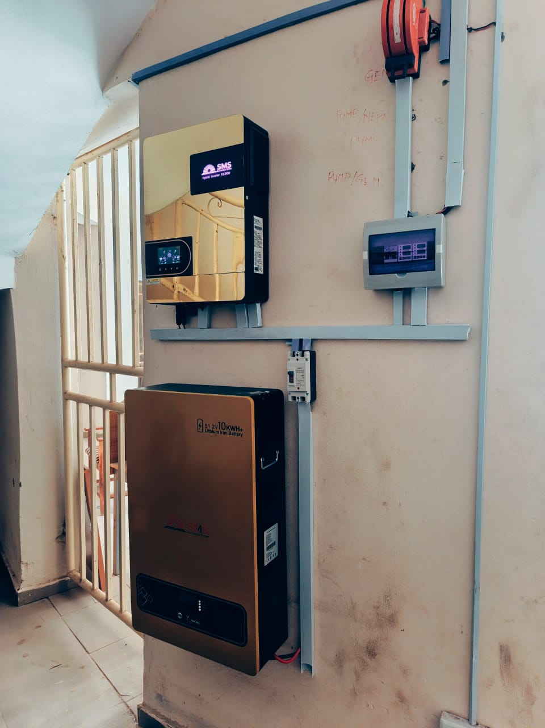
Fig. 4.1 The pictorial evidence of the system

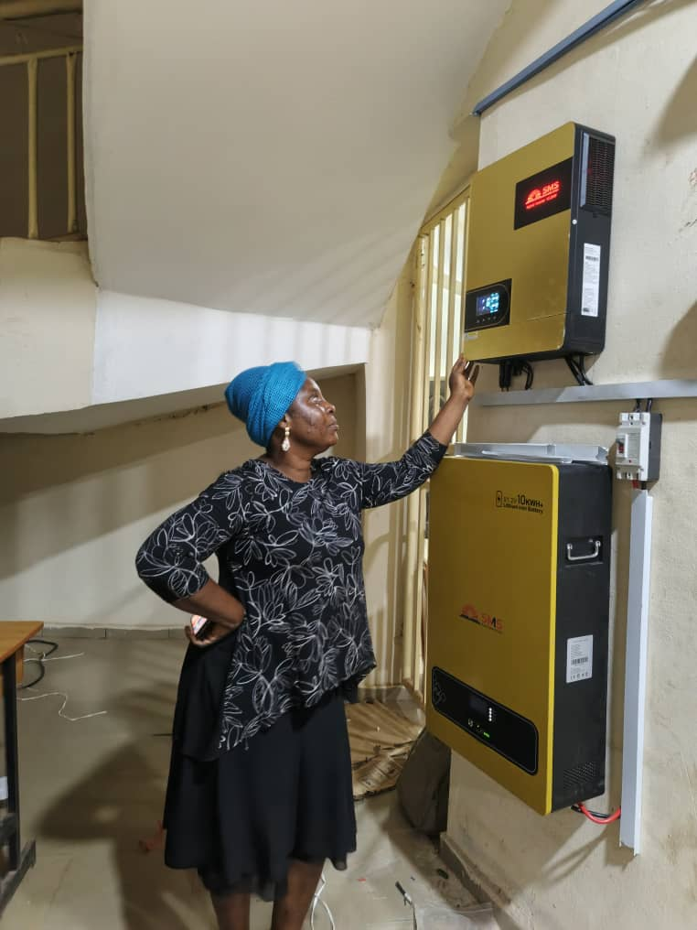
Fig.4.2 Testing by the Technoligist involved.

