

REPORT ON

STUDENT INDUSTRIAL WORK EXPERIENCE SCHEME (SIWES)

HELD AT

KWARA STATE LIBRARY COMPLEX, ILORIN
(Period of Attachment, August 2024 to November 2024) BY
OGUNBANWO OLUWATENIOLA ELIZABETH (ND/23/LIS/FT/0040)

SUBMITTED TO

DEPARTMENT OF LIBRARY AND INFORMATION SCIENCE INSTITUTE OF INFORMATION COMMUNICATION TECHNOLOGY KWARA STATE POLYTECHNIC, ILORIN

APRIL, 2025

TABLE OF CONTENTS

Title page | 1
Table of Content | 2
Report Overview | 3
Chapter 1  Introduction | 4
Background | 4
Objectives | 5
Chapter 2  Description of the Establishment | 6
Location and Brief History of the Establishment | 8
Organizational Structure | 10
The Various Departments at the Kwara State Library and their Function Library Advocacy  Chapter 3  Report on Actual Work Carried Out | 11  17 - 21
Experience Gained During the Training | 17 – 21
Library Advocacy | 21
Chapter 4  Equipment and Tools Used | 22 - 23
Chapter 5  Summary | 24
Conclusion | 24
Problems Encountered During the Programme | 25
Recommendations | 25
Reference | 26

REPORT OVERVIEW
This report presents the experience gained during my Student Industrial Work Experience Scheme (SIWES). SIWES is an industrial training program that assists students to gather practical experience in their various disciplines. It is designed to expose students to the industrial work place during their course of study. This report also contains information pertaining to where I carried out my training, the description of the establishment/institution of my attachment. It includes the location and brief history of the establishment, organizational structure, the various sections in the establishment and their functions. The report also contains some challenges I encountered during the period of my attachment and some recommendations that could help improve both the scheme and the organization.

CHAPTER ONE INTRODUCTION
Library and Information Science as a course of study is a professional one. It is essential that library and information science practitioners possess the needed training skill to function effectively in its practical environment—Libraries and Information centers. Training is an activity of impacting and acquiring skills in a particular field of study to enable one fit in to such field and carry out one’s duty effectively and efficiently. In view of this, my training was carried out in Kwara State Library Complex Ilorin. It is a public library where I was able to put to use all theoretical knowledge impacted in the lecture room. The Student Industrial Work Experience Scheme (SIWES) prepares students for the outside world and I got a barrage of experience in a library that gave me a preamble of what the labour market looks like.

BACKGROUND OF THE REPORT

Students Industrial Work Experience Scheme (SIWES) is a mandatory skill acquisition and training programme. It is designed to expose students to the industrial work place in their respective disciplines during their course of study. The unit was initiated by the Industrial Training Fund (ITF) in 1973 so as to complement the theoretical knowledge acquired in higher institutions with practical experience. It provides advisory guidance to participating students on career employment opportunities. Students are also expected to develop occupational competencies that would facilitate their fitting in the world of work after graduation. The minimum duration for the SIWES should normally be 24 weeks except for engineering and technology program where the minimum duration is 40 weeks; the scheme is a tripartite program, involving the students, the universities and the industry employers of labour. Growing public demand and legislative expectation for accountability in the past two decades have made it imperative that higher education administration and researchers pay attention to the potential impact of students’ work programs on skill development, which in turn, impacts development directly on national development objectives.
The student industrial work experience scheme (SIWES) is a planned and supervised training intervention based on stated and specific learning and career objectives and geared towards developing the occupational competencies of the participants; this work experience program gives students the opportunity to be part of an actual work situation outside the classroom. The Scheme has four supervising agencies as follows: The industrial training fund, the coordinating agency (NUC), the employer of labour and the institution.

OBJECTIVES

The objectives of the Students Industrial Work Experience Scheme are to:

    - Provide avenue for students to acquire industrial skills and experience during their course of study.
    - Prepare students for the industrial work situation they are likely to meet after graduation.
    - Expose students to work methods and techniques in handling equipment and machinery that may not be available in schools.
    - Provide students with the opportunities to apply their educational knowledge in real work situations, hereby bridging the gap between university work and actual practice.
    - Make the transition from schooling to working easier through enhancing students contact for later job placement.

CHAPTER TWO DESCRIPTION OF THE ESTABLISHMENT

2.0. Location of Collections, Divisions, Sections and Offices
Kwara State library is a magnificent two story building. It houses some volumes of books, newspapers, pamphlets, journals, reports and government document. It can accommodate 1,000 to 1,500 users at a time. It has study carrels, halls and offices.

UNDER GROUND FLOOR

UNDER GROUND
Archival Unit
Store
Bindery Unit
Offices for Business
Rest Rooms

GROUND FLOOR

LEFT WING | RIGHT WING
Porters Desk
Business Offices (Photocopy Repair and maintenance ) | Disability Unit and Stair case
Business Offices | Business Offices (Coaching Class & Photocopy )
Children Reading Area | Head of Reader Service Office
Children Librarian Office | Library Registration Point
Wash Rooms (Gents, Ladies) | Reading Area
Stair case

1st FLOOR

LEFT WING | RIGHT WING
Serial and Government Publication Unit | Science Technology (Reading Hall)
Reference Reading Hall | Office of the Head of Science and Tech
Reserve Section | Wash Rooms (Gents, Ladies)
Reference Librarian Office | Acquisition Work Room
Deputy Director Office | Head of Technical Department Office
Wash Rooms (Gents, Ladies) | Cataloguing Work Room
Stair Cases | Classification Unit (Office)
 | Acquisition Unit (Office)
 | Automation Unit
 | Study Carrels

2nd FLOOR
LEFT WING | RIGHT WING
Office | Event Hall
E-Library Unit | Maintenance Unit Office
Director’s Office | Accountant Office
Administrative Office | Store Officer’s Office
Stair Cases | Offices
 | Training Hall
 | Wash Rooms (Gents, Ladies)

Location and Brief History of the Establishment

The state library is located at House 3, Sulu Gambari Road, P.M.B. 1561, Ilorin, Kwara State, Nigeria. Kwara state library commenced service to the public on 1st April 1968, with the growth in status of the new state in term of increase in population and economic development, it was obvious that the old site was no longer suitable for the provision of services due to its closeness to the central market. A major landmark was recorded in Kwara state in November 1987 when the then military Governor of the state, Lt. Col. Ahmed Abdullahi laid the foundation stone of a modern multipurpose library situated at its present’s location and the library was officially commissioned by then military president, General Ibrarhim Babangida, on November 21, 1990 (Moses, 2013). Regrettably, due to poor funding the library suffered a major set-back as the structure became dilapidated with outdated and irrelevant information resources, it remains in this sorry state until the administration of Dr. Bukola Saraki who paid a working visit to the library and pledge to give it a face lift and upgrade it to world class standard library, the transformed library building was commissioned and put back to use on 1st July 2006 (Kwara State Library Handbook, 2018).
Again in 2020, Governor AbdulRaman Abdulrasak paid a working visit to the library. Having seen the state of the library first hand, he promised to renovate the library and ensure there is stable power supply in the library. Few weeks later, the governor budget the sum of one hundred million and consequently released for work to commence in the library. He also ensures money was released to buy new books and other equipment for the library. As at today, the library is now enjoying 24 hours’ power supply through grid and solar. According to Moses (2013), the primary purpose of Kwara State Public Library involves the provision of resources and services in a variety of ways in order to; create informal education opportunities for the citizens in the immediate community, provides avenues to meet the information needs of the people, support the education, civil and cultural activities of groups and organization, provide

recreational opportunities and encourage constructive use of leisure time, enrich the knowledge of individual in various subjects.
The Kwara State Library has many staffs this includes professionals and non- professionals, with a Director and a Deputy Director as the head of the institution. The Professional staffs head each units of the library while the non-professional staffs assist the professionals in discharging their duties. Like every other public library in the country, the Kwara State library makes adequately provision of information materials for its users as well as provides conducive environment. Every user of the library must have the library identity card which he or she must present at the security desk before he or she is allowed in and the same way, show the card to the library unit attendant of any unit the user is visiting, this practice helps in monitoring the library users. Being a public library, the library is majorly funded by the State Government and little with internal generated revenue through the lease of offices, multi-purpose hall used for seminars, conferences and meetings and training, registration of users, payment charged for making use of the toilet. The Library gets its books through gift and donation, legal deposit, international books Aid for example Aids for British Colonized Countries and purchasing.

  - Organizational structure

ORGANOGRAM OF KWARA STATE LIBRARY

BOARD CHAIRMAN
& MEMBER

DIRECTOR

TECHNICAL
DEPARTMENT
ADMINISTRATIVE
DEPARTMENT
READER SERVICE DEPARTMENT

ACQUISITION
SECTION
CATALOGUING
SECTION

CIRCULATION
SECTION

CHILDREN
SECTION

CLASIIFICATION SECTION
AUTOMATION SECTION
HUMANITY SECTION
SCIENCE & TECHNOLOGY SECTION

b

E-LIBRARY
SECTION
SERIAL & GOVERNMENT PUBLICATIONS

SECRETARY& ACCOUNTANT UNIT
REFERENCE & RESERVE SECTION

BINDERY SECTION

SECURITY & MAINTENANCE UNIT

SPECIAL PEOPLE SECTION

The various departments and their functions
The Kwara State Library has three (3) major departments which are subdivided into sections. These major departments are:
    - Administrative department
    - The Technical department
    - The Readers department

Administrative Service Department
This department is in charge of posting, deployment, staff nominal roll, manpower statistics and hall leasing etc. The offices under this department are:
Finance Department: They are in charge of expenditure and capital budget, cash book, hall rent, registration fee, leasing of office and bank reconciliation statement, etc.
Store: Keeping of library properties
Maintenance: In charge maintaining and repairing of electrical appliances and usable items in the library. Cleaning and cutting the grasses around the library
Security: See to the day to day safe keeping of library property and environment

Technical Department:
The technical department carries the following functions
  - The technical department collect letters that come to the library e.g. the SIWES students submit their SIWES letter at the admin department.
  - They are also responsibly to collect and maintain staff files.
  - They give necessary notice to all staffs.
  - They are in-charge of staff welfare
  - They take disciplinary action on staff
  - They are in charge of library treasury
out all technical processes in the library. The technical processes are collation, stamping, accessioning, cataloguing and classification, spine labeling, fixing of book pockets and book cards. This section processes all new books and journals in the library. The technical department comprises of the following sections:
- Acquisition section
- Classification section
- Cataloguing section
- Automation section

- Serial and government publication section

Acquisition section:

This section is basically responsible for the acquisition of all library materials. The acquisition section also receives books gifts and donations from organizations, philanthropists and prominent individuals. This section maintains a registrar called accession register, this register is used for keeping information of the books such as date, the accession number, author’s name, title, publication, year of publication, cost, source and no of copies.
Acquisition section assign accession number to new materials and also apply the appropriate stamp on books examples of stamps in the section are; ownership stamp, legal deposit stamp, donation stamp and the accession stamp. The section there after forwards the materials to classification section for assigning of class number.

Functions of Acquisition section
  - They serve as gateway of collection of materials into the library.
  - They make proper ordering of both printed and non-printed materials.

Classification section:
Classification is a systematic process of arranging library material according to the subject, discipline, likeness in order to aid easy retrieval and use of a particular information resource. The Kwara state library uses Sear’s List of Subject Heading and Dewey Decimal Classification (DDC) scheme, edition 22 and 23, as a guide to arrange all library materials being a Public Library. The major function of the section is to determine the subject and apply classification number to new materials after receiving them from the acquisition section and then sent them to cataloguing section for cataloguing and inventory.

Functions of Classification section
- The section gives subject(s) to materials.
- The section assigns class number to information resources.
- The section organized and manages all library resources.
- The section receives students who came for enquiries
- The section coordinates SIWES students from various institutions.

Cataloguing section
Cataloguing is the process of describing content of a document on a catalogue card using the author, subject and title as an entry for easy retrieval and use. The cataloguing section carries out the cataloguing of new books that is being brought from the classification section. The section is guided and abides by AACR (Anglo American Cataloguing Rules).

Functions of cataloguing section
- The section helps in describing the physical content of a book.
- The section helps in sorting out and organizing library materials for easy storage and retrieval.
- The section makes sure the materials are properly arranged.
- The section takes inventory of all library materials.

Automation section
Automation is the process of making print information resources available in electronic form. The automation section is charged with the responsibility of keeping all the library records and making it accessible on the computer, it also serves as back up for the manual way of keeping the library data. Automation section also keeps records of all the items owned by the library and the number of copies that is available at any section of the library.

Functions of Automation section
- The section helps in creating repositories for the library.
- The section subscribed for databases and make available for users.
- The section uses a computer to describe the contents of a book

Serial and government publication section:
The serial and government publication section is responsible for keeping new materials that come at regular interval. It could be daily, weekly, monthly, bi-monthly, quarterly and yearly. Serial materials include newspapers, journals or periodical, government annual reports, newsletters, gazette just to mention a few. This section catalogues and classifies serial materials to make them available to library users.

Activities of Serial Section
  - Sorting and arrangement of journals
  - Accessioning of journals
  - Serials display new journals to avail our clientele latest journal.

  - Records serial materials acquired by the library.
  - Stamps and catalogue serial for identification purpose.
  - Put serials on the shelves based on their discipline for easy retrieval by library user.
  - Keeps statistics of serial use.
  - Shelving and shelf reading
  - Guiding users/answering reference queries
  - Indexing: that is extracting key information from newspapers.

Readers Services Department
This department offers direct services to library users. It comprises of the following sections that perform specific functions.

Circulation Section (Humanity and Science & Technology Units)

This is more or less the public relation section of the library. It is at the circulation section that the library users register to become a bona fide member of the library. The section is also an avenue for users to borrow books. It is a section where library users have a close contact with the library materials and staff.

Activities at the Circulation Section
  - Registration of users.
  - Charging and discharging of materials to users.(within the library)
  - Shelving of all information materials used every morning.
  - Daily shelve reading.
  - Taking daily statistics of users.
  - Taking daily statistics of books consulted.
  - Taking statistics of registered members.
  - Periodic weeding of library collections for minor repairs.
  - Checking library tickets/expired tickets
  - Registration renewal

Reference Section

This section handles both directional and non-directional queries from users and directs them to sources from where information can be obtained. It houses the reference materials which can only be consulted in the library. They also perform referral services.

Activities at the Reference Section
  - Shelving and shelf reading reference materials.
  - Handling of reserve materials.
  - Taking statistics of users and consulted materials.
  - Answering user’s queries.
  - Referral services
  - Recording Issuance of referral letter to library patrons
  - User education: educating users on how to make use of library and its resources.

Children Section

This section is for children between the age range of 3 and 15.It contains different kinds of books that children can benefit from. The classification scheme used is different from the Dewey Decimal Classification.

Activities in Children Section
- Shelving and shelf reading.
- Reading to the children.
- Attending to the children’s information need and answering their queries.
- Educating the children on library use.
- Giving the children a tour of the library.
- Weeding out materials for minor repairs.
- Taking daily statistics of children and books consulted.
- Telling the kids about the Dos and DON’Ts of the library.

CHAPTER THREE
WORK ACTUALLY CARRIED OUT AND EXPERIENCE GAINED

Actual Work Done and Experience Gained
At the Kwara State Library I was introduced to different departments and sections available in the library. I was posted to various sections where I was taught the practical work done there and how to perform my duties efficiently and effectively.

Technical Service Department:

    - Acquisition section: at the acquisition section,

I got to know about different stamp such as (ownership stamp, accession stamp, reserve stamp, reference stamp, and donation stamp).
I gave accession number to newly acquired information materials

I filled accession register with the bibliographic details of information resources such as – accession number; year of publication; author’s name; ISBN; cost; publisher; date of purchase; and so on.
    - Cataloguing Section: at the cataloguing section

I filled catalogue worksheet with the bibliographic details of books such as - name of author, title, name of publisher, place of publication, year of publication, pagination, ISBN (International Standard Book Number) or the ISSN (International Standard Serial Number).
I did manual catalogue by transferring the bibliographic details above on a 3/5cm card catalogue I was also taught how to catalogue and classify materials that are published in volumes and materials that are accompanied with CD-ROM.
I was shown cataloguing rules in the AACRII (Anglo American Cataloguing Rules)

    - Classification Section: at the classification section

I learnt how to determine the subject heading of materials that have been catalogued by going through the introduction; preface and authors’ note if any, at the end of the information materials. This is intelligent guess.
I learnt how to confirm the subject determined above using Sears’ List of Subject Heading Scheme and possibly alternative if the subject determined above is not an acceptable one.
I learnt how to check classification number from Dewey Decimal Classification (DDC) Scheme. DDC divided knowledge into ten (10) thus:
000 | General Work, Information and Computer Science
100 | Philosophy and Psychology
200 | Religion
300 | Social Science
400 | Language
500 | Science
600 | Applied Science/Technology
700 | Art/Recreation
800 | Literature
900 | History and Geography

I assigned classification number to the new books under the supervision of classifier.

    - Serial and government publication section: at serial section

I was made to understand that serials are published in electronic or manual format and there are also local and foreign journals.
Serials are arranged on shelf based on their disciplines.

I was also taught the various methods of acquiring serial materials which are through Donations, Gifts and Purchase.
I did newspapers indexing.

I took daily statistics of serial materials consulted

Experience Gained in Technical Service Department

- I learned how accession numbers are given to newly acquired materials.

- I know why library has different stamps and when and where to apply it on a books.
- I can now paste properly the book pocket, book card and date due slip on a book.
- I became familiar with AACR II (Cataloguing Rules).

- I can now conveniently classify books using DDC Scheme (Dewey Decimal Classification Scheme).
- I became familiar with and Sears’ List of Subject Heading and how to use it determine subject of a given book title.
- I became familiar with filling system of catalogue cards.

- I processed dailies (newspapers)

- I can now do indexing and abstracting by extracting key information from the newspapers.
    - Automation Section: at the automation and e-library section;

This is a physical site that provides online access to digitized audio, video and written material. The section makes available internet facilities to users to have access to information. I learned about automation system of the library i.e. carrying out manual activities with the computer system. I learned about the online cataloguing software such as Koha and XLIB and so on. I was taught on how to search information online for valuable information and also the various databases that are used in the electronic library such as EBSCO HOST, AGORA, JSTOR etc.

Experience Garnered at the E-Library

      - Ability to search online for a require information resources.

      - Knowledge on how to become a versatile librarian.
      - Ability to access information faster using Boolean operators such as AND, OR, NOT etc.
      - I learned how to digitize library materials
      - The automation section helps in creating repositories for the library.
      - I learnt digitization library print materials in order to make it available in electronic formats.

Reader Service Department

    - Circulation Section:
The circulation section of the Kwara State Library is sub-divided into two section namely – Humanity section and Science/Technology Section. Humanity section houses materials on class 000 to 900 of the Dewey Decimal Classification (DDC), exempt class 500 and 600. This implies that all discipline related to humanity are found in this section. Science and Tech. as fondly called at the state library, houses disciplines on sciences and technologies thus gave it its name. That is, class 500 and 600 of the DDC.
I did daily shelving and shelf reading.

At the circulation section, I learnt weekly self-tiding; I learnt how to perform the duty of charging and dis-charging of information materials. I learnt how to take statistics of users every two hours and I also learnt how to take statistics of book consulted.

3.2.2. Reference Section
This section houses reference materials of the library which are only meant for consultation and not to be borrowed or read from cover to cover. Reference materials are encyclopedia, dictionaries, biographies, directories, yearbooks, map/atlas, gazetteers, abstract,

index, gazette etc. I shelved reference materials. At the State Library, this is the only section where users are allowed to bring in their Personal Computer (PC) and any users with PC must duly register it with the library staff at the section.

Experience Gained in Reader Service Department
- Perfect in daily shelving and shelf-reading.

- Learned how to register new library users and renew registration.

- I now know all processes involved in charging and discharging of materials.

- Keeping records of daily statistics in the library.
- I can now attend to users to their utmost satisfaction.

- Ability to help put information materials on reserve.

- Ability to identify reference materials from other library collections.

- Ability to shelve reference materials.

- Acquired skills used in interacting with library users.

- I learnt how to render referral services

- I learnt how to answers user queries

3.2.3. Children Section

This section deals with children between the ages of 3 to 15. The information needs of the kids are satisfied here and various programmes aimed at benefitting them are carried out in this section. I learned how to classify the children’s materials. I also learned how to relate better with the children in order to have their cooperation. The experience I garnered in this section changed my perspective about kids completely.

Experience Gained in Children Section

- I learned to control my anger and be more patient with the children.
- I learned about the different classification schemes for children’s collections

- I was taught how to answer the children’s queries.

- I learned how to select stories to be read to the kids.

LIBRARY ADVOCACY AT BISHOP SMITH MEMORIAL COLLEGE, ILORIN
Library Advocacy is a programme of Kwara State Library to target the young citizen in order to develop their reading habit at a tender age. For this assignment, we were divided into group to visit secondary school of our choice within the state. My group visited Bishop Smith Memorial College, Ilorin.
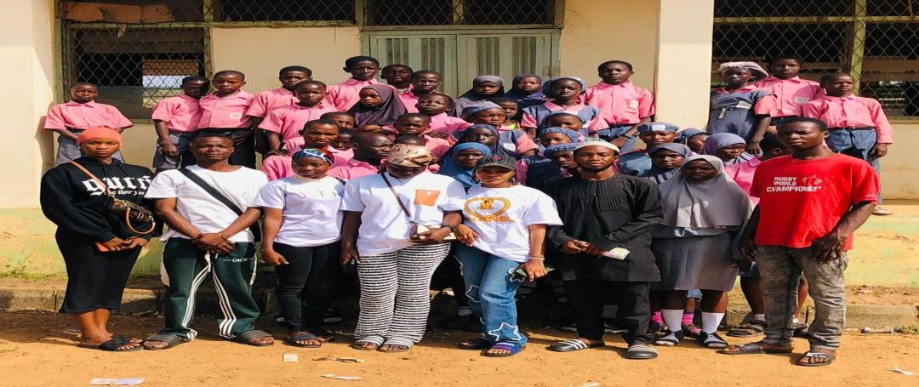

Students of Bishop Smith Memorial College, Ilorin, with Library Advocators

CHAPTER FOUR

EQUIPMENT AND TOOLS USED
4.0. Introduction
This chapter outline the equipment used, their function and detailed description of their usage at the Kwara state library complex; Ilorin

THE EQUIPMENT USED AND THEIR FUNCTION
The equipment used in Kwara State library are not much but the few that is use in some department or section is listed below.
- Biro and book: A biro and book (high note) is use in all the sections - humanity, Reference, science and technology section. This is being use to take statistics of reader and book consulted.
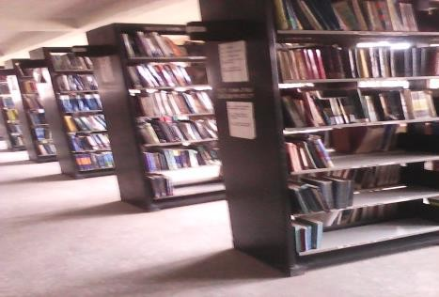
- Shelves: This is one of the equipment used in any library. It is in a flat form made with wood or metal which is fixed horizontally for storing or displaying library collections such as books, journals, magazine, and newspapers.
- Stamp and stamp pad: Stamp and stamp pad is use in acquisition unit for stamping material for identification, there are different type of stamp use in Kwara state library such as ownership stamp, accessing stamp, donation stamp, reference stamp, legal deposit stamp.
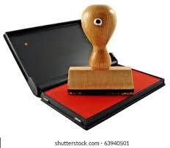

- Computers and Printer: Adoption of I.T is use in the automation unit, the usage computer is a new method use in discharging duty to user and a way of preserving information why printer is a machine use in producing a book, and it is a process involving the transfer of words or pictures to paper.
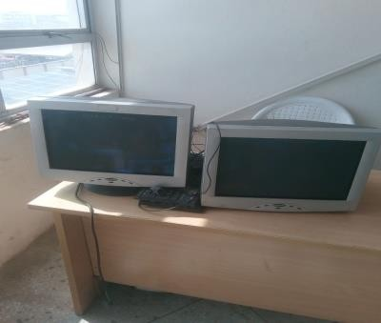

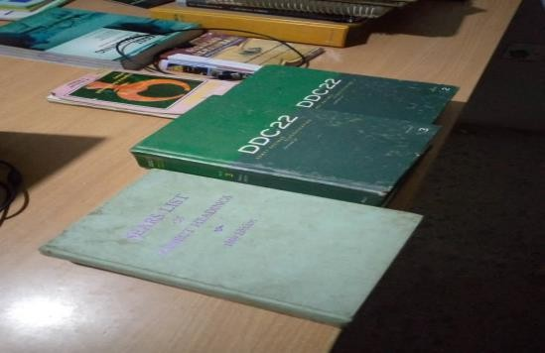
Classification Scheme (Dewey Decimal Classification Scheme DDC and Sears’ List of Subject Heading): They are used to determine the subject of a material in order to place it in its rightful place or class or group on the shelf.

Books End: A bookend is an object which is designed as book support; this is in order to ensure an upright row of books. It is placed on ei6ther end to prevent books for falling over such as in in a half filled bookshelf. In other words, they are flat iron metals that are used in holding the books from falling off.
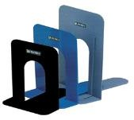

CHAPTER FIVE
SUMMARY, CONCLUSIONS AND RECOMMENDATIONS

Summary
This report contains information pertaining to Kwara State Library where I carried out my training, the description and location of the library. This report presents the experience I gained at the various section of the Kwara State Library. The report also contains some challenges I encountered at the State Library and some recommendations that could help improve the programme and the organization.

Conclusion

The six months Industrial Work Experience has really helped me to achieve what I could not get in the four walls of classroom. It really changes my negative perception on librarianship. It gave me the opportunity to practice my profession in its real sense in terms of library automation, electronic library, cataloguing and classification, how to charge and discharge materials, how to acquire new materials.

Problems Encountered During the Programme
Some of the problems I encountered during my training are:
    - Inadequate information resources
    - Attitude of staff to work is very poor and affect our training.
    - Information materials on the shelves are too dusty hereby causing cough and catarrh.
    - The library is short of janitors, thereby putting library materials and equipment in a mess state.
    - Transportation problem:

Recommendation

With regards to the experience that I have acquired during this training, I recommend
that:

- The library management should look beyond government by approaching philanthropists, non-governmental organization and international organization for information resources.
- Library management should ensure there is regular training and retraining of staff and strict measure should be taken on none adherent staff.
- Management should ensure that staff are doing shelf-tiding regularly instead of waiting for the SIWES students.
- Proper monitoring of the student by the SIWES body and Institution concerned
- Special reward for hardworking, obedient and dedicated students

REFERENCE
Industrial Training Fund (2013). Students Industrial Work Experience Scheme in Human Resource Development in Nigeria. Jos: Industrial Training Fund handbook. Retrieved from: www.unirazak.edu.my/pintar/fit/docs/pt-handbook.doc.
Moses, E.A. (2011). Network of Rural Librarians in Nigeria Dissemination of Information: A necessity for National Development. Presented at the 2011, AGM/Conference of the Kwara State Chapter of N.L.A. Held at the Federal Polytechnic, Offa.
Osinem, E.C. and Nwoji, U.C. (2010). Students Industrial Work Experience in Nigeria: Concepts, principles and practice. Enugu: Cheston Agency Limited.
Okpo, S. and Hassan, D. (2012). Constraints to students’ effectiveness in practical skills acquisition in technical colleges in Kogi State, Nigeria. International Journal of Innovative Scientific and Engineering Technologies Research 6(1):1-9.

