

KWARA STATE POLYTECHNIC
P.M.B 1375, ILORIN NIGERIA
www.kwarapoly.edu.ng

A TECHNICAL REPORT OF STUDENTS’ INDUSTRIAL WORK EXPERIENCE SCHEME (SIWES) REPORT

HELD AT:

IBIDOWO ELECTRICAL ENTERPRISES
(No 12, Kilanko Offa Garage, Opposite Corner Stone Block Industry, Ilorin Kwara State)

PREPARED BY:
ADEYEYE JOSHUA OMOTAYO ND/23/MCT/FT/0065

SUBMITTED TO:
DEPARTMENT OF MECHATRONIC ENGINEERING,
INSTITUTE OF TECHNOLOGY,
KWARA STATE POLYTECHNIC, ILORIN.

IN PARTIAL FULFILLMENT OF THE REQUIREMENT FOR THE AWARD OF NATIONAL DIPLOMA (ND).

FROM:
AUGUST--DECEMBER, 2024
PREFACE
This contain a written report of the work done by me during the four-month industrial attachment with one of the best Organization in Ilorin, which is Ibidowo Electrical Enterprises.
This work goes further to share the experience I had in the station.
This summarize all the things I learnt and the problems encountered by me, my recommendation and conclusion of all my work.

DEDICATION
This work is foremost dedicated to Almighty Allah for His unquenchable love and gift of life during the pleasant course of my SIWES program, and my Parent Mr. and Mrs. Adeyeye and my beloved brother and sisters for their amble financial support and unseasonal advice toward my academic pursuit.

ACKNOWLEDGEMENTS
With an immense gratitude, I want to acknowledge the Almighty Allah (most superior) for His continuous love, grace and faithfulness, and his providence throughout the period of my SIWES programme. I want to acknowledge the effectual effort of my beloved parents Mr. and Mrs. Adeyeye.
I also acknowledge all the staffs of Ibidowo Electrical Enterprises (Organization Supervisor) alongside for their cordial tutorship of all I need to know about the administration.
I say thank you to you all for the opportunity and privilege granted to me to serve under your amicable organization.
Finally, this report will be incomplete if I failed to acknowledge my academic supervisor for their precious effort.

TABLE OF CONTENT
Title Page
Dedication
Acknowledgement
Table of Content
CHAPTER ONE
1.1 Introduction to Student Work Experience Scheme
1.2 Aims and Objectives of Siwes
1.3 Participants in Siwes
CHAPTER TWO
2.1 Brief History of Ibidowo Electrical Enterprises
2.2 Operations Carried Out By Ibidowo Electrical Enterprises
2.3 Vision
2.4 Staff Profile and Strength
2.5 Sections at Ibidowo Electrical Enterprises
2.6 Objectives of Electrical Department
2.7 Organization Chart
CHAPTER THREE
3.1 Work Done and Experience Gained

CHAPTER FOUR
4.0 Conclusion, Recommendations, Summary
4.1 Conclusion
4.2 Recommendations
4.3 Summary for Students
References
CHAPTER ONE
  - INTRODUCTION TO STUDENT WORK EXPERIENCE SCHEME
In the earlier stage of science and technology education in Nigeria, students were graduating from their respective institutions without any technical knowledge or working experience. It was in view of this that students undergoing science and technology related courses were mandated, for students in different institution in view of widening their horizons so as to enable them have the technical knowledge and working experience before graduating from their various institutions. It is in this vein that the Students‟ Industrial Work Experience Scheme (SIWES) was initiated.
The student industrial work experience scheme (S.I.W.E.S) is a program designed and coordinated by the Industrial Training Fund (ITF), a Federal government establishment in conjunction with institution of higher learning in Nigeria.
SIWES was established by ITF in 1973 to solve the problem of inadequate practical skills preparatory for employment in industries by Nigerian graduates of tertiary institutions.
The aim of the program is to expose student to practical aspects of their various fields of discipline and the industrial work situation they are likely to encounter in pursuit of their careers during this period.
Students come across new equipment different from the ones they are familiar with, they also get accustom with new techniques of handling the equipment which enable them to apply the various theoretical class works to the practical aspect of the job in order to enhance the understand of their discipline.
The Scheme exposes students to industry based skills necessary for a smooth transition from the classroom to the world of work. It affords students of tertiary institutions the opportunity of being familiarized and exposed to the needed experience in handling machinery and equipment which are usually not available in the educational institutions.
Participation in Industrial Training is a well-known educational strategy. Classroom studies are integrated with learning through hands-on work experiences in a field related to the student‟s academic major and career goals. Successful internships foster an experiential learning process that not only promotes career preparation but provides opportunities for learners to develop skills necessary to become leaders in their chosen professions.
One of the primary goals of the SIWES is to help students integrate leadership development into the experiential learning process. Students are expected to learn and develop basic non-profit leadership skills through a mentoring relationship with innovative non-profit leaders.
By integrating leadership development activities into the Industrial Training experience, they hope to encourage students to actively engage in non-profit management as a professional career objective. However, the effectiveness of the SIWES experience will have varying outcomes based upon the individual students, the work assignment, and the supervisor/mentor requirements. It is vital that each internship position description includes specific, written learning objectives to ensure leadership skill development is incorporated.
Participation in SIWES has become a necessary pre-condition for the award of Diploma and Degree certificates in specific disciplines in most institutions of higher learning in the country, in accordance with the education policy of government. There operations include the ITF, the coordinating agencies (NUC, NCCE, and NBTE), employers of labour and the institutions. They are funded by the Federal Government of Nigeria
Beneficiaries - Undergraduate students of the following: Agriculture, Engineering, Technology, Environmental, Science, Education, Medical Science and Pure and Applied Sciences.
Duration - Four months for Polytechnics and Colleges of Education, and Six months for the Universities.
The second semester, fourth year of the undergraduate degree in the Nigeria University of Technology is used for this industrial training program which is a period of six months. During this period, I was attached to the Ibidowo Electrical Enterprises.

AIMS AND OBJECTIVES OF SIWES
The key objectives of the scheme include:
    - To make the labour force more vibrant and simultaneously making the economic sector more buoyant.
    - To prepare students to be accustomed to work and other administrative assignments, and also, to cultivate the spirit of punctuality when employed in the future.
    - To assess the interest of the student and the suitability for the occupation he/she has chosen.
    - To provide students with an opportunity to apply his/her knowledge in real work situation thereby bridging the gap between academic work and actual set up.
    - To expose the student to work methods not taught in the institution and to provide access to production equipment.
    - To ease transition from school to the work environment and make work easier and also to enhance students contact for later job placement.
    - To enlist and strengthen employer involvement in institutional activities and in the entire educational process of preparing the student for employment in the industry.
    - To provide the students with an opportunity to apply his/her theoretical knowledge in normal work situation thereby bridging the gap between class-work and actual practice.
    - To make the transition from school to the labour market easier for the student.
    - To enhance the assessment to students‟ interest and suitability in their various courses of study.
    - To strengthen employers‟ involvement in institutional activities and in the entire education process of preparing the students for industrial employment.
    - To enlighten students on the pit falls to avoid in the business world as well as to maximize profit in their various industrial and commercial settings.

PARTICIPANTS IN SIWES
The major participants in the SIWES are below listed.
    - The Federal Government
    - The Industrial Training Fund
    - The Coordinating Agency (NUC)
    - The Institutions (Universities)
    - The Students
    - The Employers

CHAPTER TWO
  - BRIEF HISTORY OF IBIDOWO ELECTRICAL ENTERPRISES
Ibidowo Electrical Enterprises is a private body responsible for the development, management, and regulation of electrical and electronics resources in the state. Established as part of the consumer commitment to enhancing electrical and electronics provision and accessibility, this has evolved from earlier frameworks focused primarily on energy supply, electrical and electronic resources to a comprehensive entity overseeing various energy sectors, including renewable energy, electricity distribution, and energy conservation.
Initially, the organization was part of a broader private framework, tasked with handling energy-related projects and policies at a rudimentary level. Over time, it transformed into a dedicated organization, expanding its functions to include strategic planning, policy formulation, and the implementation of sustainable energy practices.
In line with its mission to ensure reliable energy supply and promote renewable energy initiatives, the Ibidowo Electrical Enterprises has entrusted the organization with crucial roles aimed at improving infrastructure and enhancing the quality of life for citizens.
SIWES COORDINATOR: MR. JOLAYEMI MATHEW OLAITAN

OPERATIONS CARRIED OUT BY IBIDOWO ELECTRICAL ENTERPRISES
The operational departments under the organization include:
- Electricity Regulation: Overseeing the distribution and management of electricity supply within the state.
- Renewable Energy Development: Promoting the use of alternative energy sources to support sustainable development goals.
- Energy Conservation Unit: Focusing on initiatives that encourage energy efficiency and conservation among households and businesses.

VISION AND MISSION
VISION STATEMENT
- To be a leading governmental body in the promotion and implementation of sustainable, accessible, and efficient energy solutions that drive socio-economic development and industrial growth throughout Kwara State.
- To position Kwara State as a regional model for clean and renewable energy innovation.
- To ensure every household, business, and industry in Kwara State has access to reliable, safe, and affordable energy.
- To reduce dependence on fossil fuels by integrating renewable energy technologies such as solar, wind, and biomass into the state’s energy mix.
- To foster public-private partnerships that enhance the state’s energy infrastructure and create job opportunities for the youth.
- To build a digitally intelligent energy management system for real-time monitoring and smart distribution.
- To lead the fight against energy poverty and climate change at the state level.

MISSION STATEMENT

To formulate, implement, and monitor strategic energy policies and programs that guarantee sustainable power supply, promote renewable energy usage, ensure regulatory compliance, and support socio-economic transformation across all sectors in Kwara State.

To expand rural electrification and off-grid energy access through solar mini-grids and hybrid systems.

To collaborate with national and international energy agencies to attract investment and technical expertise into the energy sector.

To ensure regular maintenance and upgrading of the state’s power infrastructure to minimize energy losses and downtime.

To support local capacity-building initiatives that train technicians, engineers, and entrepreneurs in the energy space.

To enforce safety standards, environmental protection protocols, and efficient energy use across all energy projects.

To promote energy literacy and community awareness through campaigns, workshops, and school outreach programs.

STAFF PROFILE AND STRENGTH
The organization comprises a minimum of 200 staffs rendering different level of services. There are at least 150 professionals that assist Ibidowo Electrical Enterprises on policy matters, designing and consultancy, and also special services. The professional staffs include Electrical Engineers, Civil Engineers, Mechanical Engineers, Architects, Accountants and many more.
The presence of these experts has increased the workforce and increased the efficiency of major projects carried out by Lagos state government.
Other category of staffs include: craftsman, Technicians, workshop supervisor.

SECTIONS AT IBIDOWO ELECTRICAL ENTERPRISES
    - Finance and administrative Department
    - Human resources Department
    - Technical services Department
    - Mechanical and Electrical Engineering Department
    - ICT Department
    - Procurement Department
    - Audit Department

OBJECTIVES OF ELECTRICAL DEPARTMENT
    - Troubleshooting of electrical faults within and outside the secretariat
    - Installation of electrical fittings
    - Repair of electronics appliances owned by staffs
    - Maintenance of electrical equipment’s
    - Maintenance of Substations and generators
    - Design of electrical drawings

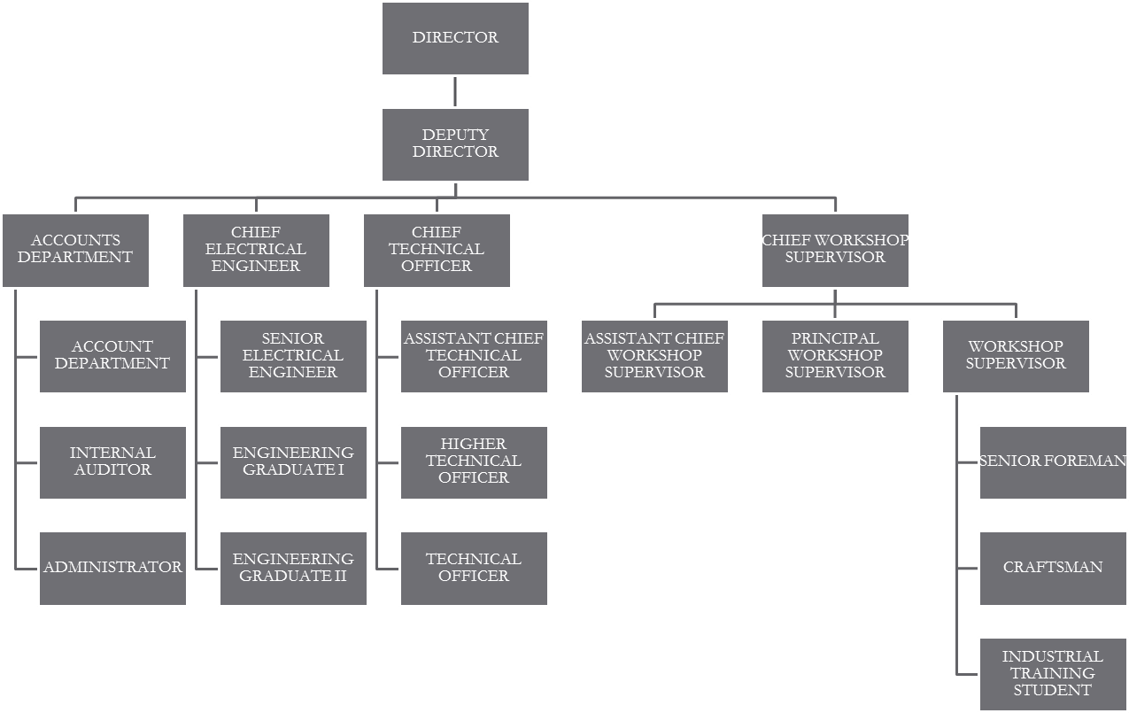
ORGANIZATION CHART
Figure 1: Organization chart

CHAPTHER THREE
3.1 WORK DONE AND EXPERIENCE GAINED
During the first week, we were introduced to essential tools and equipment necessary for electrical installations. Hands-on training involved working with tools like multimeters, wire strippers, and circuit testers. This experience was pivotal in understanding the functionality of each tool and how to employ them safely within an electrical context. Emphasizing strict adherence to safety protocols, our supervisor highlighted the significant role these measures play in preventing accidents while working with electricity. This foundational knowledge is crucial for anyone aspiring to work in the electrical field, as it instills a deep respect for safety and the operational standards required in professional environments.
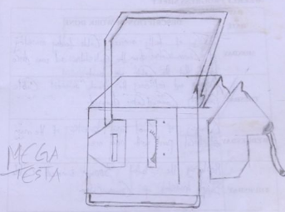
In the second week, we shifted gears to practical applications by engaging in the replacement of damaged electrical components. This included hands-on experience with communication systems, where we learned the systematic approach necessary for replacing old wiring and faulty equipment. The importance of evaluating existing installations to determine necessary repairs was emphasized, revealing the critical thinking involved in electrical maintenance. This week not only equipped me with the skills to perform repairs but also developed my problem-solving abilities, making it evident how essential such skills are in diagnosing and addressing issues within electrical circuits and systems.
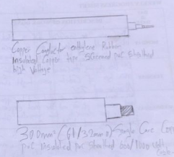
During our third week, we focused on the operational dynamics of electrical sub-stations. We engaged in a comprehensive study of various materials used in constructing sub-stations, including transformers, insulators, and circuit breakers. A significant learning outcome was understanding the functional differences between step-up and step-down transformers, as well as their applications within the power distribution framework. Through practical engagement and discussions on the role of sub-stations, I gained valuable insights into the complexities of electrical distribution systems. This knowledge will prove invaluable in future careers, particularly in ensuring safe and efficient power delivery through well-designed infrastructures.
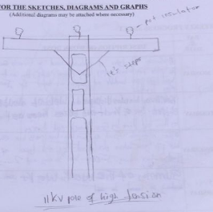
In the fourth week, our exploration of sub-station components deepened further. We examined the roles of insulators, switches, and various transformers in enhancing the safety and efficiency of electric power systems. Through collaborative discussions and hands-on installations, we applied our theoretical learnings by engaging directly with the equipment. This experience underscored the importance of each component in maintaining a stable electric supply and highlighted the significance of thorough knowledge when troubleshooting electrical systems. Such discussions provided a clearer understanding of our responsibilities as future professionals in the electrical field, emphasizing the critical nature of reliability and safety.
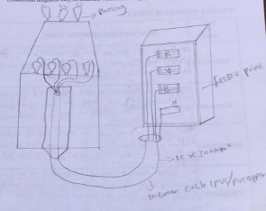
The fifth week centered around low-tension networks, with a detailed examination of the various types of conductors utilized in these systems. We participated in practical exercises focused on installing service lines, where we learned the importance of selecting suitable materials tailored to the network's requirements. Our supervisor guided us through the technical specifications and best practices, fostering an environment where I could directly apply my academic knowledge. This week was pivotal in enhancing my practical skills concerning network installations, which are crucial for ensuring not only the efficiency but also the safety of electrical systems.
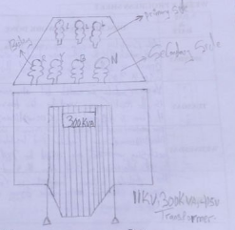
In the sixth week, we focused on the installation guidelines specifically for low-tension networks. Engaging in practical exercises related to pole installations and conductor placements highlighted the crucial engineering standards required for successful deployments. We learned about the concept of "span" to define the distance between poles, which is essential for maintaining system stability and performance. This week reinforced the significance of combining theoretical knowledge with practical application in promoting safe and effective electrical systems. The skills acquired in this week’s training prepare us well for real-world applications, ensuring that we can effectively contribute to developing reliable and efficient electrical infrastructures.
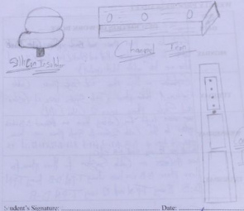
In the seventh week, we engaged in discussions about three-phase and single-phase systems. We began by learning the color coding for wires, where we identified red, yellow, blue, and black colors used in three-phase systems, with single-phase wiring typically using red and black. This foundational knowledge is essential for safely working with electrical systems, as understanding wire color coding prevents confusion and ensures correct connections during installations. We also explored cable systems in detail, specifically focusing on the differing configurations used in three-phase as opposed to single-phase applications.
The focus on understanding wiring configurations underlines the importance of precise installations and maintenance across different electrical systems. This clarity not only enhances safety but also promotes efficiency in operations. Additionally, we discussed different types of cable systems, which enriched my knowledge of installation requirements and the specific uses of cables in various electrical applications.
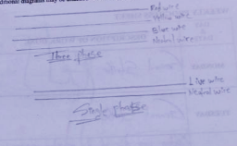
During the eighth week, we faced a general strike that slowed our activities. However, on Wednesday, we resumed work on the organization mosque, where the electrical department was responsible for various installations. We laid cables to support the newly designed power supply system and worked on the wiring required for different lighting points and sockets. This practical application of our skills reinforced the theoretical knowledge we had acquired about electrical cabling and installation.
In addition to working on the new installations, we learned about the proper techniques for laying cables, ensuring they were appropriately insulated and routed to prevent interference and electrical shorts. My experience this week highlighted not only the technical skills required for such projects but also the importance of teamwork and communication within the workplace.
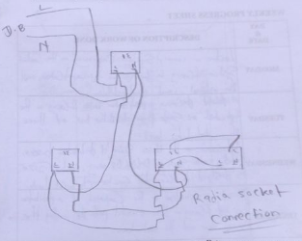
In the ninth week, we focused on a lecture centered around control systems, particularly the various types deconstructed within electrical engineering. We delved into installation practices and emphasized the materials used during these processes. A significant part of our training involved understanding distribution boxes, where we discussed the various configurations, such as single-phase and three-phase setups, and the specifications for these boxes.
Further discussions regarding the sizing of distribution boxes were also beneficial. We learned about models designated for specific applications, including socket installations which had to accommodate different capacities. This week’s focus not only deepened my understanding of distribution systems but also underscored the critical role that proper sizing and installation of distribution boxes play in ensuring efficient electrical distribution across circuits.
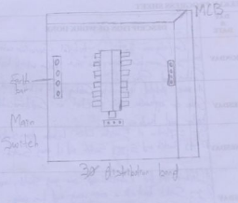
During week ten, we engaged in a comprehensive review of electrical services, placing a particular emphasis on lighting systems, cabling, and socket installations. Practical demonstrations were conducted alongside theoretical learning. We examined the different types of socket installations, including their configurations and appropriate applications in residential and commercial settings.
This week was instrumental in cementing my understanding of how various electrical components interact within a system. The hands-on work involved in socket installation allowed me to practice wiring techniques, ensuring that I grasped the theoretical concepts by applying them directly in real-world scenarios. Each session contributed significantly to my development, equipping me with the skills necessary for future tasks in the electrical engineering field.
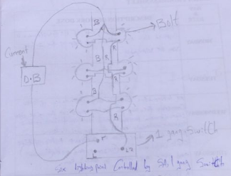
In the eleventh week, a focus on transformers was central to our learning. We examined the principles governing the primary and secondary sides of transformers. Emphasis was placed on understanding how transformers function within power distribution networks and their significance in stepping voltage up or down based on system requirements.
This theoretical groundwork was complemented by practical sessions on monitoring current flow through transformers. Understanding transformer functionality is vital, as it forms the core of many electrical distribution systems, ensuring stability and efficiency in power delivery. This week expanded my technical knowledge substantially, establishing a robust foundation for understanding complex electrical systems in operation.
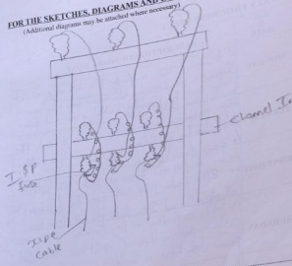
In the twelfth week, our discussions centered around feeder pillars, essential components of electrical distribution systems. We examined their role in providing stable connections for overhead or underground power supply systems. We also explored the installation process of feeder pillars, emphasizing the need for secure mounting on stable foundations to enhance durability and safety.
Lectures included detailed explanations of various sizes of feeder pillars, such as 800A feeder pillars with a 600A fuse, and the implications of these specifications in ensuring effective power distribution. The critical role these components play in the broader electrical framework became clear, equipping me with insights into their importance in building electrical systems. The knowledge gained this week is invaluable as it relates directly to future projects where precise installation and thorough understanding of equipment specifications are mandatory.
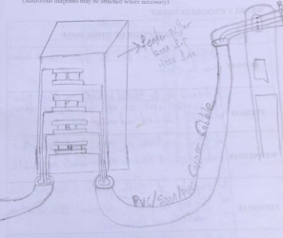
In the thirteenth week, we delved into the intricacies of low-tension networks with a detailed lecture that explained the various factors influencing their design and implementation. We studied the standard practice of placing poles, particularly focusing on the placement at appropriate depths—between 6 to 8 feet—to maintain stability and balance against mechanical stresses and environmental factors. This practical aspect reinforced my understanding of how essential proper pole placement is in ensuring the longevity and safety of electrical infrastructure.
We also discussed the specifications for using 25-foot poles in installations, emphasizing that the depth must be adequate to provide a secure foundation, ultimately contributing to the durability and efficiency of the network. Additionally, an overview of setting poles at 6 feet deep with a 60-meter span was provided to optimize conductivity and performance in network applications, further enhancing my understanding of the technical requirements for stable electrical systems.
On Thursday, we moved on to discuss high-tension cables, specifically those rated at 11 kV and 33 kV, addressing their specifications and roles in electrical distribution systems. This discussion highlighted the distinctions between various high-tension cables, including their construction and application in transmission lines. This knowledge will be essential as I progress into more complex areas of electrical engineering, where high-tension systems are commonly applied.
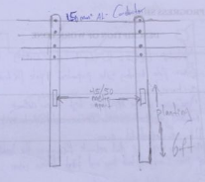
In week fourteen, we shifted our focus to high-tension lines and the critical steps involved in erecting high-tension poles. Our initial sessions provided detailed insights into site preparation, which is a crucial factor influencing the durability and functionality of high-tension networks. We explored the importance of assessing site conditions to determine suitable pole types and configurations.
On Tuesday, we discussed the appropriate high-tension network for various applications, particularly emphasizing the differences between urban and rural deployments. Our lessons on setting up poles carrying different voltages highlighted the necessity for careful planning to serve multiple power needs efficiently.
Later in the week, we focused on aluminum cables rated at 150 mm², discussing their essential characteristics that make them suitable for high-tension systems. The lectures emphasized their capacity to handle voltage and current efficiently while ensuring safety standards. Additionally, we covered the construction of poles and how they must be engineered to withstand environmental challenges, making this week instrumental in enhancing my understanding of high-tension power distribution.
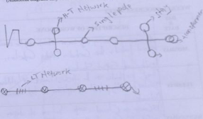
The fifteenth week concentrated on the construction and materials used for high-tension networks. Our sessions began with a thorough review of components essential for constructing these networks, including conductors, insulators, and support structures. Understanding these elements is fundamental for ensuring that high-tension systems function effectively and safely.
A key topic this week involved discussing the technical aspects of installation, which included safety protocols and best practices for handling high-tension equipment. We also examined channel iron specifications and their lengths for 11 kV and 33 kV lines. This included learning how different types of channel iron correlate to structural integrity and support in high-tension networks. I appreciated how essential proper material selection is for ensuring that the system can withstand not only operational loads but also environmental stresses.
On Thursday, our discussions shifted towards the essential components required for maintaining high-tension lines. We focused on stay wires, supports, and other components that provide stability and safety to the network. Understanding these elements is crucial for anyone involved in electrical engineering, as they are vital to the integrity of power distribution systems.
The week concluded with a lecture on the process of telemetering within high-tension networks. This involved using silicon insulators as a reference point for electrical measurements and monitoring. This knowledge proved to be invaluable as telemetering is becoming increasingly relevant in modern electrical engineering, where real-time data collection is essential for efficient grid management.
Overall, this week solidified my foundation in high-tension systems and the various considerations that come into play during their construction and maintenance. The blend of theoretical knowledge and practical application prepared me for future challenges in the field.
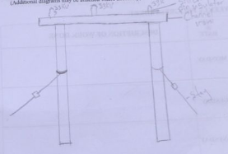

CHAPTER FOUR

CONCLUSION, RECOMMENDATIONS, SUMMARY

CONCLUSION
In conclusion, the SIWES experience has been instrumental in bridging the gap between academic knowledge and practical application in the field of electrical engineering. The exposure to real-world challenges and solutions has equipped me with both technical skills and a deeper understanding of the complexities involved in electrical systems.
As I transition from this internship back to my academic studies, I carry with me a comprehensive skill set that encompasses safety awareness, technical competencies, and a solid foundation in contemporary electrical engineering practices. The variety of tasks I undertook and the insights gained will undoubtedly shape my future career, enabling me to contribute effectively to the electrical engineering industry.
I express my gratitude to my supervisors and colleagues for their mentorship and support throughout this internship, and I look forward to leveraging this experience as I advance in my studies and professional development.

RECOMMENDATIONS
Based on the experience I acquired and the training I received during the SIWES program, I thereby make the following recommendations:
FOR ITF
    - ITF should ensure the regular visitation of the ITF officers to Supervising Agencies Institutions, Employers and students on attachment.
    - The log-book issued to students at attachment by institutions must be checked and signed by the institutions‟ and ITF Supervisors responsible during supervision not in their offices at the end of attachment.
    - ITF should be providing insurance cover to students on attachment and improve on paying Students and supervisor’s allowances for motivation.
    - The SIWES coordinators, ITF agencies, and Area office should institute their machinery to quicken the vetting of students log-books.

FOR STUDENTS
Students on attachment must carefully record all training activities and other assignments in the log-book daily, complete ITF Form 8 and submit them to ensure proper assessment which is used in payment of their allowances.

SUMMARY
The Student Industrial Work Experience Scheme (SIWES) provided an invaluable opportunity to apply theoretical knowledge gained in the classroom to real-world electrical engineering situations. Over the course of the program, I engaged in a variety of activities that encompassed the installation, maintenance, and operation of electrical systems, with a particular focus on low-tension and high-tension networks.
Throughout the weeks, I gained practical experience in wiring techniques, pole installations, and the specifications required for both low-tension and high-tension cable systems. Key topics included understanding wire color coding, the importance of safety protocols, and the installation of components such as transformers and circuit breakers. Additionally, I explored advanced concepts such as smart grid technology, renewable energy integration, and automation in electrical systems, which highlighted the evolving nature of the electrical engineering field.
Participation in hands-on projects, such as the installation of electrical systems in a local mosque and discussions on high-tension lines, allowed me to apply my knowledge practically. Weekly lectures and workshops reinforced critical concepts and expanded my understanding of industry standards, safety measures, and technical specifications.

REFERENCES
B. o. P. Enterprises, "Power Generation: "Status and Outlook" Electric Power Sector," Reform Workshop, Abuja, 2011.
Gupta J.B.,(2013), A COURSE IN ELECTRICAL POWER: TRASIMISSION AND DISTRIBUTION OF ELECTRICAL POWER.
Nigerian Bulk Electrcity Trading Plc per com (2011). “Personal communication wrt Nigerian Power
A. a. G. K. Eberhard, An Analysis of power IPPs in Africa, Africa: Gratwick, K.N. , 2011.
Oyeleye S.A; (2015): Electrical service design lecture note, Department of Electrical/Electronics Engineering, Federal University of Technology Akure, Ondo State.
Whitfield J., (1993): The Electrician‟s Guide to the 16th edition of the IEE wiring regulations BS 7671,(2nd ed.),Essex: E.P. A Press
Wikipedia.com
Kwara State Electricity Board

