

KWARA STATE POLYTECHNIC
P.M.B 1375, ILORIN NIGERIA
www.kwarapoly.edu.ng

A TECHNICAL REPORT OF STUDENTS’ INDUSTRIAL WORK EXPERIENCE SCHEME (SIWES) REPORT

HELD AT:

AYOLOLA MOTORS LIMITED
(129, BODE THOMAS STREET, SURULERE LAGOS)

PREPARED BY:
ABDULAZEEZ YUSSUF OLATUNJI
ND/23/MCT/FT/0036
SUBMITTED TO:
DEPARTMENT OF MECHATRONIC ENGINEERING,
INSTITUTE OF TECHNOLOGY,
KWARA STATE POLYTECHNIC, ILORIN.

IN PARTIAL FULFILLMENT OF THE REQUIREMENT FOR THE AWARD OF NATIONAL DIPLOMA (ND).

FROM
AUGUST--NOVEMBER, 2024
PREFACE
This report documents the comprehensive work accomplished during my four-month industrial attachment with Ayolola Motors Limited, one of the leading organizations in its field. The primary objective of this report is to share a detailed account of my practical experiences, the insights I gained, and the challenges I encountered during my time at the organization.
Throughout the attachment, I was exposed to a variety of tasks and responsibilities that allowed me to bridge the gap between theoretical knowledge and real-world application. This report is organized to present a clear narrative of my journey, starting from the initial stages of integration into the work environment, through the daily tasks and problem-solving processes, to the critical reflections and recommendations for future improvement.

DEDICATION
This report is wholeheartedly dedicated to Almighty Allah, whose boundless mercy and protection have been my constant companions throughout this journey. His divine guidance has been a source of strength, enabling me to overcome challenges and remain steadfast in pursuit of excellence during the program.
I also dedicate this work to Cherished Mrs. Abdulazeez Basirat and Mr. Azeez Kabir. Your unwavering support, encouragement, and belief in my potential have inspired me to strive for greatness. Thank you for being pillars of strength in my life.

ACKNOWLEDGMENT
I express my deepest gratitude to Almighty Allah for the mercy and blessings that have illuminated my path during both my academic pursuits and my industrial training. His grace has been the cornerstone of my success.
I would also like to extend my sincere appreciation to my industrial lecturer. Your accessibility, tireless effort, patience, and insightful guidance have played a crucial role in the completion of this report. Your mentorship not only enriched my learning experience but also provided me with the practical tools necessary to thrive in a professional environment. May Allah continue to guide and protect you and your loved ones.
Additionally, I am profoundly grateful to my family especially the cherished ABDULAZEEZ’S for their unwavering moral and financial support both before and throughout my SIWES program. Your encouragement has been a beacon of hope and motivation. I pray that you live long enough to witness the abundant fruits of your labor. (Amin)
TABLE OF CONTENT
Title page
Preface
Dedication
Acknowledgment
Table of content
CHAPTER ONE
Introduction to SIWES
Brief history of SIWES
Importance and objectives of SIWES
CHAPTER TWO
Brief history of organization
Objective of establishment
Department and their function
CHAPTER THREE
Technical training experience/ work done
CHARTER FOUR
Exclusive summary

CHAPTER FNVE
Challenges encounter
Recommendation
Conclusion

CHAPTER ONE
INTRODUCTION TO SIWES
The Students Industrial Work Experience Scheme (SIWES) is a structured training program designed to prepare students in Nigerian tertiary institutions for the practical demands of their chosen professions.
The scheme was introduced to bridge the significant gap between theoretical classroom teachings and practical applications in industries. It ensures that students in science, engineering, technology, and other applied fields acquire relevant hands-on experience before transitioning into the workforce.
SIWES plays a crucial role in national development by equipping students with problem-solving skills, industry-related expertise, and exposure to real-world challenges in their respective disciplines.
The program is a collaborative effort involving universities, polytechnics, and technical colleges, with funding and supervision provided by the Industrial Training Fund (ITF) and the Federal Government of Nigeria.
Over the years, SIWES has become an essential part of the education system, ensuring that graduates are not just theoretically sound but also practically competent.

OBJECTIVES OF SIWES
The primary objective of SIWES is to provide students with the opportunity to apply the theoretical knowledge acquired in the classroom to real-world industrial challenges. This practical exposure is essential in building students' competence, confidence, and adaptability in the workplace.
Another key objective is to expose students to the latest technological advancements, innovations, and industry best practices within their chosen professions. Many educational institutions lack the necessary facilities and equipment to provide students with hands-on experience, making SIWES a critical component of their training.
Furthermore, SIWES prepares students for life after graduation by familiarizing them with industrial operations, workplace culture, teamwork, and professional ethics. It also serves as a means for students to identify their areas of interest within their respective fields, helping them make informed career choices.
By participating in SIWES, students gain industry-specific skills that enhance their employability and competitiveness in the job market. Many employers prefer candidates with practical experience, and SIWES ensures that graduates meet these expectations. Additionally, the scheme helps students develop soft skills such as communication, problem-solving, and time management, which are essential for career growth.
BRIEF HISTORY OF SIWES
SIWES was introduced in Nigeria in 1973/74 by the Industrial Training Fund (ITF) as a response to the growing concern over the lack of practical skills among graduates of science and technology-related disciplines.
At that time, many employers found it challenging to hire fresh graduates due to their limited exposure to practical industrial applications. The scheme was initiated to address this shortfall and equip students with the necessary skills and experience required in the workplace.
Initially, the scheme was fully funded and managed by ITF. However, as the number of participating institutions increased, the financial burden on ITF became overwhelming. In 1978, ITF withdrew from direct funding, leading to a restructuring of the program's management. In 1979, the Federal Government transferred the responsibility of overseeing SIWES to the National Universities Commission (NUC) and the National Board for Technical Education (NBTE), which coordinated the program for a few years.
Recognizing the need for more effective management, the Federal Government reassigned the administration of SIWES back to ITF in November 1984. By July 1985, ITF had fully resumed control, with the Federal Government assuming full financial responsibility for the scheme. Since then, SIWES has continued to expand, adapting to technological advancements and industry needs to ensure students gain relevant and up-to-date training.
IMPORTANCE OF SIWES
The Students Industrial Work Experience Scheme (SIWES) plays a vital role in the education and industrial sectors by providing students with practical exposure and equipping them with essential skills. The importance of SIWES can be categorized into several key areas:
- Skill Acquisition and Hands-on Experience: SIWES enables students to acquire technical skills that are not typically available within the classroom setting. Through hands-on training, students learn how to operate industry-specific machinery, tools, and equipment. This experience enhances their understanding of theoretical concepts and improves their ability to solve real-world problems.
- Bridging the Gap Between Theory and Practice: One of the major challenges in education is the disconnect between what students learn in theory and what they encounter in practice. SIWES provides an avenue for students to apply theoretical knowledge to actual industrial tasks. This integration ensures that graduates are better prepared to handle the demands of the workforce.
- Exposure to Industrial Processes and Work Ethics: Students participating in SIWES gain firsthand experience of industrial processes, procedures, and work ethics. They learn about company policies, workplace discipline, teamwork, and organizational structures. This exposure helps them adapt more quickly when they transition into full-time employment.
- Enhancing Employability and Career Readiness: Employers often prefer graduates with practical experience. SIWES provides students with a competitive edge by giving them real-world exposure before they enter the job market. This experience not only makes them more employable but also allows them to develop professional relationships that may lead to job opportunities after graduation.
- Meeting Accreditation Requirements: Many professional and regulatory bodies mandate industrial training as part of their accreditation requirements. SIWES ensures that students meet these requirements, making their academic qualifications more valuable and recognized within their industries.
- Encouraging Self-Reliance and Entrepreneurship: Through SIWES, students develop problem-solving and critical-thinking skills that can help them start their own businesses. Exposure to industrial challenges allows students to identify gaps in the market and develop innovative solutions that can lead to entrepreneurial ventures.
- Creating Awareness of Career Opportunities: Many students are often unsure of the specific career paths available in their fields of study. SIWES helps students explore different roles within their industries, allowing them to identify areas of interest and make informed career decisions. This exposure helps in career planning and specialization.
- Developing Professional Relationships: SIWES provides students with the opportunity to interact with professionals in their fields, creating valuable networks that may lead to mentorship, job placements, or future collaborations. Building strong industry connections can significantly impact a student's career progression.
- Contribution to National Development: By equipping students with relevant skills and experience, SIWES contributes to the development of a skilled workforce that supports national growth and economic advancement. A well-trained workforce enhances productivity, innovation, and industrial competitiveness, positioning Nigeria for greater technological and economic progress.
SIWES continues to be an essential component of higher education in Nigeria. With continued support from the government, educational institutions, and industries, the program will remain a key driver of professional development and industrial growth in the country.
CHAPTER TWO
INTRODUCTION
I, ABDULAZEEZ YUSSUF OLATUNJI, began my industrial attachment on the Monday 2nd September, 2024. I obtained placement with the AYOLOLA MOTORS LIMITED which is located at 129, Bode Thomas Street, Surulere Lagos. My industrial attachment ended on Saturday 30th November, 2024, making 13 Weeks.
HISTORY OF AYOLOLA MOTORS LIMITED
Ayolola Motors Limited was founded in 2000 by Mr. Ayolola Babalola. located at 129, Bode Thomas Street, Surulere Lagos. The company started as a small automotive repair shop, focusing on delivering high-quality services to local customers. With a commitment to excellence and reliability, Ayolola quickly gained a reputation for its professional service and customer satisfaction.
As demand for automotive services grew, Ayolola Motors expanded its operations. The company began to offer a wider range of services, including vehicle maintenance, repair, and parts supply. Over the years, Ayolola established partnerships with various automobile manufacturers, allowing it to provide authorized service and support for a diverse lineup of vehicles.
To stay competitive, Ayolola Motors embraced technological advancements in the automotive industry. The company invested in modern tools, equipment, and training for its technicians. This commitment to innovation enabled Ayolola to improve service efficiency and accuracy, leading to increased customer trust and loyalty.
A core philosophy of Ayolola Motors is its customer-centric approach. The company prioritizes understanding customer needs and providing tailored solutions. This focus has helped Ayolola build long-lasting relationships with clients, many of whom return for regular maintenance and repairs.
Today, Ayolola Motors Limited is recognized as a leading automotive service provider in the region. The company continues to expand its service offerings and invest in employee training and development. With a vision for sustainable growth and a dedication to customer satisfaction, Ayolola Motors is well-positioned to meet the evolving needs of the automotive market.
With years of experience in the automotive industry, Ayolola Motors Limited remains committed to providing top-notch services and fostering a culture of excellence. As the company looks to the future, it aims to further refine its services and enhance its reputation as a trusted name in automotive care.
ADMINISTRATIVE AND OPERATIONAL STRUCTURE
Managing Director (MD)/Chief Executive Officer (CEO)
Under the visionary leadership of Mr. Ayolola , Ayolola Motors Limited is guided by a Managing Director (MD)/Chief Executive Officer (CEO) who provides strategic direction and overall leadership. The MD/CEO is responsible for establishing long-term business objectives, forging key partnerships with automobile manufacturers, and ensuring that the company consistently upholds its commitment to high-quality service and customer satisfaction.
General Manager
Reporting directly to the MD/CEO, the General Manager oversees the day-to-day operations of the company. This role involves coordinating the activities of various departments, ensuring efficient resource allocation, and implementing operational strategies that align with the company’s strategic goals. The General Manager plays a crucial role in driving operational efficiency and maintaining smooth business processes.
Administrative & Finance Department
This department is tasked with managing the company’s administrative functions, including record keeping, payroll, budgeting, and financial reporting. By ensuring that all financial transactions are accurately documented and regulatory requirements are met, the Administrative & Finance Department supports Ayolola Motors Limited’s sustainable growth and long-term operational stability.
Human Resource (HR) Department
The HR Department is dedicated to attracting, training, and retaining a skilled workforce. Responsibilities include recruitment, staff development, performance evaluations, and ensuring compliance with labor laws and workplace policies. Through these efforts, the HR team cultivates a professional and motivated work environment, which is key to the company’s commitment to excellence.
Automotive Service Operations Department
At the core of Ayolola Motors Limited’s operational framework is the Automotive Service Operations Department. This team handles vehicle maintenance, diagnostic services, and repair operations using state-of-the-art tools and modern techniques. Their expertise ensures that every service meets high-quality standards, contributing significantly to customer trust and satisfaction.
Parts Supply & Logistics Department
Supporting the service operations is the Parts Supply & Logistics Department, which is responsible for sourcing and managing the supply of genuine automotive parts. This department ensures that quality components are available when needed, streamlining repair and maintenance processes and contributing to the overall efficiency of service delivery.
Technical & Engineering Department
To remain competitive in a rapidly evolving automotive industry, the Technical & Engineering Department focuses on integrating technological advancements into service practices. This department is responsible for implementing innovative diagnostic tools, upgrading service methodologies, and providing ongoing technical training for staff, ensuring that Ayolola Motors Limited remains at the forefront of automotive care.
Customer Service & Marketing Department
Finally, the Customer Service & Marketing Department manages client relationships and promotes the company’s services. By handling inquiries, delivering excellent after-sales support, and executing targeted marketing strategies, this department enhances the company’s brand reputation and broadens its market reach.
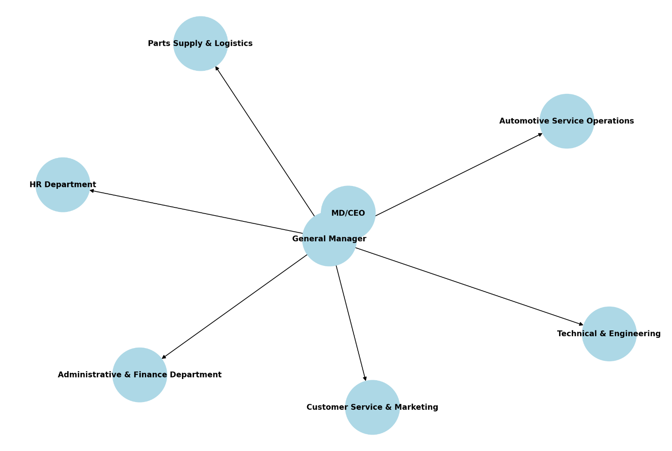
ORGANOGRAM STRUCTURE OF THE ORGANIZATION

CHAPTER THREE

TECHNICAL TRAINING EXPERIENCE
This report provides a detailed account of my 13-week industrial training experience, including the tasks I performed, challenges encountered, and recommendations for future training programs. The training covered various aspects of automotive diagnostics and repairs, including engine maintenance, brake systems, suspension work, and routine service procedures. Through this experience, I gained practical skills and deepened my understanding of vehicle mechanics, which will prepare me for a successful career in the automotive field.
During my industrial training at a reputable automotive service center, I was immersed in various tasks that significantly enhanced my mechanical and diagnostic skills. Each week involved hands-on tasks that enhanced my troubleshooting abilities and technical expertise. This document aims to reflect on my experiences and learning throughout the training period. The objectives of this training were to apply theoretical knowledge, improve practical skills, and gain insights into the automotive industry's operational mechanisms.
BACKGROUND INFORMATION
The training center, known for its commitment to excellence in automotive service, provided an ideal environment for learning. The importance of hands-on experience in the automotive industry cannot be overstated; it allows trainees to bridge the gap between theory and practice. Understanding how various systems work in real-world applications is crucial for developing efficient mechanics.
INITIAL ASSESSMENT AND ROUTINE TASKS
At the beginning of my training, I performed routine inspections and maintenance tasks. This included brake pad replacements on a Lexus GX460. The process involved draining the engine oil, replacing it with new oil, inspecting the brake pads, and replacing them as necessary.
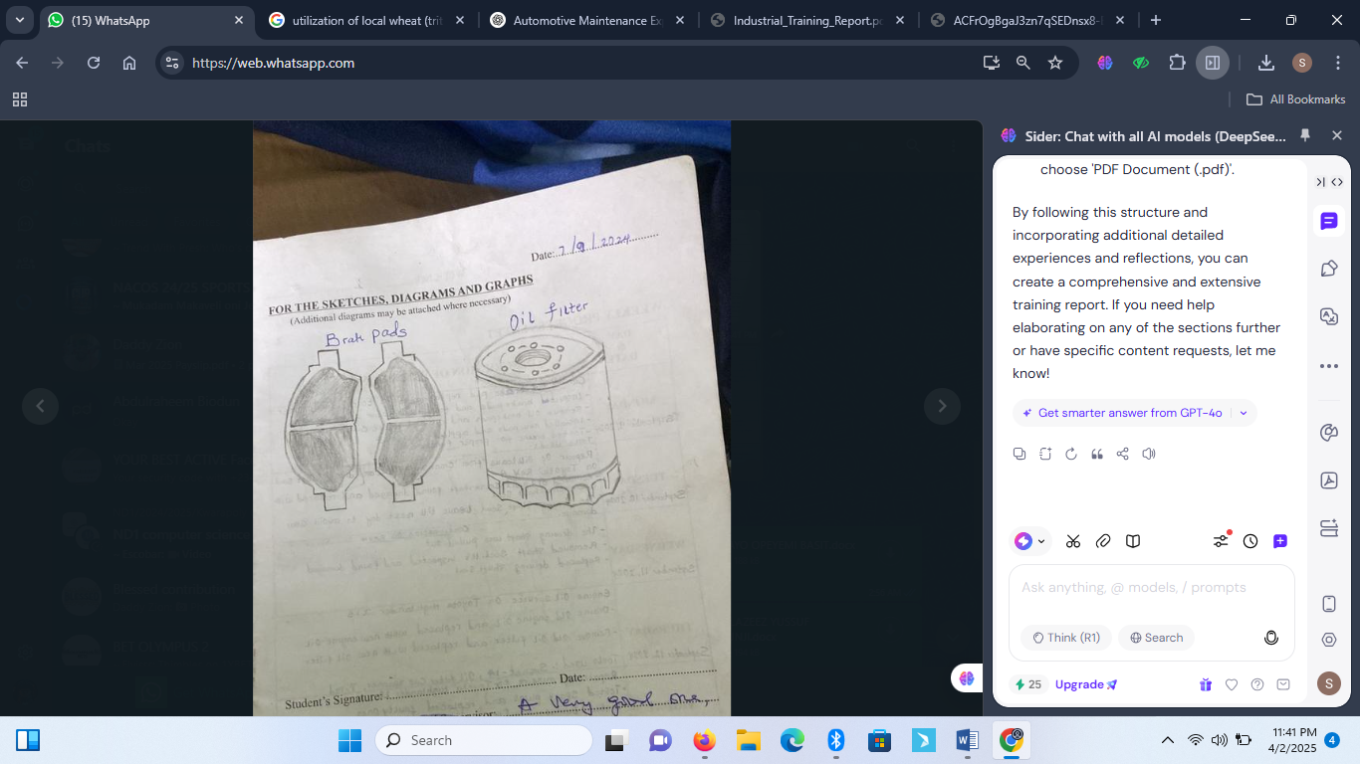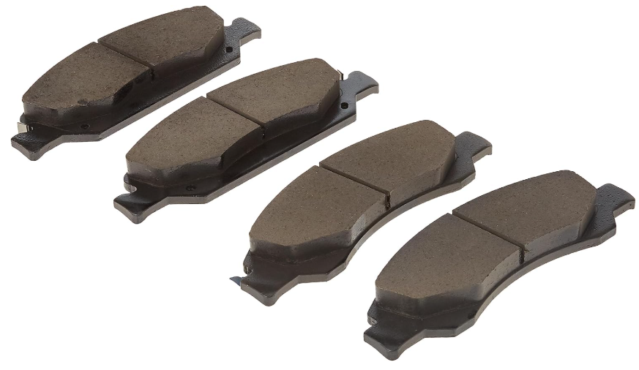
The meticulous nature of this work taught me the importance of attention to detail. I learned to identify worn-out components and understand the implications of neglecting such maintenance.
OIL CHANGE ON TOYOTA HIGHLANDER
Performing an oil change on the Toyota Highlander involved several steps. First, I drained the old oil into a container, ensuring no spillage occurred. This was followed by removing the old oil filter and replacing it with a new one. The importance of using the correct oil type was emphasized during this task, and I learned to consult manufacturer specifications.
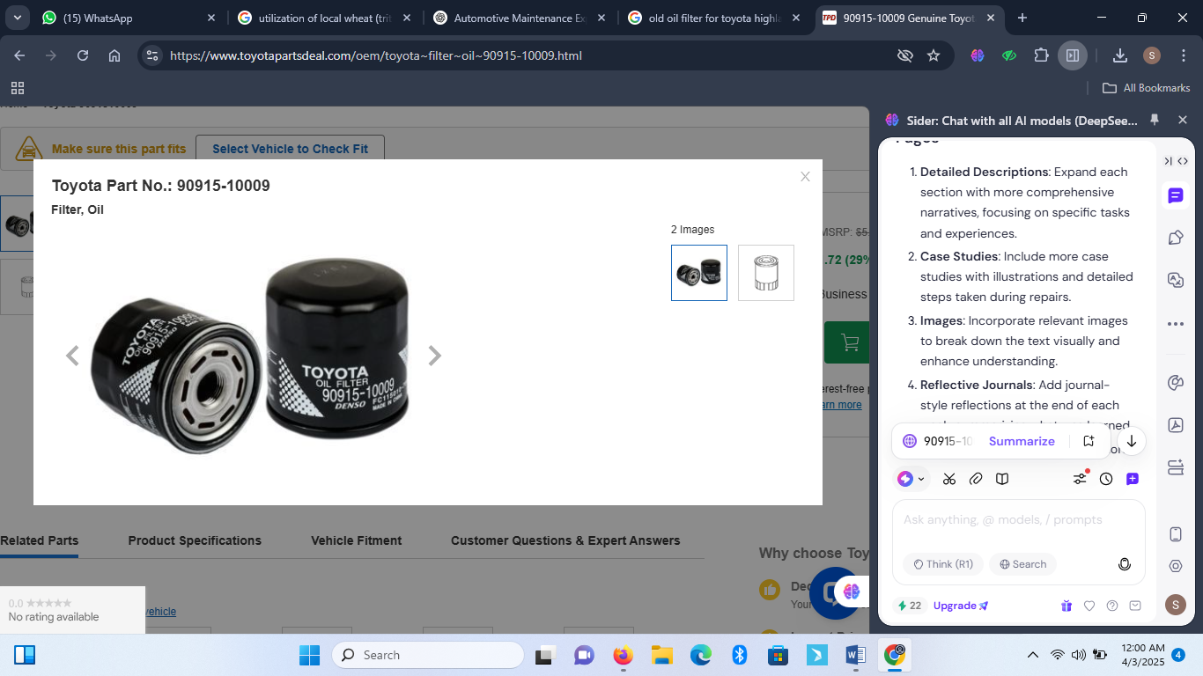
SCHEDULED MAINTENANCE ON TOYOTA HILUX
During the scheduled maintenance for the Toyota Hilux, I inspected the brake system and replaced the brake fluid. This task involved removing the wheels to inspect the calipers and discs. I documented the wear levels and ensured all measurements were within safe limits.
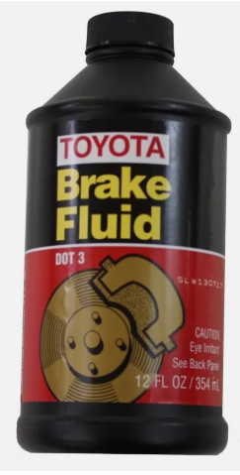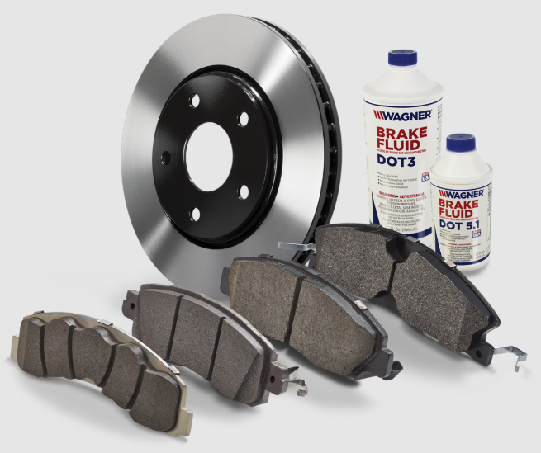
ADVANCED MECHANICAL REPAIRS
As my training progressed, I engaged in advanced repairs. For example, I replaced the front shock absorbers on a Toyota Camry. Understanding the suspension system was critical as it plays a significant role in vehicle safety and comfort.
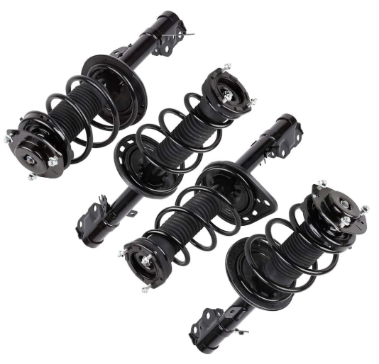
I also conducted routine maintenance on the Toyota RAV4, where I inspected the wheel systems, focusing on aligning and balancing the tiresskills essential for maintaining driving stability.
ELECTRICAL SYSTEMS OVERVIEW
A significant component of my training involved diagnosing electrical systems. I diagnosed a faulty ignition coil in a Toyota Highlander. This process required understanding electrical circuits and the importance of a functional ignition system in vehicle performance.
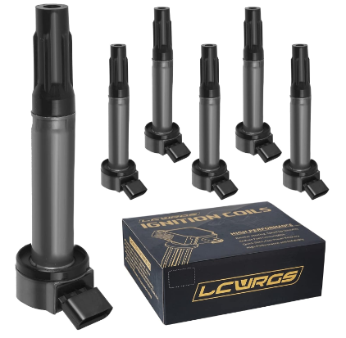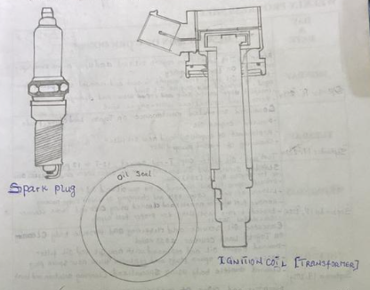
USING DIAGNOSTIC TOOLS
Learning to use OBD-II scanners was a game-changer in my training. By connecting the scanner to various vehicles, I could retrieve diagnostic trouble codes. For instance, while working on a Toyota Cruiser, I identified a fuel pump issue by interpreting the codes.
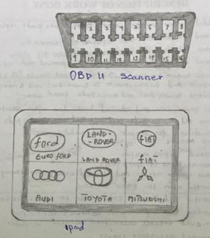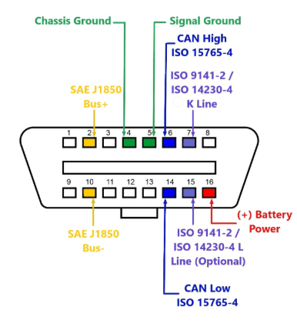
This tool became invaluable in diagnosing problems before they escalated, reinforcing my understanding of preventive maintenance.
COMPLEX REPAIRS AND PROBLEM SOLVING
Throughout my training, I tackled complex repairs, such as addressing oil leaks from the valve cover of a Toyota Highlander. This task required meticulous inspection and part replacements. It honed my troubleshooting skills and showcased the importance of thorough inspections.
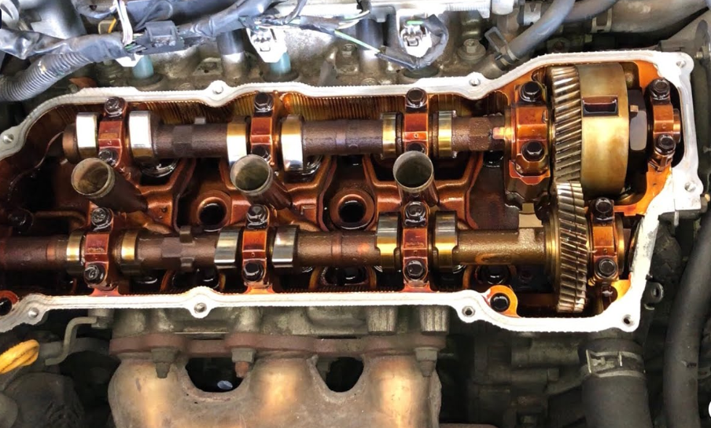
REFLECTIONS AND LEARNING OUTCOMES
Reflecting on my training, I gained versatile skills ranging from mechanical repairs to electrical diagnostics, all of which were instrumental in developing my technical expertise. This experience not only sharpened my practical skills but also allowed me to understand the intricate relationship between mechanical and electrical systems in vehicles. Each task I undertook was a valuable opportunity to grow in different aspects of automotive maintenance, whether it was diagnosing engine problems, troubleshooting electrical faults, or performing routine servicing.
The challenges I faced were numerous, but they were essential in shaping my resilience and perseverance. From dealing with the frustrating issues of faulty parts to the more complex tasks like diagnosing electrical issues in modern vehicles, every challenge pushed me to think critically and stay determined. For instance, encountering faulty fuel pumps, electrical short circuits, or issues in the ignition system required a methodical approach to problem-solving, and often, a little bit of creative thinking.
The importance of continuous learning became evident to me, especially when I had to stay updated with new technologies or troubleshooting techniques. Each vehicle model came with its unique set of challenges, requiring me to learn and adapt quickly. The experience taught me that in automotive maintenance, there is always something new to learn, whether it’s understanding new vehicle technologies or improving efficiency in diagnostic procedures.
My exposure to various vehicle models significantly contributed to my comprehensive understanding of automotive maintenance. For instance, working on a Lexus GX460 and Toyota Highlander introduced me to the importance of regular engine oil changes and brake system maintenance, while servicing vehicles like the Toyota Land Cruiser and Toyota RAV4 expanded my knowledge of suspension systems and drivetrain issues. Each vehicle model provided insight into the nuances of its design and mechanics, and I had the opportunity to work on different components, from fuel systems to electrical circuits, each teaching me how everything in a vehicle is interconnected.
The versatility of tasks I performed, such as brake system repairs, suspension inspections, fuel system diagnostics, and electrical troubleshooting, allowed me to develop a well-rounded skill set. These experiences have deepened my understanding of automotive engineering, enabling me to appreciate the complexities involved in keeping vehicles running smoothly. My confidence in diagnosing and solving issues has grown significantly, and I now feel well-equipped to tackle both routine maintenance and more complex repairs in the future.
In summary, my training was not just about acquiring technical skills but also about cultivating a mindset of continuous improvement and adaptability. The diverse tasks and challenges I encountered were crucial in shaping me into a more resourceful and knowledgeable technician. This experience has prepared me for future endeavors in automotive maintenance and repair, and I look forward to applying the knowledge gained in real-world scenarios.

CHAPTER FOUR
EXCLUSIVE SUMMARY
Over a span of 13 weeks, I acquired extensive hands-on experience in automotive maintenance and repair, working on various Toyota and Lexus models. My tasks ranged from routine servicing, oil changes, and brake pad replacements to more complex diagnostics and repairs. In the initial weeks, I focused on essential maintenance procedures such as draining and replacing engine oil, inspecting brake systems, and replacing worn-out brake pads and discs. As I progressed, I took on more advanced tasks, including diagnosing and fixing faulty ignition coils, fuel pumps, and tie rod ends. I also worked on suspension systems, replacing shock absorbers and wheel brake discs, reinforcing my understanding of vehicle stability and performance.
Midway through the training, I encountered electrical and mechanical issues, diagnosing and repairing oil leaks, kick starter failures, and faulty horn contacts. I also gained experience in troubleshooting and repairing fan modules and faulty starter connections. By week ten, I had developed proficiency in using diagnostic scanning tools to retrieve trouble codes, enabling me to pinpoint and fix vehicle malfunctions efficiently.
In the final weeks, I expanded my expertise in steering system repairs, including replacing a faulty steering rack for a Toyota Sienna and addressing an oil leak from the steering rack of a Toyota Hiace. Additionally, I conducted preventive maintenance and road tests to ensure vehicles were in optimal working condition. This intensive training not only deepened my understanding of automotive systems but also strengthened my diagnostic and repair skills. By handling real-world mechanical and electrical issues, I developed problem-solving abilities and gained confidence in vehicle maintenance and repair. This experience has prepared me for future challenges in the automotive industry, equipping me with the practical skills necessary to excel in the field.
BENEFITS OF THE TRAINING
The SIWES training was incredibly beneficial in several ways, particularly in technical skill development, practical application of knowledge, and career advancement. One of the most significant benefits was the opportunity to work in a real-world electrical environment, which solidified my understanding of electrical systems, wiring techniques, and troubleshooting methods. Through hands-on work, I was able to bridge the gap between theoretical concepts and actual field applications, making learning more effective.
Another major benefit was my exposure to industrial and domestic electrical installations, where I developed proficiency in handling tools, connecting circuits, and managing electrical faults. Working on residential, commercial, and industrial electrical systems enabled me to gain diverse experience that will be useful in various fields of electrical engineering.
A particularly important aspect of my training was solar energy system installation. With the increasing demand for renewable energy solutions, my exposure to solar panel installations, inverter setups, and battery storage systems gave me a deeper understanding of alternative power solutions. This knowledge is highly relevant in today’s world, where energy efficiency and sustainability are critical.
Beyond technical skills, my training experience enhanced my soft skills, such as teamwork, communication, and problem-solving. I learned how to collaborate effectively with other electricians, follow supervisory instructions, and manage work schedules efficiently. These skills are essential for professional development and will help me excel in future work environments.

CHAPTER FIVE
CHALLENGES ENCOUNTER
Throughout the training, I faced several challenges that tested my problem-solving abilities and adaptability. One of the most significant challenges was diagnosing intermittent vehicle faults, where issues would appear inconsistently, making it difficult to pinpoint the root cause. These required extensive testing and careful observation to accurately identify the underlying problem.
Another challenge was working under time constraints, as many repair tasks needed to be completed efficiently without compromising the quality of work. This required a balance of speed and precision to ensure that all maintenance and repairs were performed correctly.
Additionally, dealing with stubborn or rusted components presented a physical challenge. Some bolts and parts were difficult to remove due to corrosion or tight fittings, requiring specialized tools and techniques for extraction. Handling such issues not only demanded patience but also an understanding of the proper use of tools to avoid damage to vehicle components.
Electrical system troubleshooting also posed initial difficulties, as modern vehicles have complex wiring and electronic systems. Understanding wiring diagrams and diagnosing electrical faults took time and practice, but with continuous exposure and guidance, I gradually improved my ability to work on vehicle electronics.
Lastly, environmental factors, such as working in high temperatures or handling heavy components, sometimes made tasks physically demanding. However, adapting to these conditions helped strengthen my resilience and endurance in real-world automotive repair scenarios.
RECOMMENDATIONS
To further enhance my skills and knowledge in automotive maintenance and diagnostics, I recommend continuous learning through advanced training programs, technical workshops, and industry certifications. Acquiring in-depth knowledge of modern vehicle diagnostic tools and software will be essential in keeping up with the growing complexity of automotive systems.
Additionally, gaining more hands-on experience by working alongside experienced professionals will provide valuable mentorship and practical insights into problem-solving techniques. Expanding my knowledge of emerging automotive technologies, such as hybrid and electric vehicles, will also be crucial for staying competitive in the industry.
Furthermore, improving my familiarity with vehicle service manuals, technical bulletins, and diagnostic guides will enhance my efficiency in troubleshooting and repairs. Investing time in understanding the latest advancements in automotive engineering, such as electronic control systems and automated vehicle diagnostics, will help me adapt to future industry demands.
Lastly, ensuring proper safety practices while working in an automotive environment will be key to long-term career success. Using appropriate protective equipment, following proper lifting techniques, and maintaining an organized workspace will contribute to efficiency and reduce the risk of workplace accidents. With continuous learning and hands-on experience, I aim to refine my technical expertise and establish myself as a skilled professional in the automotive maintenance and repair industry.
CONCLUSION
Over the 13-week training period, I gained invaluable hands-on experience in automotive maintenance and repair, working extensively on various Toyota and Lexus models. The training allowed me to develop a strong foundation in essential vehicle servicing, including oil changes, brake pad and disc replacements, and suspension system inspections. Additionally, I advanced my technical expertise by diagnosing and repairing mechanical faults such as faulty ignition coils, fuel pumps, tie rod ends, and starter failures.
Beyond mechanical repairs, I gained exposure to electrical diagnostics, working on issues such as faulty horn contacts, fan module replacements, and starter system failures. The opportunity to use diagnostic scanning tools to retrieve trouble codes enhanced my ability to identify and resolve vehicle malfunctions efficiently. By the end of the training, I had developed a comprehensive understanding of both mechanical and electrical vehicle systems, improving my troubleshooting, repair, and preventive maintenance skills.
This training significantly boosted my confidence and prepared me for real-world challenges in the automotive industry. The hands-on experience, coupled with the ability to analyze and solve complex automotive problems, has given me the necessary foundation to pursue a successful career in vehicle maintenance and repair.

