CHAPTER ONE
1.0 INTRODUCTION
  - Background to the Study
The advent of digital mapping has revolutionized how spatial data is acquired, processed, and utilized in various sectors, particularly in urban planning, construction, and educational infrastructure management. In Nigeria, the importance of accurate spatial data has gained prominence due to the need for proper planning and resource allocation (Nwilo& Olayinka, 2010). Schools, as critical public institutions, require precise spatial representation to facilitate infrastructural development and management.
Federal Staff School in Ilorin, like many public institutions, has experienced rapid infrastructural expansion. Despite this growth, there is a notable lack of up-to-date and accurate spatial data necessary for effective school management and planning. Traditional mapping methods, often time-consuming and prone to errors, are no longer sufficient for detailed and modern infrastructure surveys (Ajayi et al., 2015). This reality has necessitated the adoption of advanced geospatial technologies, such as the use of total stations for high-precision digital mapping.
Digital mapping plays a significant role in the education sector, particularly for resource planning, land use management, infrastructure maintenance, and safety planning. For a school like Federal Staff School, Ilorin, having a detailed and up-to-date digital map of buildings, open spaces, utilities, and other spatial features will enhance operational efficiency and assist in making informed decisions (Uluocha, 2017).
The use of total station technology in school mapping has not been fully embraced in many parts of Nigeria due to challenges such as lack of awareness, technical skills, and access to equipment. However, several studies have demonstrated the effectiveness of total stations in generating precise maps of academic environments. For instance, Akinyemi and Ige (2014) showcased how total stations can be utilized to produce accurate and usable campus maps for planning and academic purposes.
Moreover, integrating total station-acquired data into Geographic Information Systems (GIS) provides a powerful means for spatial visualization, analysis, and decision-making. Such integration enhances the retrieval and interpretation of spatial data, supporting future expansion plans, classroom allocation, emergency response strategies, and general infrastructure improvement (Adeoye et al., 2020).
Given the increasing student population and dynamic academic programs, educational institutions require effective space and infrastructure planning. Digital mapping contributes significantly to achieving these goals by providing reliable and scalable spatial data that reflect current realities and future needs (Iyiola& Adebayo, 2019).
Digital mapping supports administrative needs such as resolving land disputes, planning new buildings, and monitoring construction projects. By adopting total station surveying, the school can establish a comprehensive and accurate baseline dataset that can serve a variety of future uses, including renovations, security planning, and environmental monitoring (Onyeka et al., 2013).
Total station surveys also minimize human error and enhance productivity by enabling surveyors to complete mapping tasks more efficiently. The data collected can be processed using CAD or GIS platforms to create comprehensive digital maps enriched with both spatial and attribute information (Abiodun & Ayoola, 2021). This ensures that the mapped data is not only precise but also functional for various planning and management activities.
Digital mapping of Federal Staff School, Ilorin using a total station is a vital initiative that aligns with modern trends in infrastructure planning and geospatial data acquisition. As Nigeria continues to integrate digital technologies into public services, using total station surveys for school mapping will serve as a model for improving educational facility planning, administration, and development.
  - Statement of the Problem
Accurate and up-to-date spatial information is essential for effective planning, development, and management of educational facilities. However, Federal Staff School in Ilorin currently lacks a comprehensive digital map that accurately represents its physical infrastructure and spatial layout. The existing records are mostly outdated or in analogue form, making them unreliable for informed decision-making regarding infrastructure maintenance, future expansion, or emergency response planning. The absence of reliable geospatial data hampers the school's ability to monitor land use, allocate resources effectively, and plan for growth in a systematic and sustainable manner.
Traditional surveying methods previously used in similar environments are often time-consuming, labor-intensive, and prone to errors, resulting in maps that may not meet modern standards for precision and usability. With increasing demand for spatial data in school management and the growing complexity of educational infrastructure, there is a critical need to adopt advanced surveying technologies such as total station equipment. Without transitioning to digital mapping methods, the school risks inefficient land management, planning delays, and increased maintenance costs due to inaccurate or incomplete spatial records. This project seeks to address these challenges by generating an accurate digital map of the school using total station technology.
1.3 Aim and Objectives
1.3.1 Aim
The aim of this project is to produce an accurate and up-to-date digital map of Federal Staff School, Ilorin using total station technology for efficient planning, management, and infrastructural development.

    - Objectives
- To acquire precise spatial data of Federal Staff School, Ilorin using total station equipment.
- To process and generate a detailed digital map of the school’s infrastructure.
- To support effective planning, development, and management through accurate spatial representation.
  - Justification of the Project
The need for accurate spatial data in educational institutions has become increasingly important due to the growing demand for proper planning, infrastructural development, and efficient resource management. Federal Staff School in Ilorin, like many public schools in Nigeria, lacks a current and reliable digital map that can guide administrative decisions, land use planning, and facility expansion. A digital mapping project using total station technology will provide high-precision data that can be integrated into a Geographic Information System (GIS) for enhanced decision-making, ensuring that the school’s infrastructure is properly documented and utilized.
Furthermore, the study will serve as a reference model for other educational institutions aiming to adopt modern geospatial technologies in their operations. By demonstrating the application of total station in mapping school infrastructure, the project will contribute to the body of knowledge in surveying and geoinformatics, while also highlighting the practical benefits of digital mapping for educational facility management. This is especially relevant in an era where data-driven planning is crucial for the sustainable development of public institutions.
  - Scope of the Project
This study is limited to the digital mapping of Federal Staff School, Ilorin, focusing on the acquisition of spatial data using total station equipment. It covers the measurement and mapping of physical features such as buildings, roads, open spaces, and other infrastructure within the school premises. The data collected will be processed and used to generate a detailed and accurate digital map that reflects the current layout of the school. The scope does not extend to underground utilities, structural assessments, or the mapping of areas outside the school’s boundary.
1.6 Personnel
The project was assigned to and was successfully carried by the personnel listed below;
NAME | MATRIC. NO.
Akinyejo Ezekiel Damilola | HND/23/SGI/FT/0051 | Writer
Ojo Adebisi Motunrayo | HND/23/SGI/FT/0041 | Member
Adebayo Blessing Mary | HND/23/SGI/FT/0042 | Member
Dada Elizabeth Oluwapelumi | HND/23/SGI/FT/0043 | Member
Oladimeji Raphael Oluwasegun | HND/23/SGI/FT/0045 | Member
Ibitoye Joshua Ayokunle | HND/23/SGI/FT/0047 | Member
Osunleke Habeeb Olaide | HND/23/SGI/FT/0052 | Member

1.7 Study Area
The study was carried out at the Federal Staff School, located in Ilorin, the capital city of Kwara State, and Nigeria. Ilorin lies in the north-central region of the country and serves as a major administrative and educational center. The Federal Staff School is situated within the Federal Secretariat Complex along Fate Road, in the Ilorin West Local Government Area. The school is a government-owned institution established to provide quality education for the children of federal workers and the general public. Its campus comprises classroom buildings, administrative blocks, playgrounds, and other school infrastructure that require proper spatial documentation for effective planning and management.
Spatially, Federal Staff School, Ilorin, is located approximately within the coordinates 8.4820°N latitude and 4.5600°E longitude. The school is bounded by Kano Road to the west, residential areas to the north and south, and other government facilities to the east. The perimeter of the school covers a modest area suitable for basic and secondary education activities, making it ideal for digital mapping using total station technology. The well-defined boundary and relatively flat terrain provide a conducive environment for field data acquisition, spatial analysis, and the eventual production of a detailed digital map to support school administration and infrastructural development.
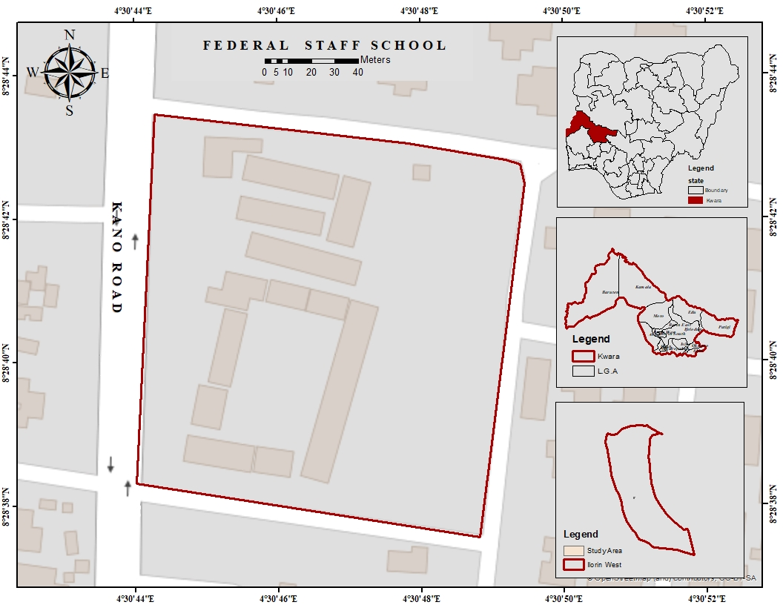
Figure 1.1: Study Area Map

