

KWARA STATE POLYTECHNIC
P.M.B 1375, ILORIN NIGERIA
www.kwarapoly.edu.ng

A TECHNICAL REPORT OF STUDENTS’ INDUSTRIAL WORK EXPERIENCE SCHEME (SIWES) REPORT

HELD AT:

NIGERIAN AUTOMOBILE TECHNICIANS ASSOCIATION
(Festac Town, Lagos State)

PREPARED BY:
MAHMUD UMAR OLAKUNLE
ND/23/MCT/FT/0045
SUBMITTED TO:
DEPARTMENT OF MECHATRONIC ENGINEERING,
INSTITUTE OF TECHNOLOGY,
KWARA STATE POLYTECHNIC, ILORIN.

IN PARTIAL FULFILLMENT OF THE REQUIREMENT FOR THE AWARD OF NATIONAL DIPLOMA (ND).

FROM
AUGUST--NOVEMBER, 2024

DEDICATION

I dedicate this technical report to the Almighty Allah, the giver of knowledge, wisdom and who is rich in mercy.

ACKNOWLEDGEMENT

I take this opportunity to express my profound gratitude and deep regards to the creator of heaven and earth, the one who knows the beginning and the end, the alpha and the omega, the Almighty Allah and also to my guides (MR & MRS MAHMUD, and to all those who has helped me during my SIWES programme. The blessings, help and guidance given by them, time to time has carry me so this far and shall carry on the journey of life on which I am about to embark. I also take this opportunity to express a deep sense of gratitude to compliment my mentor for his cordial support valuable information and guidance which helped me in completing my SIWES through various stages.

Lastly my deep regard to the best and most inspiring brother and sister who has contributed in one ways or other for the completion of the siwes programme.

A big thanks goes to my friends, May Almighty Allah bless, protect, keep, nourish and guide you through all your life’s entire journey. And also my regard to the school board of trustees and the staff a very big thank you to all and sundry.

TABLE OF CONTENT
Title page
Dedication
Acknowledgements
Table of Contents
CHAPTER ONE
1.1 Background of SIWES
1.2 History of SIWES
1.3 Objectives of SIWES
1.4 Objectives of Establishment
CHAPTER TWO
2.1 Benefit derived from SIWES programme
2.2 Safety precautions and practices observed during training
CHAPTER THREE
3.1 Work Done
CHAPTER FOUR
4.1 Summary
4.2 Conclusion
4.2 Recommendations

CHAPTER ONE

1.1 INTRODUCTION TO SIWES

Students Industrial Work Experience Scheme (SIWES) is a Skills Training Program designed to prepare and expose Students of Universities, Polytechnics, Colleges of Technology, Colleges of Agriculture and Colleges of Education for the Industrial Work situation they are likely to meet after graduation. The Scheme affords Students the opportunity of familiarizing and exposing themselves handling equipment and machinery that are usually not available in their institutions.

1.2 HISTORY OF SIWES

The Students’ Industrial Work Experience Scheme (SIWES) was initiated in 1973 by the Federal Government of Nigeria under the Industrial Training Fund (ITF) to bridge the gap between theory and practice among products of our tertiary Institutions. It was designed to provide practical training that will expose and prepare students of Universities, Polytechnics, and Colleges of Education for work situation they are likely to meet after graduation.

Before the establishment of the scheme, there was a growing concern among the industrialists that graduates of institutions of higher learning lacked adequate practical background studies preparatory for employment in industries. Thus the employers were of the opinion that the theoretical education going on in higher institutions was not responsive to the needs of the employers of labour.

As a result of the increasing number of students’ enrolment in higher institutions of learning, the administration of this function of funding the scheme became enormous, hence ITF withdrew from the scheme in 1978 and was taken over by the Federal Government and handed to National Universities commission (NUC), National Board for Technical Education (NBTE) and National Commission for Colleges of Education (NCCE). In 1984, the Federal Government reverted back to ITF which took over the scheme officially in 1985 with funding provided by the Federal Government.

1.3 OBJECTIVES OF THE PROGRAMME

The specific objectives of SIWES are to:
- Provide placements in industries for students of higher institutions of learning approved by relevant regulatory authorities (NUC, NBTE, NCCE) to acquire work experience and skills relevant to their course of study
- Prepare students for real work situation they will meet after graduation.
- Expose students to work methods and techniques in the handling of equipment and machinery that may not be available in schools.
- Make transition from school to the labour market smooth and enhance students’ conduct for later job placement
- Provide students with the opportunity to apply their knowledge in real life work situation thereby bridging the gap between theory and practice
- Strengthen employer involvement in the entire educational process and prepare students for employment in industry.
- Promote the desired technological knowhow required for the advancement of the nation.

1.4 OBJECTIVES OF ESTABLISHMENT
- To provide optimum and individual care to patients.
- To develop recognition for patients needs for privacy and preservation of dignity.
- To maintain good relationship with patients, relations and the community through health education.
- To carry out diagnosis and intervention.
- To provide training for students.
- To maintain sufficient hospital supply of equipment and promote their utilization and maintenance.
- To treat and control diseases.

CHAPTER TWO
  - BENEFIT DERIVED FROM SIWES TRAINING PROGRAMME

The Student Industrial Work Experience Scheme (SIWES) served as a transformational bridge between classroom learning and real-world engineering application at Nigerian Automobile Technicians Association. Over the course of my training, I gained practical knowledge, interpersonal skills, and professional exposure that will shape my future career in engineering. The following are the core benefits I derived from the SIWES programme:
- Technical Skill Acquisition: I gained hands-on experience in electrical installations, inverter wiring, battery bank configurations, and troubleshooting complex electrical faults.
- Tool Proficiency: I learned the correct use of electrical tools such as digital multimeters, conduit benders, cable crimpers, insulation testers, and hand tools. This made me more confident and competent in handling fieldwork.
- Understanding of Industry Standards: Through direct mentorship and field engagement, I learned how to align my work with national and international electrical and safety standards.
- Improved Communication Skills: I regularly communicated with clients, supervisors, and fellow technicians honing my ability to convey technical information in clear, understandable terms.
- Teamwork and Collaboration: Working in cross-functional teams, improved my coordination and adaptability in diverse work environments.
- Time Management and Documentation: I developed better time awareness during installations and learned how to record site data, load estimation results, and installation reports skills that are critical for professional practice.
- Increased Employability: This industrial training has equipped me with a competitive edge, preparing me for job roles in the electrical and project management sectors.

2.2 SAFETY PRECAUTIONS AND PRACTICES OBSERVED DURING TRAINING

Safety in engineering environments especially those involving electricity and mechanical work is non-negotiable. Nigerian Automobile Technicians Association placed a strong emphasis on maintaining high safety standards, and I was thoroughly trained in adhering to these practices.

Safety precautions and protocols observed include:

Use of Personal Protective Equipment (PPE):

Safety gloves, helmets, insulated boots, and goggles were used at all times during installations and diagnostics.

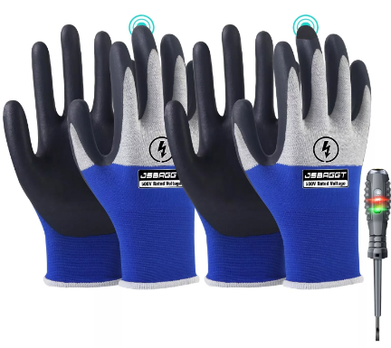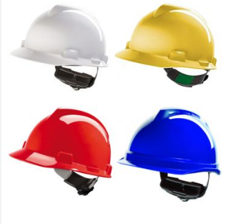

Power Isolation:

Power sources were always de-energized before beginning any maintenance, installation, or repair work.

Tool Inspection:

Tools were routinely checked for damage or defects before use, especially multimeters and high-voltage testers.

Emergency Response Preparedness:

We participated in fire drills, electrical shock recovery simulations, and learned how to use fire extinguishers and first-aid kits.

Electrical Code Compliance:

All wiring procedures followed the Nigerian Electrical Code guidelines, including proper earthing, cable sizing, and breaker selection.

Clean Work Environment:

Workstations were kept neat to avoid accidental tripping, cable entanglements, or equipment mishandling.

These safety procedures not only ensured a risk-free environment during the training but also instilled a disciplined mindset I intend to carry into my professional career.

CHAPTER THREE
3.1 WORK DONE
At the commencement of my SIWES training, I was enthusiastically introduced to the Service Department, which served as a crucial entry point into the technical aspects of electrical and mechanical systems. This initial phase was foundational, as it helped me grasp the essential tools and protocols utilized within the field. Under the guidance of experienced engineers, I was tasked with identifying and familiarizing myself with various common tools. This included basic hand tools such as cutting pliers, long-nose pliers, and screwdrivers, as well as testing equipment like test lamps and multimeters. Additionally, I learned about insulation tapes, vital for ensuring safety in electrical work. The training involved a comprehensive overview of safety equipment, emphasizing the importance of gloves, goggles, and insulated footwear to protect ourselves from potential hazards.
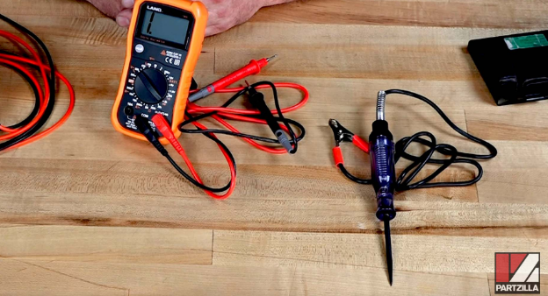
During my tenure in this department, I observed numerous fault diagnosis and repair operations, which provided me with invaluable practical experience. I learned how to detect electrical faults in both residential and commercial buildings using digital and analog multimeters. The range of faults I encountered was extensive, including burnt sockets, broken switch terminals, overloaded MCBs (Miniature Circuit Breakers), and faulty breakers. Engaging in repair work allowed me to assist in replacing these components, reinforcing my understanding of the protocols involved. I learned the critical importance of de-energizing circuits by turning off power from the main circuit breaker before commencing any repair activities, a practice I adhered to rigorously throughout my training.
A particularly enlightening aspect of my experience in the Service Department was my involvement in responding to emergency maintenance calls. I had the opportunity to accompany technicians to clients' homes, where real-world fault tracing was demonstrated. This exposure significantly boosted my confidence in performing basic electrical repairs and enhanced my customer interaction skills. The training I received underscored the significance of adhering to safety procedures, including the use of insulated tools and verifying that power sources were correctly isolated during all tasks. These foundational experiences fostered not only my technical skills but also my professional demeanor.
3.1.2 Initial Assignments and Repairs
The training commenced with basic familiarization with the workshop environment. Tasks included diagnosing and repairing ignition systems, which involved working on various components such as spark plugs and ignition coils. This foundational work was crucial for understanding the intricacies of engine functionality.
On one occasion, the team diagnosed an issue with a Toyota Camry where the engine coolant temperature sensor was replaced, addressing a critical overheating problem. This involved systematic troubleshooting methods that pinpointed the defective component, emphasizing the importance of methodical approaches in automotive repair.
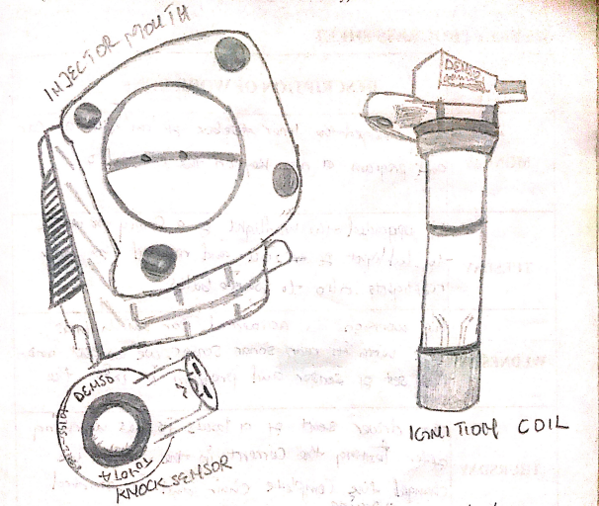
Diagrams related to the ignition system and coolant sensor.
3.1.3 Advanced Engine Repairs
As the training progressed, responsibilities increased in complexity. Notably, there was an instance where a complete engine service was conducted, involving the replacement of engine oil, filters, and checking for leaks. Additionally, the team engaged in reprogramming engine control units (ECUs) for a Nissan vehicle, which highlighted the integration of technology in modern vehicles. Understanding the programming aspects reinforced the mechanical skills and introduced software considerations in automotive maintenance.
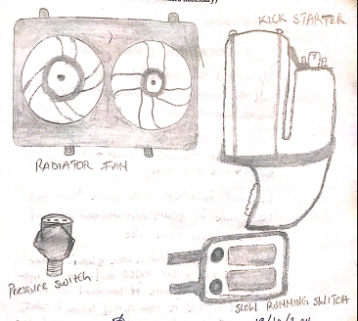
Diagrams of engine parts and ECU configurations
3.1.4 Electrical Systems and Components
A considerable portion of the training focused on electrical systems. Replacing components like the ABS master pump and assessing the wiring of various sensors were critical tasks. This exposure to electrical systems enhanced problem-solving skills, particularly in diagnosing issues related to starters and ignition timing. The experience underscored the importance of precise electrical schematics and the impact of electrical malfunctions on vehicle performance.
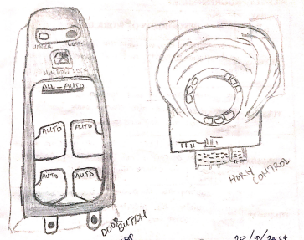
Electrical components images

3.1.5 Hands-On Experience with Diagnostics
Each day included detailed diagnostic procedures, such as identifying and resolving faults in starting systems and performing brake adjustments. One notable project involved troubleshooting the anti-lock braking system (ABS) of a vehicle. This required a methodical approach to identify the sensor faults contributing to braking inefficiencies, which were successfully resolved through meticulous checks and component replacements.
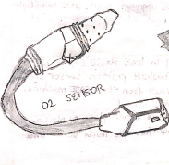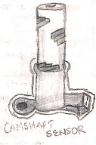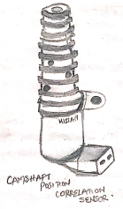
ABS sensors and their connections for clarity
Towards the conclusion of the training period, focus shifted toward final service checks and preparing vehicles for client delivery. This involved performing quality assurance tests on repairs completed, ensuring all systems were functioning optimally. The experience culminated in developing both technical competence and confidence in working in a professional automotive environment.
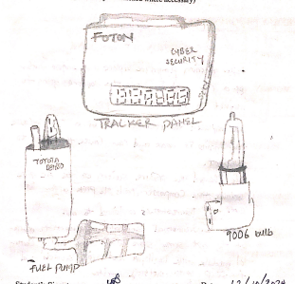
Illustrations of vehicle systems and final checks
In summary, the SIWES experience was transformative, providing critical insights into the automotive repair industry. The practical skills gained through troubleshooting, diagnostics, and repairs will undoubtedly serve as a solid foundation for future career endeavors in mechanical engineering and automotive technology.

CHAPTER FOUR

4.1 SUMMARY

The Industrial Training at Nigeria Automobile Technician Assoication provided a comprehensive look into automotive engineering, encompassing practical exposure to various mechanical and electrical repair tasks. Over the course of the training, numerous hands-on experiences were undertaken, ranging from the installation of vehicle components to in-depth diagnostics of automotive systems.

The training involved tasks such as replacing spark plugs, fixing ignition systems, and reprogramming engine control units (ECUs). Specific projects highlighted include the diagnosis and repair of cooling systems, installation of safety devices like airbags, and troubleshooting electrical malfunctions in vehicles. The training also featured quality assurance checks, ensuring that completed tasks met industry standards before vehicles were returned to clients. It was a multifaceted experience that honed technical skills while fostering an understanding of how automotive technology integrates with contemporary engineering practices. Each task contributed not only to mechanical proficiency but also to problem-solving skills, which are critical in the automotive industry.

4.2 CONCLUSION

The SIWES experience at Nigeria Automobile Technician Association was invaluable in bridging theoretical knowledge with practical application in the field of automotive engineering. The opportunity to work directly with experienced technicians allowed for an enhanced understanding of complex automotive systems and the challenges they present. The skills developed during this period ranging from technical diagnostics to effective communication are essential for a successful career in engineering. This industrial training has significantly contributed to my professional growth, providing a solid foundation for my future endeavors in the automotive field. The supportive environment fostered by the staff and the chance to engage with real-world problems have instilled a confidence that I will carry into my career.

4.3 RECOMMENDATIONS
- It is recommended that future industrial training programs include more structured training modules that focus on the latest automotive technologies and systems. Introducing advanced diagnostic tools and software training could significantly enhance the trainees' experience.
- Incorporating regular workshops and seminars led by industry experts would provide trainees with insights into emerging trends in automotive engineering and practical applications, further enriching the learning experience.
- Establishing a formal mentorship program where experienced technicians guide interns could foster deeper learning and provide support for troubleshooting complex issues.
- Implementing a robust feedback mechanism where trainees can evaluate their experiences and suggest improvements would benefit the program's development and tailor it more closely to industry needs.
- Encouraging collaborative projects that involve multiple departments within the organization can help trainees understand the interconnectedness of various automotive systems and the importance of teamwork in problem-solving.

