DISTRIBUTIONAL ANALYSIS OF PRIMARY AND SECONDARY SCHOOLS IN PART
OF ILORIN EAST AND MORO LOCAL GOVERNMENT OF
KWARA STATE, USING GIS APPROACH

By
OLATUNBOSUN ABOLADE CHRISTIANAH
MATRIC NO :HND/23/SGI/FT/0001

Supervisor
Surv. AG AREMU

CHAPTER 1
- INTRODUCTION
1.1BACKGROUND OF THE STUDY
In the field of surveying, the accuracy and reliability of spatial data are paramount. Distribution analysis plays a critical role in assessing how data points—such as positional coordinates, elevations, or errors—are spread across a given area. It provides insights into the nature of the data collected, identifies potential anomalies, and aids in ensuring that measurements adhere to acceptable standards of precision.

Traditionally, surveying relied on manual instruments and observations, which were prone to human and instrumental errors. With the advent of modern technologies such as total stations, Global Navigation Satellite Systems (GNSS), and Geographic Information Systems (GIS), the volume and complexity of spatial data have increased significantly. This evolution has necessitated more robust analytical techniques, including distribution analysis, to process and interpret the data accurately.
Distribution analysis in surveying allows for the statistical examination of spatial data, such as evaluating the frequency, pattern, and dispersion of points. This is crucial in detecting systematic errors, outliers, or inconsistencies that may affect the final outcome of a survey. It also supports the optimization of data collection methods and enhances the quality control processes within surveying projects.
Moreover, distribution analysis is integral in geodetic and cadastral surveys, topographic mapping, engineering surveys, and environmental assessments. By understanding the spatial distribution of features or measurement errors, surveyors can make more informed decisions that contribute to the effectiveness and sustainability of land development and management.
Therefore, the study of distribution analysis is essential in modern surveying practices, not only for improving data quality but also for supporting the planning, design, and implementation of various spatially-related projects.
1.2 RESEARCH QUESTIONS
Research Premise and Questions
This research seeks to analyze the spatial and infrastructural dynamics of the school environment to support better planning and resource allocation. The study is guided by the following key questions:
1. What is the spatial distribution of structures in the school?
• Assessing the arrangement and positioning of buildings within the school premises.
• Identifying patterns in the distribution of classrooms, administrative blocks, dormitories, and other facilities.
2. What are the capacities of classrooms in relation to their area in square meters?
• Measuring classroom sizes to determine their capacity for accommodating students.
• Evaluating how well the available classroom space meets student needs.
3. What is the ratio of classrooms to students in a day and boarding school setting?
• Comparing the number of classrooms to student enrollment.
• Differentiating between day and boarding students to assess space utilization.
4. What is the configuration of the school, and how do erosion and other natural phenomena affect it?
• Examining the layout, accessibility, and connectivity of school structures.
• Assessing the impact of erosion, flooding, and other environmental factors on school infrastructure.
5. How can the generated products support decision-making?
• Developing maps, models, and reports to guide school management.
• Providing data-driven insights for optimizing space, improving infrastructure, and mitigating environmental risks.

By addressing these questions, the research aims to enhance the planning, safety, and functionality of the school environment
1.3 Statements of problem
In surveying, the precision and accuracy of spatial data are fundamental to the success of any mapping or land development project. However, challenges often arise due to the uneven distribution of data points, measurement errors, and varying field conditions that can compromise the integrity of survey results. Despite advancements in surveying technologies and data processing tools, there remains a significant gap in the consistent application of distribution analysis to identify and correct these spatial inconsistencies.
Many surveying projects suffer from inadequate evaluation of the spatial distribution of collected data, leading to the misrepresentation of physical features, poor decision-making, and increased project costs. Errors that go undetected due to a lack of distribution analysis may result in the propagation of inaccuracies throughout mapping outputs, engineering designs, or cadastral records.
1.4 Aim of the project
The aim of this project is to conduct a distribution analysis of primary and secondary schools in parts of Ilorin East Local Government, Kwara State, using surveying and GIS approaches. This study seeks to assess the spatial distribution, accessibility, and infrastructural adequacy of schools to support effective educational planning and decision-making.
1.5 Objectives of the project
The project will involve key operations necessary for achieving accurate distribution analysis. These include:
1. Data Collection / Acquisition:
• Gathering spatial data on the location and distribution of primary and secondary schools in Ilorin East Local Government.
• Using surveying techniques (GPS, total station) and GIS datasets (satellite imagery, government records) to ensure accuracy.
2. Data Processing:
• Analyzing spatial data using GIS tools to assess school distribution, accessibility, and infrastructural capacity.
• Performing geo statistical analysis, spatial interpolation, and mapping to visualize school locations and coverage.
3. Data / Information Presentation:
• Creating thematic maps, reports, and charts to present findings effectively.
• Providing insights for policymakers and stakeholders to enhance educational planning and infrastructure development.
These processes will ensure a comprehensive spatial analysis that supports better decision-making regarding school distribution and accessibility.
1.6 Scope of the project
The scope of this project outlines the key steps and methodologies that will be implemented to achieve accurate distribution analysis of primary and secondary schools in Ilorin East Local Government, Kwara State. The following activities will be carried out:
1. Reconnaissance:
• A preliminary field visit to assess the study area and identify key locations for data collection.
2. Station Selection
• Identifying and establishing control points for accurate data collection.
• Ensuring proper geo referencing of survey points to maintain spatial accuracy.
3. Data Acquisition Using Radiation Method with Total Station (Kolida R554):
• Employing the radiation method of surveying to measure school locations and spatial coordinates.
• Using the Kolida R554 Total Station to obtain precise positional data.
4. Data Processing Using AutoCAD 2018 and ArcMap 10.2 Series:
• Importing and refining survey data using AutoCAD 2018 for accurate mapping.
• Analyzing spatial distribution patterns in ArcMap 10.2 for GIS-based assessment.
5. Information Presentation in the Form of Plans and Maps:
• Producing thematic maps, charts, and spatial models to visualize school distribution.
• Generating site plans and digital maps for decision-making support.
6. Comprehensive Report Writing:
• Documenting findings, methodologies, and recommendations in a detailed report.
• Providing insights for stakeholders to improve school planning and infrastructure allocation.
This structured approach ensures that the study effectively captures, analyzes, and presents the spatial distribution of schools, contributing to better educational infrastructure planning.
1.7 Significant of the study
This study will guide school planners, policymakers, and administrators in assessing the distribution of secondary schools, ensuring better infrastructure planning and resource allocation. It will also help educators, students, and researchers understand the importance of facility management and accessibility to quality education.
1.8 Study Area
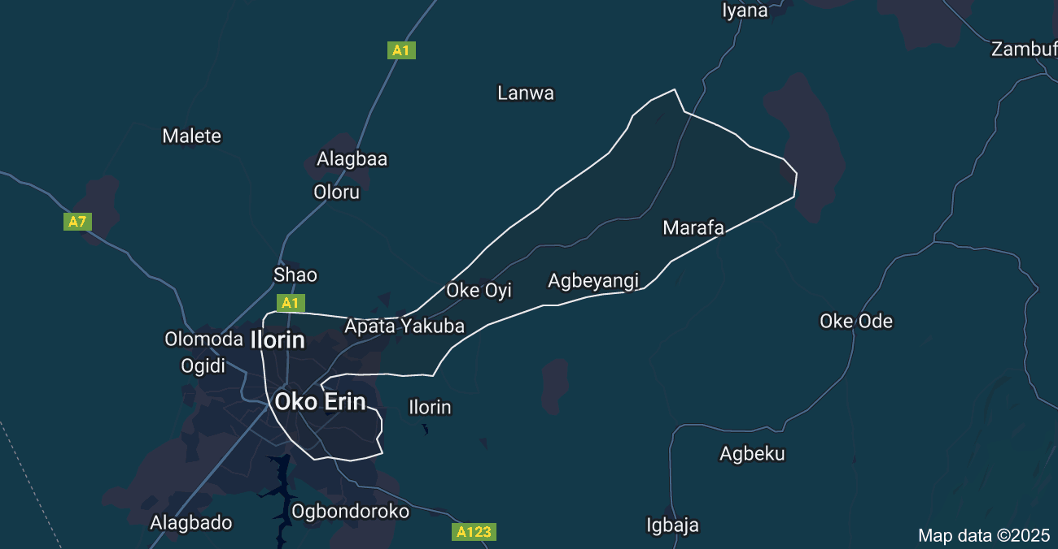
Ilorin East Local Government, one of 16 in Kwara State, has a rich history from pre-colonial trade to modern development. Key landmarks include the University of Ilorin, Ilorin International Airport, and the Central Mosque. The project area spans Kulende Junction to Oke Oyi, covering 14 km

1.9 Personal Assigned for the project
Fieldwork Participants

The following students participated in the fieldwork for this project:
S/N | Name | Matric No.
1 | Olatunbosun Abolade C. | HND/23/SGI/FT/0001
2 | Lawal Zainab O. | HND/23/SGI/FT/0002
3 | Abiola Aminat T. | HND/23/SGI/FT/0010
4 | Olagunju Segun | HND/23/SGI/FT/0003
5 | Omotosho Jamiu O. | HND/23/SGI/FT/0005
6 | Safadeen Akanfe O. | HND/23/SGI/FT/0004

