DISTRIBUTIONAL ANALYSIS OF PRIMARY AND SECONDARY SCHOOLS IN PART OF ILORIN EAST AND MORO LOCAL GOVERNMENT OF
KWARA STATE, USING GIS APPROACH

By
Lawal Zainab Omowumi
MATRIC NO :HND/23/SGI/FT/0002

Supervisor
Surv. AG AREMU

CHAPTER ONE
1.0 INTRODUCTION
1.1 Background of the Study
Education is a fundamental pillar of societal development, and the equitable distribution of educational facilities is crucial for ensuring access to quality education. In Nigeria, the disparity in the distribution of primary and secondary schools has been a persistent challenge, particularly in rural and semi-urban areas. Kwara State, located in North-Central Nigeria, faces similar issues, with some regions having inadequate educational infrastructure. Ilorin East and Moro Local Government Areas (LGAs) are among the regions where the spatial distribution of schools may not optimally serve the population.

Geographic Information Systems (GIS) have become an essential tool in spatial analysis, offering capabilities for mapping, analyzing, and optimizing the distribution of social amenities, including schools. In the field of **Surveying and Geo-Informatics**, GIS provides a robust framework for assessing the accessibility, density, and coverage of educational facilities. This study leverages GIS techniques to evaluate the distribution of primary and secondary schools in parts of Ilorin East and Moro LGAs, identifying gaps and suggesting improvements for better educational planning.

1.2 Statement of the Problem
The uneven distribution of schools in Kwara State has led to disparities in educational access, with some communities having an over-concentration of schools while others suffer from a lack of adequate facilities. Factors such as population density, terrain, and urban-rural divide contribute to these imbalances. In Ilorin East and Moro LGAs, some students travel long distances to attend school, which can lead to increased dropout rates and reduced academic performance.

Despite the recognized importance of education, there is limited geospatial analysis of school distribution in these areas. Traditional methods of school planning often rely on demographic data without considering spatial factors, leading to inefficient resource allocation. This study addresses this gap by employing **GIS and surveying techniques** to analyze the spatial distribution of schools, ensuring data-driven decision-making for educational development.

1.3 Aim of the project
The aim of this study is to assess the spatial distribution of primary and secondary schools in parts of Ilorin East and Moro LGAs using GIS techniques.

1.4 Obejectives of the project
1. To map the existing primary and secondary schools in the study area.
2. To analyze the spatial distribution patterns of schools using GIS tools.
3. To evaluate the accessibility of schools based on proximity to settlements.
4. To assess the adequacy of schools relative to population density.
5. To identify underserved areas requiring additional educational facilities.
6. To recommend optimal locations for new schools based on spatial analysis.

1.5 Research Questions
To achieve the objectives, this study seeks to answer the following research questions:
1. What is the current spatial distribution of primary and secondary schools in the study area?
2. Are the schools evenly distributed, or are there clustering patterns?
3. How accessible are the schools to students in different communities?
4. Does the number of schools correspond to the population density in the area?
5. Which areas are underserved and in need of additional schools?
6. Where should new schools be located to improve accessibility?

1.6 Significance of the Study
This study is significant for several stakeholders, including:
- Government and Education Planners:The findings will assist policymakers in making informed decisions on school location and resource allocation.
- Community Leaders: The study will highlight areas needing educational infrastructure, enabling advocacy for better facilities.
- Researchers in Surveying and Geo-Informatics:The methodology can serve as a reference for similar studies in other regions.
- Students and Parents:Improved school distribution will reduce travel distances, enhancing enrollment and retention rates.

By integrating GIS into educational planning, this study contributes to sustainable development goals (SDGs), particularly SDG 4 (Quality Education) and SDG 11 (Sustainable Cities and Communities).

1.7 Scope of the Study
This study focuses on selected areas within Ilorin East and Moro LGAs in Kwara State. The analysis covers:
- **Primary and secondary schools** (both public and private).
- **Population data** from recent census and school enrollment records.
- **Geospatial techniques**, including buffer analysis, nearest neighbor analysis, and overlay mapping.

The study does not cover tertiary institutions or non-formal education centers. Data limitations, such as outdated population figures, may affect some analyses, but efforts will be made to use the most recent available data.

1.7 Methodology Overview
The research adopts a **mixed-method approach**, combining geospatial analysis with field surveys. Key steps include:
1. Data Collection:
- Coordinates of schools (using GPS).
- Population data from the National Population Commission.
- Satellite imagery and base maps.
2. GIS Analysis:
- Mapping school locations using **ArcGIS or QGIS**.
- Proximity analysis to determine service areas.
- Density mapping to identify clustering patterns.
3. **Field Validation:**
- Ground-truthing to verify school locations and conditions.
4. **Recommendations:**
- Proposing optimal sites for new schools using suitability analysis.

1.8 Study Area Description
1.81 Location
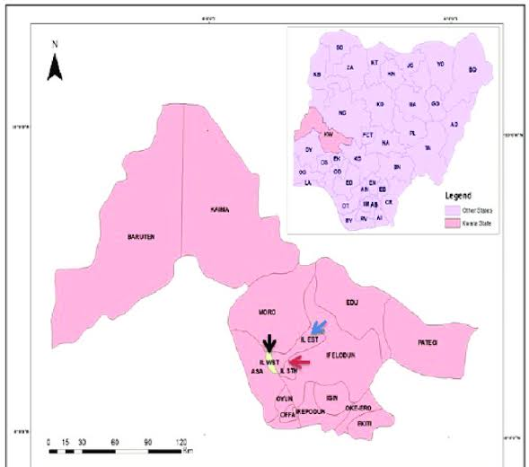
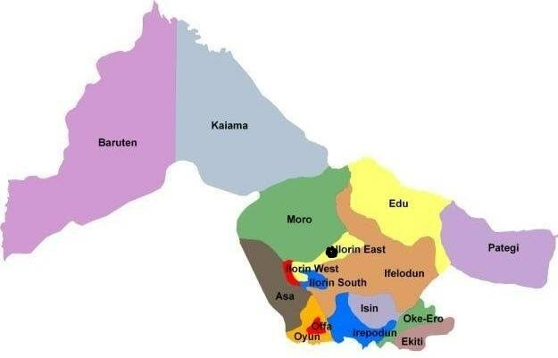
Ilorin East and Moro LGAs are two of the sixteen local government areas in Kwara State, located in the north-central geopolitical zone of Nigeria. Ilorin East is situated within the Ilorin metropolitan area, while Moro lies to its north. The study area lies approximately between latitudes 8°30’N and 9°00’N and longitudes 4°30’E and 5°00’E.

1.82 Physical Characteristics
The area experiences a tropical wet and dry climate, with two distinct seasons: the rainy season (April to October) and the dry season (November to March). The terrain is largely flat with patches of undulating hills and is traversed by a network of rivers and streams.
1.83 Socioeconomic and Demographic Features
Ilorin East LGA is largely urban and semi-urban, hosting parts of the state capital, Ilorin. It is characterized by high population density, diverse ethnic groups, and relatively better infrastructure. Moro LGA, on the other hand, is predominantly rural, with agriculture being the mainstay of the economy. The population distribution across both LGAs is uneven, influencing the demand for and accessibility to educational facilities.
1.9 Personnel Assigned to the Project
Fieldwork Participants
The fieldwork component of this project was carried out by the following students:
S/N | Name |  |  | Matric No.
1 | Lawal Zainab O |  |  | HND/23/SGI/FT/0002
2 | Olatunbosun A Christianah |  |  | HND/23/SGI/FT/0001
3 | Abiola Aminat T. |  |  | HND/23/SGI/FT/0010
4 | Olagunju Segun |  |  | HND/23/SGI/FT/0003
5 | Omotosho Jamiu O. |  |  | HND/23/SGI/FT/0005
6 | Safadeen Akanfe O. |  |  | HND/23/SGI/FT/0004

