DISTRIBUTIONAL ANALYSIS OF PRIMARY AND SECONDARY SCHOOLS IN PART
OF ILORIN EAST AND MORO LOCAL GOVERNMENT OF
KWARA STATE, USING GIS APPROACH

By
OLATUNBOSUN ABOLADE CHRISTIANAH
MATRIC NO :HND/23/SGI/FT/0001

Supervisor
Surv. AG AREMU

CHAPTER 1
- INTRODUCTION
1.1BACKGROUND OF THE STUDY
In the field of surveying, the accuracy and reliability of spatial data are paramount. Distribution analysis plays a critical role in assessing how data points—such as positional coordinates, elevations, or errors—are spread across a given area. It provides insights into the nature of the data collected, identifies potential anomalies, and aids in ensuring that measurements adhere to acceptable standards of precision.

Traditionally, surveying relied on manual instruments and observations, which were prone to human and instrumental errors. With the advent of modern technologies such as total stations, Global Navigation Satellite Systems (GNSS), and Geographic Information Systems (GIS), the volume and complexity of spatial data have increased significantly. This evolution has necessitated more robust analytical techniques, including distribution analysis, to process and interpret the data accurately.
Distribution analysis in surveying allows for the statistical examination of spatial data, such as evaluating the frequency, pattern, and dispersion of points. This is crucial in detecting systematic errors, outliers, or inconsistencies that may affect the final outcome of a survey. It also supports the optimization of data collection methods and enhances the quality control processes within surveying projects.
Moreover, distribution analysis is integral in geodetic and cadastral surveys, topographic mapping, engineering surveys, and environmental assessments. By understanding the spatial distribution of features or measurement errors, surveyors can make more informed decisions that contribute to the effectiveness and sustainability of land development and management.
Therefore, the study of distribution analysis is essential in modern surveying practices, not only for improving data quality but also for supporting the planning, design, and implementation of various spatially-related projects.
1.2 RESEARCH QUESTIONS
Research Premise and Questions
This research seeks to analyze the spatial and infrastructural dynamics of the school environment to support better planning and resource allocation. The study is guided by the following key questions:
1. What is the spatial distribution of structures in the school?
• Assessing the arrangement and positioning of buildings within the school premises.
• Identifying patterns in the distribution of classrooms, administrative blocks, dormitories, and other facilities.
2. What are the capacities of classrooms in relation to their area in square meters?
• Measuring classroom sizes to determine their capacity for accommodating students.
• Evaluating how well the available classroom space meets student needs.
3. What is the ratio of classrooms to students in a day and boarding school setting?
• Comparing the number of classrooms to student enrollment.
• Differentiating between day and boarding students to assess space utilization.
4. What is the configuration of the school, and how do erosion and other natural phenomena affect it?
• Examining the layout, accessibility, and connectivity of school structures.
• Assessing the impact of erosion, flooding, and other environmental factors on school infrastructure.
5. How can the generated products support decision-making?
• Developing maps, models, and reports to guide school management.
• Providing data-driven insights for optimizing space, improving infrastructure, and mitigating environmental risks.

By addressing these questions, the research aims to enhance the planning, safety, and functionality of the school environment
1.3 Statements of problem
In surveying, the precision and accuracy of spatial data are fundamental to the success of any mapping or land development project. However, challenges often arise due to the uneven distribution of data points, measurement errors, and varying field conditions that can compromise the integrity of survey results. Despite advancements in surveying technologies and data processing tools, there remains a significant gap in the consistent application of distribution analysis to identify and correct these spatial inconsistencies.
Many surveying projects suffer from inadequate evaluation of the spatial distribution of collected data, leading to the misrepresentation of physical features, poor decision-making, and increased project costs. Errors that go undetected due to a lack of distribution analysis may result in the propagation of inaccuracies throughout mapping outputs, engineering designs, or cadastral records.
1.4 Aim of the project
The aim of this project is to conduct a distribution analysis of primary and secondary schools in parts of Ilorin East Local Government, Kwara State, using surveying and GIS approaches. This study seeks to assess the spatial distribution, accessibility, and infrastructural adequacy of schools to support effective educational planning and decision-making.
1.5 Objectives of the project
The project will involve key operations necessary for achieving accurate distribution analysis. These include:
1. Data Collection / Acquisition:
• Gathering spatial data on the location and distribution of primary and secondary schools in Ilorin East Local Government.
• Using surveying techniques (GPS, total station) and GIS datasets (satellite imagery, government records) to ensure accuracy.
2. Data Processing:
• Analyzing spatial data using GIS tools to assess school distribution, accessibility, and infrastructural capacity.
• Performing geo statistical analysis, spatial interpolation, and mapping to visualize school locations and coverage.
3. Data / Information Presentation:
• Creating thematic maps, reports, and charts to present findings effectively.
• Providing insights for policymakers and stakeholders to enhance educational planning and infrastructure development.
These processes will ensure a comprehensive spatial analysis that supports better decision-making regarding school distribution and accessibility.
1.6 Scope of the project
The scope of this project outlines the key steps and methodologies that will be implemented to achieve accurate distribution analysis of primary and secondary schools in Ilorin East Local Government, Kwara State. The following activities will be carried out:
1. Reconnaissance:
• A preliminary field visit to assess the study area and identify key locations for data collection.
2. Station Selection
• Identifying and establishing control points for accurate data collection.
• Ensuring proper geo referencing of survey points to maintain spatial accuracy.
3. Data Acquisition Using Radiation Method with Total Station (Kolida R554):
• Employing the radiation method of surveying to measure school locations and spatial coordinates.
• Using the Kolida R554 Total Station to obtain precise positional data.
4. Data Processing Using AutoCAD 2018 and ArcMap 10.2 Series:
• Importing and refining survey data using AutoCAD 2018 for accurate mapping.
• Analyzing spatial distribution patterns in ArcMap 10.2 for GIS-based assessment.
5. Information Presentation in the Form of Plans and Maps:
• Producing thematic maps, charts, and spatial models to visualize school distribution.
• Generating site plans and digital maps for decision-making support.
6. Comprehensive Report Writing:
• Documenting findings, methodologies, and recommendations in a detailed report.
• Providing insights for stakeholders to improve school planning and infrastructure allocation.
This structured approach ensures that the study effectively captures, analyzes, and presents the spatial distribution of schools, contributing to better educational infrastructure planning.
1.7 Significant of the study
This study will guide school planners, policymakers, and administrators in assessing the distribution of secondary schools, ensuring better infrastructure planning and resource allocation. It will also help educators, students, and researchers understand the importance of facility management and accessibility to quality education.
1.8 Study Area
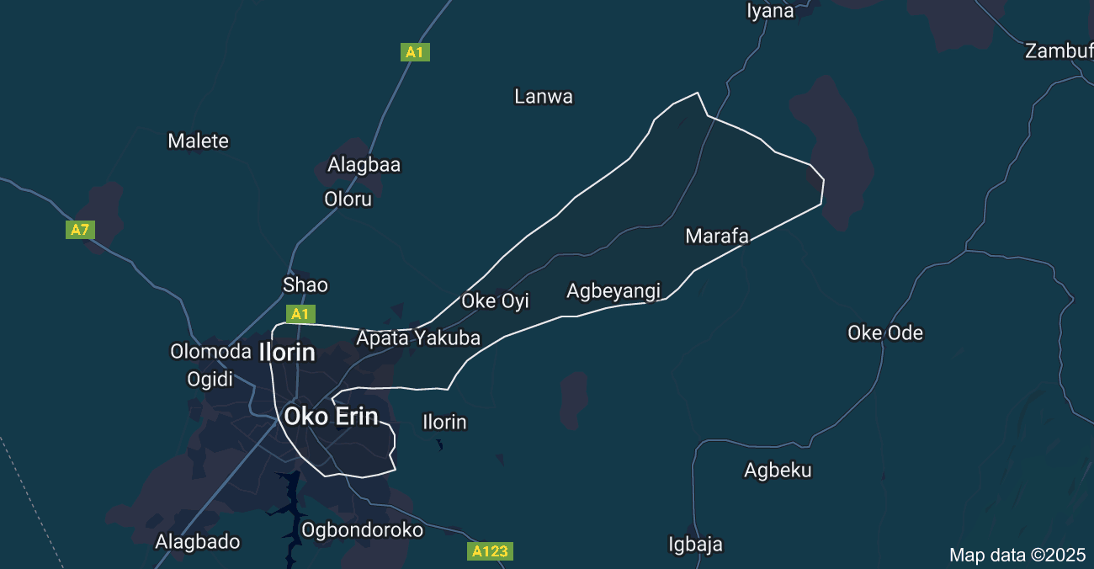
Ilorin East Local Government, one of 16 in Kwara State, has a rich history from pre-colonial trade to modern development. Key landmarks include the University of Ilorin, Ilorin International Airport, and the Central Mosque. The project area spans Kulende Junction to Oke Oyi, covering 14 km

1.9 Personal Assigned for the project
Fieldwork Participants
The following students participated in the fieldwork for this project:
S/N | Name | Matric No.
1 | Olatunbosun Abolade C. | HND/23/SGI/FT/0001
2 | Lawal Zainab O. | HND/23/SGI/FT/0002
3 | Abiola Aminat T. | HND/23/SGI/FT/0010
4 | Olagunju Segun | HND/23/SGI/FT/0003
5 | Omotosho Jamiu O. | HND/23/SGI/FT/0005
6 | Safadeen Akanfe O. | HND/23/SGI/FT/0004

CHAPTER 2

2.0 LITERATURE REVIEW

2.1 Introduction
The distribution of educational facilities, particularly primary and secondary schools, plays a fundamental role in achieving equitable access to education and fostering balanced regional development. In many developing countries, including Nigeria, disparities in school location and accessibility continue to be a major challenge, especially in rural and peri-urban areas. The physical proximity of schools to residential areas often determines enrollment rates, school attendance, and ultimately educational attainment. When schools are unevenly distributed, certain populations—especially those in remote or underserved communities—face considerable barriers in accessing quality education, thereby exacerbating existing socio-economic inequalities.
With the rapid growth of population and urbanization in Nigeria, there is an increasing need for tools and methodologies that support effective spatial planning and resource allocation in the education sector. Geographic Information Systems (GIS) have emerged as a powerful tool for capturing, managing, analyzing, and visualizing spatial data related to educational infrastructure. GIS facilitates the identification of spatial patterns and disparities, enabling planners and policymakers to make informed decisions about the placement of new schools, upgrading existing facilities, and ensuring more equitable distribution of resources.
This chapter presents a review of literature relevant to the spatial analysis of educational institutions using GIS, focusing on how GIS methodologies have been employed globally and within Nigeria to assess school distribution, accessibility, and service delivery. Particular attention is given to the Nigerian context, where studies have explored regional imbalances in educational infrastructure. The review also highlights gaps in the literature specific to Kwara State, especially in Ilorin East and Moro Local Government Areas, thereby justifying the relevance of this study.
In examining past research, the chapter addresses key themes such as the conceptual framework of GIS, its application in educational planning, the importance of spatial equity in school distribution, and the integration of GIS in identifying underserved areas. The insights gained from this literature form the foundation for the present study, which aims to apply GIS techniques to analyze and improve the spatial distribution of primary and secondary schools in the selected parts of Kwara State.
This chapter reviews existing literature relevant to the distribution of primary and secondary schools, the application of Geographic Information Systems (GIS) in educational facility planning, and theoretical frameworks that underpin spatial analysis. The review will establish the research gap that this study aims to fill, particularly focusing on Ilorin East and Moro Local Government Areas (LGAs) of Kwara State, Nigeria.

2.2 Conceptual Clarifications

2.2.1 Concept of Distribution of Educational Facilities
Educational facilities distribution refers to the spatial arrangement and location of schools within a given geographical area to adequately serve the population. According to Akintayo (2015), the spatial distribution of schools should ensure equitable access for all segments of the society, regardless of location, gender, or socio-economic status. Effective distribution minimizes the distance students travel to access schools, enhances enrollment rates, and promotes educational equity.

2.2.2 Importance of School Distribution

Proper school distribution:
- Reduces transportation costs and travel time.
- Increases student enrollment and attendance.
- Supports community development by encouraging settlements near schools.
- Promotes gender parity, as shorter distances are especially important for female students (UNESCO, 2016).

2.3 Geographic Information Systems (GIS) in Educational Planning
GIS refers to computer-based tools for capturing, storing, analyzing, managing, and presenting spatial data. In educational planning, GIS offers numerous advantages, including:
- Mapping existing school locations.
- Analyzing the spatial distribution relative to population density.
- Identifying underserved or overserved areas.
- Predicting future needs based on population growth trends.

According to Yusuf et al. (2017), GIS provides a powerful decision-making tool for governments and planners to optimize the siting of educational facilities.

2.3.1 Advantages of GIS in Educational Distribution Analysis
- Visual representation of data enhances understanding.
- Facilitates the integration of multiple variables (population, road networks, topography).
- Enables dynamic updating and simulation for future planning (Egboka & Nwankwo, 2014).

2.3.2 Application of GIS in Previous Studies
Studies such as Olatunji (2019) have used GIS to evaluate school accessibility in Lagos, finding significant disparities between urban and rural settings. Similarly, Okafor (2018) applied GIS to assess the distribution of public schools in Enugu State, concluding that most rural areas were underserved.

2.4 Theoretical Framework

2.4.1 Central Place Theory
Proposed by Walter Christaller in 1933, the Central Place Theory explains the distribution patterns of services, including schools, across a region. It suggests that central places (like towns or major villages) provide services to surrounding hinterlands, with distance and population size influencing the location of facilities (Abiodun, 2015).

2.4.2 Gravity Model

The gravity model in geography predicts that larger schools (in terms of facilities or reputation) attract more students, but the number of students decreases as the distance from the school increases (Onokerhoraye, 2016).

2.4.3 Location-Allocation Model in GIS
This model identifies optimal locations for services based on minimizing travel distance and maximizing service coverage. It is widely used in GIS applications to ensure equitable distribution of schools (Longley et al., 2015).

2.5 Educational Facility Distribution in Nigeria

2.5.1 National Overview
Nigeria’s educational infrastructure shows significant disparity between urban and rural areas. Studies (Ajayi, 2014; Ogundele, 2017) reveal that urban centers are generally better served with educational facilities compared to rural regions, where students often travel long distances to the nearest school.

2.5.2 Factors Influencing School Distribution
Several factors influence the location and distribution of schools:
- Population density: Areas with higher population often have more schools.
- Political influence: Location decisions are sometimes driven by political rather than educational needs.
- Topography and accessibility: Difficult terrain often discourages the establishment of schools (Ogundare, 2013).
- Economic activities: Areas with higher economic activity levels attract more schools.

2.6 Previous GIS-Based Studies on School Distribution
Several researchers have utilized GIS in analyzing educational facilities distribution:
- Aderamo (2007) analyzed the distribution of secondary schools in Ilorin and found clustering in urban areas with sparse distribution in peri-urban and rural zones.
- Ogunlade and Ayodele (2015) in Oyo State demonstrated that most rural dwellers travel more than 5 km to access basic education, negatively affecting attendance rates.
- Ishola et al. (2020) applied GIS to map school accessibility in Ogun State, showing that equitable distribution leads to improved literacy rates and social development.

2.7 The Study Area Context: Ilorin East and Moro LGAs
Ilorin East is part of the metropolitan area of Ilorin, with better infrastructural development and a relatively higher concentration of schools compared to Moro, which is predominantly rural with scattered settlements. The difference in settlement patterns, population densities, and road networks suggests potential disparities in school distribution that this study seeks to analyze using GIS.

2.8 Gaps in Literature
Despite the wealth of studies on educational facility distribution, relatively few have focused specifically on the localized analysis of Ilorin East and Moro LGAs using GIS. Most existing studies concentrate on broader state-wide assessments or focus solely on urban centers. Furthermore, few have provided practical location-allocation models for proposing new school sites based on accessibility and demographic needs.

2.9 Summary
While many studies have used GIS to evaluate school distribution across Nigeria, there is limited research specific to Ilorin East and Moro LGAs. Most existing works are either broad in scope or outdated. Additionally, fewer studies incorporate detailed survey data that reflects the current realities in these areas.
This study, therefore, seeks to fill that gap by using both field survey and GIS techniques to analyze the distribution of primary and secondary schools in selected parts of Ilorin East and Moro LGAs.
Author(s) | Year | Focus Area | Findings
Burrough & McDonnell | 1998 | GIS Concepts | GIS is essential in managing spatial patterns and geographic relationships
Longley et al. | 2015 | GIS in education | GIS helps identify spatial disparities in school distribution
Adebayo et al. | 2014 | Oyo State, Nigeria | Urban clustering of schools leads to rural marginalization
Adeyemi & Ukoje | 2017 | FCT Abuja | GIS revealed accessibility gaps, especially in rural areas

