CHAPTER FOUR
4.0 Result, Test and Discussion
This chapter present the result gather from the text of the installation of 4.2kva hybrid different condition, the main objective analyzed include solar power generation, the efficiency of the inverter system and stability of the voltage.
4.1 The specification of the Solar power and efficiency.
This system consist of eight monocrystalline panel which contain of four 200W and four 250W of 36.50V with different current which are 5.48A and 6.85A. mathematically
P=IV
When
p= power measure in watt
I= current meaasure in ampere
V= voltage measure in volt.
P=IV
P= 5.48A * 36.50= 200W.
P= 6.85A * 36.50V = 250W.
The solar panel was connect in series to increase the voltage and the theoretical photovoltaic input power is 1800W or 1.8kva and the real performance varies slightly because of some environmental factor such as the temperature and sunlight intensity.
panel type | power (W) | Voltage ( V) | current (A) | Quantity | total power
monocrystalline | 200W | 36.50V | 5.48A | 4 | 800W
monocrystalline | 250W | 36.50V | 6.85A | 4 | 1000W
Total | - | - | - | 8 panel | 1800W
Figure 4.1 the specification of solar panel and efficiency
4.2 The Generation of solar power through the day
The photovoltaic output charges through out the day was determine by the position of the sun and weather condition.
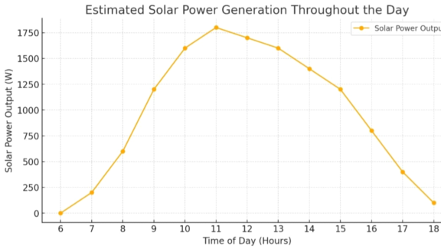Figure 4.2.The Generation of solar power through the day

4.3 The Performance of the Battery
On this installation two 12v tubular battery was use which are connected in series to increase the voltage of the battery and the energy storage of the battery can be calculated.
Mathematically:
Energy(WH)=Voltage * Capacity
The energy store in the battery (Wh) = (AH) * V
220Ah * 24= 5,280Wh or 5.28kwh
4.4 Hybrid Inverter Performance
The 4.2kva hybrid inverter install was use which can withstand the maximum load capacity of 4200W or 4.2kva with a maximum efficiency of 97% and the operating frequency of 50\60 Hz and then the nominal output voltage of 220\230\240v and handle the expected load with stable voltage output.
4.5 Voltage Balance under Different Load Condition
The hybrid inverter output voltage remain stable under the various load condition
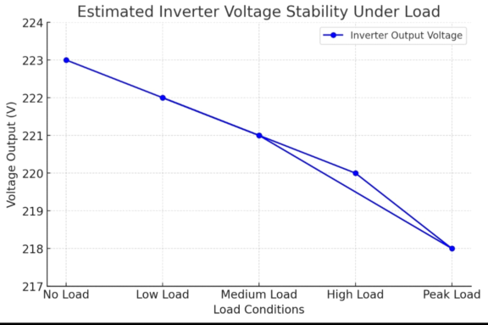
Fiqure.4.5 voltage balance under different load condition
The hybrid system mantained an efficiency of 93% which was close to the expected 97% under norminal condition with a minor voltage fluctuation were observed and also remain within safe operating limit under peak loads.

