CHAPTER THREE
3.1.1 Solar panel
A photovoltaic (PV) is an important component of a solar energy system, which comprises cells. It is a device that absorbs sun energy that penetrates through it, which is in the form of heat, and converts the energy into DC electrical energy. Then a monocrystalline panel was used for this installation, which is one of the types of solar panels. The monocrystalline solar panel is made from a single piece of silicon, which makes it easier for electricity to flow through it. The monocrystalline panel has a pyramid cell pattern, which offers a larger surface area, enabling the monocrystalline panel to collect a greater amount of energy from the sun. The monocrystalline use was comprised of 72 cells, which are made from silicon, and each cell produces 0.5 V.
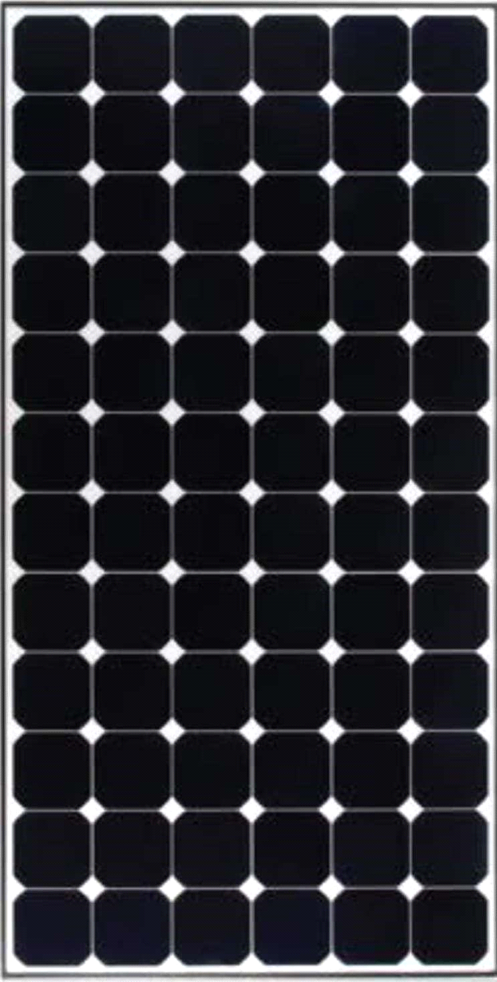
Fig. 3.1.1: A monocrystalline solar panel.

Reason for using a monocrystalline solar panel
⦁ Monocrystalline panels typically have the highest efficiency rates among common panel types, which makes them generate more power.
⦁ It performs better in low-light conditions, e.g., early morning or cloudy days.
⦁ Monocrystalline panels often have longer lifespans and better build quality with high resistance to heat and weathering.
⦁ Monocrystalline panels typically have higher power capacity, meaning they can produce more electricity.
⦁ Monocrystalline panels are less affected by temperature than other types of panels, meaning they maintain their efficiency better in hot weather.
3.1.2 Battery Bank
A battery bank was used to store excess energy to provide backup power or off-grid electricity. On this installation, a 12V, 220AH tubular battery was used, which is one of the most popular and efficient inverter batteries. They have a complex design, great efficiency, a longer operational life, and low maintenance. Because of so many advantages, they are costly.

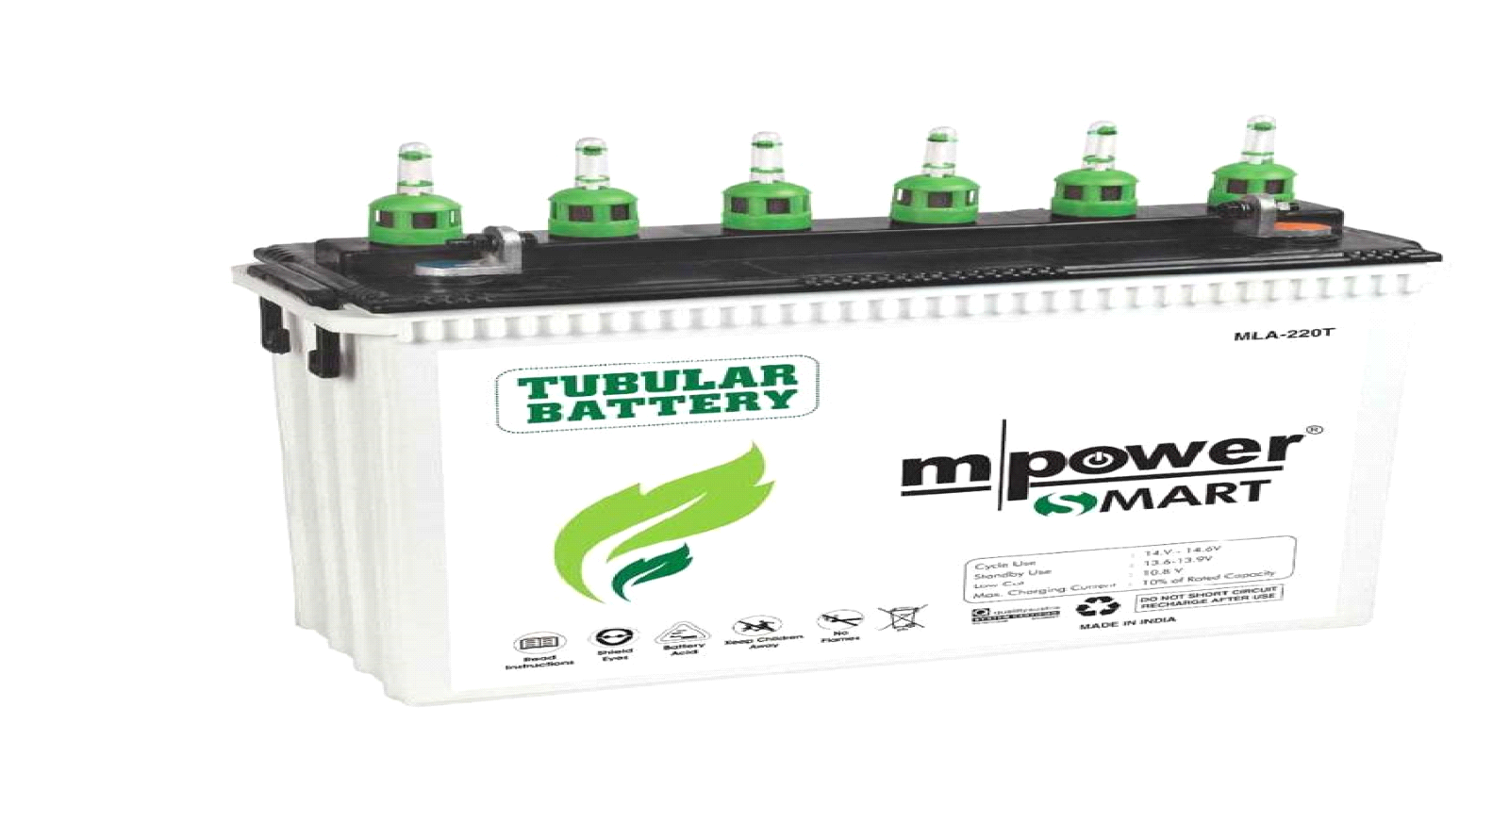

Fig.3.1.2. A 12v 220AH tubular battery
Advantages of Battery Bank
⦁ A tubular battery has a longer lifespan because it can be refilled with distilled water when the water level is low.
⦁ Deep Discharge Capacity.
⦁ High efficiency.
⦁ Low maintenance.
⦁ High load support
⦁ Better performance at high temperatures.
Disadvantages of Tubular Battery
Due to many advantages, the tubular battery is a
⦁ Highly costly in price
⦁ Heavier
⦁ Longer charging time
⦁ Initial maintenance.
Comparing both advantages and disadvantages together, a tubular battery is still recommended and preferable.
3.1.3 Hybrid Solar Inverter
A hybrid solar inverter, as its name implies, is a combination of two or more different things. 4.2KVA. A hybrid solar inverter was used for this project and is a piece of equipment that is created by combining a solar inverter, battery bank, and the utility grid all at the same time. This helps to convert the direct current (DC) direct current electricity generated by the photovoltaic to (AC) alternating current used to power the appliances that use (AC) as input. This 4.2 KVA hybrid inverter also helps or makes it possible to send excess electricity for consumption. The hybrid inverter stores charges on the battery for use in the night and gives a power output on the day without absorbing from the battery except when the PV system is not generating enough power due to weather conditions or the load (output consumption ) is higher than the available PV power. This 4.2 kVA hybrid inverter has an internal charge controller (MPPT), maximum power point tracking, to ensure that the solar panel array operates at its maximum available power from the sun.
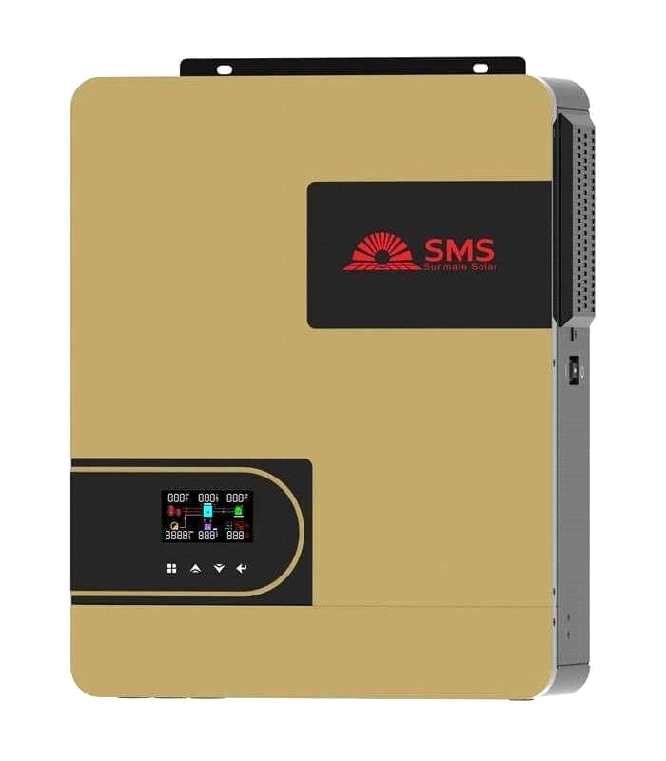 Fig.3.1.3. Hybrid inverter
The general specification of 4.2KVA hybrid
PV INPUT (solar input )
⦁ Nominal operating voltage: 240Vdc
⦁ Vmax PV (maximum photovoltaic voltage): 500 Vdc
⦁ PV input voltage range 60–450 Vdc
⦁ Imax PV (maximum photovoltaic current): 18A
⦁ Full load MPPT range: 240–450 Vdc
⦁ Maximum PV Input power: 6200W
⦁ Maximum Solar Charging Current: 120A
GRID/AC OUTPUT
Nominal Output Voltage: 220/230/240 Vac Feed-in Grid Voltage Range: 195–253 Vac Feed-in Grid Frequency Range: 50 ± 1 Hz
Nominal output current 18.2A
Power Factor Range: >0.99
Maximum Conversion Efficiency (DC/AC): 97%
Nominal Operating Frequency: 50/60 Hz
TWO LOAD OUTPUT POWER
Full Load: 4200 W
Maximum Main Load: 4200 Load
Maximum Second Load: 1400 1400W
Main Load Cutoff Voltage: 26Vdc
Main Load Return Voltage: 27Vdc
AC INPUT
Nominal operating voltage: 230 Vac
Maximum input current: 30A
Nominal operating frequency : 50/60 Hz
Surge Power: 8400 VA
Maximum AC charging current: 100 A

BATTERY
Battery Voltage: 24Vdc
Maximum battery current.

3.1.4 DC CABLE
The DC cable was used in this installation for connecting the DC devices together, such as connecting the panels together, batteries, and inverter. The DC cable helps to handle direct current (DC) to ensure safe and efficient current flow without overheating or damage; it also helps to minimize power loss.
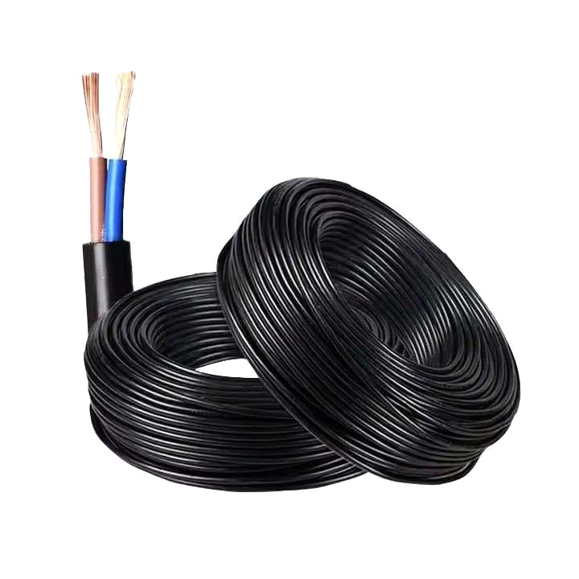
Figure 3.1.4 DC Cable.
3.1.5 AC Cable
AC cables were used to connect the load to the hybrid inverter and can also be used to connect the hybrid inverter to the grid, which are essential to safety and effectively transferring AC power. Using DC cables for this could cause overheating, voltage drop, power loss, or safety risks due to incorrect insulation and ratings.
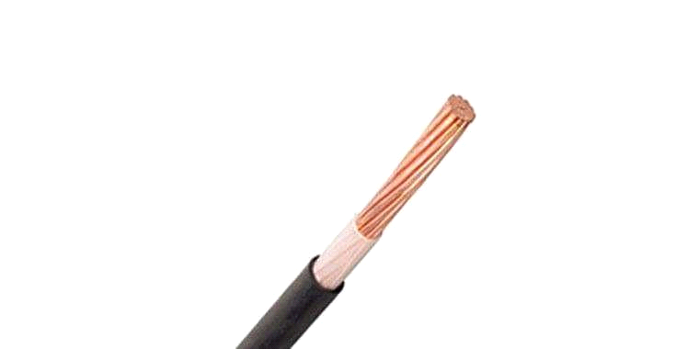 Fig.3.1.5 AC Cable.

3.1.6 Circuit Breaker
A circuit breaker is a safety device used to protect an electrical circuit from damage caused by over current, overload, or short circuit. The reason for using the circuit breaker in this installation is to automatically interrupt the flow of electricity when a fault is detected. There are two different types of circuit breaker used in this installation, which are AC and DC circuit breakers, which serve similar protective functions but are designed differently due to the nature of AC and DC current.
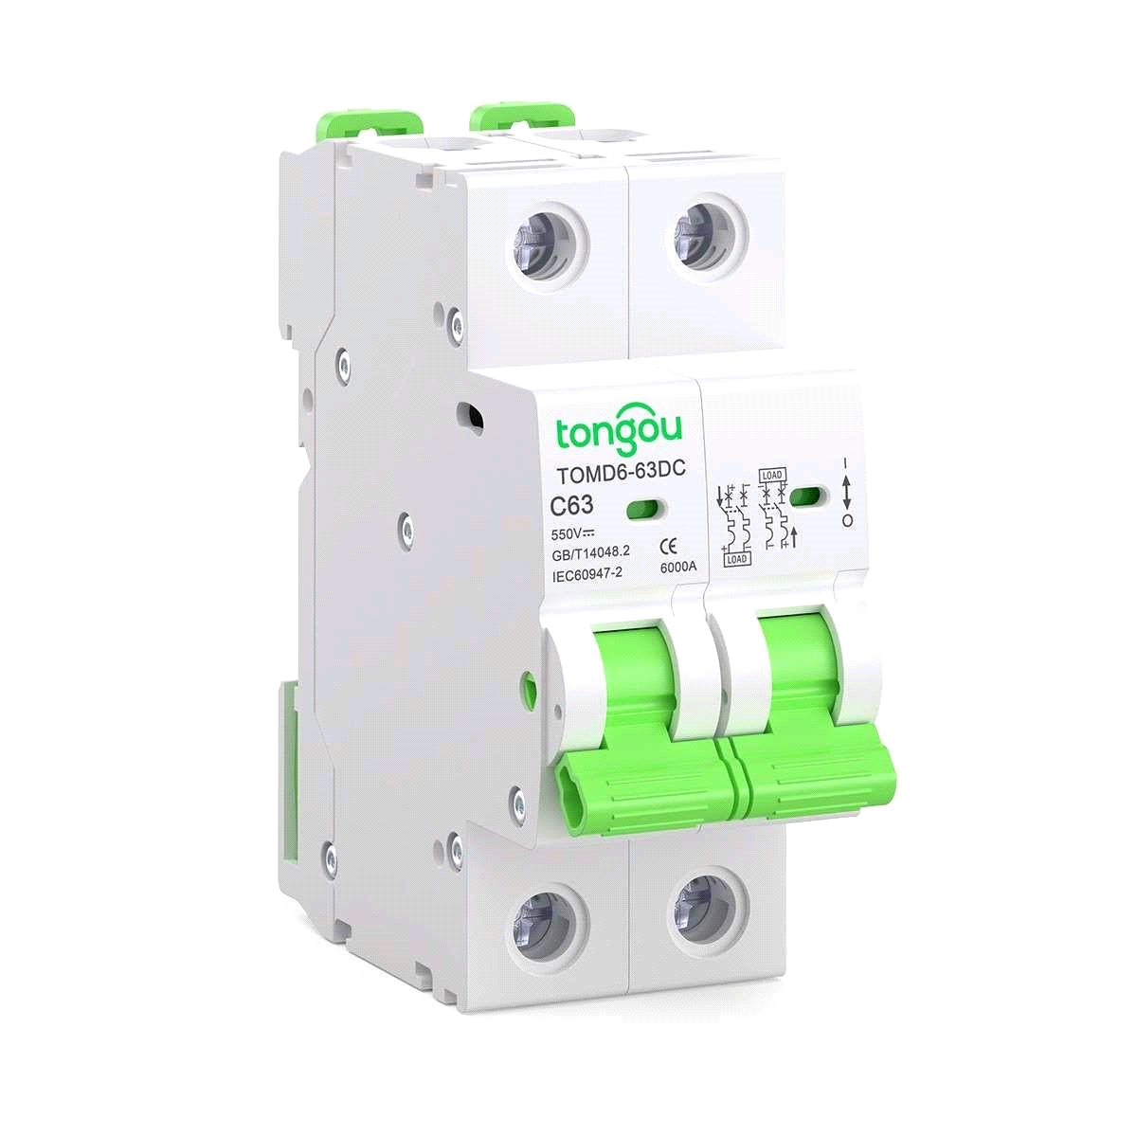
Fig.3.1.6. DC Circuit Breaker
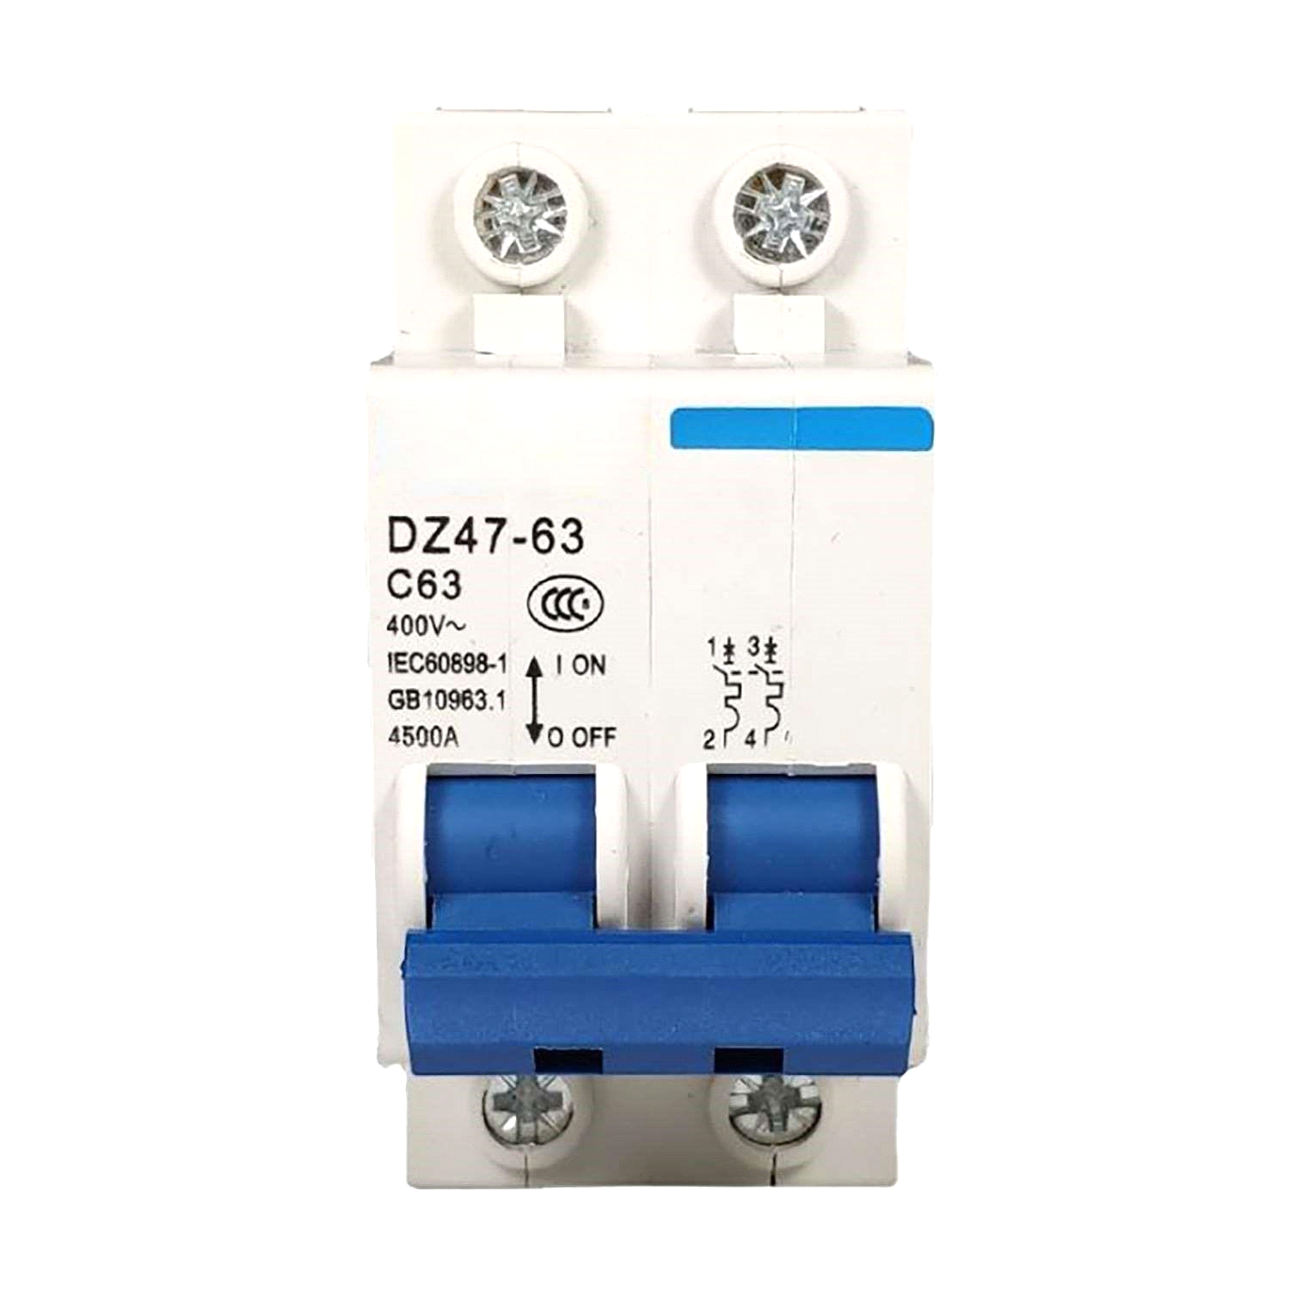
Fig.3.1.7. AC Circuit Breaker
3.1.8 Mounting Hardware
Mounting hardware is the various components and accessories used to attach, secure, and stabilize devices, equipment, or objects to a surface or structure. Mounting hardware was used in this installation to secure the battery on the ground and the solar panel on the roof using a metal rack and to mount the hybrid inverter on a plane surface by using a rubber peg and bolt.
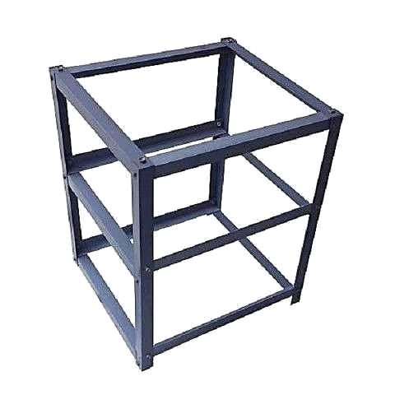
Fig.3.1.8. Metal rack.

COMPONENTS QUANTITY NOTES
Solar panels 8(4x200W,4x 250W ) In series string
Batteries 2x 12V, 220Ah Connected in series for 24v
Inverter 4.2KVA (in built MPPT) Pure sine wave
DC CABLES 1 COIL As recommended
AC CABLES 1 COIL As recommended
3.2 CONNECTION
This explains how the components were connected together.
Four 200W solar panels and four 250W solar panels were connected in series , connecting the positive (+) of the first panel to the negative (–) of the next, continuing until all 8 panels were in one series string. Connecting the final positive (+) and negative (–) ends of the series string to the solar input terminals of the inverter (with built-in MPPT). Connecting two 12V 220Ah batteries in series (positive of first to negative of second) to form a 24V battery bank. Connecting the battery terminals to the battery input of the inverter. Connecting the AC output of the inverter to the institute distribution board (load) with proper circuit breakers. installing surge protection and grounding at key points.

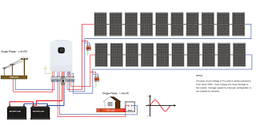
Figure. 3.2 Illustration of diagramatical connection of inverter.

