CHAPTER TWO
2.0 LITERATURE REVIEW
2.1 Overview of hybrid inverter
The population of the world and its energy demands are increasing day by day. Today most of our energy demands are dependent on nonrenewable energy sources [1]. Due to the limited amount of nonrenewable energy resources, we can't depend on them forever; therefore, it is necessary to have some other sources of energy. According to a survey in 2015, 93 percent of electricity was being produced from a combination of coal, natural gas, hydropower plants, nuclear power plants, and oil, where only 7 percent was being produced from renewable energy sources. [2]. We must find a method to get more energy from renewable energy resources, as it is eco-friendly and economical. [3] Discuss the hybrid inverter system. When an AC power outage occurs, the battery storage should be preserved. The battery will be accurately charged by a solar AC grid source during the day or in muddy conditions when source light is available. In any case, the battery will be charged. [4] Introduce a hybrid energy system that uses solar power in addition to main power as its primary source. Depending on energy availability, the system design enables the battery to receive energy from the two sources and use it to power the load separately or simultaneously. That will be useful in rural and hilly regions. The paper focuses on a hybrid battery design and its application. In the design they were able to overcome the battery of solar energy limitations. An inverter powered by a 12-volt battery powers the solar battery charging system, and the inverter creates up to 230 V AC. Thus, batteries are charged from two sources: main power and solar energy. If the main power is available, then the relay switches to the main power supply for applying the load.
The hybrid inverter operates primarily on wind turbine, main power, and solar energy, providing a reliable power supply to loads under all conditions. This is because it functions as an uninterruptible power source, offering various operating modes such as solar and wind modes. If they are unavailable, the hybrid mode can be enabled as a backup [5]. A system that draws power from two or more sources is called a hybrid power system. Solar PV systems cannot generate electricity at night or in overcast conditions. In the winter, however, sunlight intensity is low, allowing for maximum electricity production. [6]. In the event that all energy sources are unavailable, a battery that is also connected to the system will serve as a backup power source. The electric utility will retain the power utilization from renewable energy sources and use it as a power source. As the electric power system becomes more dependable, a hybrid inverter has an advantage over a single power source.
2.1.2 Types of hybrid inverter
Discusses in his paper that there are four hybrid inverters, which are the basic hybrid solar inverter, multimode hybrid solar inverter, all-in-one battery energy storage system (BESS), and advanced AC-coupled system. Basic Hybrid Solar Inverter: This is a common type that allows solar energy storage in a battery but may not reliably supply power during outages as it isn't connected to the grid. Multimode Hybrid Solar Inverter: An advanced inverter with a built-in backup or a separate unit, enabling battery charging and usage during power cuts.
All-in-one Battery Energy Storage System (BESS): This new hybrid solar inverter includes both batteries and an inverter, easily adaptable to existing solar systems. Advanced AC-Coupled System: These systems employ a DEYE hybrid inverter for battery charging and are simple to use for powering AC loads, though slightly less efficient than DC-coupled systems. Efficiency can be improved by using multiple hybrid solar inverters.
2.1.3 Important feature of hybrid inverter
Hybrid inverters can operate during off-grid and on-grid conditions. During on-grid conditions, both energy sources, i.e., solar and grid, are used, whereas during off-grid conditions, stored energy in the battery is used to power household items, as mentioned by T. Mallickj et al. [7]. When the power generation is greater than the power demanded by loads, the controller decides how much power to deliver to the load and how much for the battery charging. [8] Mention that hybrid inverters play a crucial role in modern energy systems by:
Maximizing solar energy utilization: They efficiently convert DC power from solar panels to AC power for immediate use and simultaneously charge batteries for later consumption, reducing reliance on the grid.
Providing reliable backup power: During power outages, hybrid inverters seamlessly switch to battery power, ensuring critical appliances and systems remain operational.
Enabling energy independence: By storing excess solar energy, they allow homeowners and businesses to consume self-generated power, reducing electricity bills and dependence on traditional energy sources.
Facilitating smart energy management: Advanced hybrid inverters often integrate with smart home systems and energy management platforms, allowing users to monitor and control their energy consumption, optimize energy usage, and participate in demand response programs.
Integrating battery storage: The integration of battery storage into one device simplifies installation and reduces cost compared to separate solar and battery inverter systems.
Supporting off-grid applications: Hybrid inverters can be used in off-grid or microgrid applications, providing a reliable power source in remote areas or locations without grid access to national energy sources.
Advantages of hybrid inverter: higher power output, Reliable backup power, optimized solar energy cost savings, smart monitoring, and longer battery life.

2.2 Technology related to inverter
2.2.1 Solar router
Through an intuitive interface, the solar router also lets the user know how much electricity is generated, and control, optimization, and management of the generated energy are made possible by solar routers. [12]. Energy generated by a solar system that is not being used can be transferred to the national grid, and the amount of electrical energy being sent to it can be displayed. This solar router helps in selecting the energy source. For example, a consumer can choose the energy source manually, which may be solar or power from an electric utility company. [13]. Moreover, this system also allows you to control or monitor the hybrid system remotely through an application on a smartphone or on computers and laptops. [14]. show in figure 1
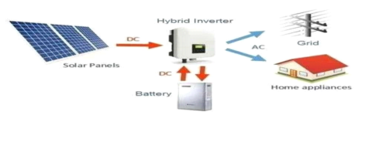
Fiqure. 2.2.1 Solar Router.

2.2.1.1 Features
⦁ Compact in size
⦁ Fully integrated with the national grid
⦁ Reliable and strong construction
⦁ A built-in solar charger (MPPT)
⦁ 220v _ 240v (sine wave )
⦁ Control microprocessor
⦁ A stable charge system
2.2.1.2 Red back technology
Redback Technology is a company that aims to change the way of electrical household usage. The hybrid system of this company stores solar energy during the daytime up to the maximum level by using batteries so that when there is unavailability of solar energy, power can be provided to the household items that operate on electricity. This initiative can help power authorities in many ways; for example, an owner can sell electricity produced by solar panels to the national grid.
Although there are many companies that are manufacturing hybrid inverters, Redback Technology is the only company that is popular for manufacturing a hybrid system that is economical to use. [15]. The Redback hybrid inverter was 30 percent less costly than that of other products. New safety measures are taken by Redback Technologies, as all switchgear is prewired and tested in the industry before releasing the product in the market. The Redback system is more adaptable and dynamic from the software perspective, and its architecture monitoring is being improved continuously.
2.3 Project related to hybrid inverter
2.3.1 Solar hybrid inverter
A hybrid inverter is a new type of uninterruptible power supply (UPS) that supplies electrical energy for household items. Maximum production from solar panels is produced around midday. Electricity produced from solar is not enough, whereby the MPPT charge is used to yield the output at a desired voltage level, as illustrated. [16]. Hybrid inverters store maximum energy during the daytime, and then later on, this stored energy can be utilized during the night.
The output of a solar panel changes with the movement of the sun. If the sun is directly above the solar panel, we will get the maximum possible voltage, but if the sun is away from the panel, then the voltage will not be sufficient by Abdur Rafay and three others. [17]. So far, for making the output voltage constant, we use MPPT (maximum power point tracking) charge control. Maximum power point tracking, or MPPT, charge control is what we employ. In essence, MPPT is a buck-boost converter that keeps the solar panel output voltage constant. The buck-boost converter will function as a buck-boost converter and scale down the voltage to a desired level if the sun is directly overhead, and the output voltage is high. In a similar manner, the converter raises the output voltage to the required amount if the sun is not penetrating the panel.
2.4 Usage of hybrid inverter during different modes.
There are 4 modes in which a hybrid inverter can be used. The modes are off-grid mode, on-grid mode, hybrid mode, and backup mode. The block diagram below will describe each of them.
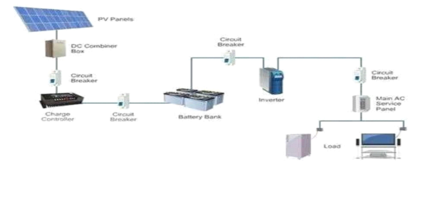Figure. 2.4.1 Off Grid mode.
2.4.1 Off Grid mode
Off-grid inverters are standalone systems, relying solely on solar and battery power. They convert DC power from solar panels and batteries into AC power for use in homes or businesses. They do not connect to the utility grid and operate independently. ALSO Rely on batteries for backup power during outages. And energy storage requires batteries for energy storage.[18].
A solar panel is linked to it during off-grid, and the battery bank should be connected to the inverter to provide power supply to the load.
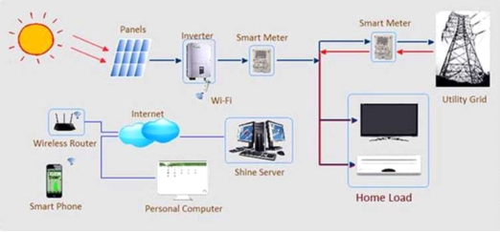
Figure. 2.4.2 On Grid mode
2.4.2. On Grid Mode
On-grid modes are designed to work directly with the utility grid, feeding excess solar energy back into it and synchronizing its output with the grid's frequency and voltage. On grid mode is used for selling extra energy to the national grid
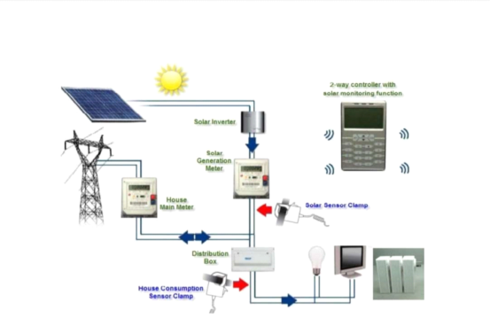
Figure. 2.4.3 Hybrid mode.
2.4.3 Hybrid mode
Hybrid mode is the combination of off-grid and on-grid modes. A hybrid mode is created by combining a solar inverter and the main power source into a single unit. This allows the hybrid solar inverter to intelligently handle power coming from your solar panels, solar batteries, and the utility grid all at the same time.[19].
For smart energy management, we use hybrid mode in which battery bank operates the inverter.
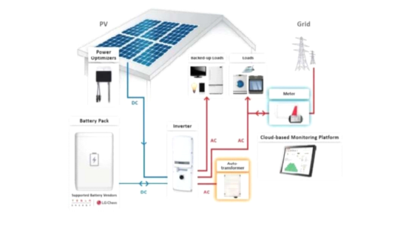
Figure. 2.4.4 Backup mode.
2.4.4 Backup mode
Backup mode is used when there is blackout and it switches itself to off grid system.[18].

2.5 SOLAR PANEL
A PV module, sometimes referred to as a solar panel or photovoltaic module, is a device that uses the photovoltaic effect to directly convert sunlight into electrical energy. It is an essential part of solar power systems, which use the sun to generate renewable energy. When exposed to sunlight, a PV module's numerous linked solar cells—which are usually composed of silicon-based materials—produce energy. To guarantee longevity and resilience to environmental influences, these solar cells are encased in a protective substance, like tempered glass. A flow of electricity is produced when photons in the sunlight activate the electrons in the solar cells on the PV module's surface. Direct current
DC is the form of electricity that is produced. An inverter is frequently used to transform DC power into alternating current (AC) electricity so that it is compatible with conventional electrical systems. PV modules differ in terms of efficiency, power output, and size. They can range from tiny panels for battery charging or powering little gadgets to huge installations for utility-scale solar power systems in residential or commercial settings. PV's output power, which is expressed in watts (W), depends on a number of variables, including the module's surface area, the solar cells' efficiency, and the amount of sunshine.
Over time, PV modules have grown more affordable and effective, which has helped solar energy become a more popular clean and sustainable electricity source. They play a crucial role in utilizing solar energy for a variety of purposes, such as off-grid installations, remote power systems, and the production of electricity for homes and businesses. [20].
2.5.1 TYPES OF SOLAR PANEL
Monocry stalline solar panels are made from a single piece of silicon, therefore making it easier for electricity to flow through. They have a pyramid cell pattern, which offers a larger surface area, enabling monocry stalline PV panels to collect a greater amount of energy from the sun's rays.
Polycrystalline PV panels are created from several parts of silicon being melted together, which makes it more difficult for electricity to flow.
Thin-film PV panels are made from one or more layers and are the least efficient photovoltaic panels available. [21].
Concentrated photovoltaic power generation uses the same photovoltaic material as PV panels, and the solar radiation is concentrated through lenses on the material.
Various solar cell panels available along with their efficiency, advantages, and disadvantages. [22].

Types of solar panel | Efficiency % | Advantages | Disadvantages
Monocrystalline panel | -20 | High lifetime and Efficiency, Used for commercial application | High Cost
polycrystalline panel | -15 | Cost Effective | Low life and Efficiency, sensitive to variation in temperature, short Life span
Thin flim: amorphus silicon solar panel | -17-20 | Cost, Effective, Flexible | Short lifespan
Concentrated PV Cell | -42 | High efficiency and performance | cooling system required
Figure. 2.5.1 Various solar cell panel
2.6 Battery Bank
A battery bank is a collection of one or more batteries connected together to store electrical energy, often used to power systems or devices when grid power is unavailable or unreliable. Battery banks serve as a storage system for electrical energy, allowing it to be used later when needed. They are used in various applications, including Renewable energy systems: storing energy from solar panels or wind turbines. Uninterruptible power supplies (UPS): Providing backup power during power outages. Electric vehicles: Storing energy for propulsion. Telecommunications: Providing backup power for critical infrastructure.[23].

2.6.1 Types of Batteries
Batteries can be categorized in terms of the materials used to build them. They define it in terms of capacity, cost, and area of usage. In this categorization there are four major types.
⦁ Nickel-cadmium (Ni-Cd) battery
⦁ Nickel-metal hydride (NiMH) battery
⦁ lead-acid battery
⦁ lithium-ion battery
⦁ lithium polymer.
A key factor in prolonging battery life and obtaining optimum performance from it is a proper charging environment. This is only possible if the charging and voltage are properly controlled and matched to the battery temperature. The circuitry to recharge the batteries in a portable product is an important part of any power supply design. The complexity and cost of the charging system are primarily dependent on the types of battery and the recharge time [23].

