CHAPTER TWO
LITERATURE REVIEW
2.1 Introduction
This section focuses on the work of others scholars as regards the impact of advertising on performance of insurance firms in Nigeria. Advertisement and promotion are some of the most effective tools of marketing. According to Stanton (1978) cited in Ezeoha(2007) opine that promotion is an exercise in information, persuasion and influence. Its aim is to reinforce positive behavior or change a negative behavior towards a product. Promotional activities include; Advertising, Publicity, Personal selling, Public relations, Sales promotion, Trade fairs and exhibitions etc. Predominantly, in this chapter, discussions are concentrated on advertising. Modes and methods of advertisement, effects of advertisement on products and literature on how advertisement and promotion can affect insurance policy or insurance firms’ product awareness, the history of insurance industry in Nigeria and the insurance market would be reviewed. Essentially, the conceptual theoretical and Empirical framework of advertising and its impact on the performance of insurance industry are hereunder discussed;

2.2 Concept of Advertising
Advertising plays an important role in our everyday life. It mainly determines the image and way of life and it has an impact on our thinking as well as on the attitude towards ourselves and the world around us. Advertising shows us ready forms of behavior in a certain situation. It determines what is good and what is bad. We buy what people say or "advise”. I chose this topic because it is very relevant today and it is interesting by its complexity and psychological essence. Everyone, even without realizing it, is influenced by advertising. We do not notice how it affects us. We have become slaves of scientific and technical progress, and advertising uses that skillfully.
The pressure of advertisement is growing every day. A significant amount of money is spent on advertising campaigns bringing to the companies multi-billion profits. Moreover, it is a "product of the first necessity" for any enterprise, aimed at a commercial success, and it is becoming more and more expensive. According to statistics media the money spent on advertising in Finland was 1313,1 million euro in 2012 and 1206,7 million euro in 2013. (Finnish Advertising Council, TNS Gallup, Ad Intelligence 2014)
Advertising is directly linked to politics. It determines not only the purchase of toothpaste, but also the choice of political candidate. In the end it determines the path of political development of the country and the politics itself. This function of advertising is very important in our society.
Advertisement appeared a long time ago. Its existence in prehistoric times is confirmed, for example, by an Egyptian papyrus with the information of the upcoming sale of a slave. Advertising in those days was presented by written or oral announcement touting a particular product or service. The oral advertising was spread by some sort of barker. Besides papyrus scrolls and wax boards, the written advertising was embodied in inscriptions on roadside rocks, as well as on buildings. As nowadays, there was a promotion of almost everything - olive oil and amphorae to keep the oil, oxen, horses and other livestock, tools and weapons. There was advertising of services as well: in the announcements of that distant era, there were calls to visit a pub that sells unique snacks and wine, or an invitation to visit public baths. (Feofanov, 2004).
However, the advertising would probably have not expanded so much, if once human had not discovered the era of mass communication. The first impetus for this was typography. Another important development was the invention and subsequent spread around the world of the art of photography in the mid- 19th century. A photograph has served as an irrefutable proof of benefits of the advertised product(Presbrey, 2009).
However, the most important developments in the global advertising business were made in the 20th century. It is no exaggeration to say that the 20th century was the “century of advertising”- at that time there were profound changes and innovations in the field of technology and advertising. It was the 20th century when advertising became this so popular – primarily due to the unprecedented growth rate of world industrial production, as well as due to the appearance of more and more sophisticated means of creating and distributing advertisements: multicolor printing, analog and then digital radio, television, satellite communications, and finally, computers and the Internet. Advertising is day to day becoming more professionally organized and more quality performed (Presbrey, 2009).

2.2.1 Nature of Advertising
Advertising is impersonal communication of information about products, services or ideas through the various media, and it is usually persuasive by nature and paid by identified sponsors (Bovee, 1992).
The standard definition of advertising includes seven main elements:
- Paid form of communication.
- The presence of an identified sponsor.
- Distribution through the media.
- The presence of a specific audience for treatment.
- Lack of personalization of distributed information.
- Aimed action.
to pay attention and reaction. Advertising can be very expensive. Some of its types, such as an ad in the newspaper or on the radio, do not require much money, where other forms of advertising, such as television, require significant funding. (Kotler and Armstrong, 2010).
Each country has its own regulations concerning advertising. Advertising can define a wide number of different aspects, such as placement, timing, and content. For example, in Russia you will not see advertising of alcohol on the TV after 9 pm, and in Sweden and Norway it is totally prohibited. There are countries that do not allow commercials aimed to children under the age of 12, and there cannot be any advertisements five minutes before or after children’s program. In the United Kingdom it is forbidden to promote tobacco on television, billboards or at sporting events. The law of advertising usually describes:
Some of the general requirements for advertising include the following;
- List of products, advertising of which is not allowed
- Public service advertising (PSA)
- Ways of advertising distribution
- Special advertising of certain goods
- Government control and responsibility for the violation of the legislation
- Etc
2.2.2 Classification of advertising
Since advertising is a sophisticated product for a variety of consumer groups, and is used to implement a wide range of functions, it is not so simple to classify it. It is possible to divide advertising into 8 main categories:
- By the method of addressing – an impersonal and personalized. Personalized advertising is represented by well-known personalities or experts of the advertised product, or consumers themselves (Sandage, 2001).
- By the method of payment – paid or free. Free advertising is rare. In the most cases it is a public or social advertising, not for commercial purposes. (Sandage, 2001).
2.2.3. Main Types of Advertising
Some of the type of advertising include but not exclusive to the following;
- Brand advertising – it is usually visual and textual advertising. Such advertising is intended primarily to achieve a higher level of consumer recognition of specific brands. (Sandage, 2001).
- Commerce and retail advertising - advertising of this type focuses on the specific production organization or product sales: it can be a service company or a shop. The main task of the commerce and retail advertising is to encourage the inflow of potential buyers by informing them about the place and the main terms of the provision of certain goods or services. (Sandage, 2001).
- Political advertising - one of the most prominent and the most influential types of advertising. A positive image of the politician is formed (Sandage, 2001).
- Advertising with a feedback – this type involves an exchange of information with potential customers. Most common way is a direct mail to specific recipients that has the greatest interest for advertisers as a possible buyers (e.g. in the form of catalogs). (Sandage, 2001).
- Corporate advertising - such advertising almost never contains advertising information (in the conventional sense of the word), and serves for the preparation of the public opinion (a certain segment of buyers) to support the point of view of the advertiser. (Sandage, 2001).
- Business advertising - professionally-oriented advertising, intended for distribution among groups formed by their belonging to a particular occupation. Such advertising is spreading mainly through specialized publications. (Sandage, 2001).
- Public or social advertising - unlike business advertising, it is oriented to the audience, united mainly by people social status - for example, single mothers, childless couples, teenagers, etc. (Sandage, 2001).
2.2.4. Functions of Advertising
There are four main functions of advertising:
- Economical function. The nature of the economical function of advertising is first of all to stimulate sales and increase the volume of profits from the sale of a certain product for a certain unit of time. Advertising informs, creates the need for a product or service, and encourages people to purchase. The more people have responded to the ad, the better it is for the economy and the economical well-being of society (Kotler, 2002).
- Social function. Advertising information has a significant impact on the formation of the consciousness of each individual. When advertising is addressed to consumers, besides the promotion of a product, it also
- helps to form ideological values of the society and at the end has an effect on the character of social relations
- causes consumer instincts, encouraging people to improve their financial state
- improves the culture of consumption. Comparing different products and services, the consumer, in any case, tends to get really the best (Kotler, 2002).
3. Marketing function. Advertising is an important component of marketing. Advertising entirely connected to the tasks of marketing, whose final aim is the full satisfaction of customer needs concerning goods and services (Kotler, 2002).
4. Communicating function. Advertising is also one of the specific forms of communication. It is designed to perform an appropriate communicating function, linking together advertisers and consumer audience by the means of information channels (Kotler, 2002).
2.2.5 Planning Of an Advertising Campaign
Organization of an Advertising Campaign
Advertising campaign is the set of promotional activities, developed in accordance with the marketing program and aimed at consumers, representing appropriate market segments, in order to cause their reaction and find a solution for the strategic or tactical objectives of a company. (Evans & Berman, 1995).
Specification of separate activities during the campaigns depends primarily on the marketing strategy, which can be expressed, for example, by capturing the overall market, its share or segment; introduction into a new niche; retention of previously captured market positions. Marketing infrastructure, human and technical resources, established level of communication and information supply are all worth considering.
Manufacturer can count on the high efficiency of advertising campaigns only if: firstly, they are prepared and carried out on the basis of preliminary studies, taking into account the dynamic nature of the market. Secondly, promotional products are reasonably created, memorable and properly acting on a pre-selected consumer audience. Thirdly, a sufficiently broad publication is provided by advertising means that are most appropriate for the task. Fourthly, the events in different places and at different levels of sales activity are coordinated. (Hopkins, 1966) .
Each advertising campaign consists of three main stages: preparatory, meridian and the final one. The preparatory stage is the most important one because two others depend on it, as well as the success of an advertising campaign in general. The preparatory phase includes planning of an advertising campaign. Planning considers the situation around the product on the market, and determines the cost of advertising. After choosing the types and methods of distribution and calculating the volume of advertising, it is easy to calculate the cost of purchased place or time for it. (Evans & Berman, 1995).
When planning the advertising campaigns it is taken into account that the success of market activity depends not only on successful advertising, but also on factors that characterize the product: the product's functionality, price and competitors.
2.2.6 Choosing Time for Promotional Activities
It is good to have an idea how to carry out advertising campaigns in different time periods. Promotional activities may be periodic (before big holidays) or sporadic (as a response to changes in demand, changes of market conditions, etc.). Promotional activities can also be planned for any special occasions, for example, new products, price change of existing products on the market, opening of new branches for the sale. (Samarina & Kalugina, 1999) .
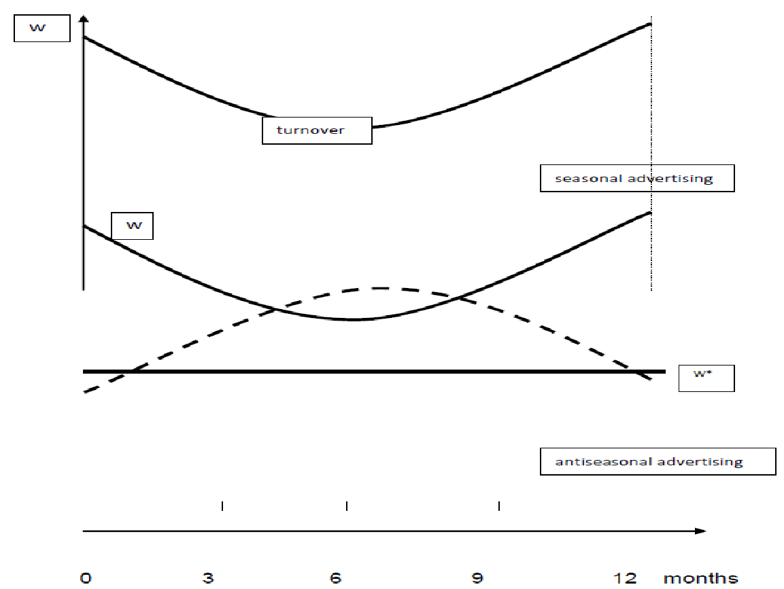
Figure 2 showing Advertising & Promotion Concept
Source: Frolova(2014)
In those cases, if the trade turnover has dynamic seasonal changes, the advertising policy provides the following strategies. managers suggest that employees are more likely to defend the interests of their company than some external organization. The second reason is that advertising departments are more manageable than the advertising agency, whose leaders can have their own views on the organization of the advertising process other than the advertiser. The third reason is to save money, which you can get when placing orders directly to the producers of advertising services. The fourth reason may lie in the specificity of the advertiser’s activities that sometimes cannot be appreciated by other organization. (Lambin, 1966).

