CHAPTER TWO
LITERATURE REVIEW
2.0 Introduction
This chapter covers the current bird pest control strategies used by farmers and their degree of effectiveness in controlling bird pest. It also covers the technologies we use in the construction of our prototype. The first scarecrows recorded in history were made along the Nile River to protect wheat fields from flocks of quail [4]. Egyptian farmers put wooden frames in their fields and covered them with nets. Therefore, protection of agricultural production areas from various animals having a tendency to damage the fore mentioned areas is an age-old problem. Farmers today still use scarecrows all over the world. In countries like India and Arab nations, old men sit on chairs and throw stones at the birds trying to eat or damage their crops.
Many techniques are available to protect crops from bird damage. The main conclusion of this study is that the effectiveness of each technique varies with bird species involved and that optimal bird control methods combine several techniques or use them in a random fashion. Human operated scaring techniques were the most effective; lethal methods are of only short-term benefit. In Africa, traditional, low-cost methods are mainly used. In a survey carried out in 2006 by Wilfred Odongola [5] in the main districts growing cereals (rice) in Uganda, 1375 individual farmers were interviewed, and 97.3% acknowledged that they were experiencing problems with cereal (rice) pests and diseases attacking their crops, particularly birds and rodents. Birds chew, squeeze, and feed on the grains in the milky stage of the crop. The damage shows milky white substances covering the grains. At grain maturation, birds remove the entire grains. Birds also perch panicles resulting in crop lodging.
The study identified several bird control techniques that were being used by farmers, amongst which were;
- Physical chasing, shouting and scaring off (83.5%).
- Beating sonorous bodies like tins and jerry cans (5.8%).
- Poisoning and trapping (1.2%).
- Use of stationary scarecrows (1.3%).
- Use of tapes that make whistling sounds around crop fields (0.6%).
Despite all the above attempts by the majority of the farmers, 7.6% of the farmers surveyed said that they completely did nothing about the problem of birds in cereals.
Although the adverse impact of birds on cereals (rice) has received much international attention in the past and is still generally recognized, little research on bird damage control is currently conducted. Therefore, it is desirable to provide a system to repel birds, and that overcomes the disadvantages of the prior arts.
2.1 Existing systems
The bio-acoustic deterrent is a device that emits sound with frequency levels targeting different bird species and covers a wide range acoustic spectrum from below that human perceive (infrasonic) to above our hearing range (ultrasonic). Although many of the commercially available sonic pests show poor results, the use of sound as a viable treatment option still exists [6]. However, this device loses its effectiveness if they are not moved regularly and have their best results in combination with a variety of techniques.
The design of smart scarecrow systems have been a growing area of interest in agricultural technology, aiming to address crop protection challenges more effectively than traditional methods.
Figure 1: Bio-Acoustic deterrent
The preventive method aims at not attracting birds to the field and can be subdivided into lethal and non-lethal techniques. Lethal techniques are aimed at suppressing pest bird population and are primarily implemented by national or regional (governmental) crop protection units. They include manual nest destruction, treatment with avicide (chemical substances lethal to certain bird species) and the use of explosives or flamethrowers. Non-lethal techniques include agronomic practices such as vegetation management, good weed management (as weeds attract bird), specific planning of the production season and choosing a variety with bird resistant characteristics. Religious techniques such as shamanism and fetishes are also still widely adopted in Africa [7]. Protective methods focus on protecting the rice crop when birds do visit the field. These include the use of repellents (chemical substances aimed at deterring birds), protecting fields or nurseries with nets or wires, covering the individual heads of ripening crops with grass or clothes, and manual bird scaring efforts. The latter may consist of a combination of auditory (e.g., noise-making devices, shouting), visual (scarecrows, flags, reflective tape) and physical measures (e.g., throwing rocks or mud).
Motion Sensor Activated Water Spray is a deterrent that is controlled by a motion sensor that sprays a jet of water once movement is detected. The shape is also designed to resemble a large predator bird to act as an additional visual deterrent. This device is relatively ineffective in scaring birds because its effective area is governed by how far the water jet can spray, and how far the sensor can detect movement. This device is best used in very small areas such as residential gardens.
Figure 2: jet water spray
In general, traditional protective methods such as manual bird scaring, flags and scare-crows can provide satisfactory protection on small-scale, privately owned farms when bird numbers are low. However, when pest bird pressure is elevated, these methods become ineffective [8]. Also on large-scale governmental production schemes, these methods are impractical, costly and ineffective [9]. This study suggests that the development of bird populations needs to be monitored and farmers need to be protected against the consequences of massive bird invasions through insurance systems. Large-scale, chemical control techniques to reduce population levels of pest birds to non-pest levels are still widely adopted in many African countries [10]. Literature suggests that these are ineffective, however, because they do not significantly lower populations due to the pest bird’s high productivity potential and high mobility [11]. The frequent inaccessibility of areas in which birds resides also creates a barrier to the efficient application of these chemicals. In contrast, lethal control to locally reduce pest bird numbers in the vicinity of important cereal production areas to give temporary relief has been applied successfully. However, the success of this approach varies regionally and by the control method deployed. It is worth noting that these approaches entail severe environmental hazards when avicide is applied.
2.2 Components used in the project
2.2.1 Resistor
A resistor is a passive component that implements electrical resistance circuit element. Resistors act to reduce current flow, at the same time, act to lower voltage levels within circuits. Resistors may have fixed resistances or variable resistances, such as those found in thermistors trimmers, photoresistors and potentiometers. The current through a resistor is in direct proportion to the voltage across the resistor's terminals. This relationship is represented by Ohm's law:
V=I/R
Where I is the current through the conductor amperes, V is the potential difference measured across the conductor in units of volts, and R is the resistance of the conductor in units of ohms (Ω).
The ratio of the voltage applied across a resistor's terminals to the intensity of current in the circuit is called its resistance, and this can be assumed to be a constant (independent of the voltage) for ordinary resistors working within their ratings.
Figure 3: Resistor
2.2.2 Capacitor
A capacitor is an electronic component that stores and releases electrical energy. It consists of two conductive plates separated by an insulating material called a dielectric. When a voltage is applied across the plates, an electric field builds up, causing positive charge to collect on one plate and negative charge on the other. The capacitor holds the charge until the circuit allows it to discharge, releasing the energy.
Key properties:
- Capacitance (C): Measured in Farads (F), it tells how much charge the capacitor can store per volts.
- Voltage rating: The maximum voltage the capacitor can handle without breaking down
- Polarity: Some capacitors (like electrolytics) are polarized and must be connected in the correct direction.
Capacitors can be used for filtering (e.g smoothing out ripples in power supplies), in timing circuits, for energy storage and also for coupling/decoupling signals.
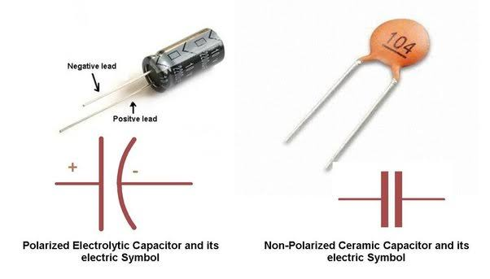
Figure 4: A capacitor
2.2.3 Diode
Diodes are used to convert AC into DC. These are used as half wave rectifier or full wave rectifier. A semiconductor device with two terminals, typically allowing the flow of current in one direction only.
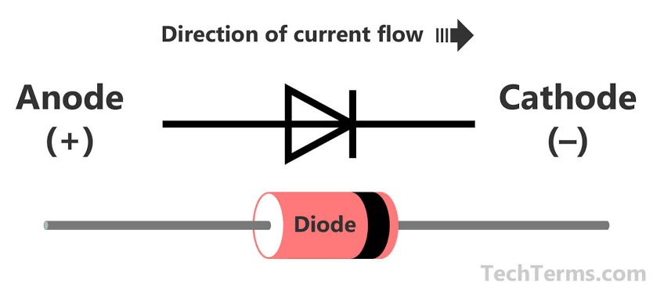
Figure 5: A Diode
2.2.4 Transistor
It is composed of semiconductor material with at least three terminals for connection to an external circuit. A transistor is a semiconductor device used to amplify and switch electronic signals and electric power. A voltage or current applied to one pair of the transistor's terminals changes the current through another pair of terminals.

2.2.5 Light emitting diode (LEDs):
A light-emitting diode is a semiconductor device that emits light when current flows through it. This allows current to flow in only one direction. By convention, current can only flow from the anode (positive) to the cathode (negative). Current is what determines how bright a LED is. More current means more light. LED current should typically be between 10 to 20mA.Therefore a current limiting resistor is used to keep the bias current in the above range. When current flows through the LED; a forward voltage drop of about 1.6V will develop between it spins, depending on the current. So this of this resistor as a valve-reduce it to increase LED brightness, or increase it to limit wasted power in the circuit. Consider an LED at maximum brightness. To achieve this, a typical LED current required.
Now we need to calculate the forward voltage drop across this diode with this current. Forward voltage drop is not just a function of current, but also LED color and temperature (because of the different LED chemistries) as shown in the table below.

Table 1: LED color and PD definition
LED color | Potential Difference
Infrared | 1.6v
Red | 1.8v to 2.1v
Orange | 2.2v
Yellow | 2.4v
Green | 2.6v

Figure 6: LED Indicators
2.2.6 Crystal oscillator
The crystal oscillator is an electronic oscillator circuit that uses mechanical resonance of a vibrating crystal of piezoelectric material to create an electrical signal with a very precise frequency. This frequency is commonly used to keep track of time to provide a stable clock signal for digital integrated circuits and to stabilize frequencies for radio transmitters and receivers. The most common type of piezoelectric used is the quartz crystal, so oscillator circuits incorporating them became known as a crystal oscillator. An ATMEGA328P microcontroller has a clock system with a maximum speed of 20MHz(20mips). However, the internal system clock has a maximum rating of 8MHZ thus for a faster performance an external clock source is connected to the microcontroller pins inform of the crystal oscillator. The oscillator must be connected to two ceramic capacitors to enable its operation especially 22PF to provide a 16MHZ frequency to the microcontroller.

Figure 7: Crystal Oscillator

2.2.7 Microcontroller (ATmega 328P)
A microcontroller is a compact, integrated circuit designed to control specific operations within an embedded system. It functions as the "brain" of the system, combining a processor, memory, and input/output peripherals on a single chip. Microcontrollers are widely used in various applications, including home appliances, automotive systems, robotics, medical devices, and IoT (Internet of Things) devices.
Figure 8: Microcontroller

Arduino Board
An Arduino board is an open-source microcontroller platform designed for easy prototyping and development of electronic projects. It features a microcontroller, I/O pins, and a programming environment that simplifies coding and hardware interaction. Arduino boards are widely used by hobbyists, educators, and professionals for developing diverse applications, including IoT devices, robotics, and automation systems.

Key Features of Arduino Boards
- Microcontroller: Each board has a central microcontroller (e.g., ATmega328P, SAMD21) that executes the program.
- Digital and Analog I/O Pins: \n - Digital pins: Used for reading digital signals or controlling components like LEDs, relays, or motors.
- Analog pins: Used for reading sensor data or providing analog output.
- Power Supply: Can be powered via USB or external power sources, typically 5V or 9-12V DC.
- Programming Environment: Uses the Arduino IDE (Integrated Development Environment), which supports C/C++ and an easy-to-learn syntax.
- USB Interface: Allows for easy programming and serial communication with a computer.
- Open-Source: Hardware schematics and software libraries are freely available, encouraging customization and community development.
Applications
- Robotics: Autonomous vehicles, robotic arms, and drones.
- IoT Devices: Environmental monitoring, smart agriculture, and wearable technology.
- Educational Projects: Learning programming, electronics, and control systems.
- Art and Design: Interactive installations and electronic music devices.
Advantages of Arduino
- Beginner-Friendly: Easy to learn and use.
- Versatile: Suitable for a wide range of applications.
- Low-Cost: Affordable compared to other microcontroller platforms.
Limitations of Arduino
- Limited computational power for complex tasks.
- Not suitable for high-speed applications or resource-intensive tasks.
- Fewer features compared to more advanced platforms like Raspberry Pi.
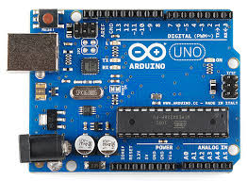

Figure 9: Arduino Board

2.2.8 Power Supply with (Voltage Regulation)
It is a three pin IC used as a voltage regulator. It converts unregulated DC current into regulated DC current. Normally we get fixed output by connecting the voltage regulator at the output of the filtered DC (see diagram below). It can also be used in circuits to get a low DC voltage from a high DC voltage (for example we use 7805 to get 5V from 12V).
LM 7805 Voltage Regulator

Figure 10: Voltage Regulator
5V Zener Diode:
A zener diode is a device that acts like a typical PN-junction diode when it comes to forward bias, but it also has the ability to conduct in the reverse-biased direction when a specific break down voltage (VB) is reached. Zener diodes typically have a breakdown voltages in the range of a few volts to a few hundred volts (although larger effective breakdown voltages can be reached by placing zener diodes in series).
Figure 11: Zener Diode
In this project design, a 5V zener diode is used to regulate the voltage supplied to a load. When Vin attempts to push Vout above the zener diode’s break down voltage (Vzener), the Zener diode draws as much current through itself in the reverse-biased direction as is necessary to keep Vout at V zener, even if the input voltage Vin varies considerably.
2.2.9 Photovoltaic Module
A PV module (Photovoltaic module) is a fundamental component of solar power systems, converting sunlight directly into electricity using the photovoltaic effect. It comprises an assembly of interconnected solar cells enclosed in a protective frame, usually made of glass and a durable backing material. PV modules are designed for long-term use and are typically installed in arrays to generate sufficient power for residential, commercial, or utility-scale applications. The sectionss possessed in the PV module are mentioned as follows;

Key Components of a PV Module:
- Solar Cells: Made primarily from silicon, these cells convert sunlight into direct current (DC) electricity.
- Encapsulation: Layers of ethylene vinyl acetate (EVA) protect the cells from moisture and physical damage.
- Frame: Typically aluminum, providing structural support and ease of mounting.
- Glass Cover: Protects the cells from environmental elements while allowing sunlight to pass through.
- Backsheet: Provides insulation and protects the module's rear side.
- Junction Box: Houses electrical connections and bypass diodes, facilitating connectivity and minimizing power loss
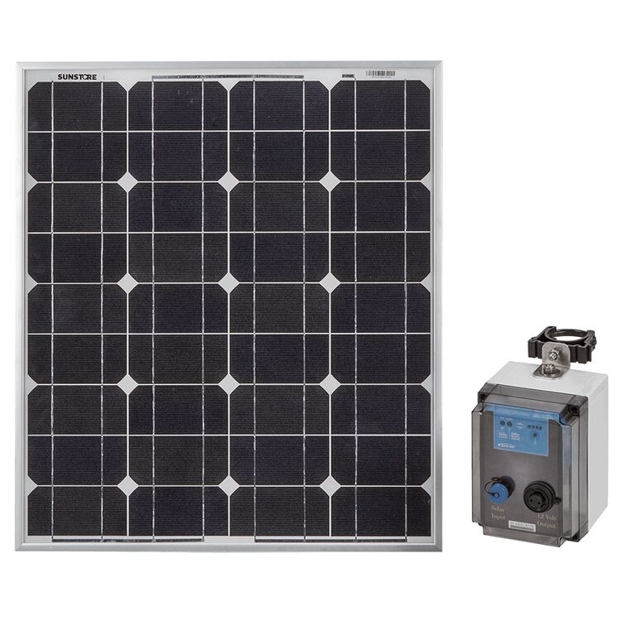
Figure 12: photovoltaic cell

