1. Introduction
The demand for alternative sources of electrical power is growing rapidly, particularly in regions where power supply from the national grid is erratic. An inverter is an essential component of an alternative energy system that converts Direct Current (DC) from batteries or solar panels into Alternating Current (AC) used by most household appliances. This project aims to design, construct, and install a 2kVA inverter to serve as a backup power supply for residential and laboratory applications. A 2kVA capacity is sufficient to power critical loads such as lighting, fans, computers, and small appliances.

2 Problem Statements
The recurring issue of erratic power supply and frequent blackouts in many areas has rendered the use of conventional grid power unreliable. Small businesses, educational institutions, and households are often left without power for hours or even days. This affects productivity and the quality of life. Commercial inverters are often expensive and may not be tailored to specific local needs or constraints. Thus, there is a need to develop a cost-effective, efficient, and locally adaptable inverter system that can bridge this power gap [2].
3 Aim and Objectives
Aim
The aim of this project is to design, construct and install 2 KVA inverter in three bedrooms flat
The Objectives of this project are
• To analyze and design the key functional stages of an inverter including oscillator, driver, power conversion, and filtering.
• To select appropriate electronic components based on performance and availability.
• To construct and assemble the inverter system using standard electrical and electronic practices.
• To test and evaluate the inverter’s performance under various load conditions.
• To provide installation and maintenance guidelines for end users.

4 Scope of the Study
This project focuses on the design and implementation of a single-phase, 2KVA inverter system. The inverter is designed to operate with a 12V DC input from a battery source and produce a 230V, 50Hz AC output. The design includes:
- Power conversion circuits using MOSFETs.
- A transformer for voltage step-up.
- An oscillator circuit for pulse generation.
- Basic filtering and protection mechanisms.
The project does not cover renewable energy integration (e.g., solar panels), although the system is designed to be compatible with such inputs.
5. Methodology
5.1 The inverter circuit will consist of the following stages:
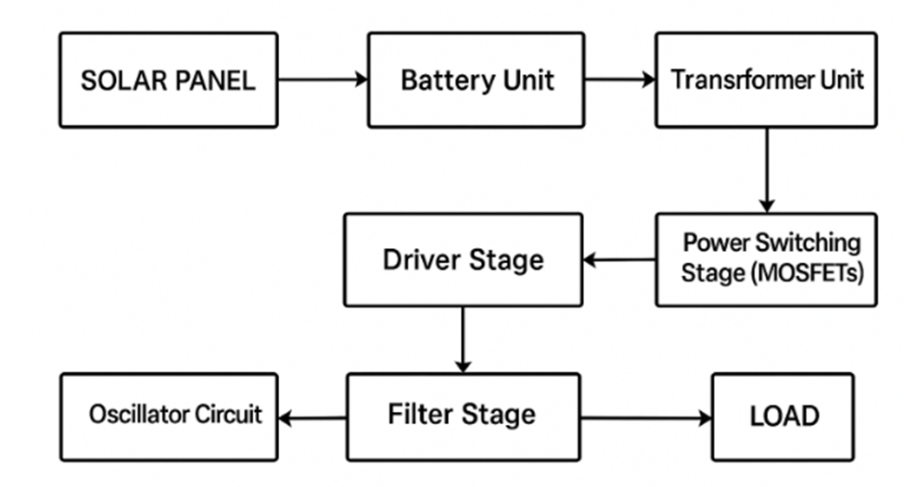
• Oscillator Stage: Generates PWM signals using IC SG3525 or microcontroller.
• Driver Stage: Amplifies control signals for power transistors (MOSFETs).
• Power Stage: Uses power MOSFETs (e.g., IRF3205) to switch DC input.
• Transformer: Steps up 24V DC (converted to AC) to 220V AC.
• Filter and Output Stage: Smooths the waveform and outputs clean AC power.
5.2 Construction and Assembly
- Build the circuit on a PCB or Vero board.
- Mount components in a metal casing with ventilation fans and heat sinks.
5.3 Testing and Installation
- Connect to a 24V DC battery bank and test with different loads.
- Monitor performance (voltage, current, temperature).
- Install in a residential or laboratory setting for practical demonstration.
6. Expected Outcomes
- A fully operational 2kVA inverter.
- Improved local technical capacity in renewable and backup power systems.
- A cost-effective alternative to imported inverters.
- Practical documentation and knowledge for future scaling and optimization.
7. Project Timeline
S/NO | TASK | DURATION
1. | Literature Review & Design | Three weeks
2. | Component Selection | Two weeks
3. | Construction & Assembly | Two weeks
4. | Testing & Troubleshooting | One weeks
5. | Installation & Documentation | Two weeks
8. Estimated Budget
S/NO | Item Description | Quantity | Unit Cost (₦) | Total Cost (₦)
1. | 12V, 200Ah Rechargeable Batteries | 2 | 250,000 | 500,000
2. | 200 W solar panel | 4 | 150,000 | 600,000
3. | Step-up Transformer (12-0-12 to 220V, 2kVA) | 1 | 45,000 | 45,000
4. | High Power MOSFETs (e.g., IRF3205) | 8 | 1,000 | 8,000
5. | 555 Timer IC | 2 | 500 | 1,000
6. | Driver IC (e.g., IR2110) | 2 | 1,500 | 3,000
7. | Capacitors and Resistors (Mixed) | 1 set | 2,000 | 2,000
8. | Diodes (e.g., IN5408, fast recovery) | 10 | 200 | 2,000
9. | Heat Sinks | 4 | 1,500 | 6,000
10. | Cooling Fan | 1 | 2,500 | 2,500
11. | PCB Board / Vero Board | 1 | 2,000 | 2,000
12. | Solar charge controller (PWM) | 1 | 50,000 | 50,000
13. | Casing (Metal) | 1 | 12,000 | 12,000
14. | LCD Display / Meters | 1 | 3,500 | 3,500
15. | Cables and Wiring Materials | 1 set | 6,000 | 6,000
16. | Soldering Materials (Iron, Wire, Paste) | 1 set | 5,000 | 5,000
17. | Switches, Fuses, and Indicators | 1 set | 3,000 | 3,000
18. | Labour / Assembly Cost |  | 30,000 | 30,000
19. | Miscellaneous |  | 5,000 | 5,000
20. | Total |  |  | 1,286,000
9. Conclusion
This project will provide a practical and scalable solution to power instability using a locally designed and constructed inverter. The 2kVA inverter will support critical domestic and institutional appliances and serve as a template for future renewable and off-grid power solutions.
10. References
[1] M. H. Rashid, Power Electronics: Circuits, Devices and Applications, 4th ed., Pearson, 2013.
[2] S. B. Norrga, “Design and Control of DC-AC Inverters,” IEEE Transactions on Power Electronics, vol. 29, no. 4, pp. 1897–1908, Apr. 2014.
[3] K. Jain and R. Saxena, “Design and Implementation of a Pure Sine Wave Inverter for Solar PV Applications,” International Journal of Engineering Research and Applications, vol. 10, no. 5, pp. 42–48, 2020.
[4] A. M. Trzynadlowski, Introduction to Modern Power Electronics, 3rd ed., Wiley, 2015.
[5] N. Mohan, T. M. Undeland, and W. P. Robbins, Power Electronics: Converters, Applications, and Design, 3rd ed., Wiley, 2003.

