TABLES OF CONCEPT
Title Page
Certification
Dedication
Acknowledge
Abstract
Table of concept
Chapter one
1.0 Introduction
1.2 Statement of Problem
1.3 Aim of the Project
1.4 Objectives of the Project
1.5 Project Specification
1.6 Participants Involved
1.7 Project Location
Chapter Two
2.1 Literature Review
Chapter Three
3.0 Methodology
3.1 Planning
3.2 Office planning
3.3 Field Reconnaissance
3.4 Instrument used
(I) Hardware Used
(II) Software Used
3.5 Monumentation
3.6 Data Acquisition
3.6.1 Instrument Check
3.7 Data Acquisition
3.7.1 Geometric Data Acquisition
Chapter Four
4.0 Data Processing
4.1 Data Download and Editing
4.2 Data Processing in Auotcad
4.3 Area Computation
4.4 Back Computation
4.5 Linear Accuracy
4.6 Product Application
Chapter Five
5.0 Summary, Conclusion, Problem Encountered, References
5.1 Summary
5.2 Conclusion
5.3 Problem Encounter
5.4 Recommendation
References
Appendices
List of Tables
1.6 Participant Involved
3.1 Show the values of controls
3.3 The observed coordinates of
3.4 The observed coordinates of
3.5 Result of the computed control check form given coordinate
3.6 Result of the computed control check form observed coordinates
4.4 Showing Back computation
LIST OF FIGURES
Fig1. Shows project location
Fig3.1 shows the typical Beacon used

CHAPTER ONE
1.0 INTRODUCTION
Digital napping (also called Digital Cartography) is the process by which data is complied, and formatted into a virtual image the primary function of this technology is to produce maps that gives accurate representation of a particular area, detailing major road, building and other points of interest.
Digital mapping is a cross disciplinary methodology is the strong relevance to anyone whose research methods is to investigate data and to answer research questions or as a publication output or both. Many of software tools and methods of digital mapping comes from geography and related disciplines in both HASS (Humanities and social sciences) and stem (Science Technology, Engineering and Math) Map making has been part of HASS research from well before the advent of computational methods.
As a way of understanding change over time, mapping can be use to track and visualize how places have change overtime. This could be looking at changes, to the used of land or shifts in social and cultural uses of a specific site or sets of sites. Techniques exist to allow research to develop layers of the Historic maps and combine these with diverse data to see pattern and prompt new questions of research materials. Finally, mapping like many others digital methods can be reshape the direction of your research. The process of converting achieved data, or finding complimentary sets of governance place for data, and creating a map from it, can make you look at your research question in a very different ways. It is like that you will come out of mop making not just answering existing question but developing a whole new sets.
Google has mastered the process of data captured from Roadways rather than rely on the eyes of people on the field, sensors and camera collect mapping data.
MAPPING: It’s a process that involves creating a visual representation of data, whether it’s Geographic information displaying exact locations on map or abstract data from one database to another, in the context of Geography, maps transfer the three dimensional world onto a flat surface, illustrating locations, points of interest, and Geological features to provide a simplified view of landscape. Meanwhile, in the data realm, mapping serves as a tool that transforms and translates data from one source format to another, ensuring compatibility between systems.
CATEGORIES OF DIGITAL MAPPING
Online Atlases
Geospatial Dataedera
Static Map: Most Maps on the internet of this type
Editable Maps: The file format for these is some PDF and they can be edited with the right software.
USES OF DIGITAL MAPPING
Digital Mapping is particularly useful for teaching and learning history because it is usually reminds students of the interaction between past and presents it is also essential for all work to be performed with a Geographical coordinate system.
1.1 STATEMENT OF PROBLEM
The first day I and my teammates went to federal staffs school Adewale Ilorin, to take permission from the school authorities, our visitation wasn’t welcomed because the authorities feels we might have another agenda aside us coming to their school to carried out our project practical work. We had to revisit that was when we were total to bring a proposal signed by our department HOD. It’s takes us almost 2 weeks to get HOD to sign for us.
1.2 AIM OF THE PROJECT
The aim of this project is to provide an up to date digital mapping of federal staffs school Adewale, Ilorin, Kwara State.
1.3 OBJECTIVES OF PROJECT
- To develop an up to date digital map of federal staffs school
- To calculate the area of the project site
- To show the artificial features of the school
1.4 SCOPES OF THE PROJECT
- Data Processing
- Planning
- Data acquisition
- Information presentation
- Report writing
1.5 SPECIFICATION OF THE PROJECT
- Burring of corner beacons at the corner points
- Area computation must be done using latitude and longitude single departure
- The linear accuracy should not less than 1500. A closed Traverse must be carried out for field work
1.6 GRIOP MEMBERS
S/N | NAME | MATRIC NO
1 | Adebayo Blessing Mary | HND/23/SGI/FT/0042 | AUTHOR 2025
2 | Ojo Adebisi Motunrayo | HND/23/SGI/FT/0041 | ASSIST
3 | Dada Elizabeth Oluwapelumi | HND/23/SGI/FT/0043 | ASSIST
4 | Oladimeji Rapheal Oluwasegun | HND/23/SGI/FT/0045 | ASSIST
5 | Ibitoye Joshua Ayokunle | HND/23/SGI/FT/0047 | ASSIST
6 | Akinyejo Ezekieh Damilola | HND/23/SGI/FT/0051
7 | Osunleke Habeeb Olaide | HND/23/SGI/FT/0052 | ASSIST

1.7 PROJECT LOCATION
The project Area is located at federal staff school Ilorin west, Ilorin, kwara state, Nigeria. This covered the buildings towards the school Gate.
STUDY AREA
The study was carried out at the Federal Staff School, located in Ilorin, the capital city of Kwara State, and Nigeria. Ilorin lies in the north-central region of the country and serves as a major administrative and educational center.
The Federal Staff School is situated within the Federal Secretariat Complex along Fate Road, in the Ilorin West Local Government Area. The school is a government-owned institution established to provide quality education for the children of federal workers and the general public.
Its campus comprises classroom buildings, administrative blocks, playgrounds, and other school infrastructure that require proper spatial documentation for effective planning and management.
Spatially, Federal Staff School, Ilorin, is located approximately within the coordinates 8.4820°N latitude and 4.5600°E longitude. The school is bounded by Kano Road to the west, residential areas to the north and south, and other government facilities to the east. The perimeter of the school covers a modest area suitable for basic and secondary education activities, making it ideal for digital mapping using total station technology. The well-defined boundary and relatively flat terrain provide a conducive environment for field data acquisition, spatial analysis, and the eventual production of a detailed digital map to support school administration and infrastructural development.
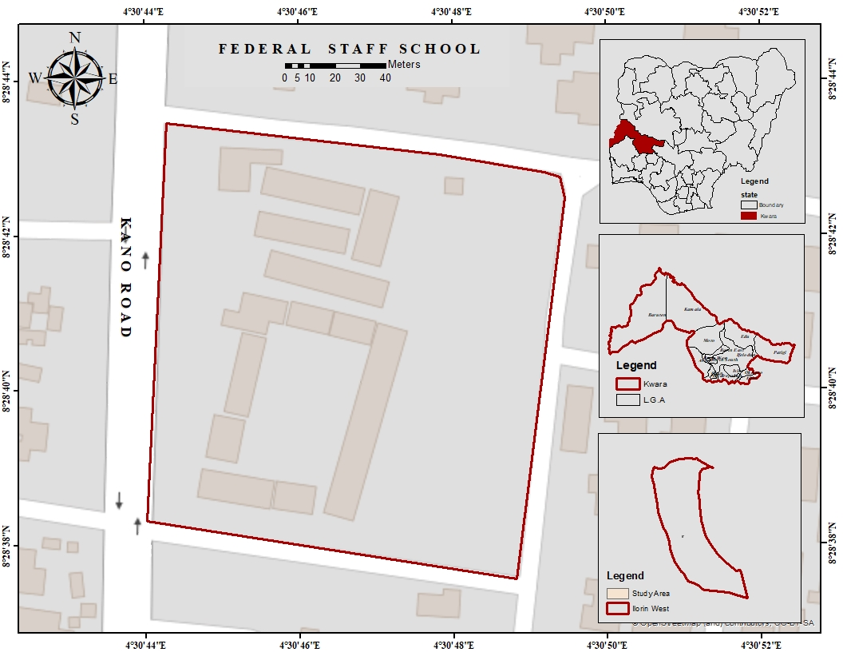
Figure 1.1: Study Area Map

