CHAPTER FOUR

4 .0 SYSTEM IMPLEMENTATION, TESTING AND RESULTS

4.1 INTRODUCTION

This chapter provides a comprehensive explanation of the implementation, testing, and evaluation of the designed 5KVA Automatic Voltage Regulator (AVR). It covers the step-by-step process of constructing the system, loading and testing the microcontroller program, troubleshooting, and validating the results obtained from the project. The performance is evaluated based on voltage correction response, output stability, and general functionality.

4.2 CONSTRUCTION PROCEDURES

The construction process was carried out in the following stages:

1. Breadboard Testing:
All individual components and sub-circuits such as the voltage divider, rectifier, regulator, and display were first assembled and tested on a breadboard. This ensured that each module functioned correctly before final integration.

2. Schematic Design:
A full circuit schematic was designed based on the finalized working concept. The schematic included the transformer, bridge rectifier, filter capacitors, voltage regulator (7805), comparator section using LM324, relay drivers, microcontroller (ATmega328), and output display.

3. PCB Design and Etching:
A Printed Circuit Board (PCB) was designed using Proteus software and the layout was printed on a glossy sheet. The board was etched using ferric chloride solution. After cleaning and drilling, components were soldered onto the board.

4. Enclosure and Wiring:
After the PCB was tested and confirmed working, it was placed in a plastic enclosure. The transformer, power input/output terminals, relays, and the display module were also connected with proper wiring and insulation.

4.3 SOFTWARE IMPLEMENTATION

The microcontroller (ATmega328) was programmed using embedded C through Arduino IDE. The logic was developed based on real-time voltage monitoring and decision-making to trigger relays for voltage correction.

Program Logic:

The ADC in the microcontroller reads input voltage via a voltage divider.

If the voltage is below a set threshold, the microcontroller switches to a higher tap using a relay.

If the voltage is above a set threshold, the microcontroller switches to a lower tap.

The output voltage is displayed via an LCD or analog voltmeter.

The code was compiled and uploaded to the ATmega328 using an Arduino Uno as ISP.

4.4 TESTING AND TROUBLESHOOTING

After completing construction and programming, the device was tested to ensure it met all functional requirements.

Testing Procedure:

An input voltage between 140V to 260V was applied.

The output was measured using a digital multimeter.

The switching action of relays was observed.

The display output was checked for correctness.

Troubleshooting:

Cold solder joints were reworked.

Resistor and diode polarities were verified.

Program logic was adjusted for better response.

4.5 RESULTS OBTAINED

Below are the observed results during the testing phase:
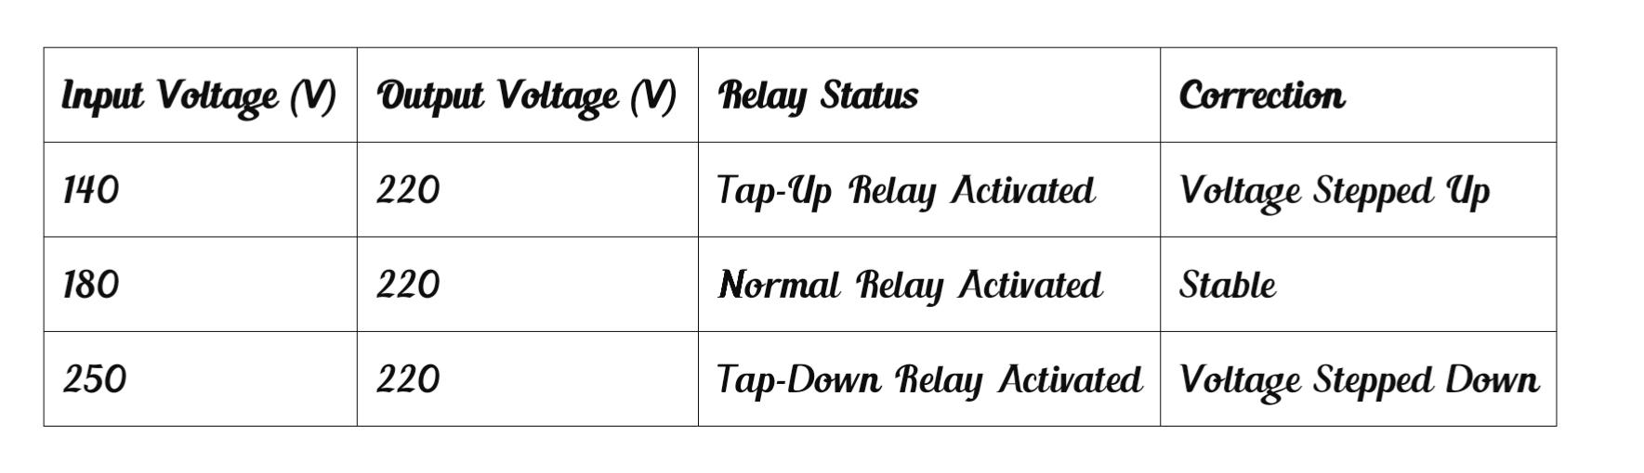

OBSERVATION:
The AVR was able to regulate voltage effectively within the range of 140V to 250V. The output voltage stayed within acceptable limits (±5% of 220V). The relay switching was smooth and the display showed accurate values.

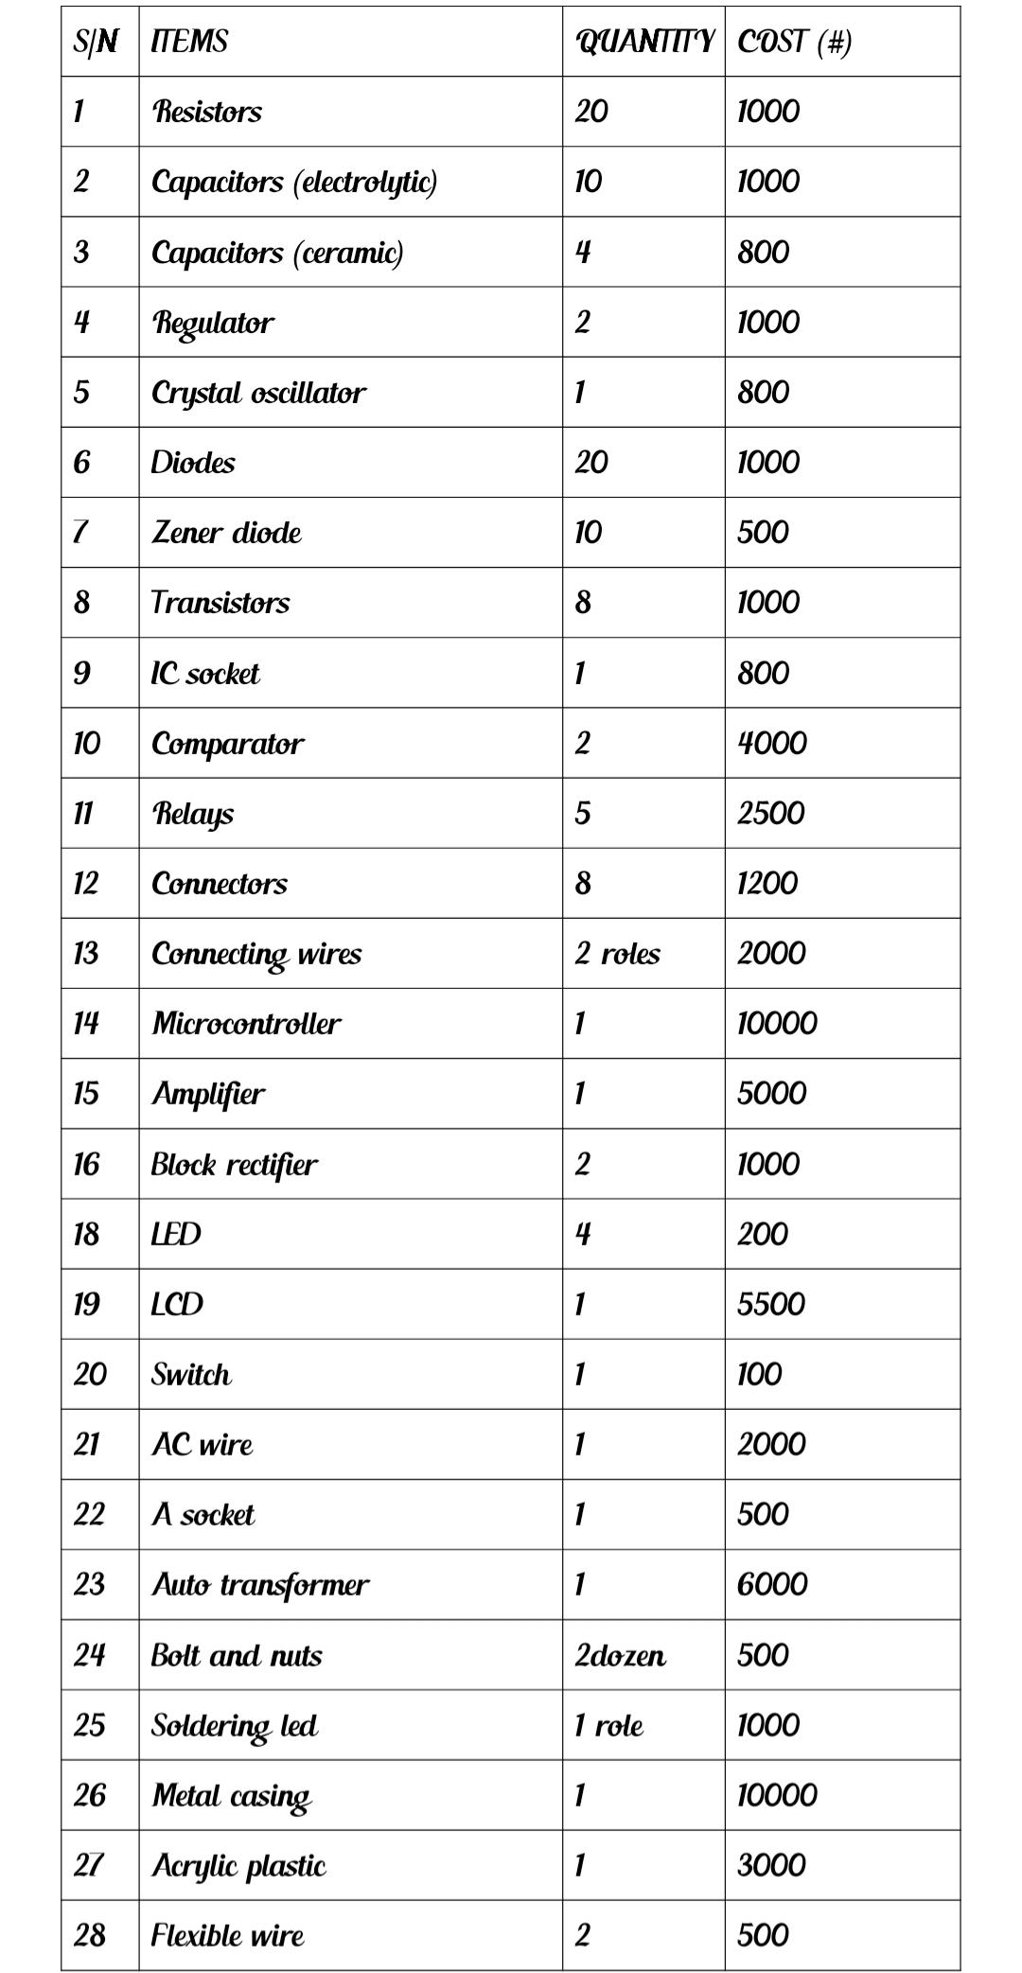
4.6 Bill of Engineering Measurement and Evaluation (BEME)
workmanship #40000
TOTAL #102900

4.7 CHALLENGES ENCOUNTERED

Difficulty sourcing original ATmega328 microcontroller.

Initial code bugs causing relay malfunction.

Heat dissipation in the relay switching section.

Physical space constraint in enclosure mounting.

4.8 SUMMARY

This chapter detailed the practical implementation of the 5KVA Automatic Voltage Regulator, from construction to programming and testing. The system performed effectively during tests, providing consistent voltage regulation and stable output. Despite minor challenges, the project achieved its desired objective.

