CHAPTER TWO

LITERATURE REVIEW
This chapter reviews previous studies and information related to voltage regulation and automatic voltage regulators (AVRs). It covers the concept of voltage regulation, how AVRs work, the different types available, and how they are used in practical situations. The aim is to understand what has been done before, identify the strengths and weaknesses of existing systems, and show how this project fits into the broader development of voltage regulation technology.
Voltage regulation is the process of maintaining a constant output voltage level despite variations in the input voltage or load conditions. This is a crucial aspect of electrical and electronic systems, especially in regions where power supply is unstable or experiences frequent fluctuations. The primary objective of voltage regulation is to ensure that sensitive electronic devices and household appliances operate within their rated voltage range to avoid malfunctions or damage.
In electrical systems, voltage regulation can be performed manually or automatically. However, with advancements in technology and the increasing demand for reliable power supply, automatic voltage regulation has become the standard solution. An Automatic Voltage Regulator (AVR) is designed to detect voltage irregularities and adjust the output voltage accordingly without human intervention.
Effective voltage regulation helps in:
Protecting appliances from under-voltage and over-voltage conditions.
Enhancing the lifespan of electrical devices.
Improving system reliability and performance.
Reducing maintenance and replacement costs of appliances.

We need to understand the methods through which voltages can be stabilized by regulating the supply coming from the mains. This stabilization should be automatic, enabling the system to switch ON or OFF to protect household appliances from damage.
In the past, the use of voltage regulators was scarce and not as common as it is today due to a more stable supply distribution system. However, with the world’s population increasing, the demand for electricity has also surged. This high demand leads to overloading of distribution transformers, causing voltage variations. Such variations can damage electrical equipment.
To prevent damage caused by voltage fluctuations, a means was devised by Thomas Alva Edison in 1879 to stabilize voltage by controlling and limiting over-voltage and under-voltage that enters a device. This method ensures a stable electrical output, thus prolonging the lifespan of appliances.
Today, voltage regulators are available in both domestic and industrial forms, varying depending on the size and capacity required for protection.
An Automatic Voltage Regulator (AVR) is designed to maintain a constant output voltage within a specified range, whether in distribution feeders or household equipment, regardless of fluctuations in supply voltage or load current.
Voltage regulators are often built into household appliances to provide a consistent output voltage, protecting the appliance from input variations.
Typically, the voltage regulator is connected to a socket, and its regulated output serves as the input for the household device.

CONTROL CIRCUIT ANALYSIS

2.1.1 RECTIFICATION AND FILTRATION STAGE
The auto-transformer is powered by a 220V supply and tapped at 12V from the center circuit.

RECTIFICATION
Rectification is the process of converting alternating current (AC) to direct current (DC). In this project, a full-wave bridge rectification method was used, which consists of four diodes.
The reduced 12V from the auto-transformer is connected to the full-wave bridge rectifier to convert AC supply to DC voltage through diodes D1-D4.

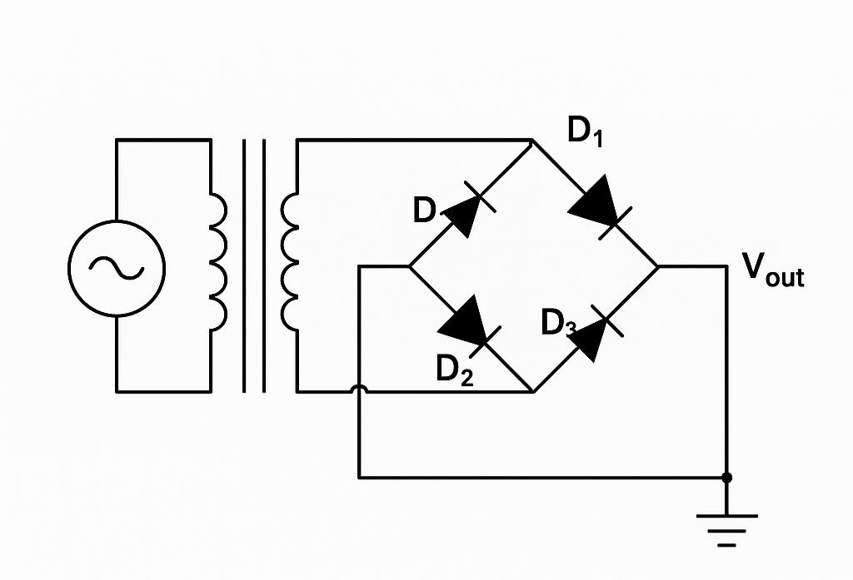

Full Wave Rectification Diagram

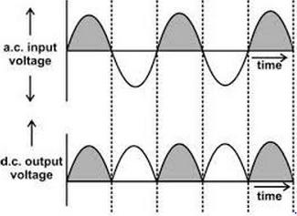
Full Wave Rectification Graph

2.1.2 FILTRATION
Filtration involves removing ripples remaining after rectification. This process is accomplished using an electrolytic capacitor (1000µF, 50V) to smooth the output voltage and prevent damage to electronic components.
The filter capacitor is connected across the output terminals of the rectifier. A voltage regulator (LM 7805) is then used to regulate the rectified 12V to 5V before it is supplied to the microcontroller (ATmega328P).
The operational amplifier in the control circuit works with the non-inverting input so that the comparator output remains high. This output automatically controls the switching stage of the circuit.

2.1.3 SWITCHING STAGE
This is the automation unit, and it is implemented using a transistor (13003) and relays for switching operations. When the comparator output is high, it forward-biases the base of the transistor, turning it ON.
Once the transistor reaches saturation, current flows through its collector, energizing the relay coil. This causes the output terminal of the stabilizer to become active.
The relays operate depending on the voltage value from the main supply, working in conjunction with the comparator stage to maintain a constant output of 220V.
Relay contacts are normally open but close whenever the relay coil is energized, thereby delivering a stable output voltage.
The 13003 transistor can be used in high-voltage applications like inverters, UPS systems, battery chargers, and motor controllers. It is also useful in low-voltage and battery-operated projects. In this AVR project, it amplifies voltage to 12V.

