CHAPTER THREE

3.0 METHODOLOGY / MATERIALS USED, FUNCTIONS, AND DESIGN SPECIFICATIONS

3.1 INTRODUCTION This chapter discusses the design and implementation of the 5KVA Automatic Voltage Regulator (AVR). It includes the block diagram, system description, components used, circuit diagram, working principle, programming logic, and PCB layout. The AVR is designed to monitor and regulate voltage levels automatically to ensure stable power supply within safe limits.

3.2 BLOCK DIAGRAM OF THE SYSTEM The system consists of the following major blocks:

- Power supply input (150V – 240V)

- Auto transformer

- Rectifier

- Voltage regulator

- Comparator

- Microcontroller unit

- Relay switching unit

- Amplifier

- Output stage

- Voltage monitoring display
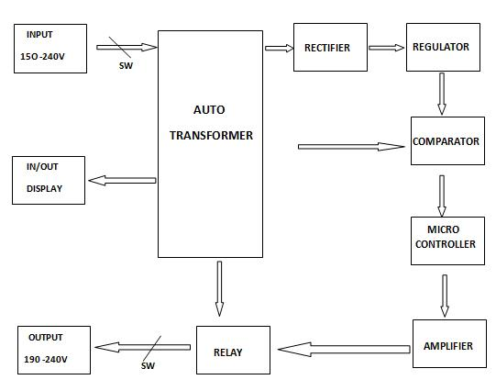

3.3 SYSTEM DESCRIPTION
The AVR system operates by sensing the input voltage using a voltage divider circuit and converting it to a readable DC voltage via a rectifier and voltage regulator. This voltage is fed to a comparator and then into the microcontroller. The microcontroller makes decisions based on programmed thresholds and controls the relay switching to select the appropriate winding on the auto-transformer. An amplifier circuit is used to boost the control signals if necessary. The output voltage is monitored and displayed.

3.1 DESCRIPTION OF COMPONENTS USED AND THERE FUNCTIONS
The electronic components used in the design and connection of the 5KVA Automatic Voltage Regulator include diodes, resistors, transistors, integrated circuits (ICs), a liquid crystal display (LCD), and power instruments such as auto transformer and essential components like Relay, Rectifier, Voltage Regulator, Comparator, Microcontroller, Amplifier, Voltage Divider, Display.
MAJOR COMPONENTS

3.1.1 Auto Transformer
A An auto-transformer is used in this project to step up or step down the AC voltage depending on the variation in the mains supply. It has multiple taps that allow the system to correct voltage irregularities automatically. The microcontroller, through the relay system, selects appropriate taps to achieve a stable The diagram of Auto transformer is shown below in fig 3.1
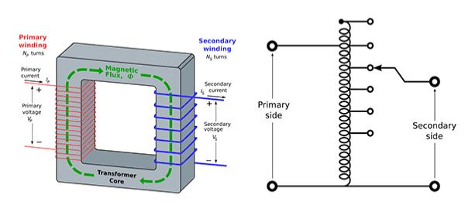
Fig 3.0: Auto Transformer

3.1.2 Rectifier
A rectifier circuit (usually a bridge rectifier) is used to convert AC voltage from the transformer into DC voltage. This DC voltage is essential for powering the microcontroller, voltage comparator, and other control circuitry. The diagram is shown below in fig 3.1.
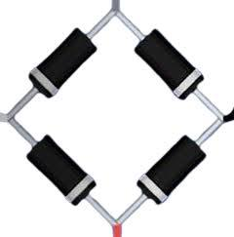
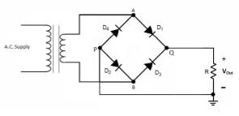

Fig 3.1: Bridge Rectifier

3.1.3 Comparator ( LM324)
The voltage comparator is responsible for monitoring the input voltage and comparing it with a set reference value. If the voltage falls below or exceeds certain thresholds, the comparator outputs a logic signal to alert the microcontroller. This helps the system decide when to adjust the voltage via relay switching. The diagram is shown below in fig 3.2

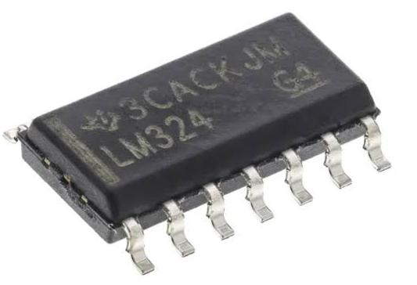
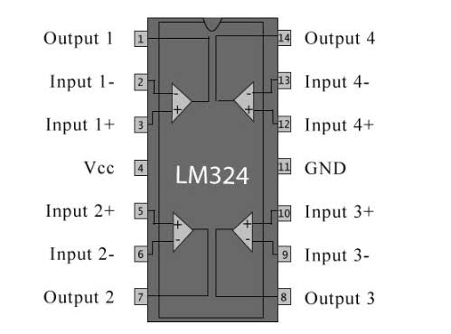
Fig.3.2 Comparator

3.1.4 The ATMEGA328P-PN (Microcontroller)
ATMEGA329P-PN is a versatile 8-bit microcontroller commonly found in Arduino boards. It has a 20MHz clock speed, 32KB flash memory, and features like UART, SPI, timers, ADC, and watchdog. It is used in this project to process and control input voltage readings and relay switching. The diagram is shown below in fig 3.3.
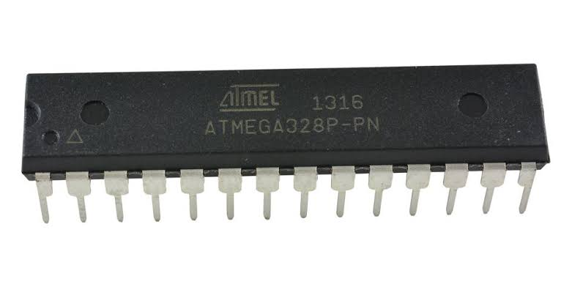
Fig.3.3:ATMEGA328P-PN ( MICROCONTROLLER)

3.1.5 Amplifier
Amplifier are used In cases where the control signal from the microcontroller is not strong enough to drive the relay coil, an amplifier circuit is used. Typically implemented using transistors or operational amplifiers, to strengthens the signal to ensure proper relay actuation. The circuit diagram is shown below in fig 3.4.
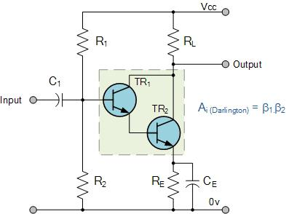

Fig.3.4: circuit diagram of an amplifier

3.1.6 Voltage Divider
The voltage divider circuit scales down the high AC input voltage to a lower, measurable level suitable for the ADC of the microcontroller. This allows the microcontroller to accurately monitor the input voltage without damage. The diagram is shown below in fig 3.5
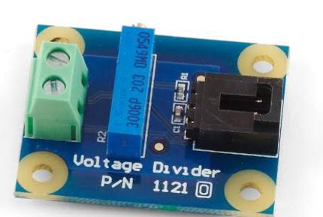
Fig3.5: Voltage divider
3.1.7. Voltage Regulator (LM7805)
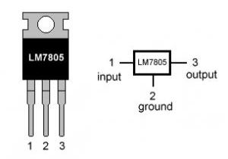
The LM7805 is a three-terminal linear voltage regulator IC that outputs a fixed 5V. It is widely used in applications requiring a regulated 5V power supply. In our project The 7805 regulator provides a stable 5V DC supply for the microcontroller and other logic-level components. This regulated voltage is crucial for consistent performance of the control circuit. The diagram is shown below in fig 3.6.
Fig 3.6: Voltage Regulator (LM7805)
3.1.8 Relay
A relay is an electrically operated switch that uses electromagnetic induction. It contains a coil and contacts (normally open or closed). When current flows through the coil, it magnetizes and actuates the contacts, enabling circuit switching in our project relay acts as an electrical switch, controlling current flow. It monitors voltage levels and switches between transformer taps or circuits to adjust output voltage, maintaining stability. Relays ensure the stabilizer provides consistent and reliable output voltage. The diagram of a relay is shown below in fig 3.7

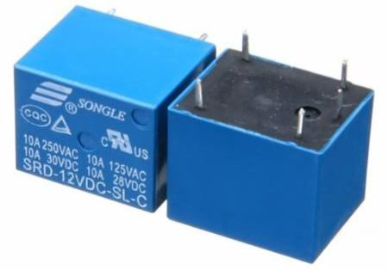

Fig 3.7: Relay

3.1.9 Liquid Crystal Display (LCD)

An LCD is a flat-panel display technology commonly used in electronic devices. In this project, it is used to display input voltage, output voltage, and system status. This provides user-friendly monitoring and troubleshooting during operation. The diagram is shown below in fig 3.8
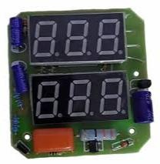
Fig 3.8: Liquid Crystal Display ( LCD)

SUPPORTING DISCRETE COMPONENTS

3.2.0 Capacitor

A capacitor stores electrical charge and energy. It consists of two conductors (capacitor plates) separated by a dielectric material. Capacitors are used in this project to filter out ripples from the rectified DC voltage, providing a steady output current.

Q ∝ V ⇒ Q = CV
Where:
C = Capacitance (Farads),
Q = Charge (Coulombs),
V = Voltage (Volts)
The diagram of the capacitor is shown below in fig 3.2
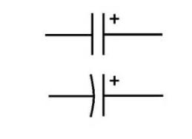
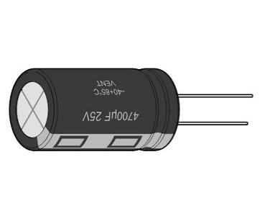
Fig 3.2: capacitor

3.1.3 Resistor

A resistor is a passive two-terminal component that resists the flow of electric current. In this project, resistors are used to limit current, divide voltage, and provide feedback to improve comparator stability. They are available as fixed or variable types. The diagram of resistors are shown below in fig 3.3
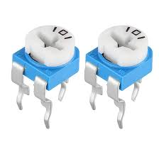
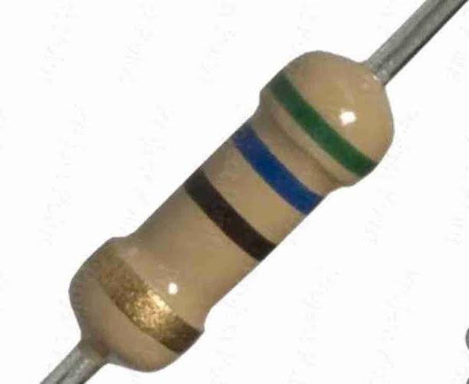
Fig 3.3: a fixed and variable resistor

3.1.4 Diode

A diode is a two-terminal semiconductor device that allows current to flow in only one direction. It is primarily used for rectification, converting AC voltage to DC in either half-wave or full-wave bridge configurations . The diagram of a diode is shown below in fig 3.4
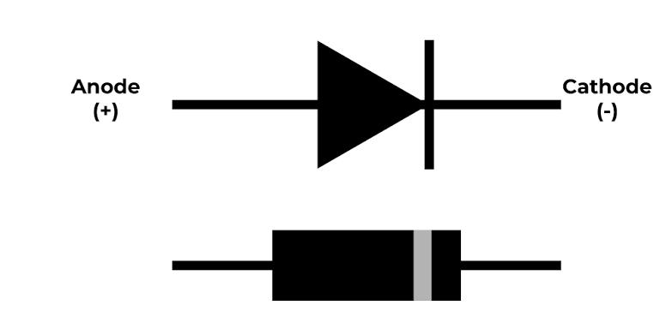
Fig 3.4: Diode

3.1.5 Zener Diode

A Zener diode allows current to flow in the forward and reverse directions. It is heavily doped and conducts in reverse once a specific breakdown voltage is reached. It is commonly used for voltage regulation due to its stable reverse breakdown characteristics. The diagram of a zener diode is shown below in fig 3.5.

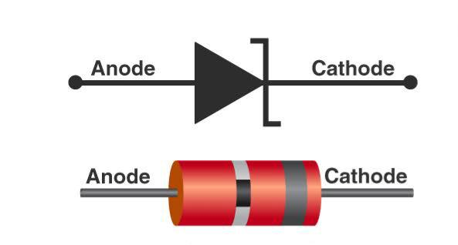
Fig 3.5: zener Diode

3.1.6 Integrated Circuit (IC)

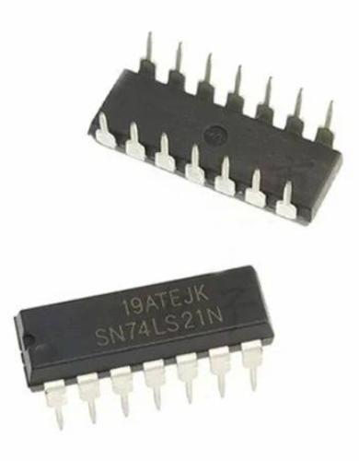
An IC is a compact device consisting of interconnected resistors, transistors, and capacitors embedded into a chip. In this project, it functions as a comparator with high gain, wide bandwidth, and temperature stability. The diagram is shown below in fig 3.6.
Fig 3.6: Integrated circuit (IC)

3.1.8 Transistor

A transistor is a three-layer semiconductor device with terminals named the base, collector, and emitter. It is used to amplify and switch electronic signals. This project uses NPN transistors for amplifying signals and switching relays. The diagram is shown below in fig 3.8.
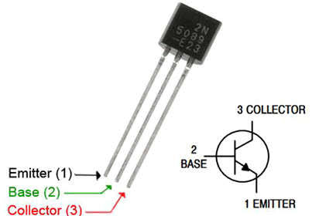
Fig 3.8: NPN Transistor

3.1.9 Light Emitting Diode (LED)

An LED is a P-N junction that emits light when forward biased. During recombination of electrons and holes, energy is released in the form of light. LEDs are used for visual indicators in this project. The diagram is shown below in fig 3.9.
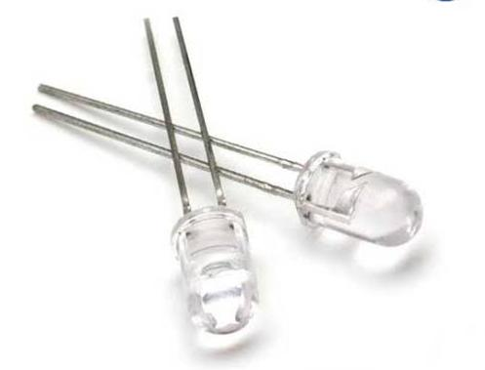

Fig 3.9: Light Emitting Diode ( LED)
3.2.3 Fuse

A fuse is a safety device that protects the circuit from excessive current by melting and breaking the circuit when current exceeds a rated limit. It prevents damage to sensitive components in case of faults like short circuits or overloading. The diagram is shown below in fig 4.3

Fig 4.3:. Fuse

3.2.4 Voltage Sensor Module

This module detects and measures AC voltage and sends the data to the microcontroller for analysis. It plays a key role in monitoring voltage levels and allows the microcontroller to make decisions about relay switching for voltage regulation the diagram is shown below in fig 4.4.
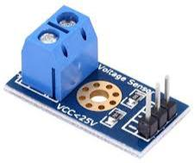
Fig 4.4: Voltage Sensor Module

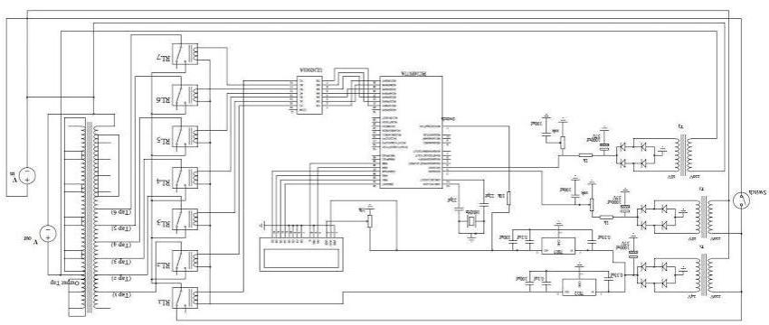
3.3 CIRCUIT DIAGRAM OF 5KVA AUTOMATIC VOLTAGE REGULATOR

3.6 WORKING PRINCIPLE
When the input voltage is applied, the voltage divider scales it down, and the rectifier converts it to DC. This is regulated and sent to a comparator which checks against a reference voltage. The comparator’s output goes into the microcontroller, which decides whether to switch the relay to increase, decrease or maintain the voltage. The selected tap on the auto transformer then feeds the corrected voltage to the output. The current output is displayed on the screen.

3.7 MICROCONTROLLER PROGRAMMING LOGIC

- Read the scaled input voltage from ADC.

- Compare with defined thresholds (e.g., <180V = low, 180–230V = normal, >230V = high).

- Decide action:

If voltage < 180V, activate relay to increase tap.

If voltage > 230V, activate relay to decrease tap.

If voltage in normal range, maintain current tap.

- Update the display with current output voltage.

3.8 Microcontroller Programming Logic Flowchart
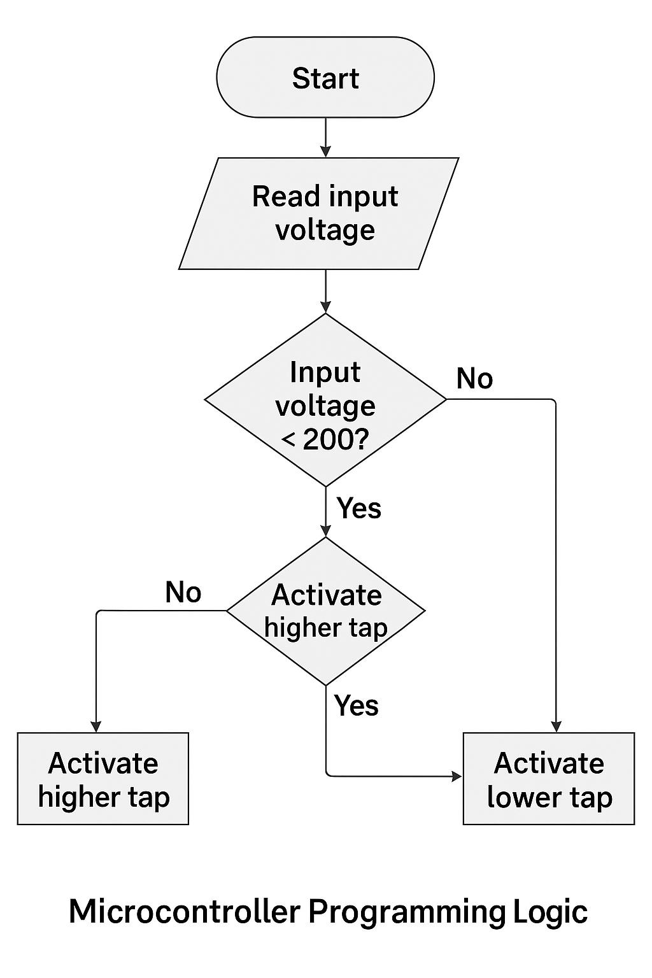

3.3DESIGN SPECIFICATIONS

Typical design specs for our project:

Power Rating: 5KVA

Input Voltage Range: e.g., 140V – 260V AC

Output Voltage: 220V ±5%

Frequency: 50Hz

Correction Time: ≤ 2 seconds

Number of Taps: e.g., 3 or 4 transformer taps

Microcontroller: ATmega328 (or the one you’re using)

Voltage Sensing Accuracy: ±1%

Control Method: Relay-based or triac-based tap switching

Cooling: Natural air cooling or fan assisted

Protection Features: Overvoltage, undervoltage, surge, short circuit, delay timer

3.2 THEORY

This part explains the working principles behind each part of our project

Transformer working principles (auto-transformer)

AC to DC conversion (rectifier theory)

Voltage regulation using feedback and microcontrollers

Relay switching and electromagnetic control

Voltage comparison using op-amps

How microcontrollers sense, process, and control outputs

Use of voltage dividers for ADC input

