CHAPTER THREE

SYSTEM DESIGN AND IMPLEMENTATION
3.1 System Design Approach
The inverter design process was initiated by defining the power requirements and performance parameters to ensure the system would meet practical energy needs while remaining cost effective, durable, and efficient. The system was designed to deliver a continuous power output of 2000 VA (2 kVA), suitable for powering common household or office appliances such as lighting systems, fans, televisions, and low power computing devices. An allowance for overload protection and thermal safety was also integrated into the design.
3.2 Specification Definition
In this phase, key electrical and operational parameters of the inverter system were defined. These specifications guided component selection and circuit design. The major specifications included:
- Output Power Rating: The inverter was designed to supply 2000 VA of apparent power, which corresponds to approximately 1600 Watts of real power, assuming a typical power factor of 0.8.
- Input Voltage: The inverter was intended to operate from a DC source, typically a battery bank rated at either 12V system was preferred due to reduced current demands and increased efficiency, especially at higher loads.
- Output Voltage and Frequency: The output was designed to be 220V AC at a frequency of 50Hz, which conforms to standard utility power in many countries.
- Load Type Consideration: The inverter was expected to power both resistive and moderate inductive loads, thus the waveform quality was considered during design.
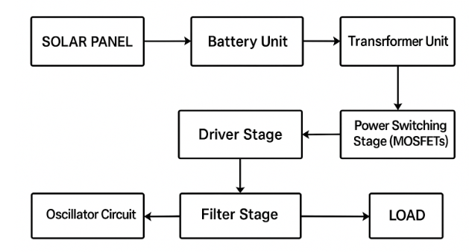
Fig 3.1 Block diagram of 2KVA inverter
3.3 Block Diagram Development
To provide a clear overview of the system architecture, a functional block diagram was developed. This diagram outlines the major subsystems and their interconnections, as shown in Figure 3.1. The key blocks are described below:
- Battery Unit: This supplies the DC power source for the inverter. A deep-cycle lead-acid battery was selected for its high current capability and resilience to deep discharges.
- Oscillator Circuit: This section generates timing pulses used to control the switching of the power transistors. A 555 timer IC or a microcontroller can be used to generate stable and adjustable pulse signals.
- Driver Stage: This circuit amplifies the low-power pulses from the oscillator to suitable levels that can switch high-power MOSFETs. It ensures fast and reliable switching to reduce heat and improve efficiency.
- Power Switching Stage (MOSFETs): High-current MOSFETs are used to convert the DC input into a square waveform, which is then stepped up by the transformer.
- Transformer Unit: A step-up transformer converts the low-voltage, high-current DC waveform into high-voltage, low-current AC output (from 12V/24V DC to 220V AC).
- Filter Stage: This smoothens the output waveform to reduce high-frequency noise and electromagnetic interference (EMI), providing a cleaner AC output suitable for appliances.
- Protection Circuitry: Not explicitly shown in the block diagram, this includes over-voltage, under-voltage, thermal shutdown, and short-circuit protection features to enhance safety and system longevity.
This block based design approach allowed for modular development and testing of individual sub units, ensuring that any errors or inefficiencies could be isolated and corrected before full system integration.
3.4 DESIGN CALCULATION
To design a 2KVA (kilovolt-ampere) inverter, you need to understand the key parameters of the inverter, including input and output power, voltage, current, and efficiency. The primary design objective is to convert DC power from a battery or solar panel into AC power typically 220V/50Hz or 120V/60Hz, depending on the region.
3.4.1 Power Rating
The inverter is designed to handle a load of 2KVA (2,000 VA).
Power Factor (PF): For simplicity, assume the power factor to be 1 (for purely resistive loads). For inductive loads (motors), the power factor would be less than 1 (typically around 0.8). Therefore, the output power in watts:
$$P_{out}=KVA x PF$$
$$P_{out}=2000 x 1=2,000 W$$

So, the inverter must supply 2,000 watts (2kW) of power.
3.4.2 DC Input Voltage and Output AC Voltage
Input Voltage (Vdc): For the design, assume the inverter uses a 12V DC battery (a common setup in off-grid applications), but this can vary depending on the battery and system requirements.
Output Voltage (Vac): For the design, assume a typical 220V AC output voltage, which is commonly used in household applications in many regions.
If the output voltage needs to be 220V AC, the inverter needs to convert the DC voltage to this AC voltage.
3.4.3 Current Calculations
The current calculations depend on the output power and the input voltage.
AC Output Current $I_{ac}$
The current drawn from the AC output side can be calculated using the formula:
$$I_{ac}=P_{out}V_{ac}$$
$$I_{ac}=2,000 W x 220V=9.09 A$$
So, the AC output current will be 9.09 A.
The current on the DC side of the inverter can be calculated using the formula:
$$I_{dc}=P_{out}xV_{dc}x efficiency$$
Assuming the inverter has an efficiency of 85% (which is typical for inverters), we can calculate the input current
$$I_{dc}=2,000W x 12V x 0.85=196.08 A$$
So, the DC input current will be 196.08 A.
3.4.4 Inverter Efficiency
Efficiency is the ratio of the output power to the input power, which accounts for losses in the inverter’s components. Assuming an efficiency of 85%
$$efficiency=P_{out}/P_{in}$$
$$P_{in}= P_{out}/efficiency$$
$$P_{in}=\frac{2,000W}{0.85}=2352.94 W$$
Therefore, the inverter will need to supply 2,352.94 watts of input power to deliver 2,000 watts at the output.
3.3.5 Designing the Transformer
Transformer Output Current (Secondary Side)
The transformer must handle the AC output current (which is 9.09A) at the required AC voltage (220V). The power delivered on the secondary side of the transformer is given by:
$$P_{out}=V_{ac }xI_{ac}=220V x 9.09 A=2,000W$$
The transformer will need to handle 2000W at 220V AC.
Transformer Primary Current (Input Side)
On the primary (DC) side of the transformer, the input current can be calculated based on the input power, voltage, and efficiency:
$$I_{primary}=P_{in} x V_{dc}=2352.94W x 12 V=196.08 A$$
3.4.6 Battery Capacity and Runtime
To calculate the battery capacity required for the inverter to run, you need to consider the energy consumption over time.
Battery Capacity (Ah)
If you are using a 12V DC battery system and want to run the inverter for a specific time (say, 1 hour), the battery capacity in ampere-hours (Ah) can be calculated as:
$$Battery capacity=P_{in }x{ V}_{dc} x time x efficiecy$$
Assuming you want to run the inverter for 1 hour:
$$Battery capacity= 2352.94W x 12V x 1hour x 0.85=230.96 Ah$$
Therefore, a 230.96 Ah battery would be required to run the inverter for 1 hour at full load.
Summary of Key Design Parameters:
Output Power: 2,000W (2KVA)
DC Input Voltage: 12V
AC Output Voltage: 220V
Efficiency: 85%
DC Input Current: 196.08A
AC Output Current: 9.09A
Battery Capacity (1-hour runtime): 230.96 Ah
The circuit diagram of the design 2 KVA inverter is shown in fig 3.2
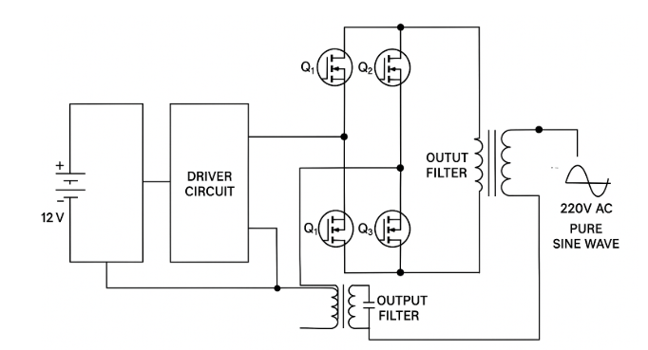
Fig 3.2 Circuit diagram of 2 KVA pure sine wave inverter

