CHAPTER TWO
LITERATURE REVIEW
2.1 Introduction
Renewable energy sources are energies that come from the Sun directly, such as thermal, photochemical, and photoelectric energy, or indirectly, such as wind, hydropower, and photosynthetic energy stored in biomass, as well as other climate regulation and natural motions, such as geothermal and tidal energy; these are then converted into usable forms of energy, such as electricity, heat, and fuels [7]. The most abundant renewable energy that is directly obtained from the Sun is solar energy, which also serves as a regulator of the hydrological cycle and a source of wind energy because the Sun’s heating effect on the atmosphere causes air to move [8,9].
Solar power, also known as solar energy, can be generated by a solar panel, which largely depends on the amount of sunlight it is exposed to. Solar photovoltaic energy has a much higher installed capacity than other renewable energy concepts and technologies due to its abundance, versatility, and ease of implementation with minimal negative environmental impact in terms of land use [10,11]. Maximum solar power can be obtained only when the Sun is directly on the panel. Due to the variation of the position of the Sun throughout the day, there is a need to adjust the solar panel so that it is always aimed precisely at the Sun. A solar tracker is a device employed to operate a solar photovoltaic panel, particularly in solar cell applications, and requires a high level of precision to ensure that sunlight is directed accurately onto the power device [12]. Solar tracking systems also play an important role in the advancement of solar concentration applications such as solar-pumped lasers and parabolic concentrators [13,14]. These trackers can improve the efficiency of the overall solar photovoltaic system, reducing the size and the cost per kilowatt hour (kWh). To increase the efficiency of photovoltaic (PV) systems, several solar tracking systems have been developed over the years, and a few have been reviewed, for instance, [15,16]. However, these reviews did not consider hybrid solar trackers or learning-based solar tracking systems as most of these reviews are limited to classification based on two-axis, single-, and dual-axis solar tracking systems and classification based on the nature of motion, that is, active and passive solar tracking systems. This paper thus aims to provide a holistic review of the different existing developed time-based solar tracking systems based on various classifications to show the trend and proffer further research directions.
2.2 Classification of Solar Tracker Based on Axis Rotation
According to the movement of the axis of rotation, two types of solar trackers have been designed and implemented in the literature. These include single-axis trackers and dual-axis trackers. In addition, some authors have designed and developed tracking systems with three or more axes categorized under hybrid-axis solar trackers. This section presents and reviews these time-based solar tracking systems based on the axis rotation.
2.2.1. Single-Axis Solar Tracking System
This solar tracking system comprises only one axis, either vertically or horizontally, and cannot rotate for both. Examples of this type of solar tracking system in the literature include Horizontal Single-Axis Trackers (HSAT), Vertical Single-Axis Trackers (VSAT), Tilted Single-Axis Trackers (TSAT), and Polar-Aligned Single-Axis Trackers (PASAT) [15]. Figure 3 depicts the various existing single-axis solar trackers.
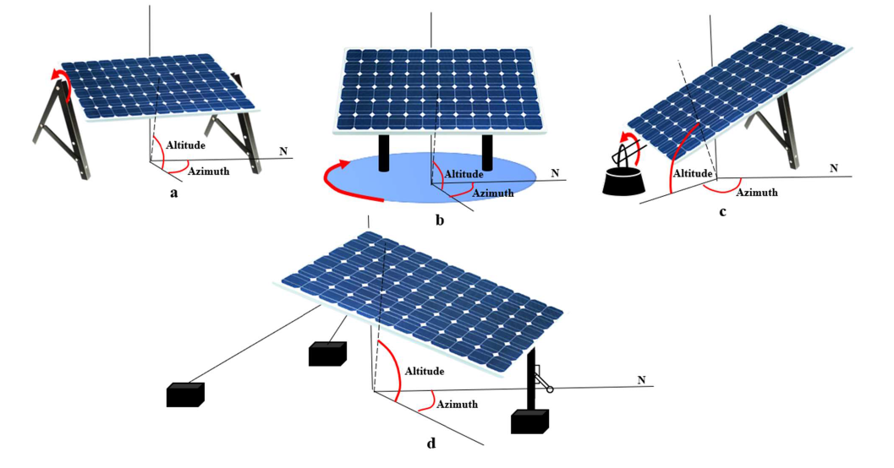

Figure 3. Various Single-axis Solar Tracking Systems. (a) HSAT; (b) VSAT; (c) PASAT; (d) TSAT.
HSAT rotates from north to south on a fixed axis parallel to the ground, as shown in Figure 3a, throughout the day and is considered the most economical tracker setup in many PV applications [17,18]. VSAT, on the other hand, rotates vertically with respect to the ground, as shown in Figure 3b, and can be mounted in either a north/south or east/west orientation to track the Sun’s movement up-and-down in the sky; such systems are more common in high-altitude/mountainous areas or more severe latitudes [19,20]. PASAT, as shown in Figure 3c, was derived by aligning the tilted single-axis solar tracker to the polar star [17]. Finally, the TSAT, shown in Figure 3d, has axes of rotation that alternate between horizontal and vertical, where the module sweeps a cylinder that is rotationally symmetrical around the rotation axis to track the Sun [12,17]. The solar azimuth angles of a single-axis solar tracking system range from −100° to 99.87° [19]. The following is a review of several developed single-axis time-based solar tracking systems.
A low-power single-axis solar tracking system was designed and developed to track the Sun’s position regardless of the motor speed and generate maximized solar power. The system implementation was divided into hardware and software parts, and the tracking system comprised two LDR sensors, a PIC16F877A microcontroller, a bi-directional DC-geared motor, a voltage regulator, a driver circuit, and a solar panel. To evaluate the performance of the developed system, a comparison with a fixed solar panel system was conducted in which the voltage and current for each system were measured between 8 a.m. to 6 p.m. The results showed that the developed system performed better than the fixed system by generating higher power. However, the system was not tested for different weather conditions[20]. A single-axis solar tracking system was developed based on LDR as a sensor. The methodology adopted for this research was divided into two parts, hardware development and programming development. The hardware development part was concerned with the components used to develop the solar tracker, which includes a solar panel, bidirectional DC geared motor, drive circuit, PIC16F667A microcontroller, two LDR sensors, and voltage regulator, while the programming development part was concerned with the development of the program that would be fed into the PIC16F667A microcontroller. To evaluate the performance of the developed solar tracker, a comparison with a fixed solar panel was conducted, and the results showed that the developed system received more sunlight and generated higher solar power than the fixed system. However, the research only considered sunny weather conditions and did not consider other weather conditions[21]. A high-efficiency single-axis solar tracking system was designed and developed in where the system was based on a microcontroller focused primarily on small applications in remote areas. The tracking system consists of a power supply circuit, servo motor, light-dependent resistor (LDR), solar panel, liquid crystal display (LCD), real-time clock, and two different types of voltage regulators. The system was demonstrated to be a cost-effective solution and increased the solar output from the panel by 30–40% compared to the fixed solar panels [22].
A single-axis solar tracker to track the Sun on the azimuth axis by using an AVR microcontroller was designed and implemented. The implemented system consisted mainly of the ATmega328 controller, DC motor, light sensors, relay, and solar panel. The results showed that the designed low-cost solar tracker increased the output power gain by 18–25% compared to the fixed panel located at Kirkuk city, Iraq. The output power was increased and improved by adding an ear side panel and reflector by about 65% and 70–80%, respectively. However, the overall system is limited to just one axis, reducing reliability [23]. A solar tracking system was utilized which operates based on light-dependent resistor (LDR) sensors, a microcontroller for controlling the system, and DC motors. The study aims to establish a cost-effective solar tracker system by identifying and removing the parts that consume unnecessary energy, reducing energy loss. To achieve this, a timer circuit was used to shut down the system for 29 min after one minute of work during which the amount of solar panel power gain and loss was measured due to the timer[24]. A single-axis time-based solar tracking mechanism was proposed by [25] that can automatically track the movement of the Sun and then display the tilt angle values and the corresponding solar irradiance values in real time. The tracking unit comprises a solar panel, a real-time clock, a stepper motor, and a stepper motor driver. The study utilized the zenithal angle as a reference angle, which the microcontroller follows and then moves the stepper motor to track the position of the Sun. The system is a cost-effective, accurate, and efficient method to track the position of the Sun compared to a stationary solar panel.
2.2.2. Dual-Axis Solar Tracking System
This solar system has two degrees of flexibility that act as the axis of rotation; that is, it allows for maximized solar power output levels due to its ability to track the Sun both vertically and horizontally. Two common implementations are Tip-Tilt Dual-Axis Trackers (TTDAT) and Azimuth-Altitude Dual-Axis Trackers (AADAT). Figure 4 depicts the operation of a dual-axis solar tracking system.
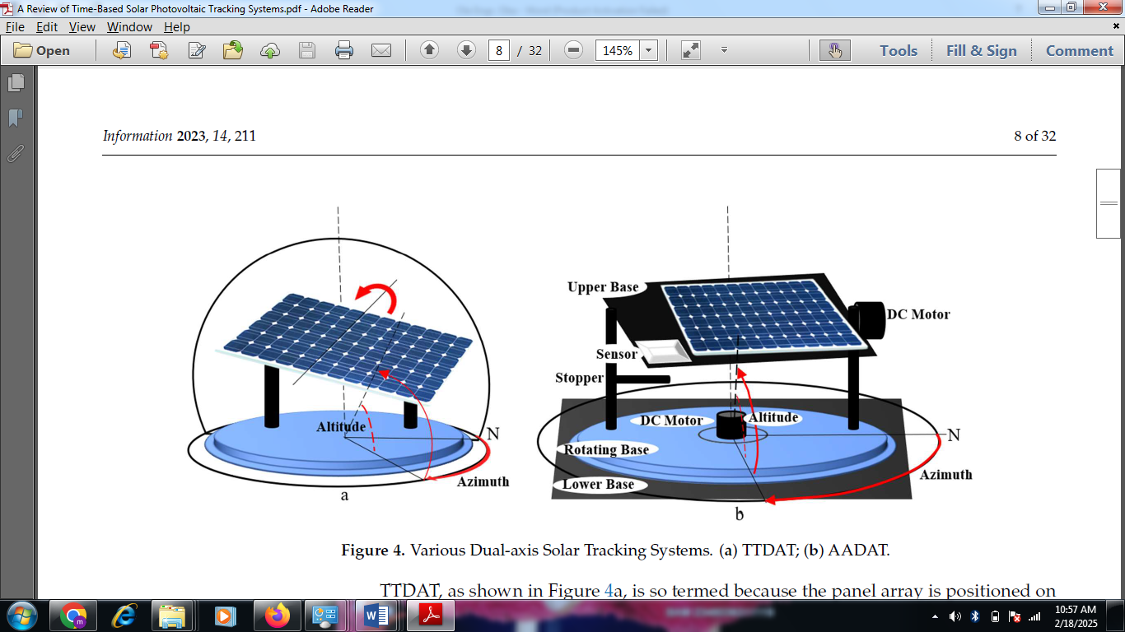

Figure 4. Various Dual-axis Solar Tracking Systems. (a) TTDAT; (b) AADAT.
TTDAT, as shown in Figure 4a, is so termed because the panel array is positioned on the top of vertical poles. Typically, the east–west movement is caused by rotating the array around the top of the pole. The posts at each end of the primary axis of rotation of a tip-tilt dual-axis tracker can be reused between trackers to reduce installation expenses [26]. The primary axis of AADAT, also known as the azimuth axis, is parallel to the ground while the secondary axis, also known as the elevation axis, is normal to the primary axis [26]. A servo motor for the azimuth axis (horizontal) and a linear actuator for the elevation axis (vertical) are used in an AADAT to track the Sun [27]. AADAT systems can use a huge ring mounted on the ground with the array positioned on a series of rollers rather than rotating the array around the top of the pole as shown in Figure 4b. This enables AADAT to support much larger arrays; however, the system cannot be positioned closer together than the diameter of the ring, which may diminish system density, especially when inter-tracker shadowing is included [26]. The solar azimuth and altitude angles of a dual-axis solar tracking system can range from 61.1° to 299.1° and −10.1° to 10.7°, respectively [28]. To ensure robust system performance, in [29] proposed a novel dual-axis solar tracking PV system design that leverages feedback control theory, a four-quadrant light-dependent resistor (LDR) sensor, and simple electronic circuits. The proposed system utilized a distinctive dual-axis AC motor and a stand-alone PV inverter to achieve solar tracking. The execution of the control was a technical innovation with a simple and effective design that did not require programming or a computer interface. In addition, a scaled-down laboratory prototype was built to test the scheme’s effectiveness, and experiment results indicated that the developed system increased the energy gain up to 28.31% for a partly cloudy day. The developed system achieved attractive features, but it is limited to a laboratory prototype with no real-life implementation.
A smart dual-axis solar system was proposed, where an embedded controller was utilized as the major system controller that detects the voltage difference and estimates the solar azimuth angle with four groups of cadmium-sulfide (CDS) as sensor elements. The control system comprises solar panels, motors, sensors, an A/D controller, an embedded controller, a drive circuit, and GSM modules. The system utilized two motors as an actuator to regulate the elevation and azimuth while the CDS tracked the position of the Sun through the movement of the embedded controller motor. The GSM module was used to notify the maintenance personnel in the event of a failure. A comparison between the proposed system and a fixed solar panel system was carried out under different weather conditions, and the results showed that the generated power increased by 30% when the proposed system was utilized [30]. The design and implementation of a dual-axis solar tracking system were presented by [31] based on a closed-loop technique. The system was divided into two parts, mechanical and electrical. The mechanical part, which was said to be the most challenging part of the development, dealt primarily with the azimuthal and vertical movements of the solar tracker and consisted of servo motors and panel carriers. The electrical part, which is concerned with sensing the sunlight and the movement of the panel in that direction, consists of four light sensors and an ATmega328P microcontroller. To evaluate the performance of the developed system, a comparison with other systems, which included the fixed solar panel system and the single-axis solar tracking system, was conducted, and the results showed that the developed dual-axis solar tracking system always outperformed the other systems. One major limitation of this research is that the developed system is limited to small-scale use.
A double-axis solar tracking system was designed and implemented by [32], where the overall system design is divided into two parts, electrical and mechanical. The electrical part is further subdivided into control system design and programming. In contrast, the mechanical part comprises two DC motors that provide horizontal-to-vertical and left-to-right motions, as well as gears that transfer their movements to the solar panel. Other components include a light-dependent resistor (LDR), microcontroller, battery, mount limit switches, profile iron stand, and roller. To evaluate the performance of the system, a comparison was made between the proposed system and a stationary solar panel system; the results showed that the generated energy increased by 25% when the proposed system was utilized and based on the cost analysis carried out in the study, the proposed system is very cost-effective. An automatic dual-axis solar tracking system was designed and developed using a light-dependent resistor (LDR) to determine the intensity of falling sunlight and DC motors on a mechanical structure with gear arrangement to track the Sun accurately. The results showed that the energy gained from the solar panel with the dual tracker exceeds 35% of the energy gained from the fixed solar panel. In analyzing the data, the energy gained from the solar tracker is mostly in the morning and the evening because there is little difference at noon, proving that the fixed solar panel is efficient at noon. One major limitation of the system is the cost, as the system utilizes four LDR sensors [9].
A dual-axis solar tracking system was designed and developed in [33] for a standalone PV system using worm gear. The system comprised solar cell plates, a PIC microcontroller, an LCD, a real-time clock, LDR sensors, DC motors, and servo motors. The performance of the system was evaluated against a fixed-axis solar panel, and the input and output power were measured and utilized to calculate the efficiency for different days. The results obtained showed that the proposed system performed better, with a power gain of 84% in the morning, and in the evening, the power gain was 100%. However, the developed system was limited to small-scale use.
2.2.3. Hybrid Solar Tracking System
The hybrid solar tracker, also known as the three-axis or triple-axis solar tracker, moves along three axes, allowing it to capture solar energy for the longest time of the day and with the most accurate alignment with the position of the Sun in different seasons and weather conditions [34]. Figure 5 depicts a hybrid solar tracker system developed in [35], which comprised a solar panel mounted between two vertical poles and a rotating horizontal surface adapted to mount the two vertical poles. A scissor lift approach was employed to smoothly move the axis up and down to obtain the third axis and minimize shading. The location of the Sun was tracked using four LDRs placed on top of the solar panel, and signals from these sensors are sent to the servo motor through the microcontroller, which thus moves the solar panel toward the direction of the Sun. Another LDR is connected at the bottom of the solar module and was used to automatically control the functioning of the third axis, sending signals to a relay and activating the DC motor to move the scissor lift upward when shading is detected. The system was compared with both fixed and dual-axis solar tracking systems in terms of power output and energy efficiency, and it was shown the hybrid system produced the highest power output, particularly in shading areas; however, it consumed more energy than the dual-axis solar tracking system. The relative error of the solar azimuth and altitude angles ranges from 0.844° to 0.251° and −0.498° to 0.576°.
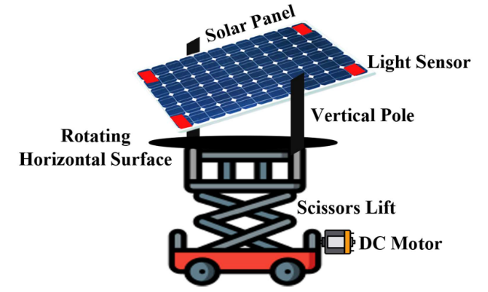

Figure 5. Hybrid Solar Tracking System.
A hybrid solar tracking system was proposed by [36]. combining a mechanical and an electrical tracking system. The mechanical tracking system was based on a photodiode array (PDA) that was implemented using a sphere whose inner surface was optimized, allowing the PDA to function as a high-precision sensor. On the other hand, the electrical tracking system consisted of a maximum power point tracking (MPPT) feedback control system. The system was simulated, and it concluded that although the single solar tracking system is more efficient than the fixed solar panel, it cannot track the variation of the azimuth angle, which was hard-coded into the microcontroller of the proposed system. Additionally, the proposed system can track the Sun at any time, thus increasing the output power. The research did not implement the proposed system, hence the limitation.
A multidimensional automatic solar tracking system was developed based on a hybrid hardware and software prototype that automatically provides the best alignment of a solar panel with the Sun to obtain the maximum power output. The tracking system comprised a sensor, a light-dependent resistor, a relay, a light-emitting diode, a stepper motor, a capacitor, gears, and a microcontroller. To evaluate the performance of the proposed system, measurements of the PV system were taken with and without a tracking system in the local climates of Bangladesh, and the results obtained showed that the overall efficiency of the solar power system increased by 31% with the tracker system [37]. An electromechanical system programmed using C++ was developed by [38] that controls the solar panel movement based on a hybrid-axis tracking system (one-axis and two-axis) so that it is always positioned towards the direction of the Sun. The major component of the tracking system includes solar panels, a deep cycle rechargeable battery, a microcontroller, signal conditioning circuits, and a motor drive, which are then connected to four-quadrant light-dependent resistor (LDR) sensors and a solar rotation mechanism. The system provides a reliable and cost-effective means of aligning a solar panel with the Sun to optimize energy output and efficiency by 31% when compared to a stationary solar panel. The tracking system suitable for a smart photovoltaic blind (SPB) was investigated by [39], and an indirect tracking method was adopted as a preliminary study of a two-axis hybrid (direct and indirect) solar tracking method. According to the research, an SPB is a device that can be utilized for both electricity generation and Sun-shading functions and can be installed in the windows of buildings. The indirect tracking method was conducted via two steps: calculating the hourly altitude and azimuth of the Sun and calculating the hourly slope of the panel (SoP) and the azimuth of the panel (AoP) that are perpendicular to the altitude and azimuth of the Sun. The results obtained showed the SoP tracked the Sun from 0° to 90°, while the AoP tracked the Sun from −9° to 9°. The limitation of this research is that no solar tracking system was developed.

Table 1. Comparison between the Solar Tracking System based on Axis rotation.
Properties | Single-Axis | Dual-Axis | Hybrid-Axis
Cost | Cheap to implement | More expensive to implement than a single but less expensive than a hybrid | Most expensive to implement
Complexity | Less complex | High complexity | Very complex to implement
Tracking accuracy | It offers the least accuracy compared to the other types of trackers | It offers high accuracy compared to the single-axis | It offers the best accuracy as the Sun will be tracked at any  angle and position
Number of Axis | It is limited to only one axis | It is limited to having only two axes | It can have three or more axes
Efficiency | Very reduced since it only tracks the Sun’s movement in the East–West direction, and during cloudy days, its efficiency is almost close to the fixed-angle solar tracking system | Has high efficiency as in addition to tracking the Sun’s movement from East–West, it also follows the angular height position of the Sun | Has the highest efficiency, especially during the cloudy days

2.3. 360º Solar Tracking system
This is a system that adjusts the orientation of a solar panel to follow sun’s movement throughout the day, ensuring movement exposure to sun light unlike traditional solar tracker that track the sun only on one axis (horizontal or vertical) or two axis (azimuth and elevation), a 360º solar tracker is capable of rotating completely around to capture sunlight from any direction, it is essential in regions were the sun’s path varies significantly. The key components of the 360º solar tracker system are: solar panels, rotational mechanism (Dual axis or 360º tracking) sensors, control system, motor and Actuators and power source.
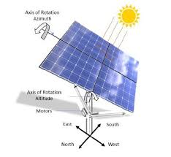

360º Solar Tracking System
Challenges of 360º Solar Tracking system
The following are challenges of 360º solar tracking system:
- 360º solar tracking system involve two separate axes of movement (typically north-south and east-west), requiring more complex control systems and more mechanical components.
- The added complexity of 360º systems can increase the risk of component failure and downtime, potentially impacting energy production.
- Active tracking systems, including 360º trackers, consume power to operate the motors and control mechanisms.
- Cloud cover and other weather conditions can affect the performance of any tracking system, including 360º trackers.
- Implementing 360º tracking systems can be challenging, particularly in areas with limited resources or where specialized technical expertise is not readily available.
- 360º trackers require ongoing maintenance, including regular inspections, repairs, and potential component replacements.

References
[1]. U. Goverment, "Solar Radiation Basics," 21 August 2013. [Online]. Available:https://www.energy.gov/eere/ solar/articles. [Accessed 28 June 2019].
[2]. Y. Jake, "Solar tracker technology," 2019. [Online]. Available: www.britanica.com/solartracker-technology. [Accessed 29 June 2019].
[3]. R. O. OLOKA, "SOLAR TRACKER FOR SOLAR PANEL," UNIVERSITY OF NAIROBI, Kenya, 2015.
[4]. M. Hossein, K. Alireza, J. Arzhang, M. Hossein and A. a. A. S. Karen, "A review of principle and sun-tracking methods for maximizing solar systems output," Renewable and Sustainable Energy Reviews, pp. 1800-1818, 2009.
[5]. N. Dangi, "Monitoring environmental parameters: humidity and temperature using Arduino based microcontroller and sensors," Helsinki Metropolia University of Applied Sciençec Halcinli Metronolio 2017
[6]. P. a. A. A. Bhavesh, "Automatic Sun Tracking System Using PSoC," International Journal of Innovative Research in Science, Engineering and Technology, vol. 1, no. 1, pp. 66-70, 2012.
[7]. Ellabban, O.; Abu-Rub, H.; Blaabjerg, F. Renewable Energy Resources: Current Status, Future Prospects and Their Enabling Technology. Renew. Sustain. Energy Rev. 2014, 39, 748–764. [CrossRef]
[8]. Oghogho, I.; Sulaimon, O.; Egbune, D.; Abanihi, K. V Solar Energy Potential and Its Development for Sustainable Energy Generation in Nigeria: A Road Map to Achieving This Feat. Int. J. Eng. Manag. Sci. 2014, 5, 61–67.
[9]. Mustafa, F.I.; Shakir, S.; Mustafa, F.F.; Naiyf, A.T. Simple Design and Implementation of Solar Tracking System Two Axis with Four Sensors for Baghdad City. In Proceedings of the 2018 9th International Renewable Energy Congress (IREC), Hammamet, Tunisia, 20–22 March 2018.
[10]. Choudhary, P.; Srivastava, R.K. Sustainability Perspectives—A Review for Solar Photovoltaic Trends and Growth
Opportunities. J. Clean. Prod. 2019, 227, 589–612. [CrossRef]
[11]. El Hammoumi, A.; Chtita, S.; Motahhir, S.; El Ghzizal, A. Solar PV Energy: From Material to Use, and the Most Commonly Used Techniques to Maximize the Power Output of PV Systems: A Focus on Solar Trackers and Floating Solar Panels. Energy Rep. 2022, 8, 11992–12010. [CrossRef]
[12]. Ray, S.; Tripathi, A.K. Design and Development of Tilted Single Axis and Azimuth-Altitude Dual Axis Solar Tracking Systems. In Proceedings of the 2016 IEEE 1st International Conference on Power Electronics, Intelligent Control and Energy Systems (ICPEICES), Delhi, India, 4–6 July 2016; ISBN 9781467385879.
[13]. Costa, H.; Liang, D.; Almeida, J.; Catela, M.; Garcia, D.; Tibúrcio, B.D.; Vistas, C.R. Seven-Rod Pumping Concept for Highly Stable Solar Laser Emission. Energies 2022, 15, 9140. [CrossRef]
[14]. Tibúrcio, B.D.; Liang, D.; Almeida, J.; Garcia, D.; Catela, M.; Costa, H.; Vistas, C.R. Tracking Error Compensation Capacity Measurement of a Dual-Rod Side-Pumping Solar Laser. Renew. Energy 2022, 195, 1253–1261. [CrossRef]
[15]. Muhammad, J.Y.; Tajudeen Jimoh, M.; Baba Kyari, I.; Abdullahi Gele, M.; Musa, I. A Review on Solar Tracking System: A Technique of Solar Power Output Enhancement. Eng. Sci. 2019, 4, 1–11. [CrossRef]
[16]. Hafez, A.Z.; Yousef, A.M.; Harag, N.M. Solar Tracking Systems: Technologies and Trackers Drive Types—A Review. Renew. Sustain. Energy Rev. 2018, 91, 754–782. [CrossRef]
[17]. Racharla, S.; Rajan, K. Solar Tracking System—A Review. Int. J. Sustain. Eng. 2017, 10, 72–81.
[18]. De Rooij, D. Single Axis Trackers. Available online: https://sinovoltaics.com/learning-center/csp/single-axis-trackers/ (accessed on 4 March 2023).
[19] Das, A.; Durgaprasad, S. Simulation and Implementation of Single Axis Solar Tracker. Int. Res. J. Eng. Technol. 2020, 7, 756.
[20] Ponniran, A.; Hashim, A.; Joret, A. A Design of Low Power Single Axis Solar Tracking System Regardless of Motor Speed. Int. J. Integr. Eng. 2011, 3, 5 – 9.
[21] Ponniran, A.; Hashim, A.; Ali Munir, H. A Design of Single Axis Sun Tracking System. In Proceedings of the 2011 5th International Power Engineering and Optimization Conference, Shah Alam, Malaysia, 6–7 June 2011; ISBN 9781457703546.
[22] Karthik, K.; Kumar, D. Design and Implementation of High Efficiency Solar Tracking System. Int. J. Eng. 2013, 2, 2886– 2892.
[23] Akbar, H.S.; Fathallah, M.N.; Raoof, O.O. Efficient Single Axis Sun Tracker Design for Photovoltaic System Applications. IOSR J. Appl. Phys. 2017, 9, 53–60. [CrossRef]
[24] Nori, A.F.; Moh mmed, F.G. Design and Implementation of an Efficient Solar Tracker Syste . J. Phys. Conf. Ser. 2020, 1530, 12150. [CrossRef]
[25]. Musa, A.; Suleiman, S.A.; Fijabi, M.M.; Hussain, A.O.; Ganiyu, I.A. Design and Implementation of a Real Time Clock Based Solar Tracking System. Zaria J. Electr. Eng. Technol. 2021, 10, 39–46.
[26]. Balaji, B.; Arulvizhi, J.A. Maximum Solar Power Tracker Mechanically by Using Dual Axis Tracker. J. Int. J. Adv. Res. 2017, 3, 1157–1162.
[27]. Driggs, D.; Mensah, P.; Stephen, A.; Fareed, D.; Jana, A. Dual Axis Solar Panel Optimized Using Programming Languages. In Proceedings of the 2006 GSW; ASEE Conferences, Tuscaloosa, AL, USA, 6–10 March 2006. Available online: https://sites.asee. org/se/publications/proceedings/2006-asee-se/ (accessed on 6 March 2023).
[28]. Shufat, S.A.A.; Kurt, E.; Hancerliog˘ulları, A. Modeling and Design of Azimuth-Altitude Dual Axis Solar Tracker for Maximum Solar Energy Generation. Int. J. Renew. Energy Dev. 2019, 8, 7. [CrossRef]
[29]. Wang, J.M.; Lu, C.L. Design and Implementation of a Sun Tracker with a Dual-Axis Single Motor for an Optical Sensor Based Photovoltaic System. Sensors 2013, 13, 3157–3168. [CrossRef]
[30]. Wu, Y.E.; Huang, K.C. Design and Implementation of Dual-Axis Solar Tracking System with GSM Fault Reporting Capability. In Applied Energy Technology; Trans Tech Publications Ltd.: Bäch, Switzerland, 2013; Volume 724, pp. 43–51.
[31]. Munna, M.S.; Bhuyan, M.A.I.; Rahman, K.M.; Hoque, M.A. Design, Implementation and Performance Analysis of a DualAxis Autonomous Solar Tracker. In Proceedings of the 2015 International Conference on Green Energy and Technology, ICGET 2015 , Dhaka, Bangladesh, 11 September 2015; pp. 1 – 5.
[32]. Özer, T.; Mustafa Kelek, M.; Og˘uz, Y.; Kivrak, S.; Kıvrak, S.; S¸ahin, M. Double Axis Solar Tracking System Design and Implementation. Int. J. Sci. Eng. Res. 2018, 9, 66–71.
[33]. Prakash, M.B.; Govindarajulu, K. Analysis and Testing of Dual Axis Solar Tracker for Standalone PV Systems Using Worm Gear. Int. J. Mod. Trends Sci. Technol. 2022, 8, 1 – 8.
[34]. Tamang, D.; Roy, O.P. Hybrid Solar Tracking System: A Brief Overview. In Proceedings of the 2019 3rd IEEE International Conference on Electrical, Computer and Communication Technologies, ICECCT 2019, Coimbatore, India, 20–22 February 2019 ; pp. 1 – 5.
[35]. Gupta, P.; Gupt , V.; Sharma, M.; Pachauri, R.K.; Akhtar, J. Design and Performance A alysis of Three Axis Solar Tracking System. In Proceedings of the 2022 7th Asia Conference on Power and Electrical Engineering (ACPEE), Hangzhou, China, 15–17 April 2022; pp. 1876–1880.
[36]. Siddharth, P.S.; Ganesh, S.; Sreenath, S. A Hybrid Solar Tracking System. Int. J. Electr. Electron. Eng. Res. 2013, 3, 77–80.
[37]. Mumtahina, U.; Bhuiya, M.; Sayem, A.; N, A.; Mohammad, N. Design and Implementation of a Multi-Dimensional Automatic Solar Tracking System. Energy Technol. 2014, 6, 1–11.
[38]. Abdulrahman, A.; Hamoud, A.; Al-Nehari, A.; Almakhlafy, M. Design and Implementation of Solar Tracking System. In Proceedings of the 2015 International Conference on Applied Science and Engineering Innovation (ASEI 2015), Jinan, China, 30–31 August 2015; Volume 12, pp. 785–788. [CrossRef].

