
TECHNICAL REPORT
ON
STUDENT INDUSTRIAL WORK EXPERIENCE
SCHEME (SIWES)

HELD AT

GLOBA.COM NIG LTD
201 AJASE IPO ROAD ITA ALAMU ILORIN
BY
ADEBISI RIDWAN AKINKUNMI
ND/23/BAM/PT/0216
SUBMITTED TO
THE DEPARTMENT OF BUSINESS ADMINISTRATION,
INSTITUTE OF FINANCE AND MANAGEMENT STUDIES
(IFMS)
KWARA STATE POLYTECHNIC, ILORIN
IN PARTIAL FULFILMENT OF THE REQUIREMENTS FOR THE
AWARD OF NATIONAL DIPLOMA IN BUSINESS
ADIMINSTRATION
OCT- NOV, 2024

CERTIFICATION
This is to certify that the bearer has successfully completed the Student Industrial Work Experience (SIWES).

Department Cordinator Date

SIWES Director Date

DEDICATION
This report is dedicated to the almighty God, the giver and sustainer of life, for His unconditional love and mercy granted to me throughout the period of my Industrial Training.

ACKNOWLEDGEMENTS
I appreciate the Almighty God for the knowledge, endurance, safety, and courage upon throughout the period of my Industrial attachment and kwara state polytechnic for the privilege of this siwes program

TABLE OF CONTENT
Title page
Dedication
Acknowledgement

CHAPTER 1
1.1 Introduction
1.2 Aims and objectives of SIWES (Definition of SIWES)
1.3 Historical background of the organization
1.4 Network diagram of the organization
CHAPTER 2
2.1 Major activities of the organization
2.2 Student involvement at various section/ unit
  - Interpersonal relationship with the organization
2.4 Communication in organization

CHAPTER 3
  - Relevance experience gained to the student field study
3.2 Personal Impression about the organization

CHAPATER 4
4 Recommendation

CHAPTER 1

1.1 INTRODUCTION
This program called (SIWES) student industrial work experience scheme is compulsory to all ND1 student who offer science course or any other practicable course. It enables student to have the experience of the aspect which have been taught in school. It is a program that takes up to four month in which student are expected to be able practices what they are taught.

1.2 AIMS AND OBJECTIVES OF SIWES
The student industrial work experience scheme (SIWES) can be define as a technical skills and acquisition of knowledge from the organization, industrial sector. It is also serving as the complement the learning which student have acquired in the lecture room or theoretically.
The objective of the student industrial work experience scheme is as follow It enables the
student to practically different test from what they learnt theoretically in the lecture room.
- It also enlighten student to various s division of industrial or organization of work in which the course of study can be radicalized.
- It relate the student to the labor market and how it being operated.
- To enable student to defend his or her self in anywhere he or she found itself.

1.3 HISTORICAL BACKGROUND OF THE ORGANIZATION
The name of the organization is globa.com nig ltd It was directed by engineer nasirudeen
The aims and objective of the organization is to train both SIWES and its student and also individual how to use network in order for them to know much or deep about and they have taught in their various institutions.

1.3 NETWORK DIAGRAM

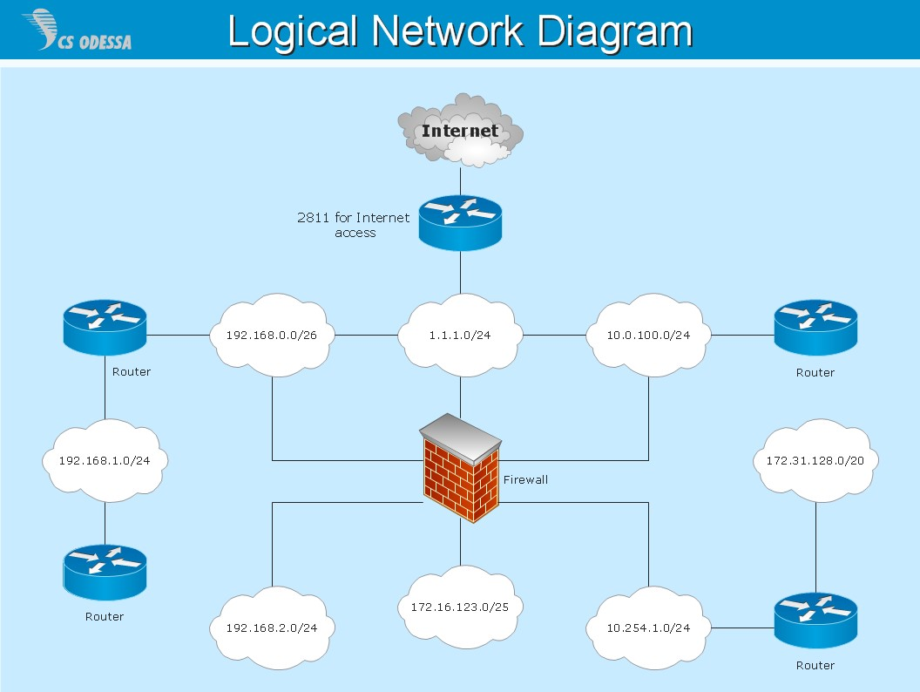

CHAPTER 2

2.1 Major activities of the organization
Network Provisioning:
- Network Planning: Designing and planning the network architecture to meet customer demands.
- Network Deployment: Deploying and configuring network infrastructure, including hardware and software.
- Network Testing: Testing the network to ensure it meets performance and quality standards.
Service Delivery:
- Service Provisioning: Provisioning and configuring services, such as internet, voice, and data services.
- Service Monitoring: Monitoring services to ensure they meet performance and quality standards.
- Service Troubleshooting: Troubleshooting and resolving service issues and outages.
Customer Support:
- Customer Onboarding: Onboarding new customers, including provisioning services and providing training.
- Customer Support: Providing ongoing support to customers, including answering questions and resolving issues.
- Customer Feedback: Collecting and acting on customer feedback to improve services.
Network Maintenance:
- Network Upgrades: Upgrading network infrastructure and services to meet changing customer demands.
- Network Maintenance: Performing routine maintenance tasks, such as backups and software updates.
- Network Security: Ensuring network security, including monitoring for threats and vulnerabilities.

Quality Assurance:
- Service Quality Monitoring: Monitoring service quality to ensure it meets performance and quality standards.
- Service Testing: Testing services to ensure they meet performance and quality standards.
- Service Improvement: Identifying and implementing service improvements to enhance customer experience.
Billing and Revenue Management:
- Billing and Invoicing: Generating bills and invoices for customers.
- Revenue Management: Managing revenue, including tracking payments and handling disputes.
- Financial Reporting: Providing financial reports and insights to stakeholders.

These activities are crucial to delivering high-quality services and ensuring customer satisfaction in a services network.

2.2 Student involvement at various section/ unit
Network Operations:
- Network Monitoring: Students can assist with monitoring network performance, identifying issues, and troubleshooting.
- Network Maintenance: Students can help with routine maintenance tasks, such as backups, software updates, and hardware repairs.
- Network Security: Students can assist with ensuring network security, including monitoring for threats and vulnerabilities.

Service Provisioning:
- Service Installation: Students can assist with installing services, such as internet, voice, and data services.
- Service Configuration: Students can help with configuring services, including setting up routers, switches, and other network devices.
- Service Testing: Students can assist with testing services to ensure they meet performance and quality standards.

# Customer Support:
- Customer Service: Students can assist with providing customer support, including answering questions, resolving issues, and providing training.
- Technical Support: Students can help with providing technical support, including troubleshooting and resolving technical issues.
- Customer Feedback: Students can assist with collecting and acting on customer feedback to improve services.

Billing and Revenue Management:
- Billing and Invoicing: Students can assist with generating bills and invoices for customers.
- Revenue Management: Students can help with managing revenue, including tracking payments and handling disputes.
- Financial Reporting: Students can assist with providing financial reports and insights to stakeholders.
Quality Assurance:
- Service Quality Monitoring: Students can assist with monitoring service quality to ensure it meets performance and quality standards.
- Service Testing: Students can help with testing services to ensure they meet performance and quality standards.
- Service Improvement: Students can assist with identifying and implementing service improvements to enhance customer experience.
Research and Development:
- Research Projects: Students can assist with research projects, including studying new technologies, services, and trends.
- Service Development: Students can help with developing new services, including designing, testing, and deploying.
- Innovation: Students can assist with identifying and implementing innovative solutions to improve services and customer experience.

By involving students in these areas, services provide networks can provide hands-on experience, develop skills, and foster innovation.

2.3 Interpersonal relationship with the organization
Interpersonal relationships play a crucial role in the organization of network services, as they can impact the effectiveness of communication, collaboration, and problem-solving. Here are some aspects of interpersonal relationships in a network service organization:
Types of Interpersonal Relationships:
- Colleague Relationships: Relationships among team members, including network engineers, technicians, and administrators.
- Supervisor-Subordinate Relationships: Relationships between managers and their direct reports.
- Customer Relationships: Relationships between network service providers and their customers.
- Vendor Relationships: Relationships between network service providers and their vendors or partners.
Importance of Interpersonal Relationships:
- Effective Communication: Interpersonal relationships facilitate effective communication, which is critical for network service organizations.
- Collaboration and Teamwork: Positive interpersonal relationships promote collaboration and teamwork, leading to better problem-solving and decision-making.
- Customer Satisfaction: Strong interpersonal relationships with customers can lead to increased satisfaction and loyalty.
- Conflict Resolution: Interpersonal relationships can help resolve conflicts and issues that may arise in a network service organization.
Challenges in Interpersonal Relationships:
- Communication Breakdowns: Technical jargon and complex concepts can lead to communication breakdowns.
- Different Work Styles: Team members may have different work styles, leading to conflicts and challenges.
- Cultural and Language Barriers: Network service organizations may have team members from diverse cultural and linguistic backgrounds, leading to potential communication challenges.
- High-Pressure Environment: Network service organizations often operate in high-pressure environments, which can impact interpersonal relationships.
Strategies for Building Strong Interpersonal Relationships:
- Active Listening: Practice active listening to ensure effective communication.
- Clear Communication: Use clear and concise language to avoid misunderstandings.
- Respect and Empathy: Treat colleagues, customers, and vendors with respect and empathy.
- Regular Feedback: Provide regular feedback to team members to promote growth and improvement.
- Team-Building Activities: Organize team-building activities to foster collaboration and camaraderie.

2.3 communication in organization
Effective communication is crucial in a network service provider organization to ensure smooth operations, efficient problem-solving, and excellent customer service. Here are some key aspects of communication:
Types of Communication:
- Internal Communication: Communication among employees, teams, and departments within the organization.
- External Communication: Communication with customers, partners, and stakeholders outside the organization.
- Formal Communication: Official communication through channels like email, reports, and meetings.
- Informal Communication: Casual communication through channels like chat, phone calls, and watercooler conversations.
Communication Channels:
- Email: Official communication channel for formal messages, reports, and documents.
- Instant Messaging: Real-time communication channel for quick queries, updates, and discussions.
- Phone Calls: Voice communication channel for urgent or sensitive discussions.
- Meetings: Face-to-face communication channel for team discussions, planning, and decisionmaking.
- Collaboration Tools: Platforms like Slack, Trello, or Asana for team collaboration, task management, and knowledge sharing.
Communication Skills:
- Clear and Concise Language: Using simple, straightforward language to convey messages.
- Active Listening: Paying attention to others, asking clarifying questions, and responding thoughtfully.
- Non-Verbal Communication: Using body language, facial expressions, and tone of voice to convey messages.
- Conflict Resolution: Managing conflicts, negotiating, and finding mutually beneficial solutions.
Communication Strategies:
- Regular Updates: Providing regular updates on network status, outages, and maintenance.
- Transparency: Being open and honest about network issues, causes, and resolutions.
- Feedback Mechanisms: Encouraging feedback from customers, employees, and partners to improve services.
- Crisis Communication: Having a plan in place for communicating during network outages, security breaches.

CHAPTER 3

3.1 Relevance experience gained to the student field study
- Networking Fundamentals: i gain hands-on experience with networking fundamentals, including network architecture, protocols, and devices.
- Network Administration: i learn about network administration, including user management, security, and troubleshooting.
- Network Security: i understand the importance of network security and learn about security measures, including firewalls, VPNs, and access control.
Industry Insights:
- Industry Trends: i gain insights into industry trends, including cloud computing, IoT, and SDN.
- Best Practices: Students learn about best practices in network design, implementation, and management.
- Real-World Challenges: i understand the real-world challenges faced by network service organizations, including scalability, reliability, and security.
Skill Development:
- Technical Skills: i develop technical skills, including network configuration, troubleshooting, and management.
- Soft Skills: i develop soft skills, including communication, teamwork, and problem-solving.
- Analytical Skills: i develop analytical skills, including data analysis, network monitoring, and performance optimization.
Career Opportunities:
- Network Administration: i can pursue careers in network administration, including network engineer, network architect, and network manager.
- Cybersecurity: i can pursue careers in cybersecurity, including security analyst, penetration tester, and chief information security officer.
- IT Management: i can pursue careers in IT management, including IT project manager, IT director, and CIO.
Research and Development:
- Research Projects: i can work on research projects, including network performance optimization, network security, and cloud computing.
- Innovation: i can develop innovative solutions, including network protocols, network architectures, and network applications.
- Collaboration: i can collaborate with industry partners, including network service providers, equipment manufacturers, and research institutions.

3.2 Personal Impression about the organization
- Reliable and Efficient: The network service organization has consistently provided reliable and efficient services, ensuring minimal downtime and maximum productivity.
- Professional and Responsive: The staff are professional, responsive, and courteous, making it easy to communicate and resolve issues.
- Proactive Maintenance: The organization's proactive maintenance approach has prevented potential issues, ensuring the network runs smoothly and securely.
- Customer-Centric: The organization prioritizes customer needs, providing personalized support and tailored solutions.
Areas for Improvement:
- Communication: While the staff are responsive, there have been instances where communication could be improved, such as providing more detailed explanations of technical issues.
- Pricing: The pricing structure could be more transparent, with clearer explanations of costs and billing.
- Scalability: As the organization grows, it's essential to ensure that the network infrastructure can scale to meet increasing demands.
- Innovation: While the organization provides reliable services, it could benefit from exploring innovative solutions and emerging technologies to stay ahead of the competition.

Overall Impression:
My overall impression of the network service organization is positive. The staff are knowledgeable, responsive, and customer-focused. While there are areas for improvement, the organization's commitment to reliability, efficiency, and customer satisfaction makes it a valuable partner for any business.
Recommendations:
- Regular Feedback Sessions: Hold regular feedback sessions with customers to ensure that their needs are being met and to identify areas for improvement.
- Invest in Emerging Technologies: Explore innovative solutions and emerging technologies to stay ahead of the competition and improve services.
- Transparent Pricing: Implement a transparent pricing structure, providing clear explanations of costs and billing.
- Staff Development: Invest in ongoing staff development and training to ensure that the team remains knowledgeable and up-to-date with the latest technologies and trends.

CHAPATER FOUR

4 Recommendation
- Implement a Ticketing System: Use a ticketing system to manage customer requests, issues, and outages.
- Establish a Knowledge Base: Create a knowledge base to document network information, procedures, and troubleshooting guides.
- Conduct Regular Maintenance: Schedule regular maintenance windows to perform upgrades, patches, and other necessary tasks.
- Monitor Network Performance: Use monitoring tools to track network performance, identify issues, and optimize configuration.
Customer-Facing Recommendations:
- Provide Clear Communication: Communicate clearly and transparently with customers about network issues, outages, and maintenance.
- Offer Multi-Channel Support: Provide support through multiple channels, including phone, email, chat, and social media.
- Implement a Customer Portal: Create a customer portal to provide access to account information, billing, and support resources.
- Conduct Regular Customer Surveys: Survey customers regularly to gather feedback and improve services.
Security Recommendations:
- Implement a Security Information and Event Management (SIEM) System: Use a SIEM system to monitor and analyze security-related data.
- Conduct Regular Vulnerability Scans: Perform regular vulnerability scans to identify and remediate potential security threats.
- Implement Multi-Factor Authentication: Require multi-factor authentication for all users to access network resources.
- Develop an Incident Response Plan: Create an incident response plan to quickly respond to and contain security incidents.

Financial Recommendations:
- Implement a Cost-Effective Pricing Model: Develop a pricing model that balances revenue goals with customer affordability.
- Optimize Resource Utilization: Use monitoring and analytics tools to optimize resource utilization and reduce waste.
- Invest in Automation: Automate repetitive tasks and processes to reduce costs and improve efficiency.
- Develop a Revenue Growth Strategy: Create a strategy to grow revenue through new services, partnerships, or customer acquisition.
Human Resources Recommendations:
- Develop a Training Program: Create a training program to ensure employees have the necessary skills and knowledge to support network services.
- Implement a Performance Management System: Use a performance management system to evaluate employee performance and provide feedback.

