CHAPTER TWO: LITERATURE REVIEW
2.1 Introduction
Inverters play a pivotal role in modern power systems by converting direct current (DC) into alternating current (AC), allowing the use of DC power sources such as batteries and solar panels for AC-powered devices. Over the years, inverter technologies have evolved to meet the growing demand for energy efficiency, reliability, and sustainability. This chapter explores the classification, operating principles, topologies, control methods, and recent advances in inverter systems relevant to the development of a 2KVA standalone inverter.

2.2 Classification of Inverters
Inverters are commonly classified based on several criteria, including the nature of their output waveform, the type of input power source they utilize, and their operational mode. These classifications help in selecting the appropriate inverter for specific applications, depending on power quality requirements, system configuration, and intended use.

1. Classification Based on Output Waveform
The output waveform of an inverter significantly affects the performance, compatibility, and efficiency of the devices it powers. The three main types are:
- Square Wave Inverters: These are the simplest and most basic type of inverters. They produce a square-shaped alternating current waveform, which switches abruptly between high and low voltage levels. Due to the high harmonic distortion associated with this waveform, square wave inverters are inefficient and unsuitable for sensitive electronic equipment. They are typically used in very low-cost applications where power quality is not a critical concern.
- Modified Sine Wave Inverters: These provide a stepped approximation of a sine wave, offering an improvement over square wave inverters in terms of power quality. While still not suitable for all types of equipment, they are adequate for less sensitive appliances such as lights, fans, and simple tools. Modified sine wave inverters are commonly used in budget-conscious systems due to their relatively low cost and moderate performance.
- Pure Sine Wave Inverters: These generate a smooth, continuous waveform that closely replicates the quality of power supplied by the electrical grid. They are ideal for powering sensitive electronics such as computers, audio/video equipment, and medical devices, which require clean, distortion-free power. Pure sine wave inverters are generally more complex and expensive but offer superior performance and compatibility across a wide range of appliances.

2. Classification Based on Input Source Type
Inverters can also be classified based on the type of DC input they accept and how they regulate power:
- Voltage Source Inverter (VSI): This is the most common type of inverter in low- and medium-power applications. It operates by converting a fixed DC voltage into a variable AC output. VSI designs are widely used due to their simplicity, ease of control, and suitability for a wide range of applications, including renewable energy systems and uninterruptible power supplies.
- Current Source Inverter (CSI): Unlike VSI, a CSI accepts a constant current source as input and converts it to an AC output. CSIs are typically used in specific industrial applications where current control is essential. They are less common in residential or portable inverter systems due to the complexity of implementation and limited compatibility with standard DC sources like batteries.

3. Classification Based on Operation Mode
Depending on how they interact with the utility grid, inverters are also categorized as:
- Stand-Alone Inverters: These operate independently of the power grid and are typically used in off-grid systems or during power outages. They rely solely on stored energy sources such as batteries or renewable sources like solar panels. Stand-alone inverters are essential in remote areas where grid access is unavailable or unreliable.
- Grid-Tied Inverters: These are designed to synchronize with the grid's voltage and frequency, allowing energy to be fed into the grid, usually from renewable sources such as solar PV systems. Grid-tied inverters include sophisticated features such as maximum power point tracking (MPPT), anti-islanding protection, and voltage regulation. They help reduce dependence on the grid and enable users to benefit from energy generation incentives or net metering.
These classifications serve as a foundational guide for understanding inverter technologies and aid in choosing the appropriate design for specific applications. In the context of this project, a pure sine wave, voltage source, stand-alone inverter design is preferred to ensure stable and reliable power for typical household and small office equipment in off-grid or backup scenarios.
Recent studies highlight a strong trend toward pure sine wave inverters for residential and commercial applications due to their superior compatibility with a wide range of appliances and low total harmonic distortion (THD) [1].

2.3 Review of Inverter Topologies

Inverter topology refers to the specific circuit configuration used to convert direct current (DC) into alternating current (AC). The choice of topology has a significant impact on the inverter’s performance, including efficiency, waveform quality, power handling capability, thermal characteristics, and cost. Various inverter topologies have been developed to cater to different power levels, output requirements, and application scenarios. The most common topologies used in practical inverter designs include the H-bridge, push-pull/full-bridge, and multilevel configurations.

2.3.1. H-Bridge Inverter

The H-bridge topology is one of the most widely used inverter circuits, especially for single-phase applications such as the 2KVA inverter system.

Configuration: It consists of four electronic switches typically power MOSFETs or IGBTs arranged in an “H” configuration. The load is connected between the midpoints of each leg, allowing for alternating current flow across it.

Operation: By switching diagonally opposite transistors (e.g., Q1 and Q4, then Q2 and Q3), the H-bridge generates a full bipolar AC waveform, effectively simulating grid-like alternating voltage.

Advantages: The H-bridge is simple, compact, cost-effective, and provides precise control over output polarity and voltage. These characteristics make it highly suitable for reliable DC-AC power conversion in lower power applications.

Application: Commonly used in household inverters, uninterruptible power supplies (UPS), and solar systems, particularly in the 1–5KVA range.

Recent Research: Studies show that H-bridge inverters using modern MOSFETs offer enhanced efficiency and thermal performance at 1–5KVA levels due to their fast switching, low on-resistance, and superior thermal characteristics [2].

2.3.2. Push-Pull and Full-Bridge Converters

These topologies are frequently employed in the DC-DC conversion stage of inverter systems, particularly when transformer isolation and voltage step-up are required.

Push-Pull Inverter: Utilizes a center-tapped transformer and two switches. Each switch alternately drives one half of the primary winding, creating alternating magnetic flux that induces an AC voltage in the secondary coil. While simple and cost-effective, it can suffer from core saturation and efficiency losses at higher loads [2].

Full-Bridge Converter: Similar in structure to the H-bridge, this topology uses four switches to drive a transformer without the need for a center tap. It provides high voltage gain and galvanic isolation, making it ideal for medium-power DC-DC applications.

Advantages: Both offer electrical isolation, efficient energy transfer, and are ideal for stepping up low DC voltages (e.g., 12V or 24V) to higher intermediate levels (e.g., 310V DC), which are later inverted into AC.

2.3.3. Multilevel Inverters

Multilevel inverters are advanced inverter configurations that produce high-quality AC outputs with reduced Total Harmonic Distortion (THD) and electromagnetic interference (EMI).

Configuration: These topologies combine multiple voltage levels derived from separate DC sources or capacitor banks. Typical types include:
- Diode-Clamped (Neutral Point Clamped)
- Flying Capacitor
- Cascaded H-Bridge

Advantages:
- Improved power quality and reduced harmonic distortion
- Better voltage stress distribution across components
- Enhanced modularity and scalability

Limitations: These systems require more components, complex control strategies, and higher cost factors that limit their practicality in low-power or residential inverters like the 2KVA system. They are more suited for industrial drives, HVDC transmission, and grid-tied renewable energy systems [3], [4].

2.4 Key Components in Inverter Design

The performance, efficiency, and reliability of an inverter system are largely determined by the quality, selection, and integration of its individual components. Each component plays a critical role in shaping the output waveform, managing thermal conditions, ensuring safety, and maintaining long-term operational stability. Key components include:
    - Switching Devices in Inverter Systems

Switching devices are the core components in an inverter system, as they are responsible for converting the DC input into an AC output through rapid on/off transitions. The type and characteristics of switching devices directly affect the inverter's efficiency, switching frequency, power handling capacity, and thermal behavior.
- MOSFETs (Metal-Oxide-Semiconductor Field-Effect Transistors)

MOSFETs are voltage-controlled devices, ideal for low to medium power applications (typically up to 5 kVA), which include residential inverters, small UPS systems, and solar micro-inverters. The fig 2.1 shown MOSFET

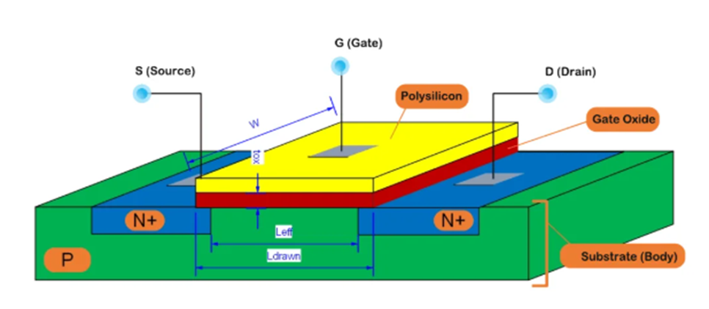

Fig 2.1 Schematic diagram of MOSFET cross sectional structure

Advantages:
- High switching speed – suitable for high-frequency PWM control
- Low conduction (ON-state) losses – results in higher efficiency
- Low gate drive power – enables simpler control circuits
- Better thermal performance at higher switching rates

Limitations:
- Higher voltage drop at elevated voltages (above 400V)
- Limited current handling compared to IGBTs

- IGBTs (Insulated-Gate Bipolar Transistors)

IGBTs combine the high input impedance of MOSFETs with the high current-carrying capacity of bipolar transistors, making them suitable for high power and high voltage applications, typically above 5 kVA. Fig 2.2 show IGBT

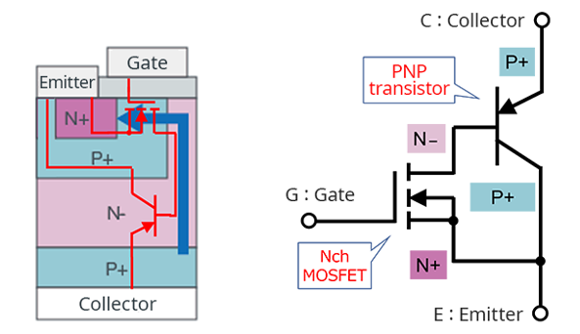

Fig 2.2 Schematic diagram of IGBT cross sectional structure

Advantages:
- Better voltage blocking capability
- Efficient in low-frequency, high-current operations (e.g., industrial motor drives)
- Lower saturation voltage in high-current applications

Limitations:
- Slower switching speed than MOSFETs
- More switching losses at high frequencies

    - Transformers in Inverter Systems

Transformers are essential components in many inverter designs, particularly in configurations where voltage transformation and electrical isolation are required. In a 2KVA inverter, a transformer typically serves two major purposes:
- Voltage Step-Up

Most inverter systems operate from a low-voltage DC source such as a 12V or 24V battery. However, standard appliances require 230V AC, which necessitates a voltage step-up process. The transformer increases the low input voltage to the required AC output level.
- Galvanic Isolation

Transformers provide electrical isolation between the input (DC) and output (AC) sides of the inverter. This helps prevent faults or surges on the AC side from damaging the DC side or connected batteries, enhancing safety and reliability.

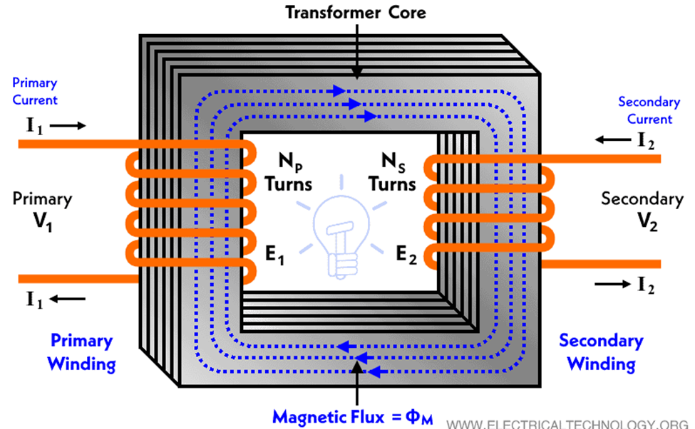

Fig 2.3 show a transformer

Key Design Considerations
- Designing an efficient and durable transformer for inverter applications requires careful attention to the following parameters:
- Power Rating: For a 2KVA system, the transformer must reliably handle 2000 VA without overheating.
- Core Material and Size: Choose high-permeability materials (e.g., ferrite or silicon steel) that support high-frequency operation without core saturation.
- Winding Ratio: Determines voltage transformation; for example, a 12V to 230V step-up requires a turns ratio of approximately 1:19.
- Thermal Management: The transformer must dissipate heat effectively to avoid insulation breakdown or magnetic losses.
- Frequency Response: In high-frequency inverters (20kHz–50kHz), transformer cores must be optimized for high-frequency switching to reduce eddy current and hysteresis losses.

2.4.3 Control Circuits

The control circuitry plays a pivotal role in managing the performance and reliability of the inverter system. It primarily governs the operation of the power electronics components by generating switching signals and monitoring output parameters.
- Microcontrollers and PWM ICs

Microcontrollers or dedicated Pulse Width Modulation (PWM) Integrated Circuits (ICs) are responsible for generating the switching signals that control the MOSFETs or IGBTs in the inverter's H-bridge or full-bridge topology. These components convert the DC input into an AC output with the desired frequency and voltage characteristics. A common microcontroller used in such applications is the ATmega328, while popular PWM ICs include SG3525, TL494, and IR2110 (for gate driving).

These devices operate by adjusting the duty cycle of the PWM signal, which directly influences the output voltage and helps shape the AC waveform. The microcontroller may also handle additional tasks like:
- Monitoring input/output voltage and current.
- Managing startup/shutdown sequences.
- Communicating with external interfaces or displays.

- Feedback Loops

To ensure stable and accurate voltage regulation, feedback control mechanisms are integrated into the control circuit. The output voltage is continuously monitored and compared with a reference value. Any deviation triggers a corrective action by adjusting the PWM signals. This feedback loop ensures that:

The output voltage remains within acceptable limits despite load variations.

Over-voltage, under-voltage, over-current, and short-circuit conditions are promptly detected and handled.

Such closed-loop systems typically employ Proportional-Integral-Derivative (PID) control algorithms or simpler comparator-based regulation for basic protection. Sensors like voltage dividers, current shunt resistors, or hall-effect sensors provide real-time data to the controller.

Together, these control components ensure that the inverter operates efficiently, safely, and within specified design parameters.

2.4.4 Filters

The output of an inverter, especially one based on Pulse Width Modulation (PWM), is not a pure sine wave but rather a series of high-frequency pulses that approximate the desired waveform. These switching harmonics can interfere with connected loads and reduce power quality. To address this, filters are used at the output stage of the inverter to smooth the waveform and suppress harmonic distortion.

LC and LCL Filters

Two common types of filters used in inverter systems are LC (Inductor-Capacitor) and LCL (Inductor-Capacitor-Inductor) filters.

- LC Filters

An LC filter is the simplest and most commonly used type. It consists of An inductor (L) in series with the load and A capacitor (C) connected in parallel to the load (shunt configuration).

Function:

The inductor blocks high-frequency components of the output.

The capacitor bypasses the remaining high-frequency ripple to ground.

Together, they allow low-frequency components (like the 50Hz or 60Hz AC output) to pass through while attenuating high-frequency noise.

Advantages:
- Simple design and low cost.
- Effective for moderate levels of harmonic filtering.

Disadvantages:
- Limited performance in high-power systems or systems with fast-switching devices.

- LCL Filters

For more demanding applications, especially with higher power ratings or stricter harmonic standards, LCL filters are used. They consist of Two inductors (one on the inverter side and one on the grid/load side) and A capacitor placed between them, usually connected to ground.

Function:
- LCL filters provide steeper attenuation of high-frequency components.
- They are especially effective for PWM-based inverters that switch at high frequencies.

Advantages:
- Better filtering performance compared to simple LC filters.
- Improved harmonic attenuation near the switching frequency.

Disadvantages:
- More complex and expensive.
- Require careful tuning to avoid resonance issues.

Harmonic Reduction and Power Quality

The key goal of using filters is to reduce Total Harmonic Distortion (THD) and improve power quality. High THD can cause overheating in motors, interference in communication lines, and malfunctioning of sensitive electronic devices. Properly designed filters ensure that the inverter’s output is close to a pure sine wave, making it suitable for household appliances, industrial equipment, and sensitive electronics.

Ali et al. [3] emphasized the importance of gate driver circuits and thermal management in ensuring the long-term reliability of inverter systems.

2.5 Pulse Width Modulation (PWM) Techniques

Pulse Width Modulation (PWM) is a fundamental technique used in inverter design to generate a controlled AC output from a DC source. By rapidly switching the inverter’s semiconductor devices (typically MOSFETs or IGBTs) on and off at high frequencies, PWM synthesizes an output waveform that approximates a sine wave. This approach not only regulates output voltage but also improves efficiency and reduces harmonic distortion.

Several PWM techniques are available, each with its own advantages, trade-offs, and applications.

2.5.1. Sinusoidal Pulse Width Modulation (SPWM)

Sinusoidal PWM is the most widely used method in modern inverter design, particularly for pure sine wave inverters. In this technique, a sinusoidal reference signal is compared with a high-frequency triangular carrier signal. The resulting intersection points determine the switching instants.

Key Features:
- Produces a waveform that closely resembles a sine wave.
- Frequency of the output is controlled by the frequency of the sinusoidal reference.
- Amplitude of the output voltage is controlled by the amplitude of the sine wave or by varying the modulation index.

Advantages:
- Simple to implement.
- Low harmonic distortion at moderate switching frequencies.
- Suitable for most residential and industrial AC loads.

Disadvantages:
- Limited voltage utilization (maximum achievable output voltage is around 78.5% of the DC bus voltage).
- Not optimal for very high-efficiency applications.

2.5.2. Space Vector Pulse Width Modulation (SVPWM)

SVPWM is a more advanced digital PWM technique that treats the inverter as a vector system and calculates optimal switching sequences to represent the desired output. It uses complex vector mathematics to achieve higher performance.

Key Features:
- Achieves better DC bus voltage utilization (up to 90.6%).
- Reduces total harmonic distortion (THD).
- Minimizes switching losses by optimizing the switching pattern.

Advantages:
- Higher output voltage and efficiency.
- Lower switching losses compared to SPWM.
- Widely used in high-performance motor drive systems and industrial inverters.

Disadvantages:
- More complex to implement and requires powerful microcontrollers or DSPs.
- Difficult to tune without proper software tools.

2.5.3. Hysteresis and Delta Modulation

Hysteresis and Delta Modulation are simpler, real-time modulation techniques. In hysteresis control, the actual output is compared with a reference, and switching occurs when the error exceeds a set hysteresis band. Delta modulation is similar but focuses on incremental changes in the reference.

Key Features:
- Self-adjusting switching frequency based on load demand and error margin.
- Very fast response to load or reference changes.

Advantages:
- Simple and robust.
- Fast dynamic response.

Disadvantages:
- Switching frequency is not constant, which complicates filter design.
- Poor harmonic performance compared to SPWM and SVPWM.
- Less precise and harder to optimize for sinusoidal outputs.

PWM also influences efficiency and electromagnetic interference (EMI). Optimized PWM strategies improve inverter output quality and reduce switching stress, as noted by Singh and Jena [4].

2.6 Related Works and Technological Developments

Several academic and practical design efforts have been undertaken to develop inverter systems with varying power capacities, control techniques, and efficiency targets. These projects serve as valuable references and benchmarks for the current 2KVA inverter design, demonstrating the feasibility and reliability of similar systems when sound engineering principles are applied.

Chukwu et al. [5] 3KVA Inverter Design. Chukwu and colleagues designed and implemented a 3KVA pure sine wave inverter utilizing MOSFET-based switching and a toroidal transformer. The system architecture focused on efficient power conversion with minimal heat dissipation. Notably, the project achieved an overall efficiency of 88%, which is commendable for a locally sourced and fabricated inverter system. Their approach demonstrated that, with careful component selection and optimized switching control, high-performance inverters can be built without relying on imported systems.

Raj et al. [7] 1.5KVA Solar Inverter with Battery Management. Raj and co-researchers developed a 1.5KVA solar-powered inverter integrating a battery management system (BMS) and feedback-controlled PWM. Their design prioritized energy optimization and autonomy for renewable energy applications. The BMS ensured efficient battery charging and discharging, extending battery life, while the feedback loop dynamically adjusted the PWM signals for stable output voltage under variable load conditions. This project highlighted the importance of smart control for sustainable inverter operation, particularly in off-grid solar installations.

IoT-Based Inverter Systems and Remote Monitoring [6] More recent developments have seen the integration of Internet of Things (IoT) technologies into inverter systems. Such smart inverters feature remote monitoring, real-time diagnostics, and fault detection via mobile or web-based platforms. These capabilities allow users to monitor inverter performance parameters such as voltage, current, temperature, and battery status remotely. Fault logs and alerts also enhance maintenance efficiency and system reliability. These innovations mark a shift toward intelligent power systems and align with global trends in smart energy management.

Implications for the Present Design

These existing studies and technological trends underscore a vital point:

Locally designed inverter systems can meet or exceed international performance standards when proper design methodologies, quality components, and modern control techniques are employed.
- Key takeaways for the present 2KVA inverter project include:
- Emphasis on efficiency through low-loss components like MOSFETs.
- Inclusion of feedback and protection circuits to ensure voltage stability and safety.
- Potential for future upgrades, such as IoT integration, to enhance usability and market value.

These precedents provide a solid foundation and validation for the design choices made in this project, demonstrating the practicality and scalability of local inverter development efforts.

2.7 Challenges in Inverter Design

While significant progress has been made in inverter technology ranging from better control algorithms to more efficient switching devices several critical challenges remain, particularly in the development of medium-power systems like a 2KVA inverter. These challenges influence the overall performance, reliability, and cost-effectiveness of the inverter and must be addressed systematically during the design and implementation phases.

2.7.1. Heat Dissipation Under High Load Conditions

One of the most pressing challenges in inverter design is the management of thermal energy generated during switching and conduction processes. As the inverter handles higher loads, MOSFETs, IGBTs, and other power components experience power losses in the form of heat. If not properly dissipated using heat sinks, thermal pads, or active cooling (fans), this heat can lead to:
- Thermal runaway, causing irreversible damage to components.
- Reduced efficiency due to temperature-induced resistance increases.
- Shortened component lifespan.

Effective thermal management requires careful layout design, efficient heatsink selection, and consideration of ambient operating temperatures.

2.7.2. Minimizing Switching Losses and Electromagnetic Interference (EMI)

High-frequency switching, essential for accurate waveform synthesis using PWM, inevitably leads to switching losses and electromagnetic interference (EMI). These issues are amplified in compact inverter designs and can result in:
- Power losses that reduce overall efficiency.
- Distortion of the output waveform.
- Interference with nearby electronic equipment.

Solutions include:
- Selecting fast-recovery diodes and low-loss MOSFETs
- Incorporating snubber circuits and EMI filters.
- Optimizing gate drive circuits to control switching speeds and minimize ringing.

2.7.3. Compactness and Weight Constraints

Inverters are often expected to be portable and space-efficient, especially in residential and commercial applications. However, reducing size must not come at the expense of:
- Thermal performance.
- Power handling capability.
- Ease of maintenance.

Achieving the right balance requires:
- Use of toroidal or ferrite-core transformers for smaller footprints.
- High-density PCB designs.
- Surface-mount components where feasible.

For a 2KVA inverter, ensuring structural integrity while keeping size manageable is especially challenging given the need for robust heat dissipation and adequate insulation distances.

2.7.4. Battery Compatibility and Safety

Inverters must safely interface with DC power sources, most commonly lead-acid or lithium-ion batteries. Battery-related challenges include:
- Voltage mismatch or over-discharge, which can degrade battery performance.
- Overcharging, which poses a fire or explosion risk.
- Lack of intelligent control, leading to poor energy conversion and reduced lifespan.

To address these concerns, the inverter must incorporate:
- Battery management systems (BMS) or charge controllers.
- Undervoltage/overvoltage protection circuits.
- Reverse polarity protection.

2.7.5 Relevance to 2KVA Inverter Design

In the context of this project, which targets a 2KVA inverter, these challenges are particularly critical. A system at this power level may be subject to:
- Higher thermal stress due to continuous or peak loads.
- Increased risk of waveform distortion if filtering and control strategies are inadequate.
- Battery-related risks, especially in solar or backup power applications.
- Failure to adequately address these challenges could result in:
- System inefficiency and energy losses.
- Component degradation or catastrophic failure.
- User dissatisfaction or safety hazards.

Thus, careful design decisions, protective features, and performance optimizations are necessary to ensure a reliable and safe inverter system.

This review highlights the theoretical foundation and technological evolution of inverter systems. H-bridge topology, SPWM control, and MOSFET switching devices have emerged as optimal choices for designing efficient, cost-effective 2KVA inverters. Past works provide valuable insights, but the current project aims to enhance these through improved layout, better thermal control, and practical installation considerations.

References

[1] P. Kumar, D. Roy, and A. Sharma, "Optimized Design and Control of Low-Cost Pure Sine Wave Inverter for Domestic Use," International Journal of Power Electronics and Drive Systems, vol. 14, no. 1, pp. 98–107, 2023.

[2] Y. Zhang, Q. Lin, and M. Wang, "Comparative Study of H-Bridge Inverter Using MOSFETs and IGBTs in Off-Grid Systems," IEEE Access, vol. 10, pp. 112233–112245, 2022.

[3] M. S. Ali, A. A. Yusuf, and K. H. Bello, "Design Considerations for High-Efficiency Inverters: A Thermal and Gate Driver Perspective," Energy Systems Engineering Journal, vol. 9, no. 2, pp. 54–66, 2021.

[4] P. Singh and D. Jena, "A Review on PWM Techniques for Voltage Source Inverters," Journal of Electrical Engineering & Technology, vol. 18, no. 3, pp. 211–225, 2023.

[5] F. E. Chukwu, M. C. Eze, and U. Okoye, "Development of a 3KVA Pure Sine Wave Inverter for Residential Applications," Nigerian Journal of Engineering Science, vol. 13, no. 2, pp. 45–52, 2022.

[6] R. A. Mohammed and Y. S. Liman, "IoT-Based Monitoring System for Solar Inverter Performance," Journal of Emerging Technologies in Electrical Engineering, vol. 5, no. 1, pp. 27–34, 2023.

[7] V. Raj, A. Singh, and R. Desai, "Design and Implementation of 1.5KVA PWM Inverter for Solar Applications," Renewable Energy Technology Journal, vol. 8, no. 4, pp. 180–190, 2020.

