

A
TECHNICAL REPORT ON INDUSTRIAL ATTACHMENT FOR STUDENT INDUSTIRAL WORK EXPERIENCE SCHEME (SIWES)
HELD AT
LAGOS STATE PHYSICAL PLANNING PERMIT AUTHORITY.
(LASPPPA)

BY

ABDUL-KAREEM ARAFAT LABAKE
ND/23/PSM/FT/0101

DEPARTMENT OF PROCUREMENT AND SUPPLY OF CHAIN MANAGEMENT
INSTITUTE OF FINANCE AND MANAGEMENT STUDIES
KWARA STATE POLYTECHNIC, ILORIN.

IN PARTIAL FULFILLMENT OF THE REQUIREMENT FOR THE AWARD IN NATIONAL DIPLOMA CERTIFICATE IN PROCUREMENT AND SUPPLY OF CHAIN MANAGEMENT.

DECEMBER 2024

CERTIFICATION

This is to certify that this report is original to the author, ABDUL-KAREEM ARAFAT LABAKE of matric number ND/23/PSM/FT/0101 of the Department of Procurement and Supply of Chain Management, Institute of Finance and Management Studies, Kwara State Polytechnic, Ilorin and was supervised accordingly by;

………………………….. …………………………...
SIWES COORDINATOR DATE & SIGNATURE

……………………….. ..………………………..
SIWES SUPERVISOR DATE & SIGNATURE

…………………………… …………………………
HEAD OF DEPARTMENT DATE & SIGNATURE

PREFACE

This is a report of four months industrial training which was done as part of the requirement needed for the award of National Diploma Certificate which was embarked upon by the technical student after their first year of stay in school.
It is also done to enable the student’s to be exposed the practical aspect of their course of study and write down what he/she has gained during the training.
The program is aimed at correcting the incompetence in the school leaving the scientific and technical in country.

DEDICATION
This report is dedicated to the Almighty God, the Beneficent, the merciful, the cherisher of the universe, the uncreated creator of all creatures and the most knowledgeable who seek knowledge just from himself for giving me the opportunity, privilege an understanding to participate in the student industrial work experience scheme (SIWES).
I also dedicate this report to my amiable parent Mr. and Mrs. ABDUL-KAREEM for their financial support during the course of the program. May GOD continue to bless them (AMEN).

TABLE OF CONTENT
Title
Preface
Dedication
Acknowledgement
Table content
CHAPTER ONE
  - Introduction
  - Background
  - Objective of SIWES
CHAPTER TWO
2.0 Brief History of the Establishment
2.1 Organizational structure
2.2 The various Department/Units in the Establishment
CHAPTER THREE & FOUR
3.0 Experience gained during the SIWES program
3.1 Interactive relationship within the organization
CHAPTER FIVE
4.0 Summary
4.1 Recommendations
4.1 Conclusion

CHAPTER ONE
INTRODUCTION OF SIWES
The Students Industrial Work Experience Scheme (SIWES) for the 2024 /2025 academic session kicked off the month of in August 2024 and was concluded (4) months in the month of December, 2024. The industrial attachment program is solely aimed at improving in working skills of students in tertiary institutions as well as effecting, learning, participation and observation into proactive invariable fields with respect to grasp very useful practical knowledge which not only makes them employable but also aids in the perfect understanding of theories and operation in their different profession. It is a corporative industrial internship program that involves industries, the Federal Government of Nigeria, Industrial Training Fund (ITF), and Nigeria Universities Commission (NUC). The program is of very high importance considering the lack of adequate practical equipment for learning in most Nigeria tertiary institutions and itself proven as it has been part and parcel of the countries system of education for over 28 years.

AIMS OF SIWES
The Industrial Training Funds Policy document Number 1 of 1973, which established SIWES outline the objective of the scheme. The objectives are to:-
- To provide an avenue for Students in Nigerian Tertiary Institutions to acquire Industrial Skills and Experience during their course of Study.
- To prepare Students for the work they are likely to meet after graduation.
- To expose students to work methods and techniques of handling equipment and machinery that may not be available in their Institutions.
- To allow the transition phase from school to the world of working environment easier and facilitate students contact for later job placement.
- To provide students with an opportunity to apply theoretical knowledge in real work situation there by bridging the gap between theory and practice.

Historical Background of SIWES
SIWES (Student Industrial Work Experience Scheme) was set up by the federal government of Nigeria to close the gap between theoretical learning and practical work experience. It was first kicked off and funded by the Industrial Training Fund ITF) in 1973 the scheme has gone through series of reforms. Its management has changed hands from the ITF in 1978 to various regulatory agencies such as National Universities (NUC) and National Board for Technical Education (NBTE) and board to the ITF again in 1985. These are the major stake holders in SIWES. Consequently, SIWES program was introduced into the curriculum of tertiary institution in the country as far back as 1974 with 948 students from two institution of higher earning and the scheme has over the year contributed immensely to the personal development and motivation of their academic programs and what knowledge and skill will be expected of them on professional practice after graduation.

DEFINITION OF TERMS
- SIWES: Student Industrial Work Experience Scheme. The Scheme was established by the Industrial Training Fund (ITF) in 1973 to solve the problem of lack of adequate preparatory for employment in Industrial by Nigeria graduates of tertiary Institution.
- Industrial Training Fund: The fund was established in 1971 and has operated consistently and painstakingly within the context of its.
3. CONSOLE: It is considered as the center piece or the very heart of Radio station Hasan (2013) in Adoyi (2020:54) Says, professionally, a mixing console is an electronic device for combining (Mixing) routing, and changing the level, tone and/ or dynamics of audio signals

CHAPTER TWO
DEPARTMENTS IN LAGOS STATE PHYSICAL PLANNING PERMIT AUTHORITY (LASPPPA) AND THEIR FUNCTIONS
​The Lagos State Physical Planning Permit Authority (LASPPPA), established under the Lagos State Urban and Regional Planning and Development Law of 2010, operates as a semi-autonomous agency within the Ministry of Physical Planning and Urban Development. While specific departmental structures within LASPPPA are not publicly detailed, the Authority's core functions encompass several key areas:​

Core Functional Areas of LASPPPA

Planning Permit Processing: Overseeing the assessment and issuance of planning permits in accordance with state regulations and approved development plans.​

Compliance Monitoring: Ensuring that developments adhere to physical planning regulations and approved plans.​

District and Local Planning Offices: Establishing and managing district and local planning permit offices to facilitate decentralized service delivery.​

Development Plan Preparation: Preparing and periodically reviewing various categories of physical development plans, including district, development guide, town, and local plans.​

Record Keeping and Publication: Maintaining records of planning permit applications and publishing relevant information in the State Official Gazette.​

Technical Report Evaluation: Evaluating physical planning technical reports in consultation with the Ministry.​

Brief History of Lagos State Physical Planning Permit Authority (LASPPPA)
The Lagos State Physical Planning Permit Authority (LASPPPA) was established as part of the Lagos State Government’s efforts to regulate physical development and ensure sustainable urban planning within the state. Its creation is rooted in the Lagos State Urban and Regional Planning and Development Law of 2010, which consolidated various planning laws and streamlined building and planning permit processes.
Prior to LASPPPA’s formation, building permit functions were handled by the Development Permit Department (DPD) under the Ministry of Physical Planning and Urban Development. However, to improve efficiency, transparency, and accountability, LASPPPA was created as a semi-autonomous agency to oversee the issuance of planning permits and ensure compliance with building regulations.
Since its inception, LASPPPA has played a crucial role in:
- Processing planning permit applications.
- Ensuring developments comply with approved layouts and zoning regulations.
- Curbing illegal developments.
- Promoting orderly and sustainable urban growth in Lagos State.
The authority operates through district offices across the state to bring services closer to the public and has increasingly integrated technology into its operations to enhance service delivery.
STRUCTURE OF LASPPPA
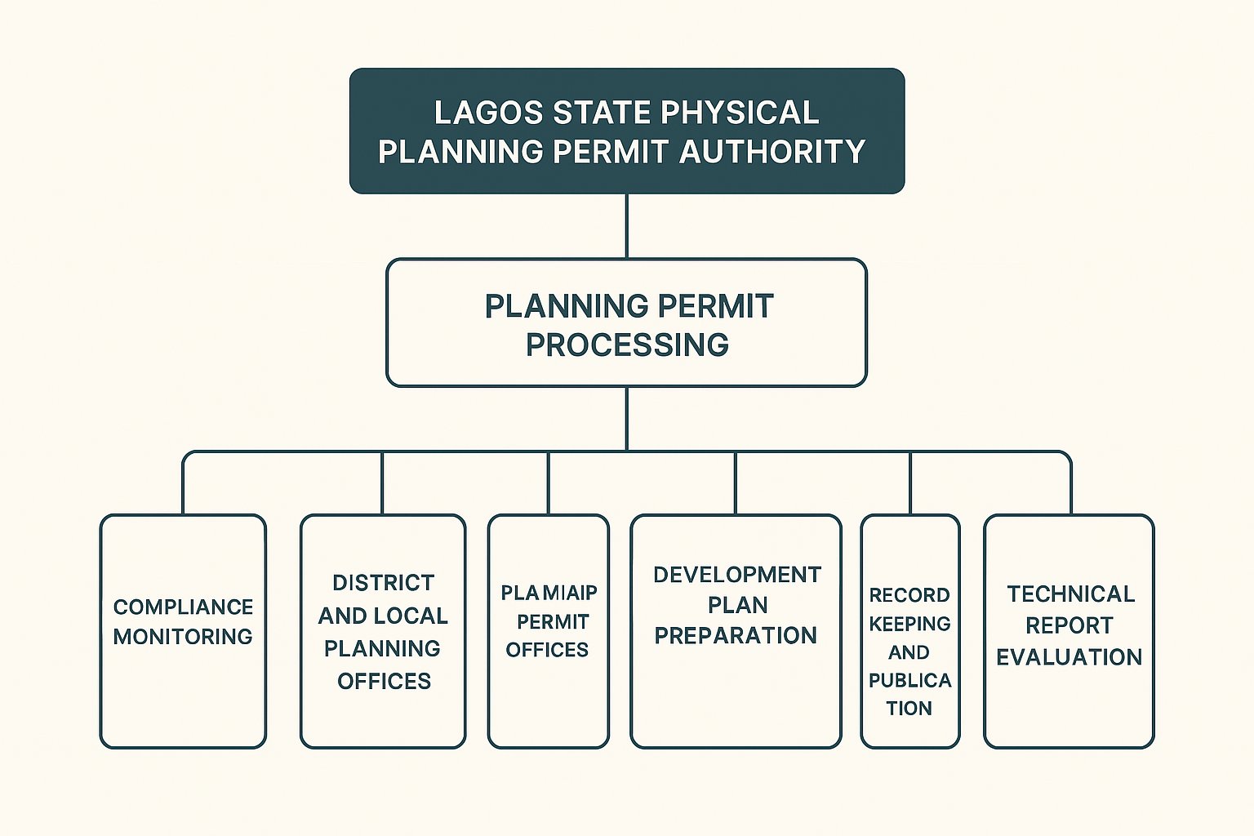

CHAPTER THREE & FOUR
  - SIWES EXPERIENCE AT LAGOS STATE PHYSICAL PLANNING PERMIT AUTHORITY (LASPPPA)
  - INTRODUCTION
I underwent my Student Industrial Work Experience Scheme (SIWES) at the Procurement and Supply Chain Department of [LASPPPA]. This report outlines the practical experience I gained, which enhanced my understanding of procurement processes, ethical standards, and documentation procedures crucial to my field of study.

Organizational Orientation
Upon arrival, I was formally introduced to the organization by the manager, who welcomed me and explained the organization’s mission, vision, and structure. This orientation helped me understand the workflow and my role within the department.
Knowledge Assessment
The manager assessed my knowledge of procurement and supply chain concepts through an interactive session. This assessment helped identify my strengths and areas where I needed improvement, which guided my training throughout the SIWES period.
Ethics of Procurement and Supply Chain
I was taught the core ethical principles guiding procurement and supply chain operations. These include transparency, fairness, accountability, confidentiality, and compliance with legal requirements. I learned how these ethics prevent corruption and ensure efficient service delivery.
Proposal Writing
I gained practical experience in drafting proposals for procurement approval. I was trained to structure proposals clearly, specifying the purpose, justification, item details, cost analysis, and expected benefits, ensuring they meet organizational standards.

Qualities of Effective Procurement and Supply Chain
The manager and other staff emphasized key qualities essential for a successful procurement and supply chain system, including:
- Timeliness
- Accuracy and attention to detail
- Strong negotiation skills
- Cost-effectiveness
- Supplier relationship management
- Risk management
Board Meeting Attendance
I had the privilege of attending board meetings alongside my boss, where procurement matters were discussed. This exposed me to high-level decision-making processes and the importance of aligning procurement with organizational goals.
File Arrangement and Documentation
I learned how to systematically arrange files to ensure easy retrieval and prevent loss of important documents. I practiced labeling, sorting, and filing both physical and digital records.
File Handling
One of my daily responsibilities was receiving and distributing files to district officers. This helped me understand the flow of communication and documentation within the organization.
Filing After Validation
Once a receipt or document had been validated, I was responsible for filing it back into the appropriate folder or cabinet. I ensured that only verified and approved documents were filed, which helps in keeping the financial records accurate and reliable. This responsibility taught me the importance of maintaining an up-to-date and well-audited filing system.
Report Writing
I was trained on how to write professional reports, summarizing procurement activities, challenges, and recommendations. I learned the importance of clarity, conciseness, and accuracy in report writing.
Maintaining Procurement Records
I participated in maintaining procurement records, which involved logging purchase orders, tracking delivery timelines, and updating supplier information. This helped ensure accountability and traceability in all procurement processes.
Raising Vouchers
I was introduced to the process of raising vouchers, which included filling out voucher forms to request payments for goods and services supplied. I learned the required documentation and approval stages involved before payments are processed.

SKILLS GAINED
- - Procurement Planning and Strategy Development
- - Proposal and Report Writing Skills
- - Knowledge of Procurement Ethics and Compliance
- - File Management and Documentation
- - Communication and Interpersonal Skills
- - Meeting Participation and Professional Conduct
- - Record Keeping and Data Management
- - Understanding of Procurement Laws and Policies
- - Voucher Processing and Financial Documentation
- - Time Management and Organizational Skills
- - Problem-Solving and Critical Thinking
- - Attention to Detail
- - Basic Negotiation Skills
- - Use of Office Equipment and Software for Procurement Tasks
- - Teamwork and Collaboration

CHAPTER FIVE
SUMMARY, RECOMMENDATION AND CONCLUSION
My experience at LAGOS STATE PHYSICAL PLANNING PERMIT AUTHORITY (LASPPPA), was a wonderful experience and I have come to say that studying Procurement and Supply of Chain Management without practical, could be regarded as a waste of time, resources and energy because the training has helped me a lot.

RECOMMENDATION
I recommend that the Student Industrial Work Experience Scheme (SIWES) be continually supported and improved by both institutions and organizations. It offers students a unique opportunity to apply theoretical knowledge in a practical setting. Organizations should also continue to provide guidance, mentorship, and hands-on tasks that help students gain relevant skills. Additionally, institutions should ensure regular monitoring and feedback to enhance the learning experience.

CONCLUSION
The SIWES experience at the Procurement and Supply Chain Department of [LASPPPA] greatly enhanced my practical knowledge and skills. I now have a deeper understanding of procurement operations, ethics, documentation, and the strategic role of procurement in organizational success.

