Dedication
I begin by dedicating this SIWES report to Almighty Allah, whose infinite mercy and guidance have seen me through every step of this journey. My heartfelt appreciation also goes to my father, Sulaiman, for his unwavering support, encouragement, and constant prayers that have been my backbone throughout this experience.

Acknowledgement
I, Sulaiman Asude, sincerely express my heartfelt gratitude to Almighty Allah for His continuous guidance, protection, and blessings throughout my Industrial Training experience.
I am deeply thankful to S.O. Automobile Services for providing me with the opportunity to undertake my four-month training (August – November 2024) within their reputable organization. Special appreciation goes to my supervisor, Engr. Sulaiman Kehinde, for his unwavering support, guidance, and mentorship throughout the training period.
I also wish to thank the Department of Mechatronics, Kwara State Polytechnic, for organizing the SIWES program and ensuring a meaningful and enriching learning experience.

TABLE OF CONTENT
Title page

Preface

Dedication

Acknowledgment

CHAPTER ONE
Introduction to SIWES

Brief history of SIWES

Importance and objectives of SIWES

CHAPTER TWO
Brief history of organization

Objective of establishment

Department and their function

CHAPTER THREE
Technical training experience/ work done

CHARTER FOUR
Skill and knowledge acquired during training

Relevance of training to academic learning

CHAPTER FIVE
Summary of attachment activities

Problem encountered

Suggestion for improvement

CHAPTER ONE

Overview of SIWES
The Student Industrial Work Experience Scheme (SIWES) stands as an essential platform aimed at providing students with hands-on exposure to practical work settings, both within and beyond national borders. Through this initiative, learners can connect theoretical instruction from the classroom to actual tasks performed in industrial workplaces, ultimately promoting technological growth in the country.
Implemented through a partnership involving universities, polytechnics, and technical institutions nationwide, the program is carefully overseen by the Industrial Training Fund (ITF), which ensures consistent quality and effectiveness.

Background of SIWES
Initially introduced to equip students of tertiary institutions—such as universities, polytechnics, and colleges of technology—with relevant work-based experiences, SIWES offers exposure to the tools, machinery, and professional standards used in real industries.
First launched in the 1973/74 academic year, the program was fully funded and operated by the ITF. In 1978, facing financial strain, the ITF stepped back from the management role. Following this, the Federal Government assigned the coordination to the National Universities Commission (NUC) and the National Board for Technical Education (NBTE) in 1979. Nonetheless, the ITF regained full control in November 1984, with full operations resuming by July 1985. Presently, the Federal Government remains the sole sponsor of the scheme.
Significance and Goals of SIWES
Outlined in the official SIWES handbook.

Importance and objective of siwes
1. Enable students in higher education institutions to gain essential practical knowledge and relevant work experience in line with their academic programs.
2. Equip students with the skills necessary to adapt to the dynamics and expectations of real-world work environments after completing their studies.
3. Facilitate the application of classroom knowledge to practical tasks, thereby narrowing the gap between academic theory and industrial practice, in support of NBTE accreditation.
4. Introduce students to the ethical standards and professional behavior required in their chosen fields, ensuring alignment between educational outcomes and industry expectations.
5. Inspire students to pursue and develop strong interests in specific career areas within their discipline.

CHAPTER TWO

Brief History of the Organization
S.O. Automobile Services is a privately owned mechanical engineering workshop founded and managed by Engr. Sulaiman Kehinde, an experienced and self-driven mechanical engineer. Located at No 51 emir's Rosa ilorin Kwara state , the workshop is known for providing reliable, efficient, and affordable automobile repair and maintenance services across various vehicle types.
Engr. Sulaiman brings a wealth of practical experience in the automotive industry and is widely recognized for his precision, work ethic, and dedication to customer satisfaction. Over time, the establishment has earned a reputation for its commitment to delivering quality mechanical services, including engine diagnostics, brake system maintenance, suspension repairs, and general mechanical troubleshooting.
Although the business is independently operated, it also serves as a valuable training ground for young and aspiring mechanical engineers. The workshop regularly accommodates SIWES students, giving them the opportunity to gain real-world experience in vehicle mechanics and servicing.

Objectives of the Establishment
The primary objective of S.O. Automobile Services is to provide high-quality mechanical solutions that enhance vehicle performance and ensure road safety. The specific goals include:
1. Delivering expert diagnosis, repair, and maintenance services for a wide range of automobile mechanical systems.

2. Ensuring timely and cost-effective servicing of engines, suspensions, brakes, and other mechanical components.
3. Promoting safe, standard, and efficient mechanical practices in vehicle repair and servicing.
4. Offering mentorship and hands-on training opportunities to SIWES students and young mechanical enthusiasts.
5. Keeping up with advancements in automotive technologies and tools to enhance service quality.

Departments and Functions
As a small-scale, privately managed workshop, S.O. Automobile Services does not operate with formal departmental structures. However, the business functions are organized around key areas of mechanical services, which include:
1. Engine Services: Involves fault diagnosis, engine tuning, repairs, and overhauling.
2. Brake and Suspension Systems: Includes inspection, repair, and replacement of brake pads, discs, shock absorbers, and suspension components.
3. General Vehicle Maintenance: Covers oil changes, filter replacements, belt adjustments, and routine mechanical checks.
4. Cooling and Exhaust Systems: Involves servicing radiators, cooling fans, exhaust pipes, and related components.
5. Training and Mentorship: Provides on-the-job training and supervision for SIWES students to help them develop practical mechanical skills

CHAPTER THREE

Technical Training Experience / Work Done
During my SIWES training at S.O. Automobile Services, I participated in several mechanical tasks that improved my practical knowledge and skills. Below are the key activities I engaged in:

1. Installation of V6 and V8 Engines
I was involved in installing both V6 and V8 engines. I learned how to mount the engines properly and connect essential components. The main difference is that V6 engines are more fuel-efficient, while V8 engines offer higher power for performance vehicles.
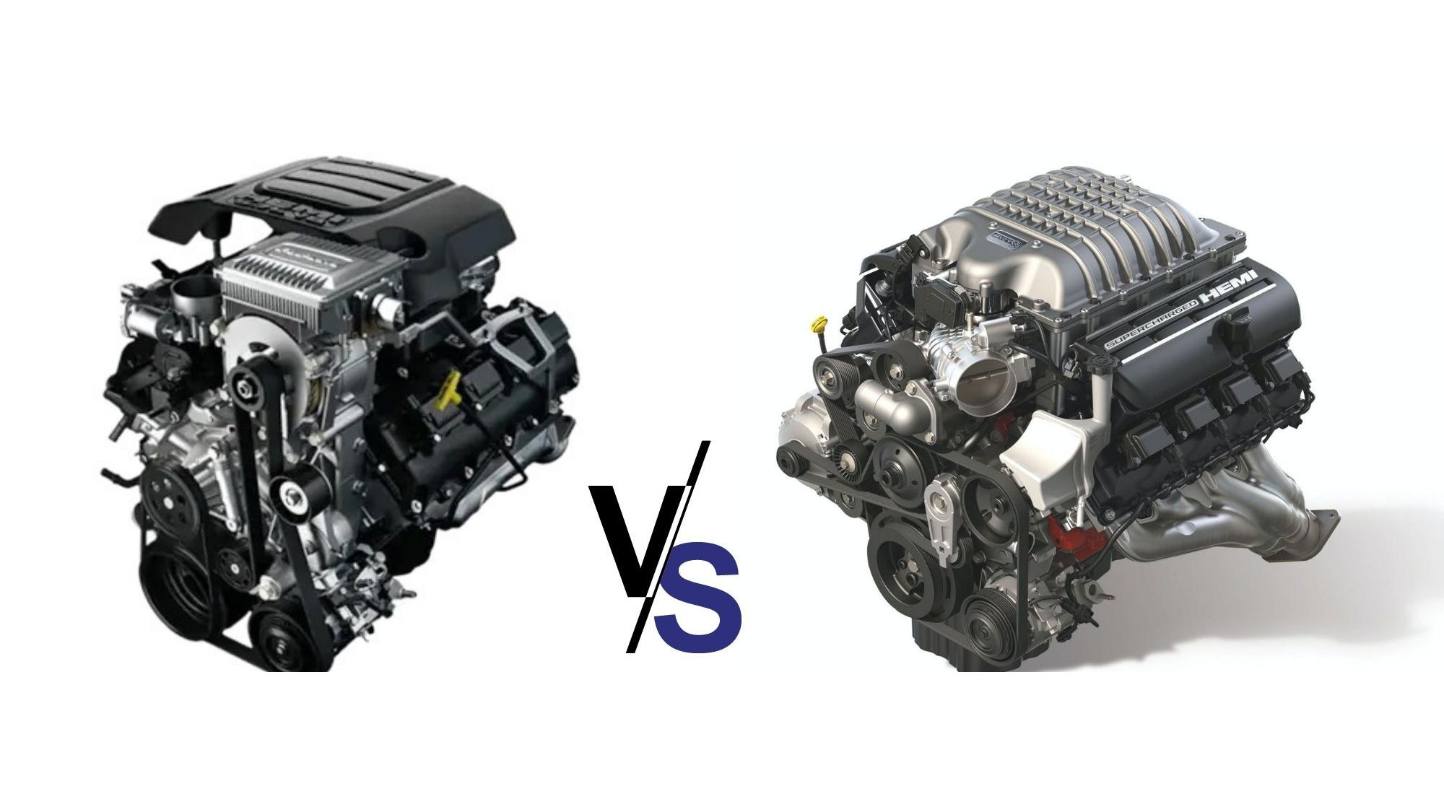
V6 and V8 engine

2. Handbrake System Diagnosis Using Software Tools
We collected data on handbrake systems using diagnostic software to trace connected parts like levers, cables, and sensors. This improved my understanding of both mechanical and electronic braking systems.
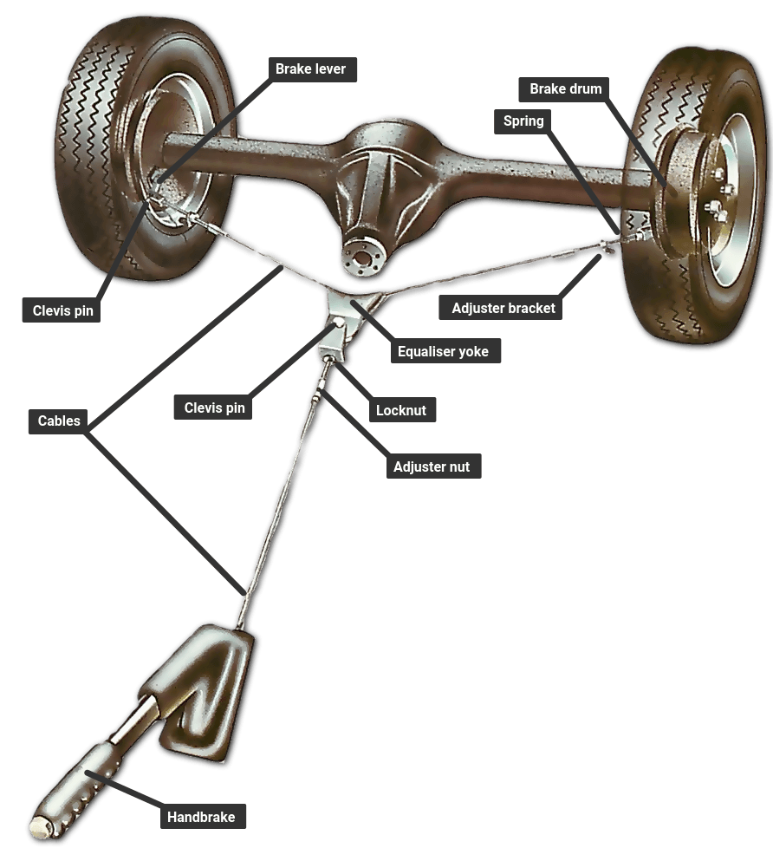
Handbrake system

3. Usage Analysis of Panels for Repair Decisions
I helped record the usage frequency of certain car parts to decide if they could be repaired or needed replacement. This taught me how to make smart decisions using available data and materials.

4. Welding and Fabrication Work
I participated in basic welding and the fabrication of frames and bars. This involved solving structural issues and learning how to build support components using metalwork.
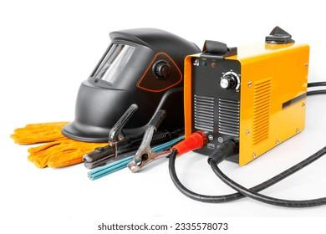
Welding tools

5. Study of Electrovacuum Pump Systems
We studied the structure of electrovacuum pumps used in petrol stations. I learned how connected wires like Elton wires (positive charge) and chrome parts work together in the pump’s operation.

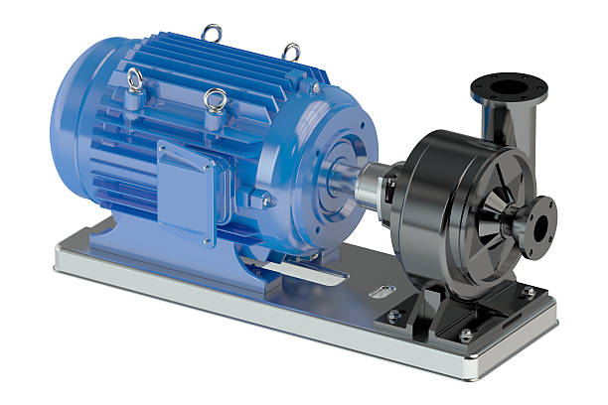
Electrovaccum pump

CHAPTER FOUR

Skills and Knowledge Acquired during training
Throughout my Industrial Training at S.O. Automobile Services, I gained essential hands-on experience that significantly broadened my understanding of mechanical engineering, particularly in the field of automobile maintenance and repair. Under the guidance of Engr. Sulaiman Kehinde, I was exposed to various real-world mechanical tasks that helped me apply classroom theories in practical settings. The key experiences include:
1. Practical Skill Development
I was actively involved in engine installation, especially for V6 and V8 engines, where I learned how to align and secure engine components correctly within vehicles. I also participated in servicing and maintaining braking systems, exhausts, suspensions, and basic engine diagnostics, which helped build my mechanical competency.
2. Technical Knowledge Enhancement
I developed a better understanding of interpreting vehicle diagrams, part alignment, and the configuration of engine components. I also used diagnostic tools to gather performance data and assess mechanical systems such as the handbrake and fuel pump. This improved my ability to evaluate system functionality and suggest suitable repair techniques.
3. Analytical and Problem-Solving Abilities
Through fault diagnosis and system testing, I was able to identify mechanical issues and participate in creating solutions. For example, I helped determine when specific panels or parts could be repaired using improvised methods or when they required complete replacement—skills that encouraged resourcefulness and critical thinking.

4. Tool Handling and Safety Practices
During the training, I became familiar with various tools such as hydraulic jacks, spanners, wrenches, welding machines, and diagnostic scanners. Safety was always emphasized—ensuring the proper use of equipment and adherence to workplace safety standards during welding, lifting, or component testing.

Effect on My Academic Understanding
This industrial experience has had a direct and positive influence on my academic development by bridging the gap between theoretical principles and hands-on applications in mechanical systems.
1. Clearer Understanding of Mechanical Concepts
Topics such as engine configurations, mechanical linkages, braking systems, and system diagnostics became more meaningful to me through real-world exposure during the training.
2. Increased Enthusiasm and Focus
Engaging with physical systems and seeing how mechanical components interact in live environments sparked a deeper interest in automotive systems. This has further inspired my desire to pursue a career in automobile engineering.

---

3. Improved Approach to Class Projects
My time at S.O. Automobile Services has made me more effective in handling practical class assignments. I now approach tasks with a problem-solving mindset and a clearer understanding of real-life mechanical applications.
4. Professional Readiness
The knowledge and experience I gained have prepared me for more advanced opportunities, such as future internships, industrial roles, or academic research projects. I now have greater confidence in my mechanical engineering abilities and my potential as a future professional in the field.

CHAPTER FIVE

Summary of Attachment Activities
During my industrial attachment at S.O. Automobile Services, I was engaged in a variety of mechanical engineering tasks. These included engine installation (V6 and V8), diagnostics of handbrake systems, panel evaluations, welding and fabrication, and fuel pump component analysis. I also observed and assisted in general vehicle maintenance and system troubleshooting. These activities enhanced my practical knowledge, improved my problem-solving skills, and deepened my understanding of mechanical systems.

Problems Encountered
1.Limited Tools: On a few occasions, the workshop lacked specialized tools needed for certain diagnostics or repairs.
2.Access to Modern Technology: Some advanced automotive diagnostic equipment was unavailable, limiting exposure to the latest tools.
3.Time Constraints: With multiple jobs in the workshop, time for in-depth learning on each task was sometimes limited.

Suggestions for Improvement
1.Upgrade of Equipment: Introducing more modern diagnostic tools would enhance training and exposure.

2.Structured Learning Time: Setting aside specific hours for SIWES students to learn and ask questions would be helpful.
3.Improved Documentation: Keeping detailed records of past work and repairs can help students learn from previous solutions.

