

A TECHNICAL REPORT
STUDENTS’ INDUSTRIAL WORKING EXPERIENCE SCHEME
(SIWES)

Held at
IBADAN ELECTRICITY DISTRIBUTION COMPANY
Bode Saadu Branch, Moro Kwara State

Prepared by:
ABUBAKAR IBRAHIM OPEYEMI
ND/23/MCT/FT/0083

SUBMITTED TO

DEPARTMENT OF MECHATRONICS ENGINEERING TECHNOLOGY
INSTITUTE OF TECHNOLOGY, KWARA STATE POLYTECHNIC, ILORIN

INPARTIAL FULFILLMENT OF THE REQUIREMENT THE FOR AWARD OF NATIONAL DIPLOMA IN MECHATRONICS ENGINEERING TECHNOLOGY (MCT)

DEDICATION
I dedicate this technical report to the Almighty, the giver of knowledge, wisdom and who is rich in mercy.

ACKNOWLEDGEMENT
All adoration and glory are due to the Almighty for His Love, guidance and protection. I thank him for the perfect health, wisdom, knowledge, strength and opportunity to complete this stage of Academic in peace.
My Profound gratitude goes to my, Parents and every individual that supported me throughout the Student Industrial Work Experience. thanks so much for your support and care.

TABLE OF CONTENTS
Front Page i
Dedication. ii
Acknowledgement iii
Table of contents iv
Chapter one: Introduction
  - Background 1
  - Objective 2
Chapter 2: Description of the Establishment
2.1 Location and brief history of the establishment 3
2.2 Objectives of the establishment 3
2.3 Organization structure (including organogram) 4
2.4 The various departments/units in the organization and their functions 5
Chapter 3: Actual Work Done
3.1 Distribution board and it’s types 6
3.2 Network system of a single phase and three phase distribution board 6
3.3 Conduit system of wiring 6
3.4 Types of conduit system of wiring 7
3.4Electrical tools and their uses 7
Chapter Four:
Relevance of Experience Gain 21
Chapter Five: Recommendation and Conclusion
5.1 Conclusion 22
5.2 Recommendation 22

CHAPTER ONE
  - INTRODUCTION
The Students Industrial Work Experience Scheme (SIWES) is a program for developing skills that exposes and gets tertiary students ready for the industrial work environment they will likely encounter after graduation. Additionally, it is a planned and structured program with clearly defined career objectives, geared toward enhancing participants' occupational competencies. Consequently, all Nigerian university students enrolled in certain courses must complete the SIWES program in order to graduate.
The Students Industrial Work Experience Scheme (SIWES) is the recognized training program that is a component of the various degree programs' approved Minimum Academic Standard for all Nigerian Universities. The program aims to close the existing gap between theory and practice in professional educational programs offered by Nigerian tertiary institutions in the fields of science, agriculture, medicine (including nursing), engineering and technology, management, and information and communication technology. It aims to familiarize students with tools and machinery, professional work practices, and strategies for protecting workplaces and employees in offices, laboratories, hospitals, and other establishments.
  - OBJECTIVES OF SIWES
- To give university students in Nigeria the chance to get practical knowledge and experience while pursuing their studies;
- To prepare pupils for the workplace they will likely encounter once they graduate;
- To introduce students to handling methods and procedures for machinery and equipment that may not be present in their colleges;
- To give students the chance to put their theoretical knowledge into practice in a real-world setting, bridging the gap between theory and practice.
CHAPTER TWO
2.1 LOCATION AND BRIEF HISTORY OF ORGANIZATION
Kwara State ministry of energy was created in 2008 with the aim of coordination and implementation of the policy of the government in power sector to the citizens of the state. It’s located at 1, Lajorin street
2.2 OBJECTIVES OF THE ORGANIZATION
- To guarantee that everyone in Kwara state has access to dependable electricity, the Ministry is in responsibility of developing, promoting, and establishing sustainable policies for energy planning.
- To meet the increasing need of electricity demand from the citizens

2.3 ORGANIZATION STRUCTURE (ORGANOGRAM)
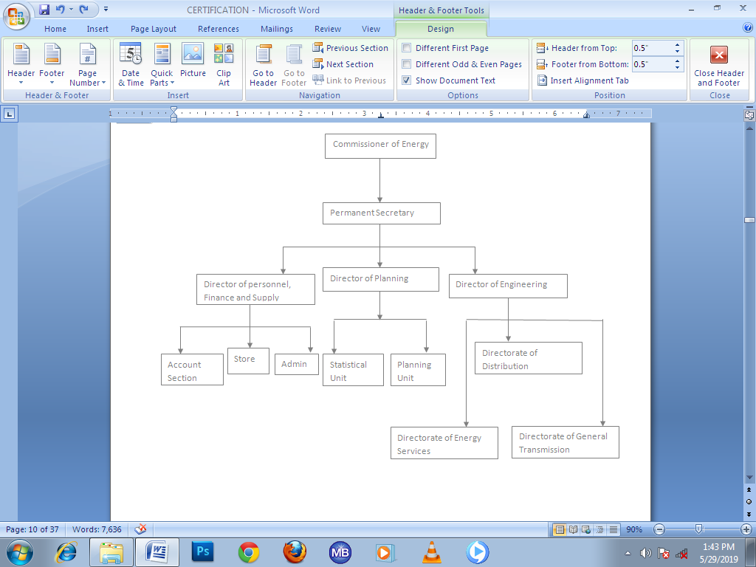
2.4 THE VARIOUS DEPARTMENT/UNIT IN THE ESTABLISHMENT AND THEIR FUNCTION
THE DEPARTMENT OF DISTRIBUTION AND SERVICES
FUNCTIONS
- To oversees the evenly distribution of energy across the state
- To ensure proper utilization of energy in the state
THE DEPARTMENT OF GENERATION AND TRANSMISSION
FUNCTIONS
- Supervision of the generation of electricity
- To ensure that the energy generated is transmitted from the generating station through transmission lines to the distributing station
CHAPTER THREE
3.0 ACTUAL WORK-DONE
3.1. DISTRIBUTION BOARD AND ITS TYPES
DISTRIBUTION BOARD
A distribution board, also referred to as a panel board, breaker panel, electric panel, DB board, or DB box, is a part of an electricity supply system that separates an electrical power feed into subordinate circuits and provides a protective fuse or circuit breaker for each circuit in a single enclosure.
TYPES OF DISTRIBUTION BOARD
- Single phase distribution board
- Three phase distribution board
3.2 NETWORK SYSTEM OF SINGLE PHASE AND THREE PHASE DB
SINGLE PHASE
Single phase network system has only two cable system which is red and black. The red indicates the live while the black is the neutral cable
THREE PHASE NETWORK SYSTEM
The 3 phase network system consists of 4 cable system, which are red, yellow, blue and black. The red, yellow and blue are live cables while the black is the neutral cable.
3.3 CONDUIT SYSTEM OF WIRING
A conduit wiring system is one in which all wires or cables are carried through iron or PVC pipes from supply to load. The purpose of running wires through the pipes is to protect it from unfavorable impacts of weather, physical deterioration, fire risks, and atmospheric influences. When running cables through pipes, care must be taken to prevent damage to the insulation. Compared to the other wiring systems, this type is the most frequently utilized.
3.4 TYPES OF CONDUIT WIRING SYSTEM
- Surface conduit wiring
- Concealed conduit wiring
SURFACE CONDUIT WIRING
Surface conduit wiring refers to the installation of conduits directly on the surface of a wall or roof.
CONCEALED CONDUIT WIRING
Concealed conduit wiring is a type of wiring in which PVC conduit is hidden by creating grooves in the wall, which are subsequently plastered over. It is known as concealed conduit wiring because only switches and lamp holders are visible from the outside on this sort of wiring. In other terms, concealed wiring refers to wire that is installed inside a pipe that is part of a wall. Plaster is applied after pipe has been installed and grooves have been created on the wall for the concealed wiring. Only a few junction box locations are still visible, from which wiring can be maintained and fixed.
3.5 ELECTRICAL TOOLS AND THEIR FUNCTION
- Hammer
Function: Use secure electrical boxes that can be nailed to wall studs and other structural members of a house.
- SCREW DRIVER
Function: enables effortless screwing and unscrewing.
- MULTIMETER
Function: for testing electrical circuits, components, and resistance, continuity, and voltage.
- PLIERS
Function: to cut, straighten, and bend wire, and also to twist wires together when making splices.
- Wire Stripper
Function: Electrical wire insulation is cut and stripped with wire strippers.
- Fixing Tape – It is used in passing wire into PVC pipe when working on conduit system wiring.
- Hacksaw – It is uses for cutting metal and PVC pipe when working on conduit wiring system.
- Center punch- It is used for making points in metal or concrete blocks before drilling.
- Soldering iron – It is used for soldering cable conductor joints.
- Safety Belts – It is used for prevention and holding the body when climbing concrete poles.
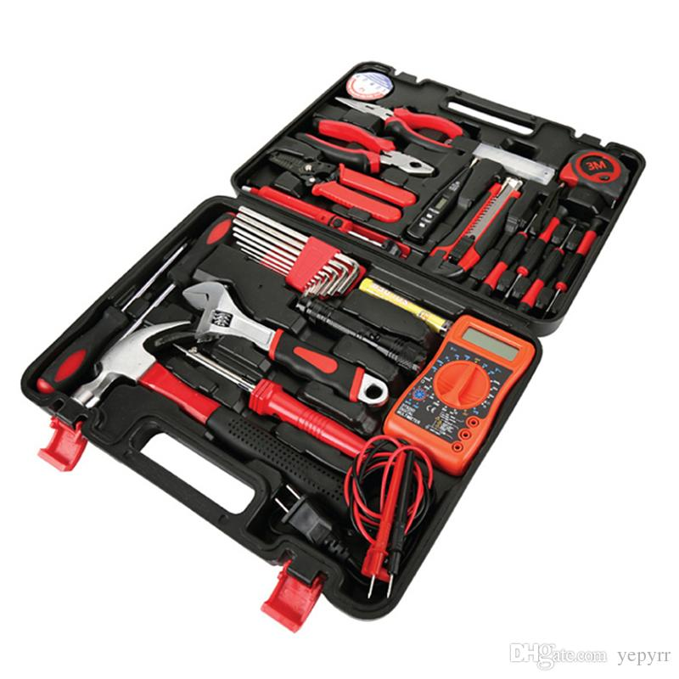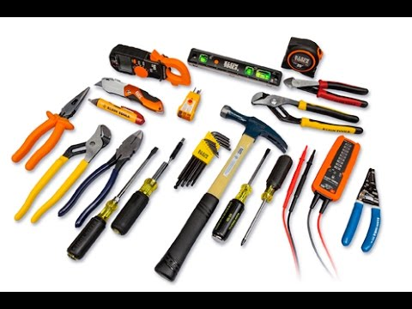

3.6 MAINTENANCE OF THE TOOLS
The maintenance are listed as follows;
- Keep the tools in cool and dry place
- It should be checked regularly
- It should be kept away from rain
- It should be taken away from in sting.

3.7 SAFETY PRECATIONS IN ELECTRICAL WIRING INSTALLATION
- Always put on your overall when in workshop or any place of work
- Always remove the fuse when carrying out installation on live cable.
- Test the conductor polarity by means of a tester not by touching it ordinarily.
- It is dangerous to operate electrical machine you are not familiar with.
- Always use correct tools for all jobs. Since incorrect tools used can result in accident
- When using a ladder make sure nit is properly place so as to avoid falling down.
- When working on concrete pole with ladder, ensure safety belt is used to hold the body when working
3.8 ADVANTAGES OF STRICT ADHERENCE TO SAFETY RULES AND REGULATIONS
- Long life of tools and equipment
- Good workmanship and work ability
- Total absence from likely danger
- Ensure conducive environment for working.
3.9 DEFINITION OF MAJOR TERMS USED IN ELECTRICAL INSTALLATION
- Accessory: Any device, other than a lighting fittings associated with the wiring and current using appliance of an installation for example a swith, a fuse, a lamp holder, or a plug.
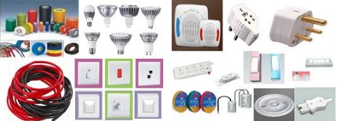

- Apparatus: This include all machines, electric fittings that use conductors for connections. For example electric motor, fluorescent fittings.
- Appliances : Any device which use Electricity for particular purpose, excluding fitting or independent motor, For example, Radio, Cooker, Electric iron etc.
- Cable : A length of insulated single conductor(solid or stranded), or of two or more of such conductor, each provided with its own insulation, which are laid up together
- Armored cable: A cable provided with herbal (Wrapping of steel) or wire or steel tape to serve as mechanical protection.
- PVC Sheathed Cable : A cable of which the conductor insulation and mechanical protection is of polyving-chloride
- Cable Trunking: A cast for cable, constructed of metal sheet, wooden or insulating materials and may be of rectangular or square cross section of which one side is removable or binged for the whole of its length for the purpose of laying cable therein
- Circuit Breaker: a mechanical device for making and breaking a circuit both under normal and abnormal condition, such as thode of a short circuit being broken automatically.
- Consumers control unit: It is a distribution board incorporation a main switch or main circuit breaker within its unit.
- Consumer Terminals: This is the point of a consumer installation where the service of the supply is connected.
- Distribution Board: This is an assemblage of parts including one or more fuses or miniature circuit breaker, arrange for the purpose of distribution of electrical energy to final sub-circuit and to other distribution boards.
- Earth Continuity Conductor: This is the earth wire that connects the earthen terminal on a apparatus to the earthing rod.
- Earth Electrode: A metal rod or rods metal plate or mat having effectual connection with the general mass of the earth.
- Earthed Lead: This is the final conductor that connects the earth continuity conductor to the earth electrode.
- Fuse: It is a device for opening a circuit by means of a conductor designed to melt when an excessive current flows. Its consist of two parts named the base and the bridge.
- Insulation of Conductor: It is a suitable non-conductor material enclosing or surrounding a conductor, which prevent be electrocuted when there is energy in the conductor.
- Joint Box: A box forming part of wiring of an installation (usually surface) provided to contain joints in the conductor.
- Junction Box: A box connecting two or more length of conductor or trunking appliance.
- Length of Run: For the purpose of the table of current rating and volt drop, the length of run is the point-to-point distance measured along the route taken by the cable.
- Lighting Fittings: A device for containing a lamp together with any holder, shade or reflector for example, (wall Bracket fittings) lamp holder, & fluorescent fittings.
- Point in Wiring: Any terminal of the fixed wiring intended for the attachment of a lighting fittings or a device connecting to the supply a current using appliance for example, a point of light, (the switch, the lam holder, and the wire that connects them together).
3.10 TRANSFORMER
A transformer is a device that is use for stepping up and stepping down voltage
3.10.1 DISTRIBUTION TRANSFORMER AND ITS TYPES
DISTRIBUTION TRANSFORMER
The ultimate voltage transformation in the electric power distribution system is provided by the distribution transformer, which lowers or raises the voltage in the distribution lines to the level that the customer uses in their residence, place of business, or other commercial building.
TYPES OF DISTRIBUTION TRANSFORMER
- Step Down transformer
- Step up transformer
3.10.2 CONSTRUCTION OF A 500 KVA TRANSFORMER
MATERIALS NEEDED
- Transformer (500 KVA)
- Danger plate
- Cable lug
- 2 nos of channel iron (6 ft)
- 3 nos of lightning arresters
- Copper cable ( Jumper)
- XLPE cable (35 mm² ) 3 nos x 1 C x 35 mm²
- Incomer cable (4 nos x 1C x 500 mm² PVC/PVC )
- Bi metallic line strip
- High tension pole (33 ft)
- 3 nos x 1 C 150 mm² aluminum conductor
- Feeder pillar
- J and P fuse/ D fuse
- HRC ( High rupturing capacity fuse)
- Upriser ( 4 C)
- Silicon pin insulator (3)
- Disc silicon insulator
- Earthing
- Low tension pole
- 6 bot clamp
- J – hook
- Mesh
- Plinth
After choosing of the site where the sub station will be installed. The civil engineers will make a plinth( a place where the transformer will be mounted upon) . After the transformer is being mounted upon the plinth an HT( high tension) pole is erected.
3.10.3 Substation (Equipment and Location)
A Substation is located in a load center, and May either be Primary/injection Substation or Distribution Substation, where fusing Equipment (feeder pillar, RMU e.t.c) and Transformer are installed. The transformer may either be; Power transformer: are rated 2.5MVA, 7.5MVA, 15MVA/Distribution transformer: all distribution transformer are designed to be either 33kV/11kV.two main type of substation exist namely;
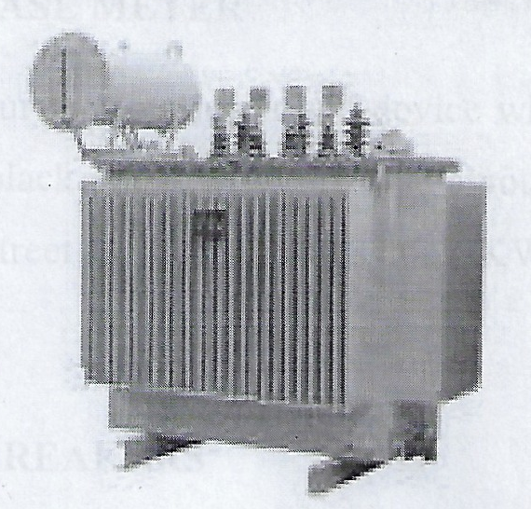
DIAGRAM OF A CONSUMER SUBSTATION TRANSFORMER

SHACKLE INSULATORS:
For low voltage line less than 11KV shackle insulators are used as strain inhalators. this is also known as spool insulators. it is used in low voltage distribution lines. Such insulators can be used either in a horizontal position or in a vertical position. They can be directly fixed to the pole with a bolt or cross arm. The conductor in the groove is fixed with soft binding wire. Coesote oil are impregnated in the ground level of the wooden pole for better foundation. These wooden poles has smaller life 20 to 25 years. Also it has less mechanical strength. it can’t be used for voltage higher than 20kv.
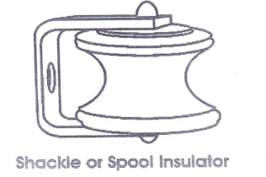

DISK:
An insulator that is made up of high-grade wet processes like brown-green glazed is known as disc insulator. These insulators are used in transmission & distribution systems. The designs of these insulators mainly change based on customer requirements. The properties of every electrical insulator include the following.
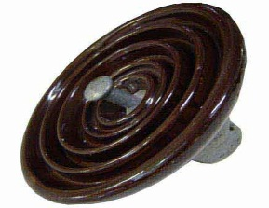
Steel Poles :
The steel poles are used generally for the distribution purpose in the city areas it has high mechanical purpose in the city areas. It has high mechanical strength with longer life poles. The outer surface of the pole is painted for longer life.
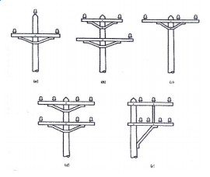

R. C. C pole
These poles are very popular in recent days. They provide longer span than steel and wood poles. They have greater mechanical strength with conger life.
These type of pole require law maintenance it has good insulating properties.These poles are heave weights. So the cast of transportation is high.
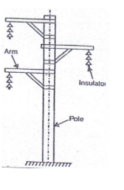
STEEL TOWERS:-
For long distance transmission at higher voltage steel towers are used. These steel towers have longer life, great mechanical strength. It is suitable for severe climate condition these type of steel towers are used for conger spans. Tower footings are grounded by driving rods in to the earth. This minimizes the lightning troubles as each tower acts as a lightning conductors it can also used as double circuit tower which allow continuity of supply in case of one circuit system down.

Thunder Arrestor (Lightning Arrester)
A thunder arrestor, also known as a lightning arrester, is a protective device used in electrical systems to prevent damage caused by lightning strikes or high-voltage surges. It is typically installed on buildings, electrical power lines, or transmission systems to divert lightning strikes safely to the ground. The arrester works by providing a low-resistance path for the lightning current, which prevents it from passing through and damaging sensitive electrical equipment. Thunder arrestors are crucial for safeguarding electrical infrastructure, especially in areas prone to frequent thunderstorms.

Short circuit
A short circuit (sometimes abbreviated to short or s/c) is an electrical circuit that allows a current to travel along an unintended path with no or very low electrical impedance. This results in an excessive current flowing through the circuit. The opposite of a short circuit is an open circuit, which is an infinite resistance (or very high impedance) between two nodes.
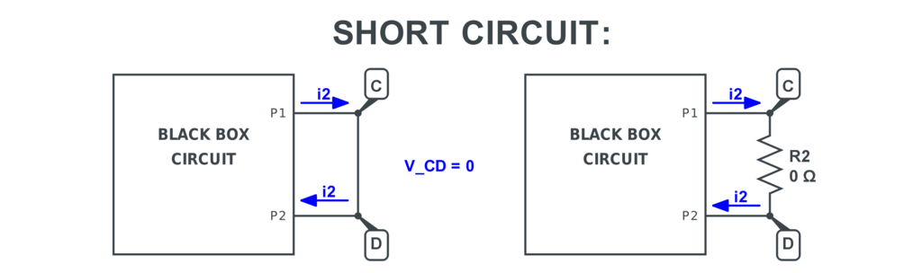

Residual Current Device (RCD)
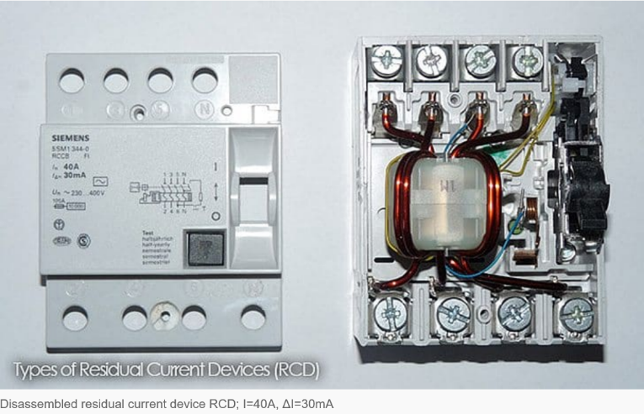
A Residual Current Device (RCD), also known as a safety switch or ground fault circuit interrupter (GFCI), is an electrical safety device that protects against electrocution by detecting and quickly shutting off power when a fault causes electricity to leak to the ground. RCDs are crucial for safety, especially in areas where there's a risk of electrical shock, such as bathrooms and gardens

Types of RCDs:
- Fixed RCDs: Installed in the fuse box and protect entire circuits or groups of circuits.
- Socket-outlet RCDs: Built into a socket and provide protection for the connected appliance and its lead.
- Portable RCDs: Plug into standard outlets and provide protection for the connected appliance.
Importance of RCDs in various settings:
- Bathrooms and gardens: Increased risk of electrocution due to moisture and contact with ground.
- Outdoors: Using electrical equipment outdoors without an RCD is dangerous.
- Homes: RCDs are often mandatory in homes to protect against electrocution and fire

CHAPTER FOUR
4.0 RELEVANCE OF THE EXPERIENCE GAINED
In summary, this program has exposed me to some practical aspect in relation to my course of study (Mechatronics Engineering Technology) and I benefitted greatly from the program. What I learnt at various site involves the following
- Wiring installation system.
- Type of wire suitable for installation
- Types of wiring system
- Tools suitable for electrical installation
- Transformer
- Short circuit
- Connection of Electrical Bus-bar
- Thunder arrestor
- Ceiling fan connector with capacitor
- Residual current device

CHAPTER FIVE
5.0 CONCLUSION AND RECOMMENDATION
5.1 CONCLUSION
It is well understood that the effort of the government in establishment of SIWES program for all student in the tertiary institution as the part of their programme is commendable.
In one way or the other SIWES programme has added value to my practical experience due the fact that I was able to handle various kind of work myself.
I can now conclude that SIWES is a very interesting program and the entire student should try and be the participant.
5.2 RECOMMENDATION
From an experience during the course of these four months program I recommend that
a. It should be mandate for each student to undergo this program because of benefit there in which will add value to lives.
b. Motivation should be given to student by federal government through the SIWES.
c. Appropriate supervision must be done to improve the seriousness of the student in their attachment.

