

TECHNICAL REPORT ON STUDENT INDUSTRIAL WORK EXPERIENCE SCHEME (SIWES)

HELD AT:

IBADAN ELECTRICITY DISTRIBUTION COMPANY
POST OFFICE CHALLENGE ILORIN KWARA STATE

SUBMITTED BY:

OLATUNJI EMMANUEL PRECIOUS
MATRIC NO: ND/23/EEE/PT/0140

SUBMITTED TO:
DEPARTMENT OF ELECTRICAL/ELECTRONIC ENGINEERING
INSTITUTE OF TECHNOLOGY (I.O.T)
KWARA STATE POLYTECHNIC, ILORIN
P.M.B. 1375 ILORIN, KWARA STATE

IN PARTIAL FULFILLMENT OF THE REQUIREMENT FOR THE AWARD OF NATIONAL DIPLOMA (ND) CERTIFICATE IN ELECTRICAL AND ELECTRONIC ENGINEERING

AUGUST – DECEMBER 2024

DEDICATION
This report work is dedicated to the Almighty God, the Alpha and Omega. The one who make me whom I am today, also dedicated to my parents Mr. and Mrs. OLATUNJI. And to all the staffs of IBADAN ELECTRICITY DISTRIBUTION COMPANY.
Lastly, to my brothers and sisters.

ACKNOWLEDGMENT
Thanks to Almighty God, who is able to do all things and make me to excel abundantly above in all I ask and think, according to the power that works in me unto him the glory and domination and also to my parents Mr. and Mrs. Olatunji for their words of encouragement and to my brothers and sisters who are too numerous to mention
The success of this report however would not have been possible without the invaluable support, assistance and encouragement of a large number of people who are too numerous to mention.
And to those whose names did not appear who at one point or the other contributed to the success of this write-up.
I say thank you and GOD BLESS YOU

PREFACE
Student industrial work experience scheme is geared towards educating and giving the participant i.e. the student to the practical aspect of the academic discipline and course he or she is pursuing.
This technical report is based on all the training acquired by me during the course of my industrial attachment the attachment lasted for four months (August – December, 2024)
This program is organized for all engineering and technological students of higher institution of leaning, is a sure way of achieving the guest for technological and self reliance in a country like ours where the need for technological advancement cannot be over emphasized.
My acquired experience on this industrial work which I did at IBADAN ELECTRICITY DISTRIBUTION COMPANY has given me insight into the course of my study. It has exposed me and given me the knowledge about the various types of electrical and inverter installation and some work techniques, whose operational techniques work only, but theoretically explained in our lectures in class. I want to appreciate the national board of technical education for the introduction of the student industrial work experience scheme programme to the higher institution to prepare us for a better future.

ABSTRACT
This report cover the systems of electrical installation the types of electrical installation system, such as surface wiring system and conduit wiring system, the tools and instruments used and their uses, various types of materials used in electrical installation including the cable to be use and various things to consider before the electrical installation of a building.

TABLE OF CONTENTS
Title i
Dedication ii
Acknowledgment iii
Preface iv
Table of contents v

CHAPTER ONE
1.0 Introduction 1
1.1 Historical Background of SIWES 1
1.2 Aims and Objectives of SIWES 2

CHAPTER TWO
2.0 Organization Description 3
2.1 Brief History of establishment 3
2.2 Location and Brief history of establishment 4
2.3 Duties of establishment 4

CHAPTER THREE
3.0 Transmission and Distribution 5
3.1 Electrical transmission by overhead wire 6
3.2 Electrical Transmission by Underground Cables 6
3.3 Step-up and Step-Down of voltages 7
3.4 Over power 7
3.5 Classification of Operating voltages 8
3.6 Load Analysis 9
3.7 Cables 9
3.7.1 Types of Cables 10
3.7.2 Cables Selection 12
3.8 Distribution Board 12
3.9 Types of Breakers based on Number of Pole 13

CHAPTER FOUR
4.0 Relevance of the Experience Gained at Students field of study 16

CHAPTER FIVE
5.0 Conclusion 17
5.1 Recommendation 17

CHAPTER ONE
1.0 INTRODUCTION
The Industrial Training program or Student Industrial Work Experience Scheme (SIWES) is appreciable skills programmed designed to equip students to the real life working experience. This scheme is a program involving universities, polytechnics and technical colleges and students of various institutions in the country. The students Industrial Work Experience Scheme (SIWES) is funded jointly by Industrial Training Fund (ITF). The training lasts for three months. The theory and practical aspect is being joined together in the programme in order to find out how things are being done. In theory, we are to read novels, books, but in practical we have to know how to do things by ourselves practically.
1.1 HISTORICAL BACKGROUND OF SIWES
The Students Industrial Work Experience Scheme (SIWES) initiated in 1973 by the Industrial Training Fund (ITF). This was in response to the mandate given to the ITF through Decree 47 of 1971, charging it with the responsibility of promoting and encouraging the acquisition of skills in Industry and commerce with the view to generate a pool of trained indigenous manpower sufficient to meet the needs of the economy.
SIWES has come to be recognized as the major avenue of bridging the gaps between the theory acquired by students of tertiary institutions and the industrial practice of the various profession and disciplines essential to the technological and economic development of Nigeria. Since its introduction by the ITF in1973, the scheme has gone through series of reforms and restructuring. For instance, its management has changed hands from the ITF to the various regulatory agencies, National Universities Commission (NUC), National Board for Technical Education (NBTE) and National Commission for Colleges of Education (NCCE) and back to the ITF. Similarly, the structure and operational framework have been reviewed, streamlined and made more functional at the various levels of its operations.
Over the years, SIWES has contributed immensely to building the common pool of technical and allied skills available to the Nigerian economy which are needed for the nation’s industrial development. These contributions and achievements have been possible because of regular innovations and improvements in the modalities employed for the management of the Scheme.
The management of a scheme as strategic as SIWES requires dissemination of reliable information in order to ensure that all stakeholders direct their energies and activities toward achieving the objectives and goals of the scheme information is, therefore, indispensable in enabling students to derive the greatest benefits possible from participating in the Scheme. The need for students to possess adequate information on SIWES is further underlined by the fact that SIWES is a course study that attracts two, four and six credit units in colleges of education, polytechnics and universities respectively. The availability of required information, therefore, enhances the capacity of students to work for and earn the credit units allotted for SIWES.
1.2 AIMS AND OBJECTIVES OF SIWES
- Provides an avenue for students in institution of higher learning to acquire industrial skills and experience during their course of study.
- Prepare students for industrial work situation that they are likely to meet after graduation.
- Expose students to work methods and techniques in handling equipment and machinery that may not be available in their institutions.
- Make the transition from school to the world of work carrier and enhances students contacts for later job placements.
Provide students with the opportunity to apply their educational knowledge in real work situations, thereby bridging the gap between theory and practical.

CHAPTER TWO
ORGANIZATION CHART
MANAGING DIRECTOR
Executive operation director
Media Officer
Legal Adviser
Project Delivery Division
Asset management directorate
water O & M directorate

Electricity O & M directorate
Supply department manager
HRA Department Manager
Finance Department manager

Customer service directorate
HSE Department

  - BRIEF OVER VIEW OF ESTABLISHMENT OF ATTACHMENT
Energy has far-reaching impact on all aspects of our socio-economic life (food production; industry output; efficient transportation; healthcare; academic endeavors; safety and security, etc.)
Inadequate supply of energy restrict socio-economic activities, limits economic growth and adversely affect the quantity of life. Energy security and self sufficiency are therefore matters that should command the government attention at all times.
Apart from the Ministry of Energy that has the Hon. Commissioner at the helm of affairs, the state chief executive, has also appointed two other officials to assist him in the energy sector, because of the importance he attached to the sector. These are S.A (ENERGY) and S.A (RURAL ELECTRICITY).
2.2 LOCATION AND BRIEF HISTORY OF ESTABLISHMENT OF ATTACHMENT
Ibadan Electricity Distribution Company (IBEDC) Post Office Challenge Ilorin Kwara State
The ministry of energy was created in the year 2009, during the restructuring of the Kwara state civil service, in order to make the machinery of government more responsive to the demand of services delivery to the people.
2.3 DUTIES OF ESTABLISHMENT OF ATTACHMENT
- Formulation and implementation of government policies on energy ( conventional power supply, biomass, solar, wind, hydro, coal and gas etc).
- Matters relating to power generation, transmission, distribution and electrical engineering services.
- Attracting private sector-led investment in the energy sector
- Collaborating with agencies like ECN, ASCON, on the supply of electricity for domestic and industrial use, in towns and villages, to meet the states current and future energy needs.
- Provision of electrical engineering support services
- Sensitization of the populace on energy related matters
- Liason with relevant agencies on power related issues.

CHAPTER THREE
3.0 TRANSMISSION AND DISTRIBUTION
The electrical energy from power stations reaches our homes because of extensive conducting cables that form the electricity transmission and distribution system. The system transmit electrical power from a fewer stations to every home from city centers to the remote areas. Electricity is transmitted mainly through overhead lines or underground cables.
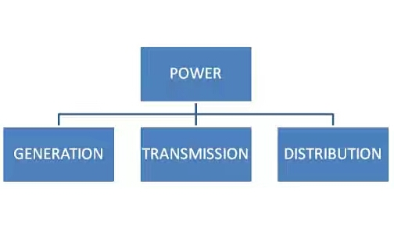

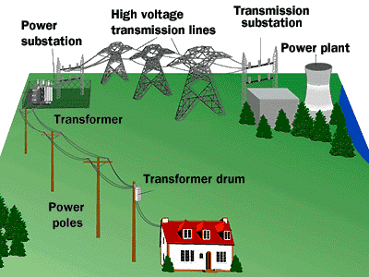
Fig 7.1: Transmission and distribution

3.1 ELECTRICAL TRANSMISSION BY OVERHEAD WIRE
Overhead lines are held high above the ground by metal tower called pylons. The overhead lines are held by stack of discs hanging from the pylon. The stack of disc is a series of suspended porcelain insulators which prevent the line from being electrically connected to the pylon and become earthed. A long stack of disc will give a better insulation to prevent conduction through the porcelain disc and will provide a thicker layer of air between the pylon and the wires to prevent electrical discharge through air. The umbrella shape of the insulating disc also has a special purpose. It prevents water from forming conductive path along the stack during rainy days.
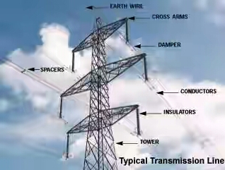
Fig 7.2: Electrical transmission by overhead wires

3.2 ELECTRICAL TRANSIMISSION BY UNDERGROUND CABLES.
In well-developed areas, where no land space can be spared for building pylons, underground cables are used to transmit electricity. These cables are buried underground avoiding any contact during operation and effect of bad weather condition like thunderstorm. Although underground cables have many advantages. Designing building and installing underground cables require more advanced technology. This explains why they are 10 times more expensive than overhead wires.

3.3 STEP-UP AND STEP-DOWN OF VOLTAGES.
A very high voltage transmission can minimize the power loss in wires through to heating effect. Yet electricity generated from power stations is not at such a high voltage, so a way to change the voltage of electricity is required. Devices called transformer are used to change the voltage. The process of raising the voltage by a transformer is called Step-up and the process of lowering the voltage by a transformer is called Step-down.
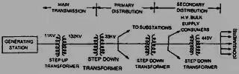
Fig 7.4 Step up and step down of voltage
3.4 OVERHEAD POWER
An overhead power line is a structure used in electric power transmission and distribution to transmit electrical energy along large distance. It consists of one or more conductors (commonly multiples of three) suspended by towers or poles. Since most of the insulation is provided by air, overhead power lines are generally the lowest-cost method of power transmission for large quantities of electric energy.
The major goal of overhead power line design is to maintain adequate clearance between energized conductors and the ground so as to prevent dangerous contact with the line and to provide reliable support for the conductors, resilient to storms, earthquake and other potential cause of damage
Today, overhead lines are routinely operated at the voltages exceeding 765,000 volts between conductors with even higher voltages possible in some cases

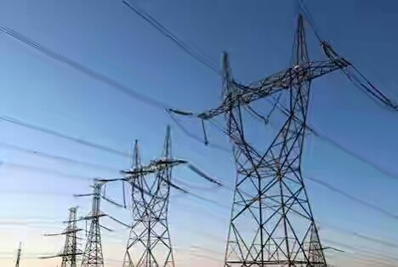
Fig 7.4: Overhead power line

3.5 CLASSIFICATION OF OPERATING VOLTAGES
Overhead transmission lines are classified in the electrical power industry by the ranges of voltages.
- Low Voltages (LV); Less than 1000 volts used for connection between a residential or small commercial customer and the utility.
- Medium Voltages (MV distribution); between 1000V (1KV) and 69KV used for distribution in urban and rural areas.
- High Voltages (HV sub-transmission less than 100KV; sub-transmission or transmission at voltage such as 115KV and 138KV), used for sub-transmission and transmission of bulk quantities of electric power and connection top very large consumer.
- Extra high Voltage (EHV transmission) – over 230KV, up to about 800KV, used for long distances, very high power transmission.
- Ultra High Voltage (UHV); higher than 800KV

3.6 LOAD ANALYSIS
Table below contains the total number of lighting points and power points used in a cold room (using abbatial cold room as a case study).

LIGHTING POINTS | NUMBER
Ceiling fittings | 73
Bowl fittings | 3
Bulkhead fitting | 20
Ceiling fan | 20
Total | 116

3.7 CABLES
Cables consist essentially of conductors carrying electric current and insulation to prevent leakage of current from the conductors. They may be provided with some form of protection against mechanical damage. The current carrying capacity of a cable is determined by the cross-sectional area of its conductor. The conditions for which a particular type of cable is suited are influenced by the type of insulation and by the external protection.
Conductors used for ordinary consumer installations are annealed copper. Hard drawn copper (which has a slight higher resistance) is used for bus bars and overhead lines. To give flexibility, the conductors are stranded. The number of wires making up stranded conductors is normally one of the following; 3,7,19 or 37. Conductors sizes are expressed either by the number of strands followed by the diameter of each strands or by the total cross-sectional area. Larger size of these cable ranges from 50mm² to 630mm^{2/}. Although copper is the commonest conductor material for cables used in ordinary electrical installation work. Aluminium is likely to be increasingly employed ensuring that the regulation eventually permit the use of aluminium cables below 10.0mm². Its weight is about one-third, that of the equal volume of copper but its conductivity is only about 30% of copper. This means that the given current carrying capacity, the cross-sectional area of an aluminium conductor is greater than that of the corresponding copper conductor.

3.7.1 TYPES OF CABLES
A cable is a length of insulated single conductor or more of such conductors, each provided with its own insulation cable used in electrical circuits are of many types but all consist of the following main part; conductor, insulator and mechanical protection.

Principal types of cable in use at the present time are;
- TOUGHER RUBBER SHEATHED (TRS) CABLE:
Tough rubber sheathed cables are mechanized rubber insulated conductors which are protected by a tough rubber sheath.

- POLY CHLOROPENE- SHEATHED (PCP) CABLES:
These cables may be used where conditions are too arduous for PVC or tes cables. Polychloropene (or neoprene) is resistant to oil and petrol and can be used where there is exposure of steam sulphur fumes, ammonia fumes, acid, direct sunlight and heat.

- MINERAL INSULATING CABLES (MICs):
This type of cable is not often used for domestic installation because of its cost but its many good properties are an advantage to industrial properties. MICs are suitable for use
In situation where flammable or exposure dust, vapour or gas is likely to be present. The

Cable consists of solid cores of high-conductivity. The whole being contained in a solid-drawn copper sheath. The sheath may be further protected by an overall covering PVC, which will prevent deterioration in the presence of moisture and of most chemicals. Standard cables are available with one, two, three, four or seven cores with voltage rating of 500V and 750V.
Mineral insulated cables are difficult to manage, are very resistant to corrosion, have high mechanical strength, bare small in size, have excellent electrical properties, are waterproof, can work at high temperature. They must be terminated with spiral seals to prevent the insulator becoming moist where it will lose its insulating properties.

- POLYVINYL CHLORIDE (PVC)CABLES:
These cables are insulated with PVC materials. Polyvinyl Chloride has high insulation resistance, good protective strength and mechanical toughness over a wide range of temperature. PVC insulated cables are generally used for low and medium domestic light and power insulations.
- ARMOURED CABLES:
An armored cable is one where the conductors and insulators are protected by layers of steel wires or tapes. This armoring protects the cable from mechanical damage while it is in service as well as giving added strength to withstand handling during insulation.

The conductors of these cables are made up of copper or aluminum, the former always stranded but the later often solid. Power cables of these types find wide application for underground electrical supplies, as well as for heavy sub-main distributors in some large buildings. They are also used for circuit wiring in factories where the likelihood of mechanical damage is great.

- SHEATHED WIRING CABLES:
For most domestic and commercial installations, the latest expensive system includes the use of sheathed cables. These consist of conductors insulated with PVC land singly with others and covered by a protective sheath.
Sheathed cables are fixed by saddles pinned to the surface or may be buried in plastic walls with or without the added protection of a conductor capping provided that they run vertically or horizontally from an outlet such as a switch or a socket. When run under floor boards, the cables must be passed through holes which are at least 50mm below the top of the joist to prevent damages by nails.
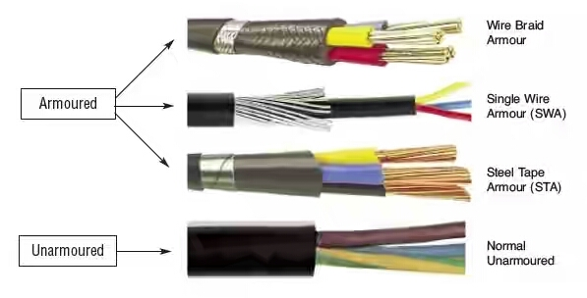

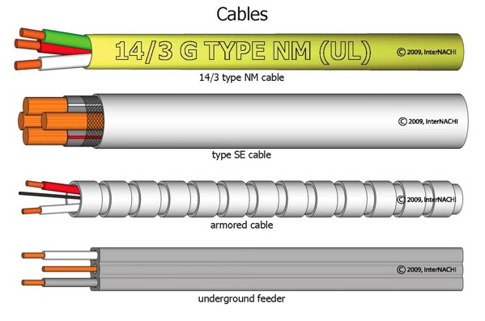

Fig 10.1: Cables
3.7.2 CABLE SELECTION
Choice of voltage rating
The voltage rating of a cable indicates its safe working voltage. This is in any given type of cable; the voltage rating is determined by the thickness of the insulators. The stranded voltage rating for most wiring cables is 600/1000V. Flexible cords have voltage rating of 300/500V and mineral insulated cables are given rating of 600V class (light duty) and 1000V class (heavy duty).
In the voltage designation above, the first number is the power frequency voltage to earth for which the cable is designed and the second number is the corresponding power frequency voltage between conductors. Thus for example, a cable rated at 600/1000V may be used on a 3-phase supply where voltage between any phase and Earth (E) does not exceed 600V and where the voltage between phase does not exceed 1000V. When selecting a cable, the voltage of the cable should never be less than the declared voltage of the circuit.
3.8 DISTRIBUTION BOARD
A distribution board is a component of an electricity supply system that divides an electrical power feed into subsidiary circuits, while providing a protective fuse or circuit breaker for each circuit in a common enclosure.
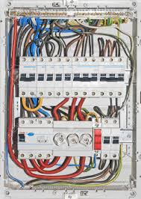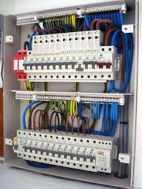

3.9 TYPE OF BREAKERS BASED ON NUMBER OF POLE:
- Based on the number of poles, the breakers are classified as
- SP – Single Pole
- SPN – Single Pole and Neutral
- DP – Double pole
- TP – Triple Pole
- TPN – Triple Pole and Neutral
- 4P – Four Pole
1. SP ( Single Pole ) MCB:
- In Single Pole MCCB, switching & protection is affected in only one phase.
- Application: Single Phase Supply to break the Phase only.
2. DP ( Double Pole ) MCB:
- In Two Pole MCCB, switching & protection is affected in phases and the neutral.
- Application: Single Phase Supply to break the Phase and Neutral.
3. TP ( Triple Pole) MCB:
- In Three Pole MCB, switching & protection is affected in only three phases and the neutral is not part of the MCB.
- 3pole MCCB signifies for the connection of three wires for three phase system (R-Y-B Phase).
- Application: Three Phase Supply only (Without Neutral).
4. TPN (3P+N) MCB:
- In TPN MCB, Neutral is part of the MCB as a separate pole but without any protective given in the neutral pole (i.e.) neutral is only switched but has no protective element incorporated.
- TPN for Y (or star) the connection between ground and neutral is in many countries not allowed. Therefore the N is also switches.
- Application: Three Phase Supply with Neutral
5. 4 Pole MCB:
- 4pole MCCB for 4 wires connections, the one additional 4th pole for neutral wire connection so that between neutral and any of the other three will supply.
- In 4-Pole MCCBs the neutral pole is also having protective release as in the phase poles.
- Application: Three Phase Supply with Neutral

3.10 WHERE TO USE 4 POLE MCB INSTEAD OF TPN MCB
- Any Protection Relay used on Neutral (Ground Fault Protection of Double ended System):
- The use of four poles or three poles CB will depend on system protection and system configuration.
- Normally in 3phase with neutral we just use 3pole CB and Neutral is connected on common Neutral Link but if application of 3pole will affect the operation of protective relay then we must use 4pole CB.
- System evaluation has to be required to decide whether three-pole circuit breakers plus neutral link can be used or four-pole breakers are required.
- If unrestricted ground fault protection is fitted to the transformer neutral, then the bus section circuit breaker should have 4-poles and preferably incomer circuit breakers should also have 4-poles because un cleared ground fault located at the load side of a feeder have two return paths. As shown in fig a ground fault on a feeder at the bus section “A” will have a current return path in both the incomers, thus tripping both Bus. The sensitivity of the unrestricted ground fault relay is reduced due to the split current paths.
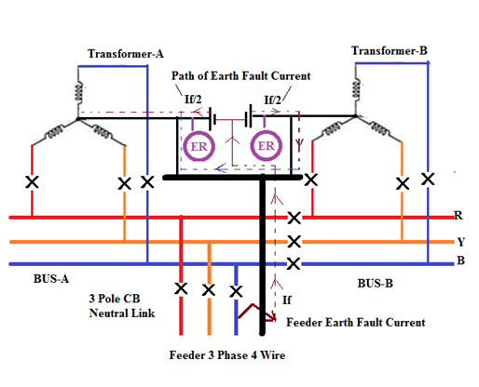

CHAPTER FOUR
- RELEVANCE OF THE EXPERIENCE GAINED AT STUDENTS FIELD OF STUDY
In summary, this program has exposed me to some practical aspect in relation to my course of study (Electrical/Electronics Engineering) and I benefitted greatly from the program. What I learnt at various site involves the following.
- Winding of three phase A.C induction motor
- Transformer winding
- Single phase A.C induction motor
- Winding of electric fan
- Wiring
- Repairing and servicing of generator
- Maintenance service

CHAPTER FIVE
5.0 CONCLUSIONS
The SIWES program had contributed positively to my exposure and training in the field of electrical and electronics engineering. It has also helped me to put practice their knowledge gained in classroom with actual industrial experience. Also to develop a critical and realistic approach with their solution in electrical field.
5.1 RECOMMENDATION
The polytechnics should make it compulsory for all students , since the program goes way in improving students practical and theoretical experience.
I recommend that the siwes letter should be given to students early so as to avoid attachment in irrelevant places
I also that substantial percent of the National budget should go into the development, improvement and sustenance of the power sector. Doing this would help improve electricity production and in turn improve development and industrialization, so that students can have a good place of attachment.

