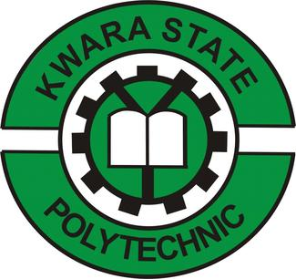

REPORT ON
STUDENTS’ INDUSTRIAL WORK EXPERIENCE SCHEME (SIWES)
AT
QUARRY LINK CONCEPT LIMITED
FROM 17th OF SEPTEMBER TO 1st OF MARCH 2025

BY

OBA, ALEM.
(ND/23/MPE/FT/0086)

SUBMITTED TO THE DEPARTMENT OF
MINERALS AND PETROLEUM RESOURCES ENGINEERING
KWARA STATE POLYTECHNIC, ILORIN, KWARA STATE

MARCH, 2025.
CHAPTER ONE
INTRODUCTION
1.1. Background
The Students’ Industrial Work Experience Scheme (SIWES) was introduced by the Federal Military Government of Nigeria in 1974 as part of the undergraduate curriculum in higher institutions to primarily bridge the gap between theory and practical training. The skills training program was designed to expose students of universities and polytechnics to real life work after graduation.
1.2. Objectives
The objective of SIWES among others includes:
- Providing an avenue for students in institutions of higher learning to acquire industrial skills and experience in their approved course of study;
- Prepare students for the industrial works situation that they are likely to meet after graduation.
- Expose students to work methods and techniques in handling equipment and machinery in their institutions.
- Provide students with an opportunity to apply their knowledge in real work situation thereby bridging the gap between theory and practices. It enables the student to have working experience.
- One of the objectives of the scheme is to promote the acquisition of skill and manpower development as well as to cater for the training of middle level cadre in both the public and private sectors. It affords students the opportunity of being familiar and exposed to the needed experience in industrial skills, training and development to meet human resource needs for rapid industrialization and sustainable economic development of Nigeria
  - ORGANIZATION AND OPERATIONS OF SIWES

Operators: | The ITF, the coordinating agencies (NUC, NCCE, NBTE), employers of labor, and the institutions.
Funding: | The Federal Government of Nigeria
Beneficiaries: | Undergraduate students of the following: Agriculture, Engineering, Technology, Environmental, Science, Education, Medical Science, and Pure and Applied Sciences.
Duration:  INDUSTRIALTRAINING  FUND  (SIWESDivision)  TERTIARY INSTITUTIONS  (Universities,Polytechnics)  STUDENTTRAINEES  (Science, Engineering & Technology)  ITF AREA OFFICES (SIWES Unit)  EMPLOYERS  (Industry/Government)  SUPERVISING AGENCIES (NUC, NBTE, NCCE)  ORGANISED PRIVATE SECTOR  (NECA, NACCIMA ,MAN)  CHIEF EXECUTIVES’  FORUM  FEDERAL GOVERNMENT  (Federal Ministry of Industry Trade & Investment) | Polytechnics and Colleges of Education-Four months Universities- Six months

IMPORTANCEOF SIWES PROGRAM
The importance of Industrial training in which students can benefit from areas follows:
- It enables students to acquire technical skills and experience for professional development in their studies.
- SIWESisanefforttobridgetheexistinggapbetweentheoryandpracticeandexpose students to necessary skills for a smooth transition from the classroom to the world of work.
- Provision of an enabling environment where students can develop and enhance personal attributes such as critical thinking, creativity, and interpersonal skills amongst others

PRODUCTS OF THE COMPANY
      - Cement
      - Fiber Cement sheets
      - Speciality building products

QUALITY POLICY STATEMENT
QUARRY LINKConcept LTD. (PIL) is committed:
- To provide high-quality &cost-effective Cement and fiber cement sheets.
- To meet our customer’s requirements through measurable objectives set at Corporate and Department levels.
- To review the objectives when necessary to ensure their continued suitability.
- To ensure the effective implementation of NIS ISO 9001:2015 as well as all other regulatory and statutory requirements.
- To constantly strive for continual improvement, higher organization effectiveness, and customer satisfaction.

DESCRIPTION OF DEPARTMENT OF PLACEMENT

In reference to my course of study; Metallurgical and Materials Engineering, I was absorbed into the organization as an engineering intern at the mining department.

The Mining department is made up of the Research & Design unit and the Quarry unit. The research & design unit is tasked with the responsibility of drawing out plans for blast designs and calculation of the number of explosives to be charged, to minimize vibration which could affect the earth’s surface. Whereas, the Quarry unit consists of other sub-units which are responsible for the overburden, drilling, charging of the drilled holes with explosives which are carried out by the Blaster, and the haulage of the limestone from the quarry to the stockpile yard.

The mining department is in charge of the mineral process (Lime stone process) which is the main material in cement production. The process involved in the mining of limestone is; Overburden, Drilling, Blasting, Haulage/Excavating & Crushing. Which is the first process in cement production? As an intern at the Mining Department, I worked together with both the research unit and the quarry unit.

Other Departments of placement
The entirety of my training program at PIL was not spent in the Mining department only. I had regular visits to other departments in the organization; the Chemical laboratory and Physical laboratory in particular. By doing this, I had the opportunity to garner enough hands- on experience under the tutelage of the industry-based engineers and experts.

The Chemical laboratory, it’s where the stoi chiometry of the raw materials (such as; limestone, late rite, gypsum, iron dust, and coal) for the production of cement are been carried out. It is responsible for the mixing ratios. Also, other tests such as; lost in the ignition, total carbonate, free-lime, blending silo composition, etc. are carried out. The QUARRY LINK concept limited, on the other hand, is responsible for the quality check of the cement after it has been produced before it’s been transported to the customers. Two main tests are been carried out in the physical laboratory which are the compressive tests and the setting time test.

This report gives a summary of my four months of industrial training with QUARRY LINKLimited (QL) for the mandatory SIWES program, and it would provide relevant details regarding the training program adhered to, an account of the work carried out, problems encountered, how many of the problems were solved, and contributions which I made to the Industrial process. This technical writing however would not provide comprehensive details of other areas of operation of the organization which were not relevant to the scope of the training schedule and discipline.

CHAPTER TWO
THE TRAINING PROGRAM

DESCRIPTION OF WORK EXPERIENCE

My Industrial Training program commenced on the 6th of September 2024 and ended on the 1st of MARCH 2025 at QUARRY LINK CONCEPT LTD.

The resumption time was 8:30am and the closing time was 5:00pm. I made sure a cordial relationship was entrenched with the employees of PIL both in the department I worked in and in other departments. I also familiarized myself with the protocol of the company.

My experience in PIL is mainly based on mineral process (Limestone process) which involves the mining of limestone from the quarry which is the nto be processed with other materials such as; laterite, coal, gypsum & iron dust in the kiln into cement.

LIMESTONE
Limestone is a sedimentary rock composed mainly of calcium carbonate, usually in the form of calciteoraragonite. It may contain considerable amounts of magnesium carbonate (dolomite) as well as; minor constituents. Limestone has two origins:
- Biogenic precipitation from seawater, the primary agents being lime- secreting organisms and foraminifera
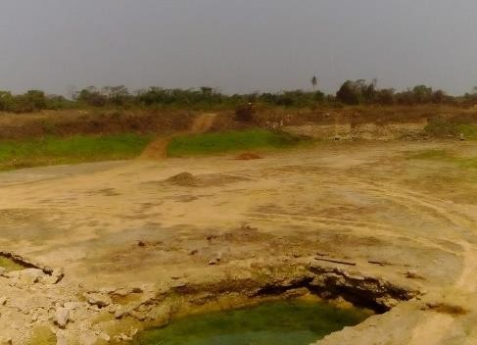
- mechanical transport and deposition of pre existing lime stones, forming clastic deposits.

LATERITE
Laterite is a soil layer that is rich in iron oxide and derived from a wide variety of rocks weathering under strongly oxidizing and leaching conditions. It forms in tropical and subtropical regions where the climate is humid. Lateritic soils may contain clay minerals; but they tend to be silica-poor, for silica is leached out by waters passing through the soil. Typical laterite is porous and claylike. It contains the iron oxide minerals goethite, HFe O2; lepidocrocite, Fe O (OH);and hematite, Fe2O3.It also contains titanium oxides and hydrated oxides of aluminum, the most common and abundant of which is gibbsite, Al2O3·3H2O. The aluminum-rich representative of laterite is bauxite
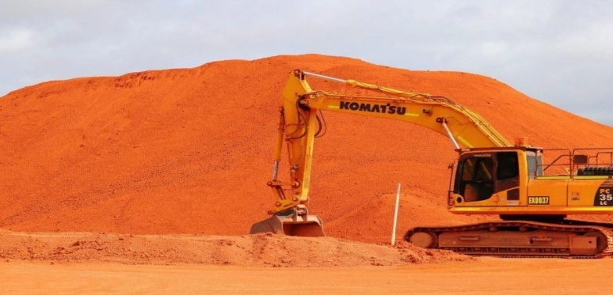

COAL
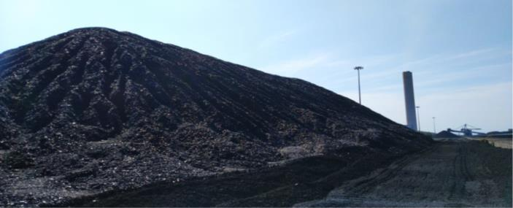
Bituminous coal, or black coal, is a type of coal containing a tar-like substance Called bitumenor asphalt. Its coloration can be black or sometimes dark brown; often there are well-defined bands of bright and dull material within the seams. It is typically hard but friable

GYPSUM
Gypsumis as of tsulfate mineral composed of calcium sulfate dehydrate, with the chemical formula Ca SO4·2H2O. It is widely mined and is used as a fertilizer and as the main constituent in many forms of plaster, blackboard/sidewalk chalk, and drywall.
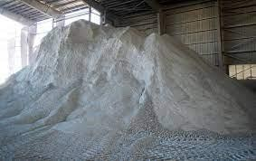

Gypsum plays an important role in cement production, it controls the setting time of cement, and that is, it slows down the hydration process in cement once it is mixed with water. The effects of gyp sum on cement are as follows:
- Gyp sum prevents the flash setting of cement during manufacturing.
- It retards the setting time of cement.
- It allows a longer working time for mixing, transporting, and placing of the cement.

IRON DUST
It contains mainly iron oxide (Fe2O3) and its usage should be 1 to 2% in cement It was found that the optimal quantity of Fe2O3 is 0,01% by weigh to fce mentin the presence of polymer powder PAV-22, because it increases the hardened cement stone flexural strength, and slightly decrease the compressive strength.

ACCOUNTOF WORK DONE IN THE MINING DEPARTMENT

RESEARCH & DESIGNUNIT

I, together with other members of the research & design team were briefed on the approach we would employ to attain our target by the Mines manager – review the work done of the previous year. In other to carry out the planned agenda, my Industrial Supervisor (Mine’s manager) exposed the research team to the concept of literature reviews on blasting designs. He extensively drilled us on its relevance and importance in every research work; likewise, helaidmoreemphasison“Blastdesignterminologyandformulas”andadherence to it. Occasionally, he emphasized the importance of research data management and requested research memos at every step.

I effort to ensure every team member participated, every member were divided in to two teams, Team A and Team B each of which were assigned a specific job description on the research effort. My, I and my team members were designated with the task to research and make a blasting design that is to be used for the next blasting operation by the quarrying unit.

The summary of the various activities I carried out on the research team in the role of blasting design and other capacities are as follows:

Review of Work done by Team A
I reviewed various reports and memos; specifically, those that focused on the blasting designs method. The reviews allowed me and other members of Team A an easy transition in to the project. After taking into account the length of the drill rod of the drilling machine which was of a length of 4m, we were able to draw a blasting design together with the aid of the formula in the manual given to us by the Industry-based supervisor.

Hole length (L)=BH+SD Charge length (C)=L-SL
Blast volume (V)= BxSxBHxN
Blasted tonnes (T)= V x Density of rock int/m3 Volume of blast hole (Vb) = π x D2/4000 x L
Mass of explosive per hole (kg)=Volume of hole length charged x Explosive density PF (kg/m3) = Total explosives in the blast/volume of rock
Blasted (for kg / Tonne, divided by blasted tones T) RWS = AWS of explosive/AWS of ANFO x 100 RBS = (RWS explosive x explosive density)/ (ANFO density)
Energy factor=PF x RWS
The vertical length of angled holes=Measured hole length x cos ∝

Compilation of Research Memos
I imbibed the culture of recording reflective notes during data collection and analysis; this helped keep myself and Team A embedded in the empirical reality and contribute to the reliability of the project. I complied research for every conceptual idea derived from different incidents from both Team A and Team B based on the principles in stilled in me by the Mines Manager and his reiteration of the fact that “memo is an important element of data analysis”

Review of various Standards Publication
As part of my responsibilities as an engineering intern, I reviewed relevant International Standards (ISO) such as; A new ISO subcommittee on mining reclamation management (ISO/TC 82/SC 7) has recently been created to develop International Standards that can helpminimizethepotentiallong-termdamagefromminingactivities,thusenhancingthe quality of life of residents living in a mining area, ISO 14001, etc. Indian Standards (IS) andvariousPublicationonlimestoneprocessesandmining.Onthereviewofthevarious publications and reports, I outlined the various mining methods and calculations of explosives to be charged during mining.

QUARRY UNIT

I, together with other trainees was assigned to the quarry/mining unit to experience first- hand the mining process and techniques that we have been taught within the walls of the classroom. It allowed us practical hands-on experience with some of the machines and equipment used on the site while under the vigilance of our supervisor. The quarry unit is mainly responsible for the extraction of limestone ores by blasting and using mechanical excavation from the quarry which is basically a Limestone process.

Safety in the Mines
Starting from the first day of resumption, the company’s HSE department took their time in reeling us in on the safety rules, risks and precautions to be taken whenever we were on site. The orientation included visits to every department in the company including the Mine Site: where they handed us over to a senior technician and the blaster who disseminated information about each equipment and machine, their safety guidelines, and the risk of not adhering to the rules which could lead to fatal injuries. I learnt the meaning of all safety signs on sites and also made sure I always had my Personal Protective Equipment (PPE) whenever I am in the quarry.
Some of the safety rules I learnt are;
        - Workers have a duty to always use correctly their personal protective equipment (PPE) provided by the company. Examples include; hearing protection, respiratory protection, hard hats/helmet, steel toe-capped boots.
        - The use of high-visibility clothing greatly improves the visibility of workers in the quarry and reduces their exposure to the risk of an accident.
        - Workers should always use the designated pedestrian routes.
        - Maintainequipment–Performregularequipmentmaintenancecheckstoensurethat hand tools and automated machines are functioning properly and updated as necessary to avoid errors and a higher probability of injury. Also, do not leave any machine/equipment on and unattended to.

LIMESTONE PROCESS

Being under the tutelage of the mining engineering, I learnt the process involved in mining limestone from the quarry, how to interpret and read blast design. I was taught the importance of calculating the explosive to be charged before blasting which plays a big role in avoiding damages to the earth surfaces which might lead to earth tears and other hazards. Limestone Process, In the field of metallurgy, it is the art of treating crude or sand mineral products (Limestone) in order to separate the valuable minerals from the waste rock or gangue. It is the first process that most ores undergo after mining.
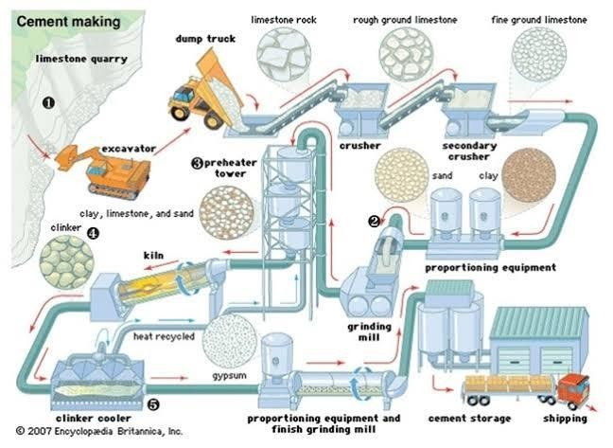

The lime stone Process is divided in to two major part namely;
- Limestone Mining process
- Cement Production

LIMESTONEMINING PROCESS
There are 5 processes involved in the mining of limestone from the quarry, which are:
  - Overburden
  - Drilling
  - Crushing
- OVERBURDEN: In mining, overburden (also called waste or spoil) is the material that lies above an area that lends itself to economical exploitation, such as rock, soil, and ecosystem that lies above the ore (limestone) body. Over burden is removed during surface mining, but is typically not contaminated with toxic components. It may also be used to restore an exhausted mining site.
- CRUSHING: Crushing is the largest process operation in mineral processing. The goal of this process is to produce or esor mineral fractions to be used as raw materials for industrial production. A crusher is used for the crushing process, which is a machine designed to reduce the size of the ore materials fed into it. The crushing process is divided into two stages which are; primary and secondary crushing.

- Primary crushing is the first stage of material reduction and can sometimes be the only stage needed to generate the desired product for the job. Depending on the setup, primary crushing will take the larger material that has been blasted, excavated, or reclaimed and process it through an impact or, jaw, or gyratory crusher to generate a specific range of product sizes needed for production.

- Secondary crushing is the second stage of material processing following its initial reduction. At this stage, the material will flow through perhaps a second impact or even a cone crusher, which is effective in breaking down the materials.

CEMENT PRODUCTION

The process for cement productionisdividedinto4stages and they are
  - Raw Mill
  - Kiln
  - Cement Mill
  - Parking
These stages are further explained using the images below:

    - The crushed limestone from the Jaw crusher is stacked through the Chev-con method in a continuous circular blending pile. The stacked limestone is reclaimed by a reclaimer and transported to raw mill hoppers.

ACCOUNTOF WORK DONEIN QUARRY LINKCONCEPT
The physical laboratory is where the quality check on the cement is being carried out before it’s been supplied to the customers. Tests on cement are carried out to check for the strength and quality of cement, cause it is important to check the quality of cement before using it. Various laboratory tests are conducted on the cement and they include:
- Fineness test.
- Consistency test.
- Setting time test.
- Crushing strength test.
- Soundness test.

FINESS TEST: To measure the size/fineness of cement particles. The fineness of cement is responsible for rate hydration, the heat of hydration, and rate of gain strength. More fine cement develops strength faster. Two methods can be used to get the fineness test of cement and they are:
- Sieveanalysis test
- Airperme ability test

Steps for the fineness test of cement
  - Take100mg (W1) cement on IS 90-micronsieve.
  - The sieving is done for at least 10 minutes
  - Weigh(W2)cement-retained onsevof90 micron
  - 𝐹𝑖𝑛𝑒𝑠𝑠𝑜𝑓𝑐𝑒𝑚𝑒𝑛𝑡=𝑊2×100 W1
  - For Ordinary Portland Cement (OPC), it should never be greater than 10%.

CONSISTENCY TEST: To measure the percentage (P) of water at which cement paste gives standard consistency.

Procedure
  - 400gm of cement is taken and mixed with percentage of water (25% to 35%)
  - The paste is then filled in vicat’s mould the whole assembly is then placed under the needle (10mm dia), which is allowed to free-fall on cement paste
  - The percentage at which plunger penetrates 33mmto35mmfromtopor5mm to 7mm from the bottom on the vic at is defined as standard percentage of water (P)

CHAPTER THREE

OBSERVATIONS
I saw the disparity between the school atmosphere and the labor market as a student and made the following observations:
    - I also noticed that safety was a top priority and that it could easily be seen as the major purpose of the entire company's workforce, not just the technicians. Safety equipment and instructions were always installed or made available in key locations across the organization, such as the mines, workshop, service desks, administrative offices, and receptions.
    - Another important quality was neatness. Technicians were always exhorted to be as neat as possible in their dressing and in carrying out their tasks, despite the fact that the work is often perceived as a dirty one. This was aided by providing rewards to technicians who could follow the guidelines to the letter.

TECHNICAL SKILLS AND PROFESSIONAL KNOWLEDGE GAINED
- Ability to carry out a research topic in my discipline.
- Ability to gain first-hand experience in mining.
- Ability to gain transferable skills which are communication ( verbal and listening skills), critical thinking ( problem-solving, analytical thinking, and teamwork which are all important skills needed in the workspace.
- Ability to operate the air hydraulic drilling machine.
- Ability to carry out and design correctly the type of drilling pattern needed to be drilled before blasting to ensure fragmentation.
- I learnt that every industrial practice and process is carried out in the agreement to a pre defined standard as this guarantees repeatability and reproducibility, consequently validating the outcome of the process and/or test results.
- My exposure to the auditing process of the organization allowed me to understand the relevance and importance of documentation of processes and results as it serves as a means of validation.
- The opportunity to apply the theoretical knowledge thought within the walls of the classroom was of utmost relevance. I was exposed to the practice background on mineral processing, destructive testing of materials, material selection, and other engineered materials mainly applicable in mineral processing industries. This opened a window of opportunities into the highly diversified field of metallurgy and materials engineering and left me with a range of options to pursue as a career.

PROBLEMS ENCOUNTERED DURING THE PROGRAM
Six months of industrial training at Pur chem Industries Limited (PIL) couldn't have gone any better despite the many challenges I faced during my programme as an industrial trainee. These challenges, if looked into and acted upon with possible solutions, would greatly improve this program. Some of these very glaring challenges are:
- Inability to secure a placement: This proved to be one of the greatest challenges I faced as companies I visited to submit my placement form were either ot accepting IT trainees or I had to know someone on the inside in other tofacilitateacceptanceor those who accepts for letters to be submitted never sent a reply across later on. This is one of the major causes for students not starting their industrial training at the speculated time.
- Remuneration: This was an equally daunting challenge as the company where I worked; QLINK Concept didn’t have any form of remuneration for their IT trainees. The financial burden was telling heavily on my pocket as transportation fare and feeding were my sole responsibilities.
- Restriction to certain areas of the company: Some areas were restricted, where I was a trainee was unable to enter and learn. This restriction was also a daunting problem I encountered during my training.
- Difficulty in operating machines: During the early month of my industrial training, it proved quite difficult to operate some machines like the air hydraulic crawler drilling machine. However, I became more acquainted with it through regularity at work and constant practice.

CHAPTER FOUR

CONCLUSION

The idea behind the Student Industrial Work Experience Scheme should be commended because it has afforded students like me the opportunity to apply our theoretical knowledge into real-life practical applications, equipping us with the technical know-how and required skills et to tackle the challenges in our respective fields as well as the opportunity to interact with experienced veterans in our various fields and learning from their experiences.
My six months industrial attachment as a materials engineering intern at Pure chem. Industries Limited was an enormous achievement and a great time of acquisition of knowledge and skills. Through my training, I was able to appreciate my course of study considerably more, because I had the opportunity to blend he theoretical knowledge acquired from school with the practical hands-on experience gained here to perform important tasks that contributed in a way to my productivity in the company. My training here has given me a more extensive view of the significance and relevance of Metallurgical and Materials Engineers in the immediate society and the world in general, as I now anticipate impacting it positively after graduation. In addition, I have been able to improve my communication and presentation skills and subsequently built a good relationship with my colleagues and supervisor at work. I have also been able to appreciate the connection between my course of study and other disciplines in producing a successful result.

RECOMMENDATION

The following recommendations were made regarding the SIWES scheme:
The portion of the ITF act which covers the employment of students by firms needs to be better implemented and strictly adhered to by companies. Ideally, companies shouldn't reject students requesting to do their SIWES with them, more so if the student's course of study is related to that firm, irrespective of whether the student's school and the company are in the same state or not. The implementation of this act should also include a form of punishment or fine for defaulting companies after proper inspection. Avenues should also be created through which students who are not treated right by the companies in which they work can air their views for appropriate discipline. When companies within the vicinity of a student employ him, it will also solve the problem of students having to go to long distances either when searching for IT placements or to work at far distances without pay, as it is known that some companies do not pay their IT students.
    - I would recommend the KWAPOLY Metallurgical and Materials Engineering department laboratory management to conduct an audit of its system to check its compliance to the standard requirement and that its students be exposed to the appropriate corresponding standards applicable to all test methods and procedures so as to meet industry standards.
    - The designated stipend for students participating in the SIWES program should be made available at the beginning of every month as this will essen the financial burden on the students. If possible, students
I implore all necessary authorities within the institution, industry, and relevant government agencies to vehemently pursue academic-industry
- partnership on various research agendas; this woulds pur innovation for technological development of the society.
- Finally, securing industrial attachment proved quite difficult for some students therefore, it would be of great advantage if the school could recommend students to preferred places of industrial attachment relevant to their course of study.

