
TECHNICAL REPORT
ON
STUDENT INDUSTRIAL WORK EXPERIENCE SCHEME (S.I.W.E.S)
HELD AT
TOPE ENGINEERING ENTERPRISES

WRITTEN BY
ABDULLAMIDI ABDULMALIK DAMILARE
MATRIC NO: ND/23/MEC/PT/0201

SUBMITTED TO:
DEPARTMENT OF MECHANICAL ENGINEERING.
INSTITUTE OF TECHNOLOGY (I.O.T) KWARA STATE POLYTECHNIC, ILORIN.

DEDICATION
I dedication this report first and foremost to Almighty Allah who made it possible for me to go through this SIWES program safely and soundly and who has been there from the beginning to this very point also for the opportunity given to me to be in Mechanical Engineering department of this citadel of learning and to complete my 4mouth SIWES.

TO GOD BE THE GLORY.

ACKNOWLEDGEMENT
I give glory to Almighty God that gave me the grace to be alive till today, to see end of my SIWES program and to write this report.
I express my profound gratitude to my department lecturers and my SIWES supervisor for the support towards the successful of the time used during my SIWES programme. I appreciate for their advice to me during SIWES programme. May almighty God bless you all (AMIN).
I also appreciate the effort of the staff of the attached company for the tremendous moral assistance throughout the period of my attachment and also my grateful lovely family MR. and MRS. Abdullamidi and my friends at the same attachment. May Almighty God bless them all and provides for Their needs.

TABLE OF CONTENT
Title page i
Dedication ii
Acknowledgement iii
TABLE OF CONTENT
CHAPTER ONE
1.0 Introduction
1.1 Definition of Siwes
1.2 Aim and Objective of Siwes
CHAPTER TWO
2.0 Brief History of the Organization
2.1 Unit of The Organization and their specification
CHAPTER THREE
DISCUSSION/RELEVANCE OF EXPERINCE GAINED TO STUDENT FIELD OF STUDY
3.0 Safety in the workshop
3.1 Definition of accident
3.2 Causes of accident in the workshop
3.3 Tools in the workshop
3.4 Type of tools and their uses
3.5 Maintenance of tools

CHAPTER FOUR
4.1 Lathe Machine and its Operation

4.2 Lathe Machine Operations:

4.3 Uses of Lathe Machine:

4.4 Welding

4.4.1 Types of Welding Operations:

4.5 How Welding is Carried Out:
4.6 Knurling Operation

4.6.1 Types of Knurling Patterns:

4.6.2 Uses of Knurling:

4.6.3 Advantages of Knurling:

4.6.4 Disadvantages of Knurling:
4.7 Chamfering Operation:

4.7.1 How Chamfering is Carried Out:

4.7.2 Uses of Chamfering:

4.7.3 Advantages of Chamfering:

4.7.4 Disadvantages of Chamfering:
CHAPTER FIVE
5.0 Conclusion
5.1 Recommendation

CHAPTER ONE
1.0 INTRODUCTION
This report covers all my experience in the Tope Engineering Enterprise. This was done within the period of four month August to December 2024.during the period I was familiar with many hand tools used in automobile which gives me the opportunity to know the operation of cars.
This kind of programmed is very good for the students of higher education. Also this will promote the technological development of our nation
1.1 DEFINITION OF SIWES
SIWES (student industrial work experience scheme) is a program designed by the school expose student to the practical aspect of his/her course of study. It involved the attachment of student to an organization in line with his/her respective course of study. This training is an essential component in the development of the practical and professional skills require of each student by their respective course of study and stand as aid to prospective employment.
As student of mechanical I have been able to do the most relevant and effective practical training and experience in a duration of four month.
1.2 AIM AND OBJECTIVE OF SIWES
- It expose student to the practical aspect of their course.
- It is use to prepare student for future employment.
- It helps the student to expose and to interact with people they don`t know.
- Expose student to work method and technique in handling equipment and machinery not available in their institution.

KPNDPT2024_1050 CHAPTER TWO
2.0 BRIEF HISTORY OF THE ORGANIZATION
Tope Engineering Enterprise is located at no 269 Sawmill Lagos Road, Ilorin kwara state
The organization was established in the year 1996 own by Engineer Temitope Olanrewaju
2.1 UNIT OF THE ORGANIZATION AND THEIR SPECIFICATION
i. Drilling operation
ii. Welding operation
iii. Threading operation
iv. Grinding operation
v. Chamfering operation

CHAPTER THREE
DISCUSSION/RELEVANCE OF EXPERINCE GAINED TO STUDENT FIELD OF STUDY
3.0 SAFETY IN THE WORKSHOP
Safety is the condition of being protected from or unlikely to cause danger, risk or injury. Safety can also be defined as the ability to manage the risk inherent to operation or related to the environment.
3.1 DEFINITION OF ACCIDENT
Accident is an unfortunate incident that happens unexpectedly, typically resulting in damage or injury. It can also be define as an event that happen by chance or that is without apparent or deliberate cause.
3.2 CAUSES OF ACCIDENT IN THE WORKSHOP
- Carelessness
- Managing machine that is already faulty
- Wearing of loose cloth or plating of long hair can cause accident in the workshop
3.3 TOOLS IN THE WORKSHOP
Tools are any physical item that can be used to achieve if the item is not consumed in the process. Tools that are used in particular field or activities may have different designation such as “instrument”, “utensils”, “implement”, “machine”. The set of tools needed to achieve a goal is called “equipment”. The knowledge of constructing obtaining and using tools is “technology”.
3.4 TYPE OF TOOLS AND THEIR USES
- SPANNER: it is also known as wrench. It is use for tighten and loosing of object like bolt and nut. It contains different sizes and shapes.
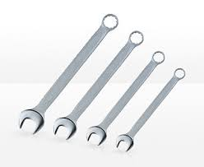
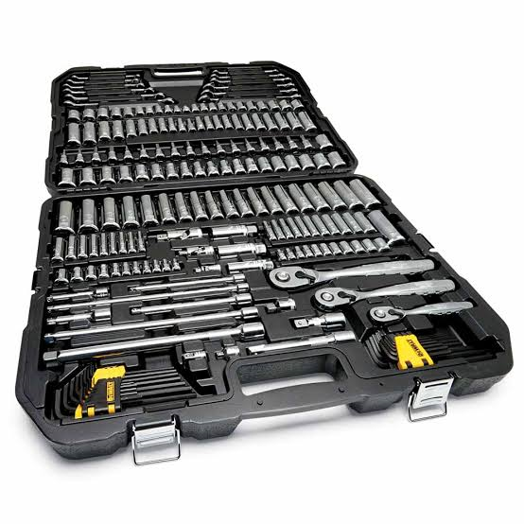
- SCREW DRIVER: it is use for the driving or moving screw. A screw driver gas handle and a shaft and a tip data user can insert into the screw head to turn it.
- Hammer: it is use for hitting hard object. It also use for driving chisel on hard object.
- WHEEL SPANNER: it is use for loosing and tightening of bolt and nut
- JACK: it is use for lifting up vehicles. There are different types of jack, triangle jack, pumping jack. Etc.
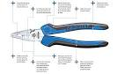
- PLIER: is a hand tool used to hold object firmly. It is develop from “tong” use in handling hot metals. There are different types of pliers for the different purpose. E.g. cutting pliers, slip joint pliers, locking and round nose pliers.

3.5 MAINTENANCE OF TOOLS
Maintenance is a systematic care and protection of tools equipment machines and vehicle in order to keep them safe, limit downtime and extend productivity.
- Always record when maintenance is conducted
- Always switch off machine when not in use order to increase its life spam
- Always clean up equipment when used and keep them in a safe place
- Always inspect the tool in order to know the one that are damage or defected.

CHAPTER FOUR
4.1 LATHE MACHINE AND ITS OPERATION
A lathe machine is a versatile and widely used machine tool in manufacturing that is primarily used to shape or machine workpieces made of metal, wood, plastic, or other materials. It operates by rotating the workpiece against a cutting tool, which removes material to create various shapes, such as cylindrical, conical, or flat surfaces.

4.2 Lathe Machine Operations:
- Turning: The most common operation performed on a lathe, where the cutting tool removes material from the workpiece to reduce its diameter and create a cylindrical shape. It can also be used for taper turning, which produces a conical shape.
- Facing: This operation involves cutting the workpiece along its face to create a flat surface. It is typically done at the ends of a workpiece.
- Drilling: A rotating drill bit is used to make holes in the workpiece, either along its center or at an angle.
- Boring: This operation is used to enlarge or finish an existing hole, often to a precise diameter.
- Thread Cutting: In this operation, a cutting tool is used to cut threads on the workpiece, either externally or internally. It can be used to make screws, bolts, and other threaded components.

4.3 Uses of Lathe Machine:
- Manufacturing of Cylindrical Parts: Lathe machines are commonly used to produce components with cylindrical shapes, such as shafts, pins, and sleeves.
- Automotive Industry: Lathes are used to manufacture engine components, transmission parts, and other essential automotive components.
- Aerospace Industry: Precision machining of components for aircraft, such as gears, shafts, and turbine blades, is often done using lathe machines.
- Tool and Die Making: Lathe machines are employed to create custom tools, molds, and dies used in the production of other parts.
- Home Appliances: Parts such as knobs, handles, and other components in household appliances are often produced on lathe machines.
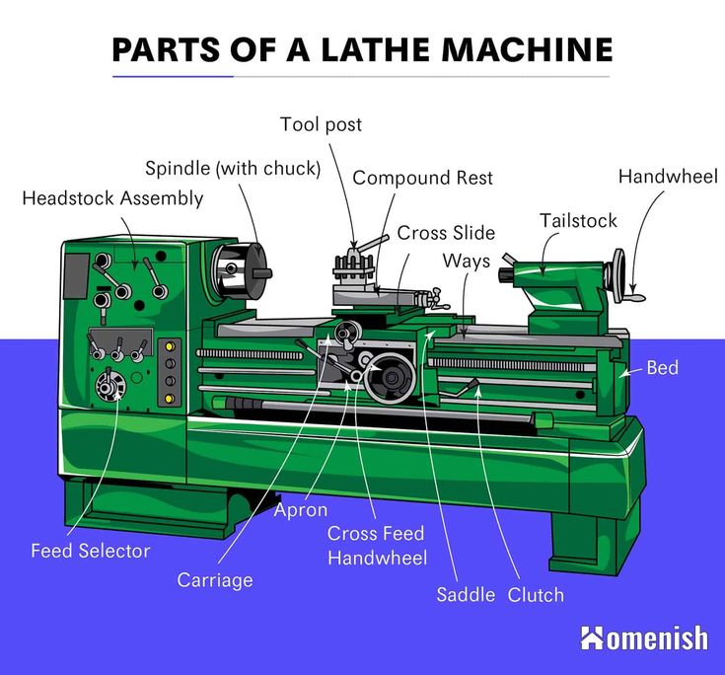

4.4 WELDING
Welding is a manufacturing process used to join two or more pieces of material, typically metals or thermoplastics, by applying heat, pressure, or both. The process melts the material at the joint to create a bond upon cooling. Welding is commonly used in construction, manufacturing, shipbuilding, automotive industries, and more.

4.4.1 Types of Welding Operations:
- Arc Welding:
  - Uses an electric arc to generate heat that melts the workpieces and the filler material to form a weld.
  - Process:
    - An electric arc is struck between an electrode (which may be consumable or non-consumable) and the workpiece.
    - The heat melts the edges of the materials being joined, and a filler metal is added to fill the joint.

- Resistance Welding:
  - Heat is generated by electrical resistance at the junction of the workpieces, typically used for spot welding and seam welding.
  - Process:
    - The workpieces are held together with pressure, and an electric current is passed through the joint.
    - The electrical resistance at the contact point causes heat to build up, melting the material at the contact point and forming the weld.
- Laser Welding:
  - Uses a high-powered laser beam to melt the materials at the joint.
  - Process:
    - A focused laser beam is directed at the workpieces, melting the material at the joining area.
    - The molten material solidifies to create a strong bond.
    - Laser welding is precise and is often used for delicate applications requiring high accuracy.
- Electron Beam Welding:
  - Uses a beam of high-energy electrons to melt the workpieces and form a weld.
  - Process:
    - The electron beam, generated in a vacuum, strikes the material, rapidly melting the joint.
    - This method is precise and is often used for applications requiring deep penetration and minimal heat-affected zones.

4.5 How Welding is Carried Out:
- Preparation:
  - Clean the surfaces of the materials to be welded to remove any contaminants (rust, oil, dirt).
  - Proper joint design is made to ensure adequate strength. Common joint types include butt, lap, edge, and corner joints.
- Set-up:
  - Select the welding equipment based on the type of welding to be used.
  - For electric welding, set up the power source, select the correct electrode or filler material, and adjust the settings (voltage, current).
  - For gas welding, set up the oxygen and fuel gas cylinders and adjust the flame.
- Welding Process:
  - Position the pieces to be welded and secure them using clamps or fixtures.
  - Strike the arc or ignite the flame to start the welding process.
  - Move the welding torch or electrode along the joint while maintaining the correct speed and angle to form a uniform weld bead.
  - If necessary, add filler material to ensure the joint is filled and the weld is strong.
- Cooling and Inspection:
  - Allow the weld to cool naturally or use a controlled cooling method to avoid defects.
  - Inspect the weld for quality, checking for any cracks, porosity, or other defects that may weaken the bond.

Welding Safety Measures:
- Wear Protective Gear: Always wear welding gloves, safety goggles, a helmet with a face shield, and flame-resistant clothing.
- Ventilation: Ensure proper ventilation to avoid inhaling harmful fumes produced during welding.
- Fire Safety: Keep a fire extinguisher nearby, as welding can create sparks that may cause fires.

Uses of Welding:
- Construction: Joining structural components like beams, columns, and trusses in buildings, bridges, and towers.
- Automotive Industry: Manufacturing car bodies, frames, and parts.
- Manufacturing: Creating machinery, pipes, and heavy equipment.
- Repair and Maintenance: Fixing damaged metal parts or machinery.
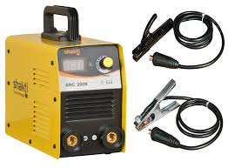
4.6 KNURLING OPERATION:
Knurling is a machining process that creates a textured pattern (usually in the form of ridges, grooves, or diamonds) on a workpiece. It is primarily carried out on a lathe machine or turning machine using a specialized knurling tool. The tool rolls over the surface of the rotating workpiece, pressing the material into the desired pattern.

Steps Involved in the Knurling Operation:
- Preparation:
  - Workpiece Setup: The workpiece is mounted on the lathe and secured firmly in place.
  - Tool Setup: The knurling tool (which contains rollers with patterns) is installed into the tool holder of the lathe. The knurling tool has multiple rollers that have sharp edges to press and shape the material.
- Selection of Knurling Pattern:
  - The desired pattern is chosen depending on the application (straight, diamond, or cross-pattern). The pattern of the knurl affects both functionality and appearance.

- Tool Feed:
  - The knurling tool is moved into contact with the rotating workpiece, and a specified force is applied. The rollers press against the surface of the workpiece, creating the textured pattern.
  - The tool is fed along the length of the workpiece to form the pattern uniformly over the desired area.
- Cutting Pressure:
  - The operation requires careful feed rate and pressure to ensure the material is displaced and formed into the knurl pattern without excessive deformation or tool wear.
- Coolant:
  - In some cases, lubrication or cutting fluid is used to reduce friction and heat generation during the operation.

4.6.1 Types of Knurling Patterns:
- Straight Knurling:
  - The grooves are straight and parallel to each other. This is the most common pattern and is widely used for applications where a simple texture is sufficient.
- Diamond Knurling:
  - The grooves form a diamond-shaped pattern. This is the most commonly used pattern for parts where a good grip is needed, such as on handles and knobs.
- Cross Knurling:
  - A combination of two intersecting knurling patterns. This creates a more complex texture and can be used for improved grip or aesthetic purposes.

4.6.2 Uses of Knurling:
- Improved Grip:
  - Handles and Knobs: Knurling is widely used on tool handles, knobs, or any cylindrical object where grip is essential. The textured surface improves the user's ability to hold or turn the object.
- Screws and Fasteners: Knurling is often applied to screws or bolts, making it easier to grip and tighten them manually.

- Aesthetic and Decorative Effects:
  - Knurling adds a distinct pattern to parts, often used for decorative purposes in products like jewelry, switches, and knobs, making them more attractive or visually appealing.
- Wear Resistance:
  - Knurling increases the surface area of parts, which can help reduce wear in applications where parts are subjected to friction, such as shafts, pins, or mechanical components.
- Cylindrical Parts:
  - Knurling is most effective on cylindrical or rotary parts. It is used on shafts, axles, and pins to improve handling or for functional reasons (such as preventing slippage in rotating components).
- Marking or Identification:
  - Knurling can also be used to mark parts for identification, as the textured pattern helps with labeling or distinguishing between different parts.
- Precision Mechanical Components:
  - In some applications, knurling is used for precision mechanical parts that require a textured surface for further assembly or functionality, such as coupling devices and alignment features.

4.6.3 Advantages of Knurling:
- Improved Grip: Provides a non-slip surface for tools, fasteners, and parts that require manual handling.
- No Need for Additional Material: Knurling is a cold-working process, meaning material is displaced from the surface rather than added, which is efficient.

4.6.4 Disadvantages of Knurling:
- Limited to Cylindrical Workpieces: Knurling is primarily used for cylindrical parts, as the tool relies on the rotation of the workpiece.
- Not Suitable for Thin-Walled Parts: The process can cause deformation or damage to thin-walled materials, especially if the pressure is too high.
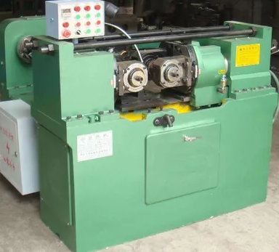

4.7 Chamfering Operation:
Chamfering is a machining operation used to remove the sharp edges or corners of a workpiece to create a beveled edge, typically at a 45° angle to the adjacent surfaces. The purpose of chamfering is to remove sharp edges, which can be dangerous, improve the appearance of a part, and facilitate assembly by allowing easier insertion of parts into fittings. Chamfering can be done using various tools, including lathes, milling machines, or hand tools, depending on the size, shape, and complexity of the workpiece.

4.7.1 How Chamfering is Carried Out:
- Workpiece Setup:
  - The workpiece is securely fixed in a machine like a lathe or a milling machine.
  - For milling, a milling cutter or end mill can be used. For turning operations, a chamfer tool is attached to the lathe.
- Tool Selection:
  - A chamfering tool is selected based on the type of workpiece, material, and desired chamfer angle.
  - The chamfering tool can be a single-point cutter, end mill, or a specially designed chamfering tool, depending on the operation.
- Setting the Angle:
  - The angle of the chamfer is set, typically at 45° (but other angles, such as 30° or 60°, are also common depending on the requirement).
  - The tool is then positioned to cut away the sharp edge of the workpiece at the designated angle.
- Cutting Process:
  - The cutting tool is brought into contact with the edge of the workpiece.
  - The machine moves the tool along the edge to remove material and create the beveled surface. In some cases, the tool moves along a specific path to chamfer multiple edges simultaneously.
- Inspection:
  - After chamfering, the workpiece is inspected for dimensional accuracy and surface finish. The chamfer angle, depth, and smoothness are checked to ensure they meet the required specifications.

4.7.2 Uses of Chamfering:
- Edge Safety:
  - Chamfering removes sharp edges and corners that could cause injury during handling or assembly. This is especially important in industries where parts are handled frequently (e.g., automotive, aerospace, or manufacturing).
- Improved Assembly:
  - Chamfering helps parts fit together easily. For example, chamfered edges allow smoother insertion of bolts into holes, reducing friction and easing the alignment of parts in assembly.
- Thread Preparation:
  - In applications where threads are involved, chamfering is used to prepare the edge of a hole for threading, ensuring that the threads start cleanly and without damage. It helps reduce stress concentrations at the edge of threaded parts.

4.7.3 Advantages of Chamfering:
- Enhanced Safety: Removing sharp edges reduces the risk of injury.
- Improved Fit and Functionality: Makes assembly easier by ensuring parts fit properly.
- Aesthetic Appeal: Chamfered edges can give parts a more polished, professional look.

4.7.4 Disadvantages of Chamfering:
- Tool Wear: Chamfering tools can wear out over time, especially when used on harder materials.
- Additional Operation: Chamfering adds an extra step to the manufacturing process, which can increase production time and costs.
- Material Removal: Some material is removed during chamfering, which may not be desirable in some cases, especially if precision or minimal material loss is required.
CHAPTER FIVE
5.0 CONCLUSION
The student industrial work experience scheme known as SIWES is an important program that makes the student to learn more practical in their various courses or their field of study. In this regards, it gives students the opportunity for looking around their place of attachment for themselves.
5.1 RECOMMENDATION
So far the aim of the program is to equip undergraduates therefore; student are to be given their attachment form to fill, specially areas and ITF being given the power to determine each student’s placement. Also to the federal government of Nigeria should make it a point of duty for industries to train undergraduate and specify the number of students to be trained in each industry in all full academic calendars.

