

KWARA STATE POLYTECHNIC, ILORIN
INSTITUTE OF TECHNOLOGY
AGRICULTURAL AND BIO-ENVIRONMENTAL ENGINEERING DEPARTMENT

A TECHNICAL REPORT ON
STUDENTS INDUSTRIAL WORK EXPERIENCE SCHEM (SIWES)
BY

ADEKUNLE AL-AMEEN BABATUNDE ND/23/ABE/FT/0002
Agricultural And Bio-Environmental Engineering Technology, Institute of Technology, Kwara State Polytechnic, Ilorin
HELD AT

KWARA STATE MINISTRY OF AGRICULTURAL AND RURAL DEVELOPMENT
P.M.B 1386, OLD JEBBA ROAD, ILORIN, KWARA STATE.

BEING A REPORT SUBMITTED TO THE SIWES UNIT,

INSTITUTE OF TECHNOLOGY CHAPTER, KWARA STATE POLYTECHNIC, ILORIN
IN PARTIAL FULFILLMENT FOR THE REQUIREMENT FOR THE STUDENT INDUSTRIAL WORK EXPERIENCE SCHEME (SIWES)

NOVEMBER, 2024

DEDICATION
This report is dedicated to God Almighty, my family, whose support was unwavering, and to the resilience within me, which has propelled me to successfully complete this Student industrial work experience through my own determination, hard work, and perseverance.

ABSTRACT
This report is based on Student Industrial Work Experience Scheme (SIWES) held at KWARA STATE MINISTRY OF AGRICULTURAL AND RURAL DEVELOPMENT,
ILORIN. P.M.B 1386, Old Jebba Road, Ilorin, Kwara State. it gives brief explanation about the SIWES program vis-à-vis its history, objectives and aims, while also provides a brief description, roles and functions of KWARA STATE MINISTRY OF AGRICULTURAL AND RURAL DEVELOPMENT, Ilorin. It further focuses more on the technical exposure and experience gained from the engineering Department of the Ministry to be specific. It finally gives an account of the equipments used, types and their function respectively as well as some of the problems and challenges faced and provide recommendations that can further improve the program.

ACKNOWLEDGEMENT
I would like to thank the Almighty God, my strong pillar, my source of inspiration, wisdom, knowledge and understanding. he has been source of my strength, commitment and patience to pass various obstacles throughout this program also, my profound gratitude goes to the Kwara State Polytechnic Management for including the Student Industrial Workshop Experience Scheme (SIWES) to the National Diploma Programme which enable me to learn and gain more experience outside the campus.
Also, I will like to say a big thank you to the management of Kwara State Ministry of Agricultural and Rural Development, Ilorin for giving me the opportunity to be trained under an organization of high status.
I would not end this acknowledgment without appreciating my parents for their unwavering support, co-operation, encouragement and understanding throughout the duration of the SIWES programme.

DECLARATION

I hereby declare that, I from Agricultural and Bio-Environment Engineering

Technology Department, Institute of Technology, Kwara State Polytechnic, Ilorin. underwent the four months students industrial work experience scheme
(SIWES) at MINISTRY OF AGRICULTURAL AND RURAL

DEVELOPMENT, ILORIN. P.M.B 1386, Old Jebba Road, Ilorin, Kwara State.from 5th August to 30th November, 2024.
I also declare that to the best of my knowledge, all sources of knowledge used have been duly acknowledged.

ADEKUNLE AL-AMEEN BABATUNDE

ND/23/ABE/FT/0002

 | TABLE OF CONTENT
Dedication |  | 3
Abstract |  | 4
Acknowledgement |  | 5
Declaration |  | 6
Table of content |  | 7

CHAPTER ONE
  - Introduction of SIWES 1
  - History of SIWES 1- 2
  - Operator of SIWES 2
  - Objective OF SIWES 3
CHAPTER TWO
  - Description of the establishment of attachment 4
  - Organization Structures 4
CHAPTER THREE
  - Necessary requirement for working in the workshop 5
  - Guide lines for safety in the workshop 5- 6

  - Important signs/labels and their meaning 6

CHAPTER FOUR
  - Acquired skills and areas of exposure 7

  - Farm layout practical 7

    - Purpose of farm layout 7

    - Specific observation 7

    - Impact of the practical 8

  - Land survey using leveling compass 8

    - Tools used 8

  - Irrigation and Drainage 9

    - Types of Irrigation 9

    - Components and Materials 9

  - Tractor 10

    - Tractor components 10- 11

    - Farm implements mounted to the tractor 11

    - General Maintenance 12

  - Repair of Disc Arrow 12

    - My Participation 12
  - Observation and participation in rice processing 13
  - Skills acquired 14
  - Challenges Faced 14
CHAPTER FIVE

5.0 | Summary | 15
5.1 | Conclusion | 15

CHAPTER ONE

  - INTRODUCTION TO SIWES
Students Industrial works experience scheme (SIWES) skill acquisition programme was introduced by the Federal Government of Nigeria to expose undergraduate in Engineering, Technology and Sciences of Tertiary Institutions (University, Polytechnics, Mono-technics and Colleges of Education) to industrial environment so as to acquire basic skills existing in their respective disciplines to smoothen their entry into industrial practices on completion of their studies and also reduce periods spent in training fresh graduates as new employees. It was first initiated and funded by industrial training fund (ITF) during the formative years 1973/1974.
The scheme forms part of the approved Minimum Academic Standards (MAS) in the various Degree programmes for all Nigeria universities. It is an effort to bridge the gap existing between theory and practice of engineering and technology, science, agriculture, medical, management and other professional educational programmes in the Nigeria Tertiary Institution. The programme mediate exposing students to design and construction of machines and equipment, professional work method and ways of safe-guarding the work area and workers in industries and organizations.

HISTORY OF SIWES
SIWES (Student Industrial Working Experience Scheme) was established by ITF in1973 to solve the problem of lack of adequate practical skills preparatory for employment in industries by Nigerian graduates of tertiary institutions.
The Scheme exposes students to industry based skills necessary for a smooth transition from the classroom to the world of work. It affords students of tertiary institutions the opportunity of being familiarized and exposed to the needed experience in handling machinery and equipment which are usually not available in the educational institutions. Participation in Industrial Training is a well- known educational strategy. Classroom studies are integrated with learning through hands on work experiences in a field related to the student’s academic major and career goals. It also expose the student to the practical aspect of some course being offer in the school.

Successful internships foster an experiential learning process that not only promotes career preparation but provides opportunities for learners to develop skills necessary to become leaders in their chosen professions.

OPERATORS OF SIWES
Operators – The ITF, the coordinating agencies (NUC, NCCE, NBTE), employers of labor and the institutions.
Funding – The Federal Government of Nigeria
Beneficiaries – Undergraduate students of the following: Agriculture, Engineering, Technology, Environmental, Science, Education, Medical Science and Pure and Applied Sciences.
Duration – Four months for Colleges of Education and Polytechnics, and Six months for the Universities
HAPTER TWO

DESCRIPTION OF THE ESTABLISHMENT OF ATTACHMENT

The four months Industrial training program was carried out at Kwara State Ministry of Agricultural and Rural Development (Agricultural Engineering Department). The
establishment take operation on Irrigation and Drainage, Crop processing, Survey, Land Clearing and Land Forming, Lease of machinery, with repair/maintenance of farm machinery and implement. These operations are carried out within the premises and on farm sites, emphasizing efficiency, sustainability, and support for the agricultural community. The department's integrated approach to agricultural engineering plays a critical role in enhancing productivity and fostering rural development.

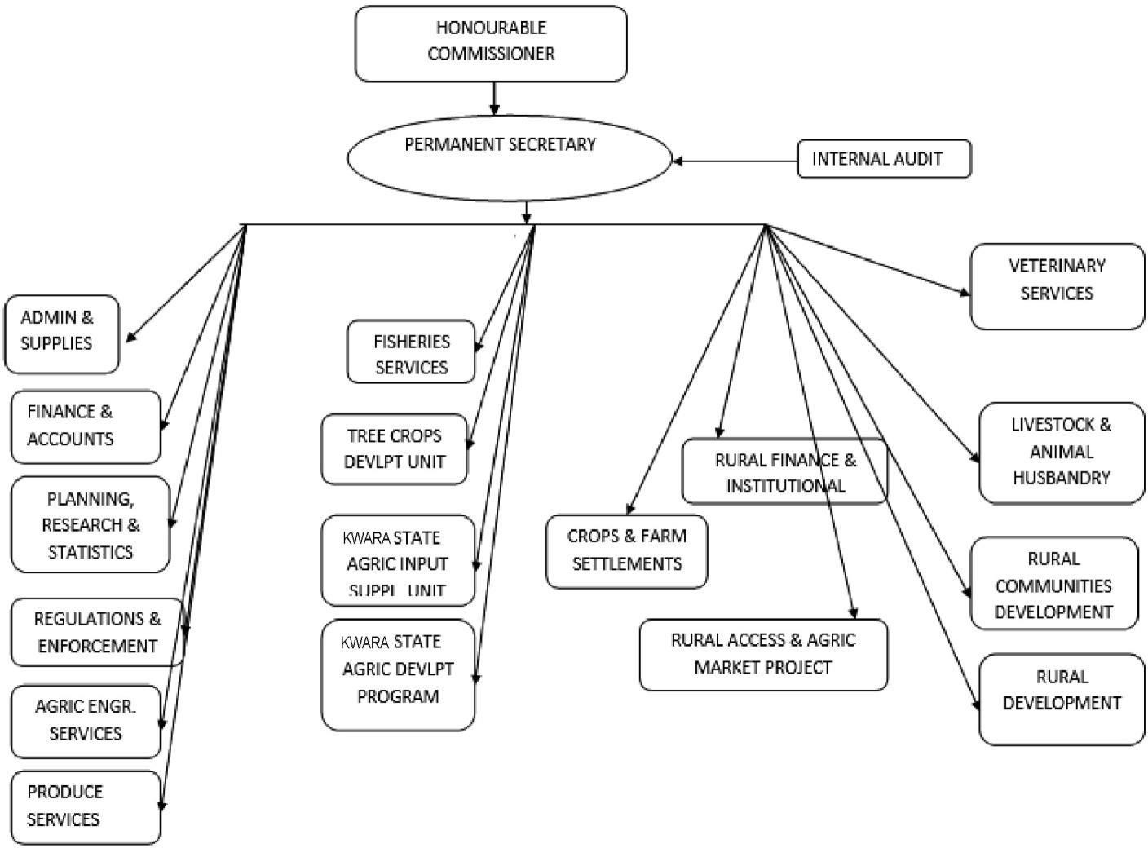
ORGANIZATION STRUCTURES

CHAPTER THREE SAFETY REGULATION

NECESSARY REQUIREMENT FOR WORKING IN THE WORKSHOP
- The ability to learn specific, practical techniques and apply this knowledge to solve technical problems.
- Good coordination and the ability to use equipment with accuracy;
- Flexibility in the work with and provision of support for other
people.

iv. Necessary qualification with practical knowledge to be able to keep records of the task performed.
vi. Excellent oral communication skills in order to work effectively with colleagues from all parts of the organization and to explain complex techniques to interested parties.

GUIDE LINES FOR SAFETY IN THE WORKSHOP
Safety is the state of being ‘safe’, the condition of being protected from any physical or electrical and other types of consequence, failure, damage, error, accident or any other event that could be considered non-desirable. For anyone working in workshop, safety should be his/her first priority. Some guide lines for safety in the workshop.
i. Qualified or suitable trained personnel only to use equipment. ii. Wear suitable attire for operating machinery or equipment.
iii. Keep equipment and the surrounding area clean and tidy at all times. iv.

Always seek instruction before using an unfamiliar piece of equipment.

- Only use tools and machines for their intended purpose.

- Report any damaged equipment and do not use it until it has been repaired by a qualified person.
- Where machine guards are provided they must be kept in place.
- Never distract the attention of another staff member when operating equipment and never indulge in horseplay.
- Always use the appropriate personal protective equipment.

- Long hair must be restrained.

- Familiarize oneself with all ON/OFF buttons on equipment, circuit breakers, and disconnect switches of a bench.
- Avoid loose wires, cables, and connections. xiii. Assume any exposed metal is live with electricity unless otherwise verified.

IMPORTANT SIGNS/LABELS AND THEIR MEANING
In every workshop, safety is essential; luckily enough, there are danger signs on any product which are classified as harmful. These signs help to warn the workers/students of the possible danger or hazard in the workshop.
Some of the signs are:
    - Electric Shock;- can be found on a machine with electrical connections ii. General warning:- This warning signs are usually used to indicate danger ahead.

CHAPTER FOUR
  - ACQUIRED SKILLS AND AREAS OF EXPOSURE
During my Student Industrial Work Experience Scheme (SIWES), I acquired various technical skills and was exposed to a range of practical applications and engineering concepts.
These experiences are summarized as follows:

FARM LAYOUT PRACTICAL

During the practical session, I learned the principles of farm layout, which involves systematically arranging farm components like farmland, irrigation channels, pathways, and storage areas to optimize efficiency and productivity. The Activities involved analyzing land topography, identifying essential components, and designing layout plans with considerations for drainage, accessibility, and crop spacing. Tools such as measuring tapes, pegs, and ropes were used to mark boundaries and plan arrangements.

PURPOSE OF FARM LAYOUT

The purpose of the farm layout is to maximize land use, improve irrigation efficiency, and separate various farm activities for better organization and management. We explored different types of layouts, including block layout and strip layout, and their applications in real-world farming.

SPECIFIC OBSERVATION
One of my key observations was how proper drainage systems prevent waterlogging and improve soil health. I also noticed that aligning pathways with the natural slope of the land reduces erosion and simplifies transportation. During the practical, I suggested positioning the storage area closer to the access road to enhance operational efficiency.

IMPACT OF THE PRACTICAL

This session highlighted the importance of proper planning in ensuring sustainable and efficient farm operations. It provided hands-on experience in designing layouts that balance productivity and environmental sustainability.
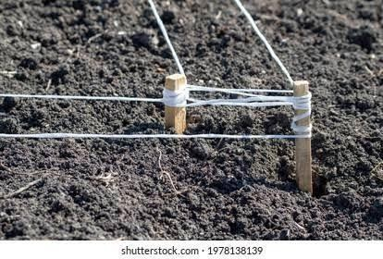

PEGS AND ROPE

MEASURING TAPE
Measuring tapes, pegs, and ropes were used to mark boundaries and plan arrangements.

LAND SURVEY USING LEVELING COMPASS

I participated in land surveying using a leveling compass. This activity involved marking contours, identifying high and low areas, and preparing the land for effective irrigation and drainage systems.
  - TRACTOR:

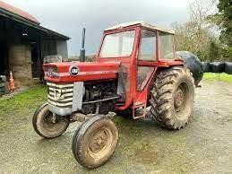
A tractor is a powerful and versatile machine primarily used in agricultural, construction, and industrial applications. It is engineered to provide high torque at low speeds, making it capable of performing a variety of tasks such as plowing, tilling, planting, and transporting heavy loads.

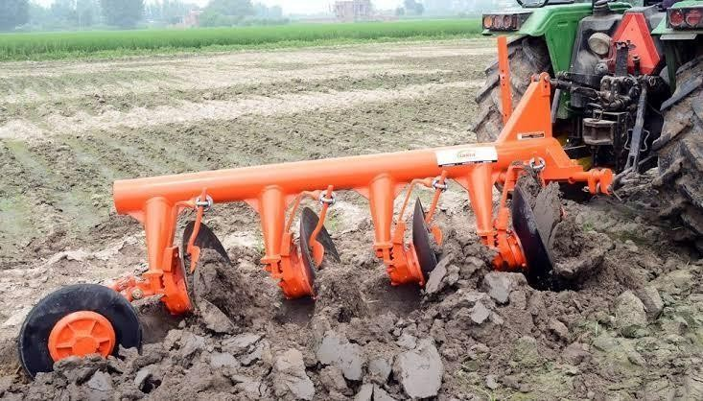

DICS PLOUGH MOUNTED TO A TRACTOR

    - GENERAL MAINTENANCE
      - Tighten loose screws and bolts.
      - Regularly clean the tractor to prevent rusting.
      - Store in a covered area to protect from weather elements.

REPAIR OF DISC HARROW

I participated in a practical session focused on repairing a disc harrow, a crucial implement used in agricultural operations for soil preparation. The session began with an introduction to the components of the disc harrow, including the disc blades, frame, bearings, and axles.

MY PARTICIPATION

      - Inspection: I assisted in examining the disc harrow for damages, identifying worn-out disc blades, loose bolts, and malfunctioning bearings.
      - Dismantling: I participated in dismantling the damaged parts, using tools such as spanners, hammers, and wrenches.
      - Replacement and Repair: I helped replace worn-out blades and lubricated the bearings to ensure smooth rotation.
      - Reassembly: After repairs, I was involved in reassembling the parts, ensuring proper alignment and tightening of bolts.
      - Testing: The repaired harrow was tested to confirm its functionality, and I contributed to making adjustments for optimal performance.
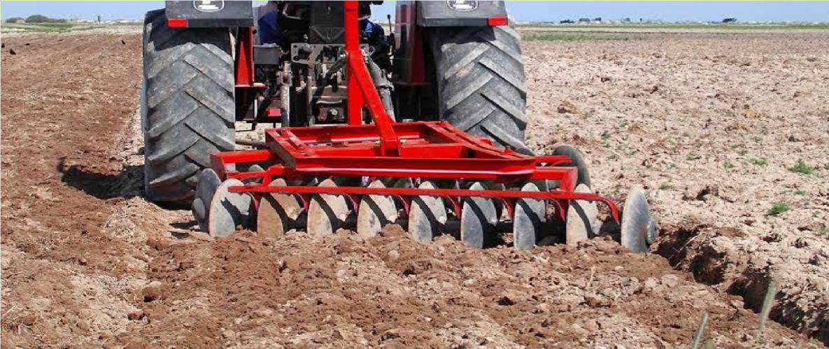

THE DISC HARROW WORKING PERFECTLY AFTER THE REPAIR

OBSERVATION AND PARTICIPATION IN RICE PROCESSING

As part of my SIWES training, I participated in a practical session on rice processing. During the operation, I carefully observed the functioning of the processing machine, which included de-husking, polishing, and grading stages. I monitored the machine’s performance to understand how each component contributed to producing high-quality rice.
After observing the operation, I actively participated in bagging the processed rice. I ensured that the rice was accurately measured and packaged into bags of the proper kilogram specification, maintaining precision and adherence to quality standards.

This activity provided me with valuable insights into rice processing techniques and allowed me to develop skills in quality control and packaging, which are essential in post-harvest agricultural operations.
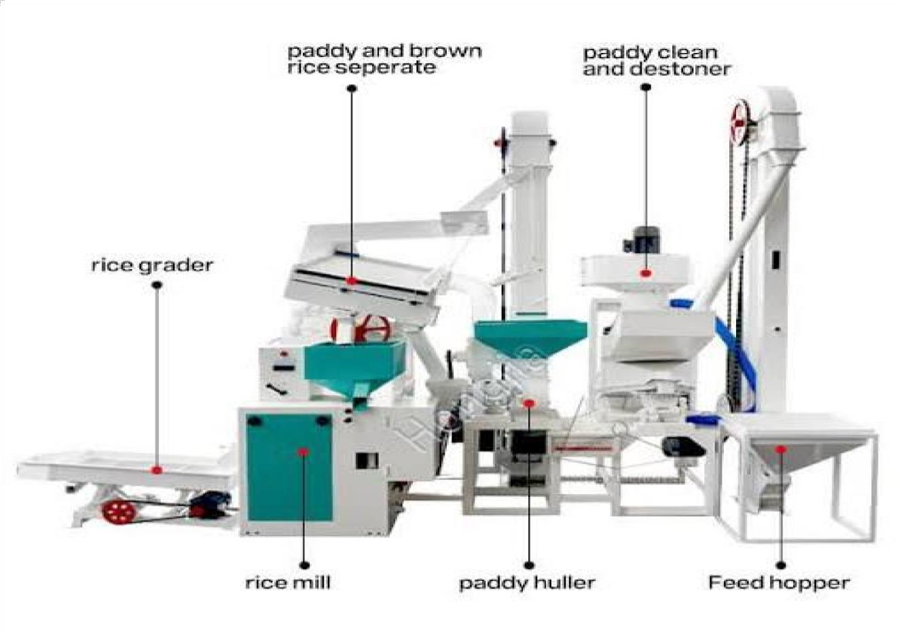

RICE PROCESSING MACHINE

SKILLS ACQUIRED
- Knowledge of mechanized farming operations and implement handling.
- Proficiency in using land survey instruments.
- Understanding of tractor functionality and maintenance.
- Practical experience in irrigation system design and implementation.

CHALLENGES FACED

- Limited access to advanced land survey tools.
- Mechanical breakdowns during tillage operations.
- Difficulty in sourcing spare parts for bulldozer maintenance.

CHAPTER FIVE SUMMARY AND CONCLUSION
  - SUMMARY

In summary, the student industrial work experience scheme (SIWES) has been carried out and it can be categorically said that objectives of the scheme has been achieved. It has exposed me to the four major units of a standard institutional Agricultural and Bio-environmental Engineering work experience (Farm Power and Machinery, Irrigation and Drainage, crop processing and farm storage structure).
The safety rules and regulations, operational guideline of some basic equipment in the workshop house were also exposed. In general, practical exposures to base engineering practicals have been learnt.

CONCLUSION

The Industrial Training Programme as its been designed has actually fulfilled its purpose by exposing undergraduate students of Engineering to industrial environment, use of tools, and equipments, practical knowledge and application of safety measure to life and properties.

