
A
TECHNICAL REPORT
ON
STUDENT INDUSTRIAL WORK EXPERIENCED SCHEME
(SIWES)

HELD AT

Manhardi Nigeria Limited

PRESENTED BY
JEREGA BITRUS PROSPER
ND/23/MPE/PT/0009

SUBMITED TO:
THE DEPARTMENT OF MINIRALS AND PETROLEUM RESOURCES
INSTITUTE OF TECHNOLOGY
KWARA STATE POLYTECHNIC, ILORIN.
IN PARTIAL FULFILMENT OF AWARD ON NATIONAL DIPLOMA.

2023/2024 SESSION

DEDICATION
This technical report is dedicated to the Almighty Allah who gave me the life, strength, ability to acquire the knowledge and practical experience for the period of my attachment of my SIWES on my field of study.

ACKNOWLEGEMENT
I’m indebted to several people who at various stages contributed towards making this industrial training programme a success. My special thanks first and foremost goes to Almighty God for the grace and enablement He gave to me during the period of my attachment and during the period of writing this technical report.
I also wish to appreciate my parent in persons of Mr. and Mrs. JEREGA who has helped me in all aspect of my life. You will reap the fruit of your labour. Thank you

PREFACE
This student industrial work experience scheme (SIWES) is purposely design to enhance student in Educational development and also in subject in gaining more experience in filled of study throughout development and industrial training for the four month attachment programme.

TABLE OF CONTENTS
Title Page
Dedication
Acknowledgement
CHAPTER ONE
1.0 Introduction
1.1 Nature and Scope of Siwes
1.2 Goals and objectives of Siwes
CHAPTER TWO
2.0 History of Manhandi Nigeria Limited 2.1 Organogram of Manhandi Nigeria Limited 2.2 Function of each unit
CHAPTER THREE
3.1 Activities done at manhardi Nigeria Limited
3.2 Quarry product and supply
3.3 The Upstream
3.4 Drilling
3.5 Blasting
CHAPTER FOUR
4.1 The downstream section
4.2 Work Shop
4.3 Experience Gained

CHAPTER FIVE
5.1 Summary
5.2 Conclusion
5.2 Recommendation

CHAPTER ONE
INTRODUCTION OF STUDENT INDUSTRIAL WORK EXPERIENCE SCHEME (SIWES)
The student work experience scheme programme prepares students for the labour market. It has been established to widen up the student’s mind on the practical aspects of his career. It has become an innovative programme in human resources development and training in Nigeria.
The contemporary environment indication expressed the need to educate and train students as suitable professional to acquire adequate skills and training in the appropriate.
NATURE AND SCOPE OF SIWES
Practical knowledge is putting into action of knowledge derived from learning. It is referred to as doing according to learning. It involves the use of equipments needed to perform a task that is related to a field study. For instance, journalist needs equipment like pen, jotter, midget camera e.t.c to perform his duty.
Progress cannot be attained in a country if the youths are not encouraged to acquire necessary practical skill which will assist in the development of industrialization to meet the need of the society. With this knowledge, SIWES was introduced in Nigeria tertiary institution.
SIWES is a skill development programme designed to prepared students for universities polytechnic, monotechnics and college of education for transition from the school environment to the practical work. This work experience programme gives the student the opportunity to relate with professional in the field.
It is a course mandatory for students studying pure sciences, engineering, vocational technologies and related courses.
SIWES forms part of the approved minimum academic standards in the institutions. It is a core academic requirement carrying four (4) credit unit.

GOALS AND OBJECTIVE OF SIWES
Specially, the major objective of SIWES is to provide an avenue for students in the institutions acquire industrial skills and experience in their course of study.
However, its aims are highlighted below
- To prepare student for the industrial work situations they are likely to face after graduation.
- It affords students the opportunity of a familiarizing and exposing themselves to the needed experience in handling equipment and machines that are usually not available in the institution.
- To provide students with the chance if applying their knowledge in a real work situation thereby birding the gap between theory and practical.
- To enlist educational process and prepared student for employment opportunities in the organization.
- To make transition from the school to the world of world easier and enhance student contact for later job placement.

CHAPTER TWO
2.0 Description of the establishment of attachment
2.1 brief history of the establishment of the attachment
Manhardi Nigeria Limited: the head office located at no 10 raldio kwara raod Ilorin, Kwara State. The quarry site is at kangile viallge, Ilorin, Kwara state.
History of the establishment
The company was establish in 2010 by the Chinese people with the aim of producing and supply. The company was establish in 2010 by the Chinese people with the aim of producing and supplying of granite to Nigerians and also provide jobs for many Nigerians.
2.2 organization structure
Managing Director

Manager
Engineer

Assistance
Manager
staffs
Departments

2.3 Various departments/ units in the establishment and their function
- Mining Egineering units
- Mechanical engineering unit
- Electrical enginnering unit
- Driving unit
- Crusher operating unit
- Drilling unit
- Welding unit.
CHAPTER THREE
3.0 Activities done at manhardi Nigeria Limited
3.1 Quarry product and supply
There are two sections in the quarry which are upstream and downstream

THE UPSTREAM

Upstream (pit): Upstream Processes in Quarry Operations
Quarrying is the process of extracting rock, sand, gravel, or other minerals from the earth to be used in construction and industrial applications. The quarrying process is typically divided into upstream, downstream operations. Upstream activities refer to the initial stages of quarrying, which involve removing of overburden, Drilling process, blasting and loading and haulaging.
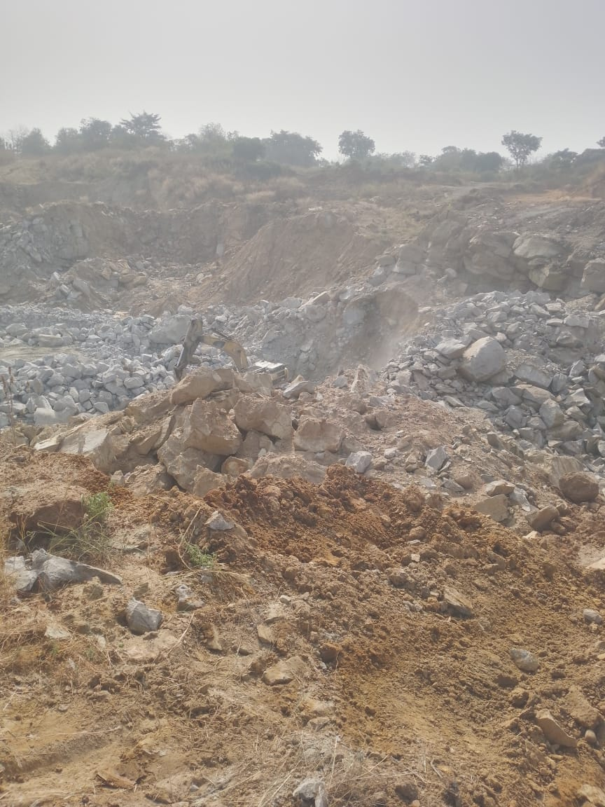
In upstream section, the first activities
- Removing of overburden
Overburden refers to the layer of soil, vegetation, and loose rock that covers valuable mineral deposits in a quarry. Before extraction can begin, this material must be removed to expose the underlying stone or minerals. The removal process starts with a site assessment to determine the thickness and composition of the overburden. Excavators, bulldozers, and scrapers are commonly used to strip away this material efficiently. In cases where the overburden is too compact or rocky, controlled blasting may be required to break it apart. Once removed, the overburden is either stockpiled for later use, such as land reclamation, or transported away if it lacks economic value. Proper disposal and management are crucial to minimize environmental impact and ensure the stability of the quarry site. Additionally, careful removal helps prevent contamination of the extracted materials and improves operational efficiency by providing clear access to the mineral deposit.
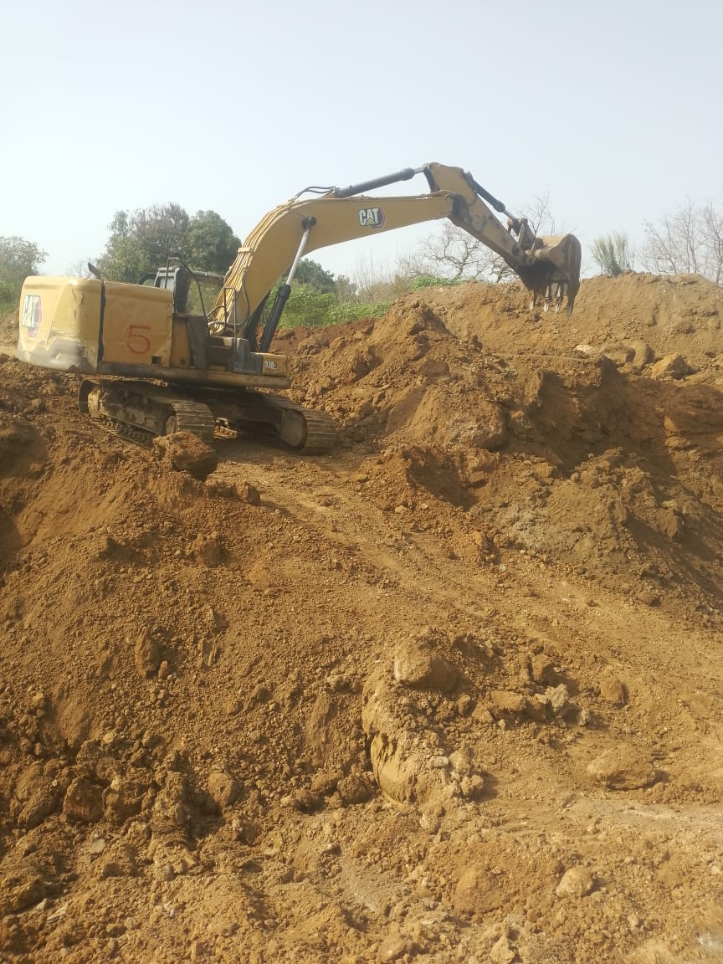
- Drilling process:
Drilling is a crucial step in the quarrying process, as it prepares the site for blasting and rock extraction. The process begins with careful planning and surveying to determine the optimal drill hole locations based on the type of rock and the desired fragmentation size. Specialized drilling rigs equipped with powerful drill bits are used to bore holes into the rock formation. The depth, diameter, and spacing of these holes depend on factors such as rock
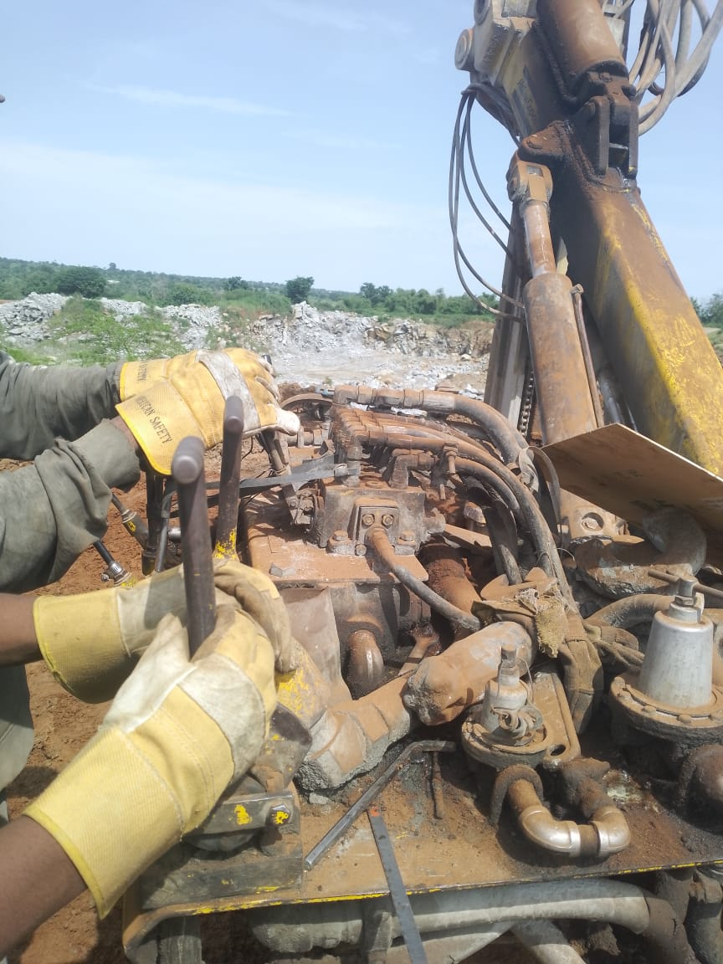

- Hardness, blasting requirements, and quarry design.
Different drilling methods are employed based on the geological conditions and the intended use of the extracted materials. Common techniques include percussion drilling, which uses repeated hammering action to break through hard rock, and rotary drilling, where a rotating drill bit grinds through softer formations. In some cases, down-the-hole (DTH) drilling is used, which involves a pneumatic hammer that provides deeper and more precise drilling.
Once the holes are drilled, they are cleaned to remove dust and debris before being filled with explosives for blasting. Proper drilling techniques ensure efficient fragmentation, reducing waste and improving the efficiency of subsequent crushing and transportation processes. Safety precautions, such as using dust suppression systems and protective equipment, are critical to minimizing risks for workers. Effective drilling not only enhances productivity but also helps in reducing environmental impact and operational costs in quarrying.
- Drilling design
Is a critical aspect of quarrying that determines the efficiency, safety, and cost-effectiveness of the rock extraction process. It involves planning the placement, depth, diameter, and spacing of drill holes to achieve optimal fragmentation and minimize environmental impact. A well-designed drilling pattern ensures that blasting operations produce uniform rock breakage, reducing waste and improving material handling.
The design process starts with a geological survey to assess rock hardness, fracture patterns, and the desired product size. Based on these factors, engineers select the appropriate drilling technique, such as percussion drilling, rotary drilling, or down-the-hole (DTH) drilling. The key parameters in drilling design include burden (distance from the first row of holes to the free face), spacing (distance between adjacent holes), hole depth, and stemming (material used to plug the top of the hole to contain explosive energy). These factors influence blast efficiency and the stability of the quarry face.

Primary and Secondary Drilling
Drilling in quarrying is categorized into primary and secondary drilling, depending on the stage of the rock extraction process and the purpose of the drilled holes. Both types are essential for efficient rock fragmentation and material handling.

Primary Drilling
Primary drilling is the initial phase of drilling in quarrying, carried out before blasting to break large rock formations. It involves creating a series of strategically placed drill holes in the quarry face to ensure uniform fragmentation. The depth, diameter, and spacing of these holes are carefully calculated based on the rock type, desired breakage size, and blasting design. Primary drilling is performed using advanced drilling rigs such as down-the-hole (DTH) drills, top hammer drills, and rotary drills. Proper execution of primary drilling ensures a controlled blast, minimizing wastage and reducing the need for additional processing.

Secondary Drilling
Secondary drilling is used when primary blasting does not completely fragment the rock or when large boulders remain after blasting. This process involves drilling additional holes into oversized rocks or misfired sections to allow for further breaking, either through secondary blasting (using smaller explosive charges) or mechanical splitting (using hydraulic breakers or wedges). Secondary drilling is more labor-intensive and costly, as it requires additional resources and time. To reduce the need for secondary drilling, efficient primary drilling and blasting techniques are crucial.

- Blasting:
Is a critical process in quarrying that involves the controlled use of explosives to break rock into manageable sizes for extraction and processing. It is designed to achieve efficient fragmentation while minimizing environmental impacts such as vibration, noise, and dust. The process starts with drilling blast holes in a predetermined pattern, followed by loading them with explosives and detonating them in a controlled sequence.
The selection of explosives depends on factors like rock type, desired fragmentation, and safety considerations. Commonly used explosives include ANFO (Ammonium Nitrate Fuel Oil), dynamite, and emulsion explosives. Once the explosives are placed, a stemming material (such as crushed rock) is used to seal the hole, ensuring that the explosive force is directed into the rock rather than escaping as air shock.
Blasting follows a carefully designed sequence to control the direction of rock breakage and reduce unwanted side effects like fly rock and ground vibrations. Delay detonators are often used to create a progressive explosion that enhances fragmentation and reduces seismic impact. After the blast, the broken rock is inspected, loaded onto trucks, and transported for further processing.
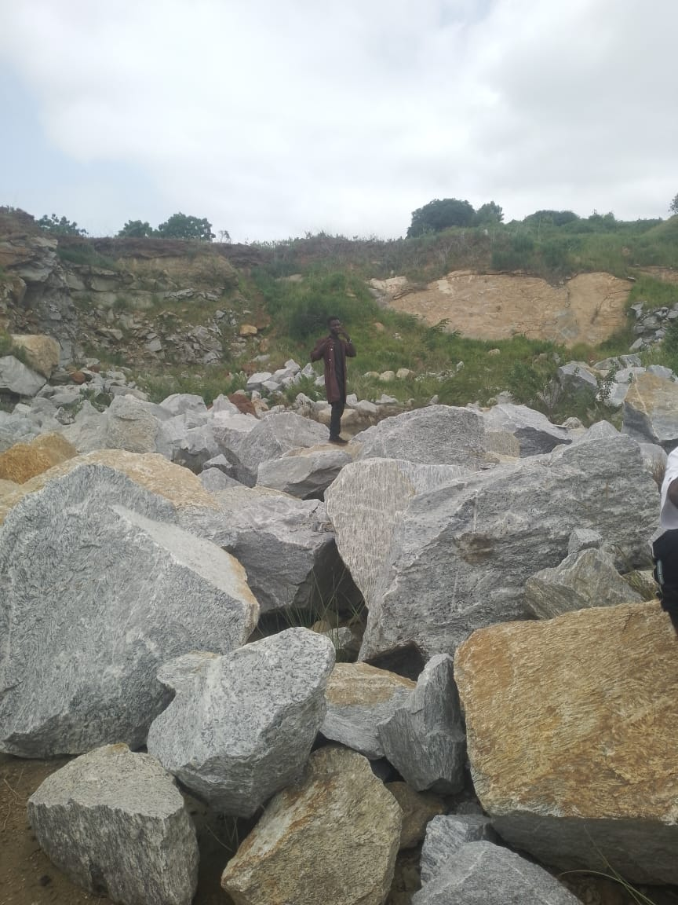
TYPE OF BLASTING
There are two types of blasting; primary and secondary blasting.
Blasting is the process of reducing a solid body such as rock, to fragments by using explosives; Explosive used are ammunition nitrates, emulsion explosive, fuses and electric detonators.
Primary blasting operation include drilling holes, placing a charge and detonator in each holes, detonation the charge.
There are three major process of charges in blasting operation.
- Primer charge
- Column charge
- Tamping.

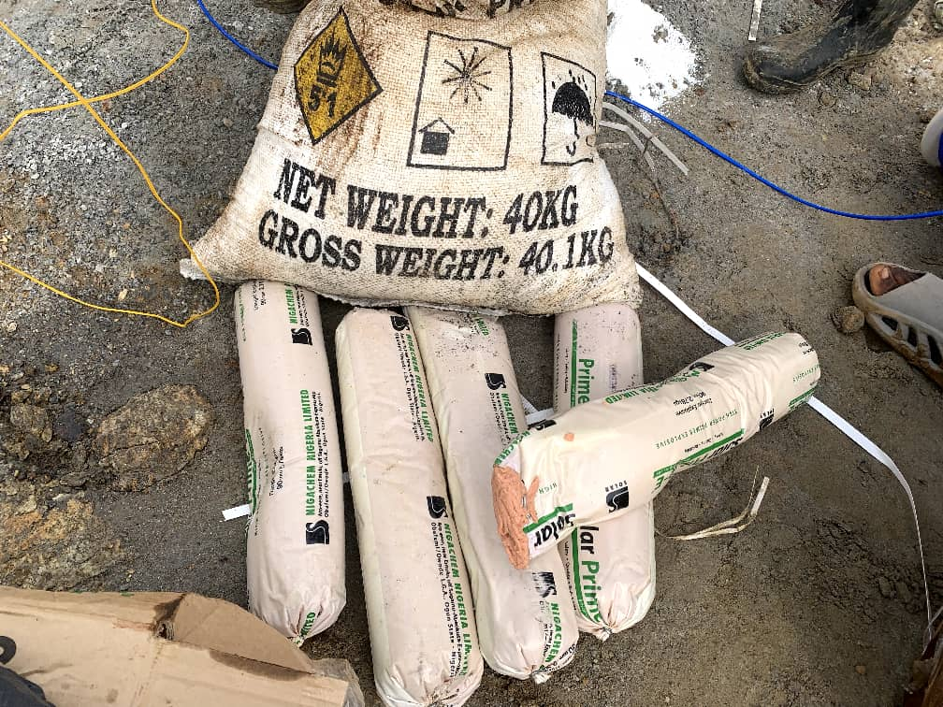
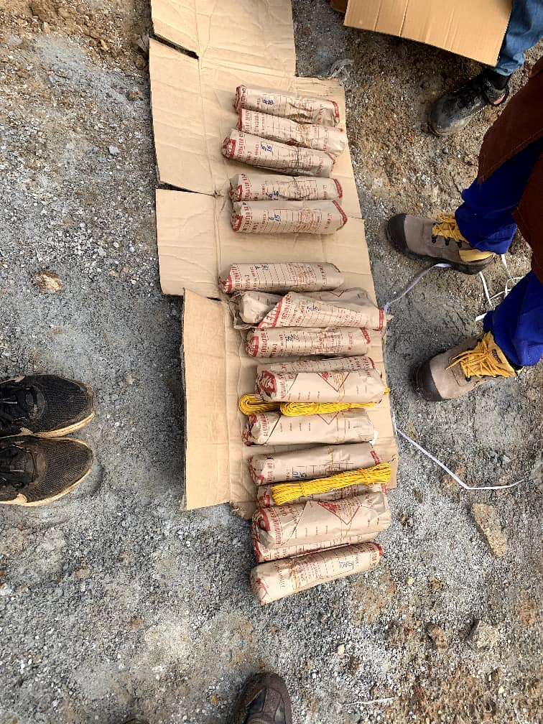

CHAPTER FOUR
4.1 The downstream section
Downstreeam is like a supply chain which includes activities from manufacturing to distribution.
The downstream section comprises of the crusher plant, work shop, generator house, the magazine stores and the stores.
- The Crusher plant: a Crusher plant is a facility that combines various equipment to process and crush minerals, rocks and other hard materials into a smaller pieces.
the type of crusher plant used is stationary crusher plant, where we have nthe Hopper, Vibrator Jaw crucher (Fixed and moveable), conveyor belts, cone crusher and screen.

Hopper: Is like a funnel where all the raw materials is being poured into before getting to the vibrating feeder.

The vibrating feeder: The vibrating feeder has a control which regulajte the rate of fragmented rocks going into the jaw crusher.
Jaw crusher
The jaw crusher is the primary crusher, it has two jaws one is fixed and the other is moveable.
Converyor belts
Converyor belts carries the rock fragmented by the primary crusher to the secondary crusher and also to the screen.
Cone crusher
The cone crusher is the secondary crusher. In this process the cone crusher crushes it into smaller size of the marketable desire.
The concrusher has a hydraulic station which cool it down when over heating.

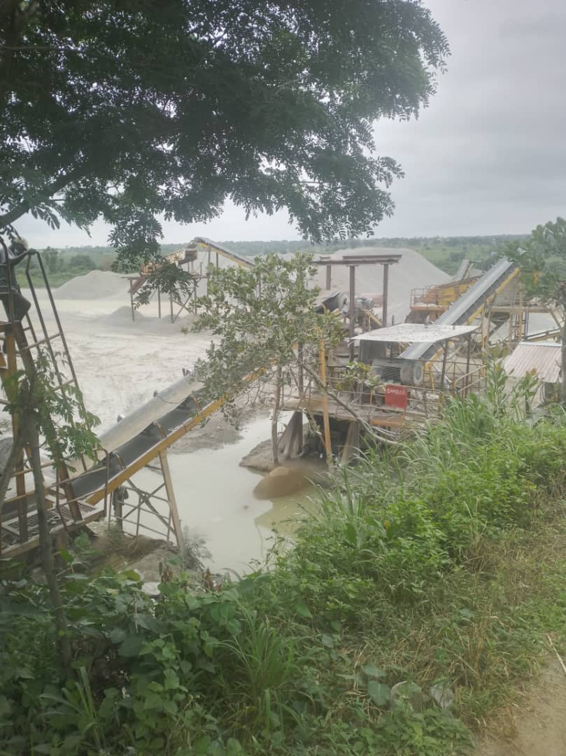
Crusher

THE SCREEN
The screen is like a sieve with perforations used to separate materials base on their sizes. The aperture on the screen;, is what separates the crushed materials into various sizes. The sizes are3/4 half inch, 3/8 and dust.

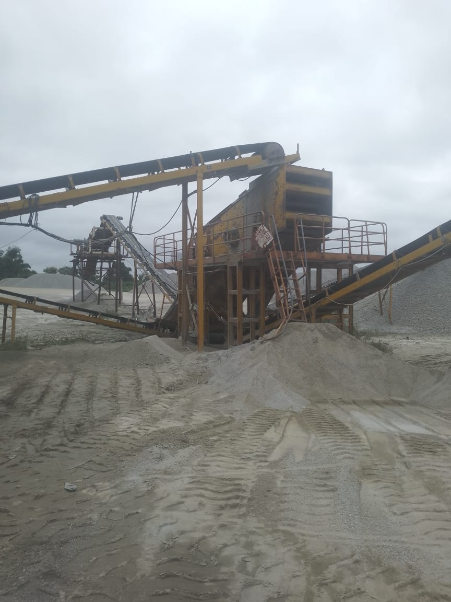
Granite
Granite is a hard, igneous rock composed mainly of quartz, feldspar, and mica. It is formed through the slow crystallization of magma beneath the Earth's surface, making it one of the most durable and widely used natural stones. The presence of different minerals gives granite its characteristic speckled appearance, with colors ranging from white and gray to pink, red, and black.

Uses of granite
Building materials
Dimension stone
Geological research

There are two main section the upstream and the downstream.
Vehicles ion the company
Wagon drill
Tipper trucks
Pay loaders
Busses
Excavators
Cars
There are various departments and each department have their manager.

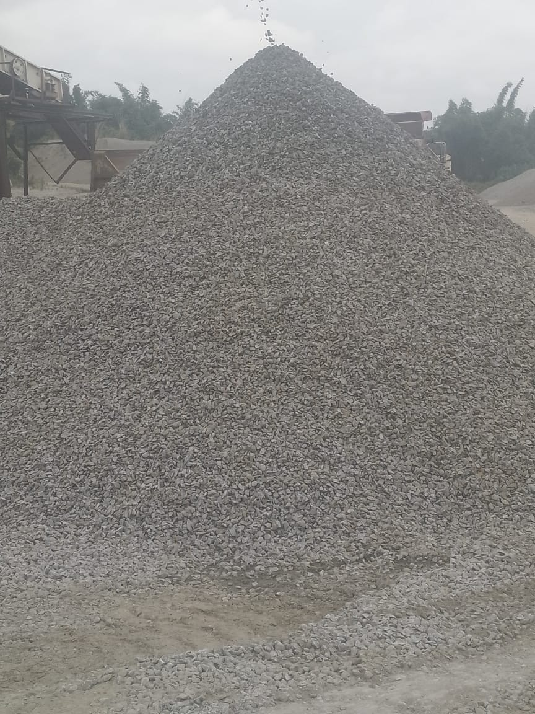
Granite

  - WORK SHOP
The work shop consist of various equipment for manufacturing, repairing and maintaining mechanical systems.
There are various machine tools in the workshop such as drilling machines, milling machines, hand tools, power tools and welding equipment arm, etc.

The magazine stores
Magazine is a place poor store where ammunition are being kept.
There are three storage facility for the explosives with temperatures of about 30⁰c.

4.3 EXPERIENCE GAINED
I observed the changing of excavator breaker to bucket.
I observed the removing of over burden with play loader
I observed the maintenance of the crusher
Every Monday we always meet with engineer for individual defense of the work done in the previous week which always interesting and impactful.

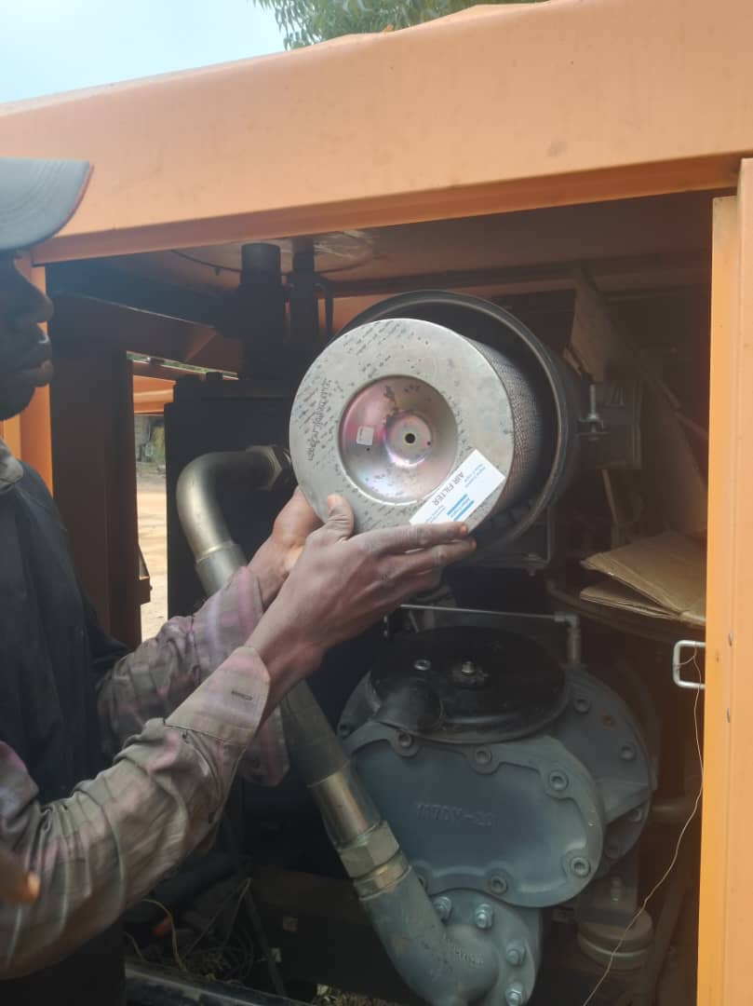
Maintenance of compressor
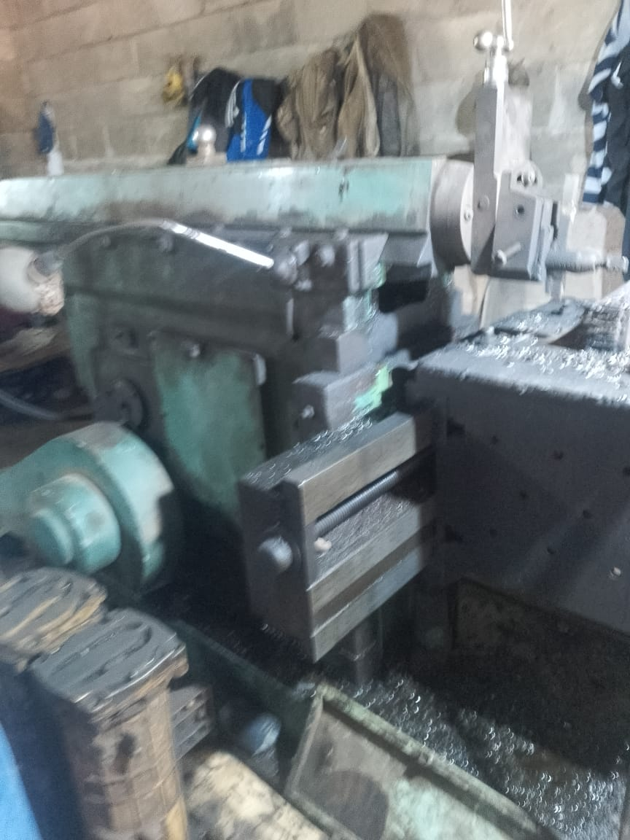

CHAPTER FIVE
5.1 SUMMARY
Manhardi Nigeria Limited is a quarry company that deals with the mining of granite rock and production of gravel.
I ended my Students Industrial Work Experience Scheme program successfully. The experiences I gained in the course of the training program were indeed a memorable one and cannot be overemphasize.

5.2 RECOMMENDATION
My recommendation is that student should endeavour to partake in the SIWES programme and make sure they keep every record of whatever they have learnt from their area of attachment because it will be relevant in the nearest future.
The school management should also support the students by producing constant supervisors to monitor the student at their area of attachment. The school should
also support the student with a little payment amount, at least every month to sustain students throughout the programme.
5.3 CONCLUSION
It is necessary to understand at this point in time that success is not measured by the height in which one finds himself, but can greatly be measured by what you can achieve through your own initiative.
With the experience gained, my advice to the school management is to add some months to the SIWES programme so as to build professional in their field of study.
Finally, I would like to state that the siwes programme is a very relevance and necessary programme for all student, for their benefit in order to be self reliance.

