CHAPTER THRE
MATERIALS AND METHOD
3.1 Preamble
This chapter explains the material used in the process of gathering the information on the research work and the methods employed in carrying out the findings.
3.2 Materials
The materials used in this research include; Water, cement, fine aggregate (sand), foaming agent, palm kernel oil solvent and water. The materials were gotten from different source to make a success of this research study.
3.2.1 Water
Portable water is used for mixing and curing. A water cement ratio (w/c) of 0.45 is adopted for concrete mix. Water is an important ingredient of concrete as it actively participates in the chemical reaction with cement. In practice, very often great control on properties of cement and aggregate is exercise, but the control on the quality of water is often neglected. Since quality of water affects the strength, it is necessary to go into the purity and quality of water.
3.2.2 Cement
The cement to be used in this study is OPC (Grade 42.5) and it will be bought from a reliable retailer shop around Maraba, along Old Jebba way, Ilorin, Kwara State. It will be properly tested to make sure it conforms to BS EN 197 – 1(2011) requirement.
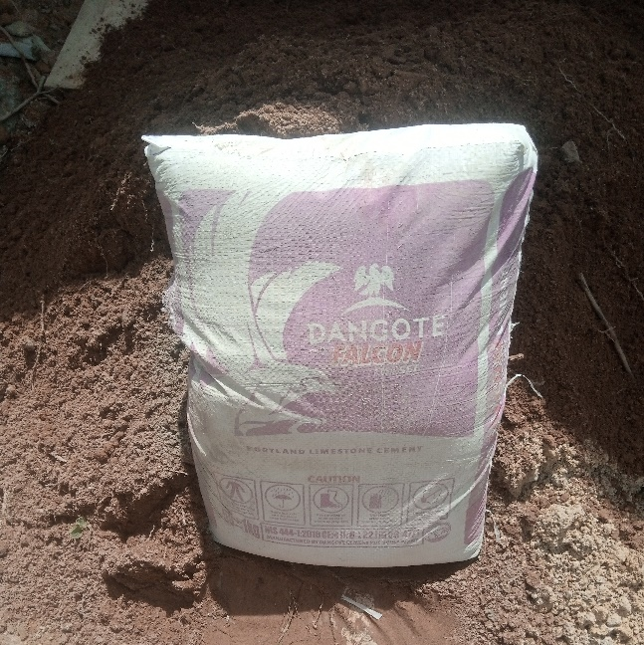
Fig 3.0 Ordinary Portland Cement

3.2.3 Fine Aggregate/ Sand
The fine aggregate to be used in this research will be obtained from a quarry shop around Maraba, along Old Jebba way, Ilorin, Kwara State and will be transported to the Civil Engineering Department Laboratory; Kwara State Polytechnic at the Institute of Technology (IOT). The fine aggregate used will be sieved through a BS 4.75mm sieve to remove some of the contained coarse aggregates.
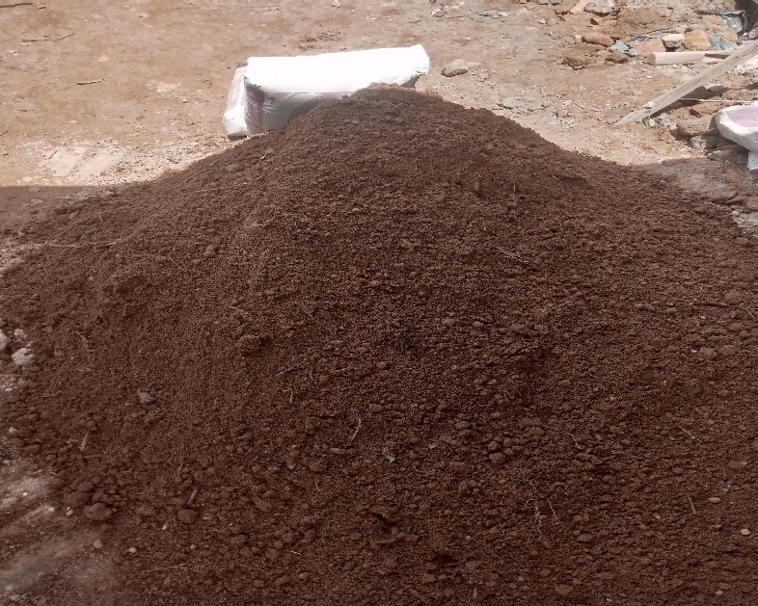
Fig 3.1 Fine Aggregate/Sand
3.2.4 Foaming Agent
The creation of a stable foam is central to achieving the desired lightweight, porous material. It is a surfactant that stabilizes the air bubbles in the mix. Commonly used synthetic agents help produce a foam with a uniform bubble size. The selected foaming agent will be compatible with both the cement hydration reaction and the polymer-based reactions introduced by the palm kernel oil solvent. Its concentration will be adjusted based on preliminary tests to create a stable and consistent foam.
3.2.5 Palm Kernel Oil Solvent
The unique aspect of this study is the incorporation of palm kernel oil solvent. Understanding its role and properties is crucial:
- Chemical Nature: Palm kernel oil solvent is derived from palm kernel oil, and its properties are influenced by its fatty acid composition. This solvent can reduce surface tension and impart hydrophobicity to local regions of the concrete matrix.
- Purpose: By modifying the interaction between the cement particles and the foaming agent, it can help adjust the pore structure, altering both the density and water absorption characteristics of the hybrid system.

3.3 Test on materials
3.3.1 Test on Cement
Testing cement is a crucial step in ensuring the quality, consistency, and performance of concrete mixes and construction materials. Various tests are conducted on cement to evaluate its physical, chemical, and mechanical properties according to international standards and specifications.
- Fineness Test
The fineness test is a crucial assessment conducted on cement to determine the particle size distribution and fineness of its particles. The fineness of cement plays a significant role in its reactivity, hydration rate, setting time, and overall performance in concrete mixes. This test is essential to ensure that the cement meets the required standards and specifications for various construction applications.
Apparatus:
- Sieve with 90-micron Opening: A sieve with a specific opening size of 90 microns (μm) is used to sieve the cement sample and separate the finer particles.
- Air-Permeability Apparatus (Blaine Apparatus): This apparatus measures the specific surface area of the cement by determining the rate of airflow through a compacted bed of cement particles.
Procedure:
- Sample Preparation: A representative sample of cement is obtained from the bulk material and thoroughly mixed to ensure uniformity.
- Sieve Analysis: A portion of the cement sample is sieved through the 90-micron sieve to separate the particles finer than 90 microns from the coarser particles.
- Air-Permeability Test (Blaine Test):
- The Blaine apparatus consists of a permeability cell, a manometer (or pressure gauge), and a vacuum pump.
- The cement sample is compacted in the permeability cell to form a uniform bed of particles.
- A vacuum is applied to draw air through the bed of cement particles, and the rate of airflow is measured using the manometer.
- The specific surface area is calculated based on the rate of airflow and the permeability characteristics of the compacted cement bed.
- The specific surface area is typically expressed in terms of square centimeters per gram (cm²/g) of cement.

3.3.2 Test on Sand
- Particle Size Distribution Test
A Particle Size Distribution Analysis (PSD) determines and reports information about the size and range of particles representative of a given material. This analysis can be performed using a variety of techniques; the most suitable will be determined based on the sample properties and question at hand.
The objective of the test is to determine the percentage of individual particle sizes present in a soil sample. Particles size distribution test was done by dry sieving and this method covers the quantitative determination of the particle size distribution in soil down to the fine sand size and the test was done in accordance to BS 1377 of 1961 “Methods of tests for soil for civil engineering purpose”
Apparatus used for particle size distribution test
The apparatus used for sieve analysis test are:
- Set of sieves
- Weighing balance machine
- Empty container
- Oven
Test procedure
- 500g of dry aggregate was weighed out of the sample.
- Each sieve size was weighed and recorded.
- The sample of soil was then poured into the sieves which has a pan at the bottom.
- The sieve was shaken manually for ten (10) minutes.
- The amount of soil retained on each sieve was weighed and the mass was recorded.
- The grain curve is then plotted with percentage passing on the ordinate axis and particle size on the co-ordinate axis.
- Percentage retained = $\frac{Weight of soil}{Total weight of sample}$ x 100%
- Cumulative % retained = Sum of percentage retained on all sieves
- Cumulative % passing = 100%
- Specific Gravity and Absorption
Specific gravity and absorption are important physical properties of aggregates, including fine aggregates used in concrete. These properties provide valuable insights into the density, porosity, and moisture content characteristics of the aggregate, which in turn influence the behavior of concrete mixes (Garcia et al., 2018).
Specific gravity, also known as relative density, is a measure of the density of a material compared to the density of water. In the context of aggregates, specific gravity indicates how dense the aggregate particles are relative to an equal volume of water. It is typically determined by comparing the weight of a given volume of dry aggregate to the weight of an equal volume of water at a specified temperature. Specific gravity values for aggregates usually range between 2.5 to 3.0 for most natural aggregates, with denser materials having higher specific gravity values. Specific gravity is an important parameter in concrete mix design as it affects the yield of concrete per unit volume and helps in estimating the proportion of solid particles in the aggregate (Garcia et al., 2018).
Absorption refers to the ability of an aggregate to absorb moisture, typically expressed as a percentage of the aggregate's weight. This property is determined by immersing the aggregate in water for a specified period and then weighing it in both dry and saturated conditions. Absorption is influenced by the porosity and pore structure of the aggregate, with porous aggregates having higher absorption values. Excessive absorption in aggregates can lead to an increase in the water demand of concrete mixes, affecting workability, strength, and durability. Therefore, controlling absorption is important in ensuring the quality and performance of concrete. Absorption values also play a role in adjusting the water-cement ratio in concrete mix designs to account for the moisture held by the aggregate (Garcia et al., 2018).
Apparatus used for test
- Pycnometer
- Container with water
- Weighing scale
- Drying pan
- Graduated cylinder
- Desiccator
Test procedure (Specific Gravity Test)
- Clean and dry the pycnometer thoroughly.
- Fill the pycnometer with water and weigh it (W1). Record the weight.
- Dry the fine aggregate sample in a drying oven until it reaches a constant weight.
- Fill the pycnometer with a known volume of dry aggregate (V).
- Add water to the pycnometer until it is completely filled, ensuring there are no air bubbles.
- Weigh the pycnometer with water and aggregate (W2).
- Calculate the specific gravity using the formula:
$$Specific Gravity= \frac{W2-W1}{W2-W1-V}$$
- Repeat the test with multiple samples to ensure accuracy and repeatability.
Test procedure (Absorption Test)
- Take a representative sample of fine aggregate and dry it in a drying oven until a constant weight is achieved.
- Weigh the dry aggregate sample (W_{d}).
- Immerse the dried aggregate sample in water in a container for a specified duration (usually 24 hours).
- Remove the saturated aggregate from the water, drain excess water, and wipe the surface gently with a cloth to remove surface moisture.
- Weigh the saturated aggregate sample (Ws).
- Place the saturated aggregate sample in a drying pan or tray and dry it in the oven until it reaches a constant weight (Wsd).
- Calculate the absorption percentage using the formula:
$$Specific Gravity=\left(\frac{W_{S}- W_{Sd}}{W_{Sd}- W_{d}}\right)×100$$
- Repeat the test with multiple samples to ensure accuracy and repeatability.
3.4 Mix Design
Concrete mix design is a crucial aspect of concrete technology that involves selecting the proportions of ingredients to achieve the desired properties in concrete. This process is essential for ensuring the durability, strength, and workability of concrete structures. A well-designed concrete mix not only meets the structural requirements but also considers factors such as environmental conditions, construction practices, and economic feasibility (Olaoye, 2013).
The mix design for hybrid foam concrete incorporating palm kernel oil (PKO) solvent is developed to achieve an optimal balance between strength, density, and water absorption characteristics. Foam concrete is typically composed of cement, fine aggregates (Clean, well graded river sand), water, and a foaming agent. The uniqueness of this lies in the incorporation of PKO either as a partial replacement for water or as a modifying agent in the mix. However, in this study, the conventional cement-sand-water slurry is modified by incorporating palm kernel oil (PKO) solvent, which is hypothesized to alter the microstructure and reduce water permeability. The cement-to-sand ratio will be maintained between 1:2 and 1:3, while the water-to-cement ratio (w/c) will be adjusted within the range of 0.4 to 0.6 to account for the presence of the PKO solvent. The foaming agent will be diluted with water and aerated using a mechanical foam generator until a stable foam is produced.
The preparation process will involve mixing the cement, sand, water (and PKO solvent), and additives thoroughly to achieve a homogeneous slurry. The pre-formed foam will then be carefully blended into this slurry to form the final mix, ensuring even distribution of air voids and any fiber reinforcements. The fresh hybrid foam concrete will be cast into 150 mm³ cube moulds in three layers, with each layer gently compacted to preserve the integrity of the foam cells. After casting, the specimens will be allowed to set for 24 hours before demolding. The cured samples will then be subjected to water curing at predetermined intervals (7, 14, and 28 days) to simulate standard curing conditions. To assess water absorption, specimens will oven-dried at 105°C until a constant mass is achieved, then immersed in water for 24 hours, and finally weighed to determine the increase in mass. The density will be measured by calculating the ratio of the specimen's mass to its volume. These tests will be repeated for different proportions of PKO solvent to determine its optimal dosage and to understand its effect on both water absorption and density in the hybrid foam concrete.
3.5 Laboratory Testing
In this study, two primary tests; water absorption and density determination will be conducted to evaluate the performance of hybrid foam concrete modified with palm kernel oil solvent (PKO). The water absorption test follows guidelines similar to ASTM C642. This is critical in understanding the material’s pore structure and durability, as highlighted by Banthia and Gupta (2006) and Hassan et al. (2015). Essential apparatus for this test include an electric oven, a water bath or large container, digital weighing scales, and safety equipment such as heat-resistant gloves.
For density determination, the mass and dimensions of the concrete specimens are measured. This test is pivotal in assessing the influence of PKO on the compactness and overall structural performance of the foam concrete, with methodologies supported by research from Chin and Ng (2010) and Kumar et al. (2017). Accurate measurement tools such as calibrated moulds, digital calipers, and precision digital scales are used to ensure the reliability of the results.
3.5.1 Water Absorption Test
The water absorption test is a critical procedure used to assess the durability and porosity of hardened concrete. By measuring the amount of water a concrete specimen absorbs, this test provides insights into the material's resistance to water ingress, which is directly related to its longevity and performance in various environmental conditions. The standard method for conducting this test is outlined in ASTM C642, titled "Standard Test Method for Density, Absorption, and Voids in Hardened Concrete."
Materials/Apparatus (Banthia & Gupta, 2006);
- Electric Oven: Capable of maintaining a constant temperature of 105°C for drying specimens.
- Water Bath or Large Container: For immersing the specimens completely for 24 hours.
- Digital Weighing Scale: A precision balance to measure the specimen’s mass before and after immersion.
- Specimen Moulds: Standard cube moulds (100 mm × 100 mm × 100 mm) used for casting the foam concrete.
- Protective Equipment: Heat-resistant gloves and safety goggles for handling hot materials.
Procedures (Banthia & Gupta, 2006);
- Specimen Preparation:
- The hybrid foam concrete will be casted into 150mm³ cube moulds in three layers, ensuring each layer is lightly compacted to maintain foam integrity.
- The specimens will be allowed to set for 24 hours before demoulding and then cured in water for designated periods (7, 14, and 28 days).
- Drying Process:
- The cured specimens will be removed from the water cure and placed in an electric oven.
- The specimens will be dried at 105°C until a constant mass is reached, as per the ASTM C642 guidelines.
- Immersion:
- The specimens will be cooled to room temperature.
- After which each specimen will be immersed fully in a water bath for 24 hours.
- Weighing and Calculation:
- After immersion, the specimens are removed, and the surfaces will be gently dried with a soft cloth, and weigh using the digital scale.
- The water absorption will be calculated using the formula below;
$$Water Absorption \left(\%\right)= \frac{(Wet weight-Dry weight}{Dry weight}×100$$
- This percentage indicates the degree of water ingress, which is directly linked to the concrete's porosity and durability.
3.5.2 Density Determination
The density determination of hardened concrete is a fundamental procedure that provides insights into the material's quality, strength, and durability. A higher density typically indicates a lower porosity, which correlates with enhanced strength and reduced permeability. The standard method for determining the density of hardened concrete is outlined in ASTM C642, titled "Standard Test Method for Density, Absorption, and Voids in Hardened Concrete."
Materials/Apparatus (Chin & Ng, 2010; Kumar et al., 2017);
- Digital Weighing Scale: For accurate mass measurement of the concrete specimens.
- Calibrated Moulds: Standard cube moulds (100 mm × 100 mm × 100 mm) to ensure consistent specimen dimensions.
- Measuring Tools: Digital calipers or a measuring tape to verify the dimensions of each specimen.
- Calculator or Software: For computing the density based on the measured mass and volume.
Procedures (Chin & Ng, 2010; Kumar et al., 2017);
- Specimen Preparation:
- The same set of cured specimens from the water absorption test will be used. Having been properly cured under water for the predetermined durations (7, 14, and 28 days).
- Measurement of Mass:
- Each specimen will be weighed using the digital scale to record the mass in kilograms.
- Determination of Volume:
- Since the specimens are cast in standard cube moulds, their volume can be calculated by cubing the side length.
$$v=0.15m×0.15m×0.15m={0.0034m}^{3}$$
- Density Calculation:
- The density of each specimen will be calculated using the formula:
$$Density ({kg/m}^{2})= \frac{mass(kg)}{volume(m^{3})}$$
- This data provides insights into the effect of PKO on the compactness and structural performance of the foam concrete.

