CHAPTER 1
- INTRODUCTION
1.1 Background to the Study
Height determination is an essential aspect of surveying that involves determining the vertical location of a point relative to a reference datum. Surveyors typically use different techniques to determine the elevation of a point, including trigonometric levelling, barometric levelling, and spirit levelling (Simbolon et al., 2017).
Levelling is a widely used method for determining the elevations of ground points relative to a reference datum. It involves measuring the vertical distance between the ground point and the reference datum to obtain what is known as the reduced level. This is an important procedure that is used in various fields such as mapping, engineering design, construction, and setting out. The reference datum used in levelling is usually the mean sea level, which is assumed to be an equipotential surface. This means that points on this surface have the same gravitational potential energy. As such, the mean sea level is adopted as the reference surface for vertical control surveys (Schofield & Breach, 2007; Uren & Price, 2010).

1.1.1 Leveling
Schofield and Breach (2007) opined that levelling is a technique used to determine the vertical location of a point on or beneath the surface of the earth relative to a reference datum, while planimetry refers to the horizontal position of a point relative to a coordinate system. The authors also noted that these two procedures are separate and distinct, as each involves different equipment, procedures, and techniques. This idea is further supported by Ghilani and Wolf (2014), who stated that levelling is primarily concerned with determining the elevations of ground points, whereas planimetry is focused on determining the position of those points in a horizontal plane. The choice of height system is critical in many applications, especially those that require accurate determination of elevation. For instance, in civil engineering projects such as road construction, it is important to know the elevation of the terrain to design the road profile, drainage, and culverts. The orthometric height system is widely used in such projects as it provides a meaningful height reference that is directly linked to the earth's gravity field.
However, other height systems, such as the ellipsoidal height system, are used in different applications. The ellipsoidal height system is based on the normal to the reference ellipsoid and is commonly used in satellite positioning systems such as GPS. The choice of height system depends on the application, and it is important to understand the differences between them to avoid errors in height determination (Torge, 2001).
Orthometric heights are determined by measuring the vertical distance between the point of interest and the geoid. This can be achieved through traditional techniques such as spirit levelling, trigonometric levelling, and GPS measurements (Odumosu et al., 2018). In spirit levelling, a series of measurements are taken with a level instrument, and the heights are computed based on the height of the instrument and the readings taken at the different locations.
Trigonometric levelling involves measuring the angles and distances between two points and computing the height difference between them using trigonometric functions. GPS measurements use satellite signals to determine the height of a point above the ellipsoid and geoid is computed with high accuracy (Ghilani & Wolf, 2014).
The process of levelling involves using a levelling instrument to measure the vertical distance between the ground point and the reference datum. The levelling instrument consists of a spirit level and a graduated staff. The spirit level is used to ensure that the staff is held vertically, while the graduated staff is marked with a series of divisions that enable the observer to measure the vertical distance between the ground point and the reference datum. There are several methods for leveling observations in modern days, they include geometric leveling and trigonometric leveling methods (Lee & Rho, 2021). The choice of method to use largely depends on the accuracy desired, nature of the work to do and the availability of instrument to use.

1. 1.2 Total Station
The total station is a surveying instrument that combines the angle measuring capabilities of theodolite with an electronic distance measurement (EDM) and processing capabilities to calculate and determine horizontal angle, vertical angle and slope distance to the particular point.
The determination of the coordinates for an unknown point in relation to a known coordinate is achievable through the utilization of a total station, provided that a direct line of sight can be established between the two points (Putra et al., 2023). The process involves measuring angles and distances from the total station to the points under survey. Subsequently, trigonometry and triangulation are employed to calculate the coordinates (X, Y, and Z or northing, easting, and elevation) of surveyed points concerning the position of the total station. To get data on the distance of a point, the Total Station emits a wave, then the object will reflect the wave and be received back by the tool. Then the software inside the tool will automatically calculate the distance from where the tool stands to the measured point. To determine an absolute location, a total station requires line of sight observations and must be set up over a known point or with line of sight to two or more points with known location (Solomon, 2014).

1.2 Aim of the Project
The primary aim of this project is to compare the accuracy and reliability of digital leveling and total station equipment in determining height measurements.

1.3 Objectives
- To evaluate the accuracy of digital leveling and total station equipment in measuring heights.
- To assess the reliability of digital leveling and total station equipment in measuring heights.
- To compare the performance of digital leveling and total station equipment in different environmental conditions.
- To determine the suitability of digital leveling and total station equipment for various applications.

1.4 Statement of the Problem
There is a need to evaluate the accuracy and reliability of digital leveling and total station equipment for height measurement, in order to determine which instrument is more suitable for specific applications.

1.5 Scope of the Project
This project will focus on comparative evaluation of accuracy and reliability of digital levelling and total station equipment to determine the height measurement. The comparison will involve assessing the consistency of height readings, identifying sources of error, and determining the efficiency of each method in height determination.

1.6 Project Justification
This project is justified for the following reasons:
- Improving Accuracy and Reliability: The project aims to evaluate the accuracy and reliability of digital leveling and total station equipment, which will help to identify the most accurate and reliable instrument for height measurement for different applications.
- Reducing Errors: By identifying the most accurate and reliable instrument, the project will help to reduce errors in height measurement, which can have significant consequences in various fields.
- Increasing Efficiency: The project will help to increase efficiency in surveying, engineering, and construction by providing a comprehensive evaluation of the accuracy and reliability of digital leveling and total station equipment.
- Cost Savings: By identifying the most accurate and reliable instrument, the project will help to reduce costs associated with inaccurate height measurements and the need for rework.
- Contribution to Knowledge: The project will contribute to the existing knowledge on the accuracy and reliability of digital leveling and total station equipment, which will be useful for researchers, surveyors, engineers, and construction professionals.

1.7 Significance of the Project
Understanding the differences between height measurements obtained from a total station and leveling instrument is crucial for surveyors, engineers, and researchers involved in topographic mapping and elevation studies. By comparing the performance of these two methods, this project aims to provide valuable insights into the strengths and limitations of each technique, helping professionals make informed decisions in choosing the most suitable method for their specific surveying tasks.

1.8 Personnel
The project was assigned to and was successfully carried by the personnel listed below;
NAME | MATRIC. NO.
Ganiyu Akeem Abiodun | HND/23/SGI/FT/0076 | Writer
Abdul Kareem Ramota Olawumi | HND/23/SGI/FT/0078 | Member
Kazeem Kabirat Damilola | HND/23/SGI/FT/0079 | Member
Adeoti Qudus Adebayo | HND/23/SGI/FT/0080 | Member
Adeleye Sheriffdeen Olawale | HND/23/SGI/FT/0081 | Member
Abdul Qudus Shukurah Temitope | HND/23/SGI/FT/0083 | Member
Ogunsuyi Babatunde Sunday | HND/23/SGI/FT/0118 | Member
Jimoh Halimah Titilayo | HND/22/SGI/FT/082 | Member

1.9 Project Location
The project site is located inside Kwara state polytechnic Ilorin, Kwara state.
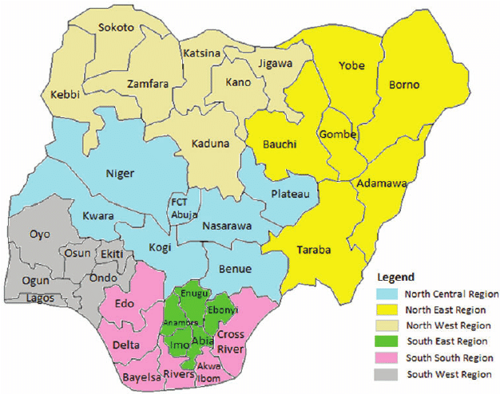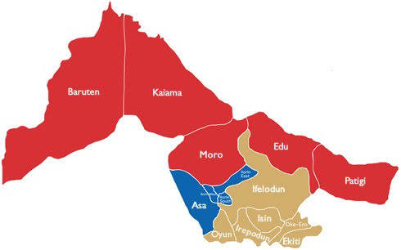
Map of Kwara State
Map of Nigeria

``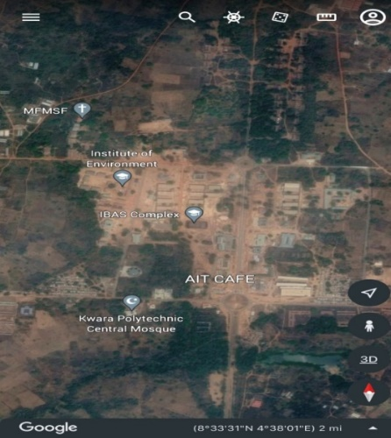 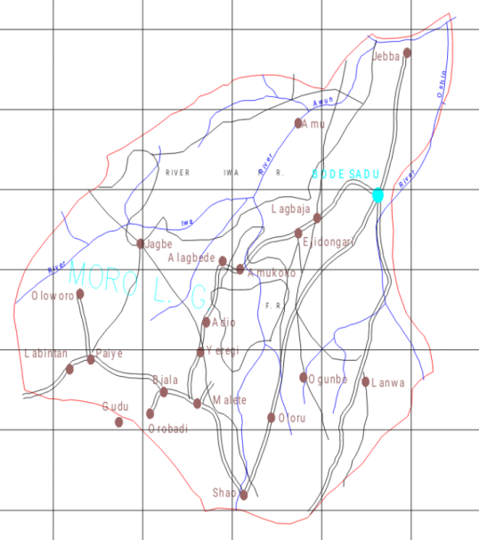
Map of Moro L.G.A
Google Imagery of the Study Area

Figure 1.10: Study Area Map

CHAPTER 2
2.0 LITERATURE REVIEW
Previous studies have investigated the accuracy and reliability of digital leveling and total station equipment. For example, a study by (Awwad & Shaker, 2013) compared the accuracy of digital leveling and total station equipment and found that total station equipment exhibited higher accuracy. Another study by (El-Sheimy & Schwarz, 2010) evaluated the reliability of digital leveling equipment and found that it was affected by various factors, including instrument calibration and operator training.
Other studies have also investigated the factors that affect the accuracy and reliability of digital leveling and total station equipment. For example, a study by (Kang & Kim, 2015) found that the accuracy of total station equipment was affected by the quality of the instrument and the skill level of the operator. Another study by (Li & Wang, 2017) found that the reliability of digital leveling equipment was affected by the frequency of instrument calibration and the type of leveling rod used.
Furthermore, researchers have also explored the application of digital leveling and total station equipment in various fields. For example, a study by (Tao & Li, 2018) investigated the use of digital leveling equipment in monitoring the settlement of buildings. Another study by (Kim & Kang, 2019) evaluated the use of total station equipment in surveying large-scale construction projects.
Additionally, studies have also investigated the impact of environmental conditions on the accuracy and reliability of digital leveling and total station equipment. For example, a study by (Schwarz & El-Sheimy, 2011) found that temperature and humidity affected the accuracy of digital leveling equipment. Another study by (Kavanagh & Bird, 2017) found that weather conditions affected the reliability of total station equipment.
Height measurement is a critical component of various fields, including surveying, engineering, and construction. With the advancement of technology, various instruments have been developed to measure heights accurately and efficiently. Two such instruments are Digital Leveling instruments and Total stations. This chapter reviews the existing literature on the comparison of height measurement using Digital Leveling instruments and Total stations.

2.1 Digital Leveling Instruments
Leveling instruments are used to measure the difference in height between two or more points on the Earth's surface. These instruments are essential tools in surveying, engineering, and construction for determining the elevation of points, establishing reference levels, and monitoring changes in the terrain.
The earliest leveling instruments were developed in the 17th century, with the introduction of the "dumpy level" (Schwarz, 2003). This instrument used a telescope and a spirit level to measure the difference in height between two points. Over the years, leveling instruments have evolved to include digital levels, laser levels, and total stations.
Digital Leveling instruments are electronic devices that use sensors and algorithms to measure the angle of elevation and calculate the height difference between two points (El-Sheimy, 2004). They are widely used in surveying, engineering, and construction due to their high accuracy, ease of use, and compact design
2.2 Total Station
Total stations are electronic instruments that combine the functions of a theodolite and an electronic distance measurement (EDM) device (Schwarz, 2003). They are widely used in surveying, engineering, and construction due to their high accuracy, versatility, and ability to measure distances and angles.
The first Total Station was introduced in the 1970s, with the development of electronic distance measurement (EDM) technology (Schwarz, 2003). Since then, Total Station has evolved to include advanced features, such as GPS integration, robotic measurement, and 3D scanning.
2.2.1 Components of Total Station
Total Station consists of several components, including:
1. Telescope: A magnifying device used to observe the target.
2. EDM: An electronic distance measurement device used to measure distances.
3. Theodolite: A device used to measure angles.
4. Processor: A computer used to process the measurements and calculate the results.
5. Display: A screen used to display the results.

2.3 Comparison of Height Measurement Capabilities
Several studies have compared the height measurement capabilities of Digital Leveling instruments and Total stations. A study by Kang (2015) found that Total stations were more accurate than Digital Leveling instruments in measuring heights, with a mean error of 1.3 mm compared to 2.5 mm for Digital Leveling instruments.

2.3.1 Factors Affecting Height Measurement Accuracy
Several factors can affect the accuracy of height measurements using Digital Leveling instruments and Total stations. These include:

- Instrument calibration and maintenance (Schwarz, 2003)
- Environmental conditions, such as temperature and humidity (El-Sheimy, 2004)
- Operator error and training (Kang, 2015)
- Quality of the instrument and its components (Schwarz, 2003)

2.3.2 Advantages and Limitations
Digital Leveling instruments and Total stations have several advantages and limitations.
The advantages of Digital Leveling instruments include:
- High accuracy and reliability
- Ease of use and compact design
- Fast and efficient measurement
The limitations of Digital Leveling instruments include:
- Limited range and accuracy in certain environmental conditions
- Requires calibration and maintenance

The advantages of Total stations include:
- High accuracy and versatility
- Ability to measure distances and angles
- Wide range of applications
The limitations of Total stations include:
- Higher cost compared to Digital Leveling instruments
- Requires more training and expertise to operate

2.4 Project Review
In conclusion, both Digital Leveling instruments and Total stations are capable of accurate height measurements. However, Total stations are generally more accurate and versatile than Digital Leveling instruments. The accuracy of height measurements using both instruments can be affected by various factors, including instrument calibration and maintenance, environmental conditions, operator error and training, and quality of the instrument and its components.

