TECHNICAL REPORT ON STUDENT INDUSTRIAL WORK EXPERIENCE SCHEME (SIWES)

HELD AT
KWARA STATE TELEVISION AUTHORITY (KWARA T.V)
APATA YAQUBA ILORIN, KWARA STATE

BY:
IDRIS TOHEEB OLAMILEKAN
ND/23/PAD/PT/0550

SUBMITTED TO DEPARTMENT OF PUBLIC ADMINISTRATION
INSTITUTE OF FINANCE AND MANAGEMENT STUDIES, (IFMS) KWARA STATE POLYTECHNIC, ILORIN
IN PARTIAL FULFILMENT OF THE REQUIREMENT FOR THE AWARD OF NATIONAL DIPLOMA (ND) IN PUBLIC ADMINISTRATION

SEPTEMBER, 2022.DEDICATION

DEDICATION
This report is dedicated to Almighty Allah for his divine mercy on me and my family who has given me the strength, wisdom, knowledge and understanding in working toward my success, I also dedicate this report to my parent Mr. and Mrs. IDRIS for their support and to my supervisor for the success of this report.

ACKNOWLEDGEMENT
To God who owns life, I wish to express my sincere appreciation and gratitude for seeing me throughout my duration in Kwara State Polytechnic and for making my vision come to reality, also for His Goodness, Mercy, Provision and Grace upon my life.
My profound gratitude goes to my Parent Mr. and Mrs. IDRIS, may God be with you.
My special thanks go to the head of Department (HOD) and the entire staff of Public Administration Department, Institute Of Financial and management study , Kwara State Polytechnic for sharing wealth of experience with me in my course of study.
Furthermore, thanks goes to my honorable and diligent supervisor for his advice, guidance and adequate encouragement relish from him which has contribute in no small measure to the success of completion of this report.
Finally, my sincere gratitude also goes to my lovely friends both within and outside the institution,

CHAPTER ONE
INTRODUCTION
1.1 MEANING OF SIWES
The Students’ Industrial Work Experience Scheme (SIWES) is a program that is coordinated by the Industrial Training Fund (ITF), in conjunction with the National University Commission (NUC).
The SIWES program is designed to engage students in various degree programs in order to provide the student with practical experience in various fields of study and to expose them to actual working conditions.
This program involves the ITF, students and industries. It is meant to bridge the gap between theory and practical work, sharpen students’ skills and understanding of actual work processes and also provide an avenue to acquire more knowledge.
The Student Industrial Work Experience Scheme [SIWES] is the accepted skill training program which forms part of approved medium academic standards in the various degrees program of the Nigeria tertiary institutions.
This scheme helps student in their various field to know or have knowledge and picture of what they have been studying in school which enable the student to practicalize the theoretical aspect of his profession. This scheme contributes largely to prepare the student for any future engagement exposing him to atmosphere of veracity and adaptation.

1.2 AIMS AND OBJECTIVE OF SIWES
- Student industrial work experience scheme [SIWES] provide avenue for student to acquire industrial skill and experience in their approved course of study
- Expose students to work methods and techniques in handling equipment and machinery that may not be available in their institutions;
- Enlist and strengthen employers’ involvement in the entire educational process through SIWES.
- To provide opportunity for students to apply their knowledge in real work situations thereby bridging the gap between theory and practice.
- To earnest placement and strengths employees involvement in the education process of preparing student for employment in industries.
- To ease the transition from school to the world of work and enhance students contact for later job.

1.3 HISTORY OF SIWES
The early phase of science and technology in Nigeria was characterized by the theoretical lectures in polytechnics and universities which have proven to be an ill method of teaching students in Universities and Polytechnics graduate with little or no technical experience in their course of study.
In the same vein, students’ inability to contribute to the society in hampering the growth and development of our country it was in this view SIWES was introduced to the industrial and Education sector.
SIWES is the acronym for Student’s Industrial Work Experience Scheme. SIWES was established in the year 1973 in order to improve the standard of Education in Nigeria.
SIWES was funded by ITF (Industrial Training Funds) during it early stage not until it was difficult to continue for economic stress: then the responsibility was shared between Industrial Training Funds (ITF) and the Federal Government.
SIWES is a scheme for the duration of sixteen weeks (4 months). SIWES is done after the first year in polytechnics (ND1) and done after second year or third year in University depending on the institution.

CHAPTER TWO
2.1 HISTORY OF KWARA TELEVISION AUTHORITY
Kwara State Television was establish in 1997 by Alhaji Shaaba Lafiaji the then Executive Governor of the state. The Television Station was promulgated into law in 1999 with six departments which are Administration, News and Current Affairs, Programs, Engineering, Accounts and Marketing.
Mallam Ishaq Moddibo Kawu was the pioneer General Manager of the television station. One of the former governors of the state, Alhaji Mohammed Lawal merged both the state broadcasting corporation and television station which was referred to as Kwara State Broadcasting Corporation, after the tenure of Malla Moddibo Kawu, Governor Lawal appointed Alhaja Meiro Mustapha as the Director General to run the affairs of both agencies.
Alhaja Mustapha was succeeded in year 2003 by Alhaji Salami Ayilara who was appointed chairman, a position he held for three months, following which Mallam Lasisi Bello former Director Programs of the station took over as the General Manager in the same year.
Mallam Lasis Bello who took over the mantle of leadership was there till the year 2005 when Mallam Tajudeen AbdulKareem was appointed the next General Manager. Mallam Tajudeen was however removed by Doctor Bukola Saraki Who became the state governor at the time.
Engineer Kolawole Tomori the Director Engineering of corporation was announced the Acting General Manager after the exits of Mallam Tajudeen AbdulKareem. Engineer Tomori’s tenure terminated two years later with the appointment of another Acting General Manager in person of Mallam Nurudeen Imam Abdulrahim with effect from 3rd June, 2009 and later became the substantive general manager of the station on 27th February, 2009.
On the 16th of June, 2010, Barrister Mahmood Abdulraheem replaced Mallam Imam as the general manager for a period of nine months before he was replaced temporarily by the state commissioner of information Mr. Tunji Moronfoye Who also doubles as the administrator of the corporation. Mr Moronfoye held sway until Alhaji Adewale Adebowale Adedeji the General Manager of the state radio station was made General Manager of both the radio and the television stations.
In Novermber 2012, Alhaji Abdulfatai Adewale Adebowale was appointed the general manager by his Excellency, Governor Abdulfatah Ahmed and on the March 5th 2019, Mallam Olarenwaju Sambo Qudus was appointed as acting General Manager of the corporation till date.
2.2 DEPARTMENTS AND THEIR FUNCTIONS
- ADMINISTRATION DEPARTMENT: This is a department that is in charge of keeping proper records of the staffs of the organization, supervises the running of the affairs and maintenance of discipline in the entire station.
- NEWS AND CURRENT AFFAIRS DEPARTMENT: It is the department that is in charge of news production and current affairs in various languages for the station.
- ACCOUNT DEPARTMENT: It is in charge of keeping the financial details and transactions of the station for both the money coming in and out.
- ENGINEERING DEPARTMENT: It is a department that is in charge of engines and all electronic equipment in the television station. It has various unit such as outside broadcasting, maintenance, V.T.R, transmitter, power plant. It is the heart of the station.
- PROGRAMS DEPARTMENT: This is the department that is in charge of the program production, it has various units such as production, presentation and film.
- MARKETING DEPARTMENT: is a department that handles the marketing strategies of the station.
- RESEARCH AND PLANNING DEPARTMENT: They are to discover and have proper planning on the events that the station is willing to do.
- AUDIT DEPARTMENT: This is department verifies and ensure that all transaction of the station are accurate.

2.3 ORGANOGRAM
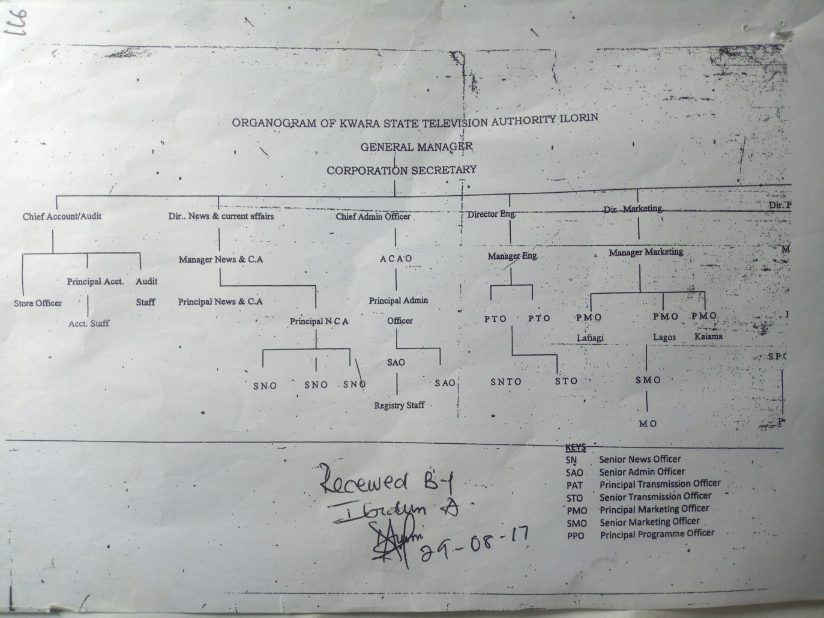
2.4 VISION STATEMENT
The vision statement for kwara tv is “to be the medium transforming the world through broadcasting by upholding our heritage using global best practice”.
2.5 MISSION STATEMENT
To build and sustain a television station that promotes stakeholders relationship through professionalism and innovative quality programming.
2.6 CORE VALUE
K- Knowledge of the job
W- Wealth of experience
A- Awareness
R- Respect for individual
A- Ability
T- Total commitment
E- Excellence
L- Lively entertainment
E- Enriching societal values
V- Viewer satisfaction
I- Innovation
S- Service
I- Insight
O- Objective
N- Newness
CHAPTER THREE
3.1. SIWES EXPERIENCE
I started my siwes program at kwara state television on the 05th of September 2022 in the program and news department under the supervision of Mr Tosin Adeoye
Here are some of the things I was opportune to do
INTRODUCTION TO MICROSOFT WORD
The chapter include information about how to boot the system, formatting of text, what we can find when we start our window and some other important things in word processor. Microsoft word is the word processing software which can be use in writing of text, placing of text in column inserting of clip art, creating of text.
HOW TO BOOT A COMPUTER
Booting is the process of starting a computer system for use which means putting on the computer before the user start using it. We have two type of booting namely;
- Cold booting
- Warm booting
The process of switching on or starting the computer system from the power button on the central processing unit (cpu) is called COLD BOOTING while the process of rebooting the computer is performing illegally is called WARM BOOTING.
STEPS REQUIRE TO ACTIVATE MICROSOFT WORD
- Step 1 Boot the system ( as state above )
- Step 2 Click start button ( or press window on keyboard)
- Step 3 Click on all program
- Step 4 Click on Microsoft office ( from the program submenus)
- Step 5 point Microsoft word
CREATING A DOCUMENT
When Microsoft word is started, a basic sheet of electronic paper is displayed on which you can type and text appear in the document and editing occurs.
HOW TO FORMAT A TEXT
Formatting is when you want to change the characters of your text such a font type, size and the thickness. Color or the position which could be superscript or subscript does as following.
- Step 1Highlight the, it is compulsory to highlight the text you want to modify either by the mouse or keyboard before the operation.
- Step 2 click format
- Step 3 click font
HOW TO SAVE A DOCUMENT
Saving a document can be done in two ways:
To save a new document
- Click file from menu bar
- Click save as
- Type a file your document
- Click on save
To save subsequent document after the first saving
- Then Click file the menu bar
- Click save or use shortcut key from keyboard “ctrl s”
ZOOMING IN AND OUT
- Select zoom tool from the tool-box
- Hold the mouse button down to access to zoom fly –out, and then select the first option
- Move your cursor, which has changed ‘above or below of the object, press the mouse button.
- Release the mouse button, the object will now take up most the screen
HOW TO SAVE
- Create content for the start drawing
- Click file from the menu bar
- Type the name in the file name box
- Click save or press enter on the keyboard
PRINTING OF FILE
- Open the file you want to print
- Click file from the menu bar
- Select print from the file menu
- Click print.
SPELLING AND GRAMMER CHECKING
- At the beginning of the document click review tab
- Select spelling and grammar from the proofing
- Select the correct word from the suggestion list bar
- Click change.
TO CREATE TABLE
- Position the cursor to where you want the table
- Click insert tab and click table button
- Select insert table from the dialog box.
- Type the number of column in the column box and the number of rows in the rows box
- Select the desired width for each column or select auto
- Click ok.
EXISTING MICROSOFT WORD
- Select the file command from the main menu
- Select exit and click it take you back to the window menu
TO INSERT WORD ART
- From the menu, click insert.
- Highlight function and click word art from the sub menu
- Select the desire word art and click it
- Type the text using the desired font and click ok.

TO INSERT SYMBOL
- Select insert from the main menu
- Select symbol from the sub menu
- Click the desired symbol
- Select close
SEND E-MAIL
- Sign in to your e-mail box
- Click on composed message
- Type the recipient email address in the space provided
- Type the message in the space provided
- Click send
A message win display to show that message was sent successfully
INTERNET BROWSER
The World Wide Web (www) is a global collection of multimedia document and file which are store on computer to the internet.
Examples of web site are:-
HTTP//WWW. Myway.com, Yahoo.com, Facebook.com etc
The first http:// www is referred to as the protocol (http means hyper text transfer protocol) while the domain is “my way” and the “com” is the domain type
Edu- educational institution
Com- Company or commercial organization
Ng- Nigeria
Org—non – profit organization
Gov--- government organization
STEPS TO BE TAKEN IN CREATING AN E-MAIL ADDRESS
Insert the password with the column by the time software, your cyber café, then click log in
- Click on the internet explorer to get connected to the internet.
- Type the required web address in the address bar of your browser e.g. www. Yahoo.com, facebook.com
- Click on sign up or new user.
- A form displayed where you are required to supply information like first name, user I D, password etc.
- Click the address with term at condition, and then click submits.
HOW TO CHECK E-MAIL BOX
- Click on internet explorer, type your e-mail website address and click go.
- Click on check mail, e-mail or mail.
- Type your user ID and your password in the space provided.
- Click on sign in.
- The page open information you have in your box.
- Click check mail or go to inbox.

CHAPTER FOUR
4.1. EXECUTIVE SUMMARY
The student industrial work experience scheme (SIWES)was established in 1973 to bridge the gap between theory and practical experience among student of engineering, technology, social science in Nigeria higher institution if learning.
It provides for the job practical experience for student as they are likely to make use of machine that may not be available in their institution.
At inception in 1974,the scheme started with 784 from 4 institution and 104 eligible course by 2008,201,390 students from 219 institution participated in the scheme with over 102 eligible course, however the rapid growth and exposition of siwes has occurred against the backdrop of successive economic crises which have affected the smooth operation below in storage capacity while completely shutdown in Nigeria.This has impacted negativity on the scheme as higher institution of learning find increasely difficult to secure placement for students industries where they could acquire the much practical experience.

CHAPTER FIVE
5.1 CHALLENGES ENCOUNTER.
One of the challenges I face most during my siwes program is difficulty in finding a place of student industrial training,I submitted in different organization but they always reject my request once they had the name of my institution, must of the organization critize kwara State polytechnic alot.
Another challenges is lack of adequate equipment at the broadcast station whereby I have to secure another place for the siwes program and they won't allow us to participate in the activities of the organization very well
Furthermore my place of industrial experience is very far from my residence I have to spent up to five hundred naira everyday.
There is also discrimination among us because they believe that we're all the same.Lastly, the issue of industrial base supervisor,I was unable to get with him/her.
5.2 RECOMMENDATION
I like to use this medium to explore the federal government at all stage to take this siwes program more seriously seen by the student of applied science as a virtual improvement in future of technology in our nature.
The federal government should also provide adequate annual proper budget for proper funding of siwes in view of the potential of the scheme to contribute to enhancing the quality of the pool to the technical skill available to the economy.
In order to guarantee quality assurance of institution and the ITF,the ITF should ensure that the backlog in payment of student allowance is cleared urgently to remove negative image being created for SIWES.
5.3 CONCLUSION
Mr three month industrial attachment with kwara State television Authority has been one of the most interesting, productive and instructive experience in my life.
Through this training I have gained new insight new insight and more comprehensive about the real industrial working condition and practice.All I have gained was not aquired through the direct involvement in task but through other aspects of training such as work observation, interaction with colleagues,staffs and other people in the field.
References
Https://www.international student.com
Error! Hyperlink reference not valid.>>>
www.wikipedia.org
Siwes.noun open University research
Oxford dictionary.

